**Parasitology lecture 8 Biotechnology 3ed stage 2022 by Dr Alia Alubadi**

1- “Nematos” - a round body with elongate, cylindrical , tapered at both ends non-segmented, parasitic and free-living , It has separate sexes, the female is usually larger than a male

2- Bilateral Symmetry

3- Triploblastic – Three tissue layers – Endoderm, Mesoderm, Ectoderm

4- Body Cavity: Pseudocoelom

5- Digestive System: – Complete digestive system (mouth and anus separate) – Specialized organs for breakdown and absorption of nutrients

6- Reproduction: – Sexual: Dioecious (sexes separate) – Asexual: None.

7- Circulation: Diffusion

8- Nervous System: – Ganglion (brain), dorsal and ventral nerve cords & sensory organs

9- Respiration: Diffusion through skin

10- Excretion: anus & tubes

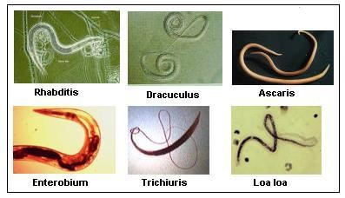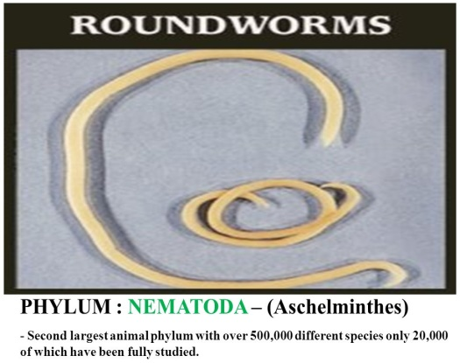

**Nematoda divided them into 2 classes phasmidia and Aphasmidia on the basis of presence and absence of phasmids.**

|  |  |
| --- | --- |
| **Class 1. Aphasmidia** | **Class 2. Phasmidia** |
| Phasmid (caudal (tail) sensory organs) absent. | Phasmids present. |
| Amphids (anterior sense organs) of various types, rarely pore-like. | Pore-like amphids. |
| Excretory system absent. If present poorly developed. | Well-developed excretory system. |
| Well-developed mesenterial tissue. | Weekly developed mesenterial tissue. |
| Caudal adhesive glands present | No caudal adhesive glands. |

**Order 1. Trichuroidea (Trichinelloidea)**

**Body filiform anteriorly.**

**Mouth without lips; pharynx slender.**

**Female with 1 ovary and male with 1 or none spicule.**

**Parasites of vertebrates.**

**Examples: *Trichuris trichiura*** (**Whipworm**) a very common intestinal helminthic infection and **about one-quarter of the world's population** is thought to carry the parasite. Only patients with a heavy parasite burden become symptomatic.

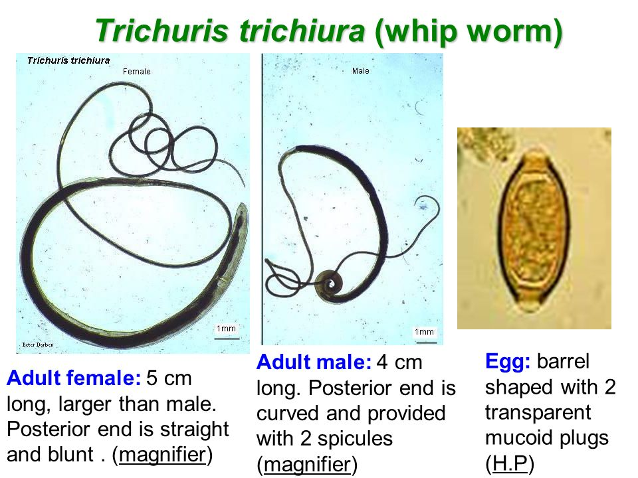

Poor hygiene is associated **with trichuriasis** transmission, and children and in the schools are high prevalence due to lacking hygiene conditions.

1. Male, 30-45 mm; female, 35-50 mm

2. Adults reside in the large intestine, cecum, and appendix of the host.

3. Buries its thin, threadlike anterior half into the intestinal mucosa and feeds on tissue secretions, not blood.

4. Transmission: faecal-oral via embryonated ova.

5. Pathology the major pathology resembles that of inflammatory bowel disease due to **mechanical disruption** and **toxicity** of whipworms.

Symptoms hyperemiaاحتقان oedema haemorrhage/bleeding In a few cases, there are cellular proliferation and thickness of the intestinal wall causing inflammatory and granulomas

6. Clinical manifestations Light infestations (<100 worms) are frequently asymptomatic.

Heavy infestations may have bloody diarrhoea. Long-standing blood loss may lead to iron-deficiency anaemia. Rectal prolapse is possible in severe cases. Vitamin A deficiency may also result due to infection. Mechanical damage to the mucosa may occur as well as toxic or inflammatory damage to the intestines of the host.

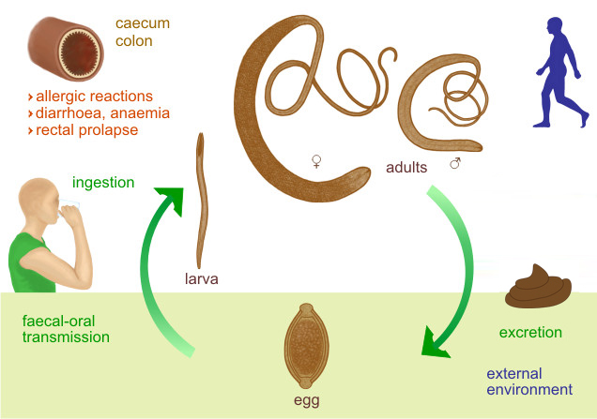

7. Diagnosis T. trichiura eggs are detected in stool examination. Eggs will appear barrel-shaped and unembryonated, having bipolar plugs and a smooth shell.

8. Prevention & Control

1- Application of hygiene conditions(good wash, cook well, etc).

2- Avoid ingesting soil that may be contaminated with human faeces, including where human faecal matter ("night soil") or wastewater is used to fertilize crops.

**Order 2. Rhabdiasoidea**

**Size medium. Smooth cuticle. Pharyngeal bulb absent. The parasitic stage in vertebrates is either hermaphroditic or parthenogenetic.**

**Examples: *Strongyloides stercoralis***

Habitat: females live in the superficial tissues of the small intestine (duodenum and jejunum)of definitive host: Human, dogs and cats

• Route of infection: Filariform larvae penetrate the skin of a human.

• Infective stage: Third stage larvae ( filariform).

• Diagnostic stage: First-stage larvae(Rhabditiform) in faeces.

life cycle: Free life cycle and Parasitic life cycle.

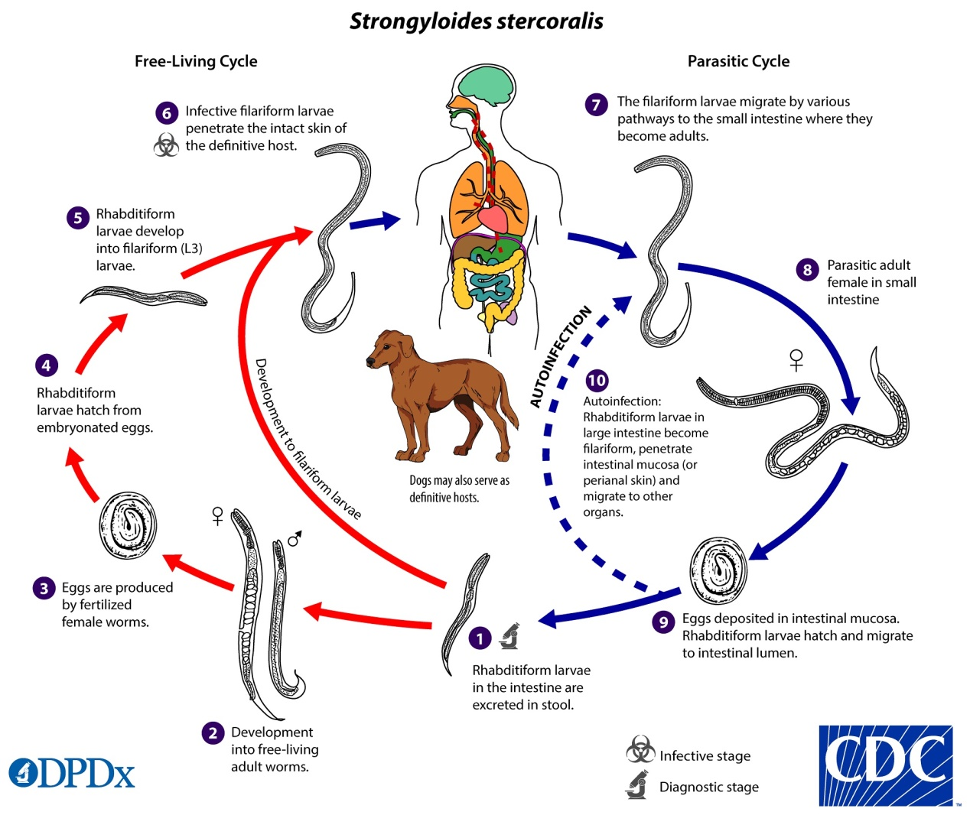

• Cause by direct contact with contaminated soil

**Egg shape:** oval, clear, thin-shelled Similar to hookworm but are smaller, laid in the mucosa, hatch into rhabditiform larvae that penetrate the glandular epithelium and pass into the lumen of the intestine and out the faeces (Eggs are seldom seen in stools).

**Adult:** Male (free-living): - 0.7 mm in length - Rhabditiform oesophagus - Posterior end curved ventrally with Spicules

**Parasitic female:** - 2.2 mm in length - Cylindrical oesophagus (1/3 body length) - Posterior end straight

**Free-living female:** - 1 mm in length - rhabditiform oesophagus - posterior end straight.

**Rhabditiform larvae** Short buccal cavity.

**Life Cycle** **in the parasitic stage, no male** form of this organism has been reliably identified, and the female reproduces in a parthenogenetic manner.

When filariform larvae encounter a human or another suitable host they penetrate the skin and are carried by cutaneous veins to the vena cava, they enter the right side of the heart and are carried to the lungs via the pulmonary artery, following a 3rd moult, the larvae rupture from the pulmonary capillaries and enter the alveoli, the larvae move to the epiglottis and subsequent swallowing by the host, they migrate over the epiglottis to the oesophagus and down into the small intestine, where they undergo a final moult and become sexually mature females and produce embryonated eggs parthenogenetically and hatch in the mucosa into 1st stage rhabditiform larvae and exit the intestine with the faeces, feeding down the length of the intestine.

Autoinfection • During passage through the host digestive system, rhabditiform larvae may undergo 2 moults to filariform larvae and by penetrating the intestinal mucosa, enter the circulatory system and continue their parasitic lives without leaving the host Autoinfection can also occur when larvae remain on and penetrate the perianal skin. • Autoinfection often leads to very high worm burdens in humans.

**In the free-living phase** dwell in moist soil in warm climates copulation occurs in the soil; egg oviposition, eggs hatch in the soil and give rise to 1st stage rhabditiform larvae and go through several moults and become sexually mature adults. This free-living heterogenic life cycle may continue indefinitely

**Pathology**

• Invasive: Skin Penetration. • Pulmonary: During Cycle or Immigration. • Intestinal: Tissue Destruction

– Commonly asymptomatic

– But symptoms may include:1. Gastrointestinal (diarrhoea, abdominal pain, malabsorption)

2. Respiratory (coughing, wheezing)

3. Dermatologic (ground itch, rash)

4. Anemia

Transmission • Direct penetration of unbroken skin by larva • Autoinfection - internal (larva becomes infectious in intestinal tract) & external

**Diagnosis** direct stool smears larvae (rhabditiform and occasionally filariform) in the stool. Histology the microscopic tissues larvae typically found.

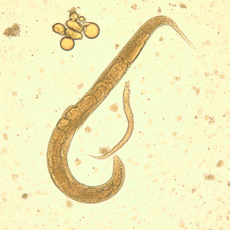 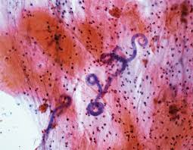 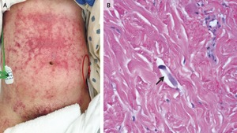

**Order 3. Oxyuroidea**

**Pin-shaped small worm.**

**Mouth surrounded by 3-6 small lips.**

**Pharynx with valvular posterior bulbs.**

**Female with a long pointed tail.**

**Parasitic in invertebrates and vertebrates.**

**Examples: *Enterobius vermicularis*** is a common intestinal parasite in humans, the body is covered with cuticle.The male worm is inconspicuous and has a length of 2 to 5mm. The female is dominant and has a length of 8 to 13mm.

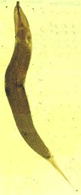 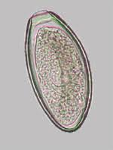

Humans are the host Infections occur by ingesting eggs The larvae hatch from the egg in the small intestine The larvae develops into male and female worms Fertilization occurs in the colon, after that males die.

Gravid female migrates nocturnally to the anus and lay eggs, after that females die. The eggs become infectious within 6 hours. The movement of the female worm and the eggs cause itching Scratching the area may result in retro infection The time period from ingestion of infected eggs to the ovideposition is approximately one month.

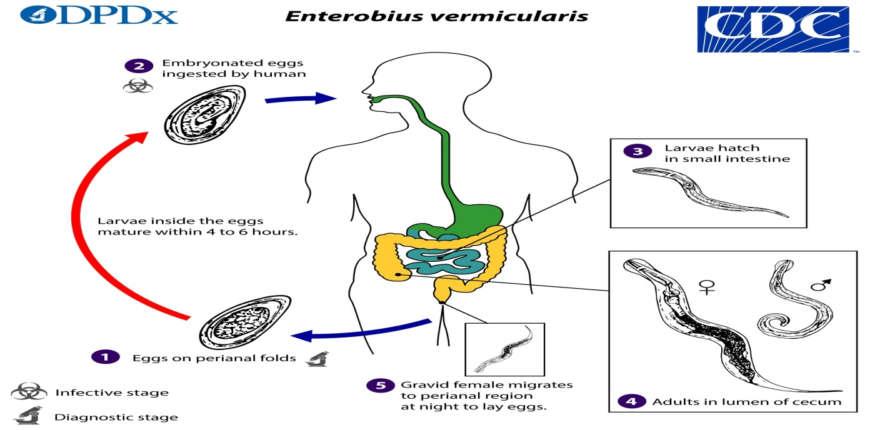

Symptoms perianal pruritus is the most common symptom It is thought to be an allergic reaction to the presence of either the adult female or the eggs Itching of the perianal and vaginal area is commonly notable, especially during night Weight loss is also observed in severe infections Scratching predisposes to secondary bacterial infection

**Diagnosis** the eggs are recovered from perianal skin by using the scotch tape technique for microscopic examination

**Prevention** Application of hygiene conditions(good wash, cook well, etc).

Change underwear and bed linen daily. Launder the bed sheets in hot water. Don't scratch and avoid nail biting. Clean toilet seats daily.

**Order 4. Ascaroidea**

**Large-sized worm. Mouth surrounded by 3 lips. Pharynx without bulb. Male with a ventrally coiled tail. Parasitic in the vertebrates.**

**Examples: *Ascaris lumbricoides*** ( Giant Intestinal round worms) is the largest nematode (roundworm) parasitizing the human intestine found in the small intestine of man. • They are more common in children then in adult.

Disease:-Ascariaisis , Host :- The human in small intestines , Infective stage :- Ovum

Female pink- creamy-white in color. The female averages 20-35cm in length, the male is smaller, averaging 15-31cm in length, the typical curled tail with a pair sickle like copulatory spines. On the tip of the head there are three toothed lips, arranged as a Chinese word “ 品 ”, the lips are one dorsal and two ventrolateral. • These lips bear sensory structures called labial papillae

Site of infection: small intestine

Infetive stage: embryonated eggs by mouth through contaminated food or water with eggs

A female may produce approximately 200,000 eggs per day, which are passed with the faeces . Fertile eggs embryonate infective, the larvae hatch , invade the intestinal mucosa - hepatic portal vessels, then systemic circulation to the lungs- penetrate the alveolar walls, ascend the bronchial tree to the throat, and are swallowed and reaching the small intestine, they develop into adult worms.

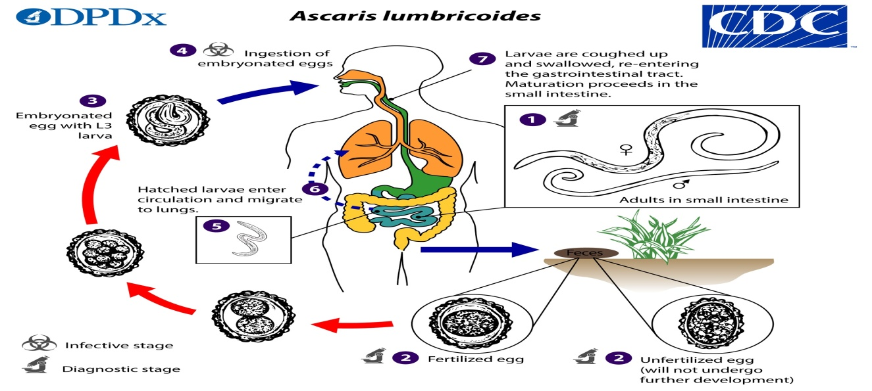

**Pathogenesis** there are two phase in ascariasis: 1. The blood-lung migration phase of the larvae may cause a pneumonia. The symptoms of the pneumonia are low fever, cough, blood-tinged sputum, asthma. Large numbers of worms may give rise to allergic symptoms. Eosionophilia is generally present. These clinical manifestation is also called Loeffler’s syndrome.

2. The intestinal phase of the adults. The presence of a few adult worms usually produces no symptoms, but heavy infection cause

1- diarrhoea, abdominal pains or intermittent colic, especially in children. 2-malnutrition. 3- Intestinal blockage - may be partial or complete • Partial intestinal blockage • Total intestinal blockage • Severe abdominal pain • Vomiting • Restlessness • Disturbed sleep.

**Diagnosis** identify worm or egg in the Stool examination.

oval shell:-Thick,consisting of 3 layers coarse consist of regular albuminous,There is crescent shaped clear space at the each end inside the shell with Golden brown color

**Prevention**

* Keeping good sanitation conditions.
* Should be avoided pollution of soil with human faeces.
* Health education. Hygienic habits such as cleaning of hands before meals.

**Order 5. Strongyloidea**

**Mouth without lips but leaf crown. Well-developed buccal capsule.**

**Pharyngeal bulb absent. Male with expanded copulatory brusa; female usually with ovijector. Parasites of vertebrates.**

**Examples: Necator, Ancylostoma**

Hookworms are the voracious blood-feeders of the nematode world. • Two principal species that infect around the earth are

• Necator americanus ( the american killer or the new world hookworm).

• Ancylostoma duodenale ( the old world hookworm).

Adult – Cylindrical with the head bent sharply backwards, head have buccal cavity 2 ventral plates and two large teeth – Males are smaller than the females and possess a bursa at their posterior end

Definitive host • Human • No Intermediate host

Adult mouthpart of Necator americanus Note : The large buccal capsule is open dorsally with one pair of cutting plate teeth.

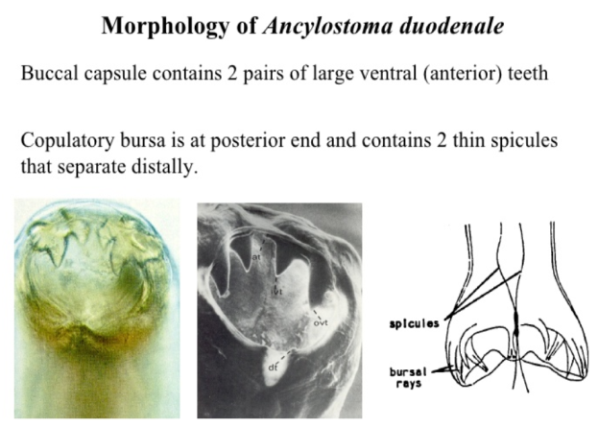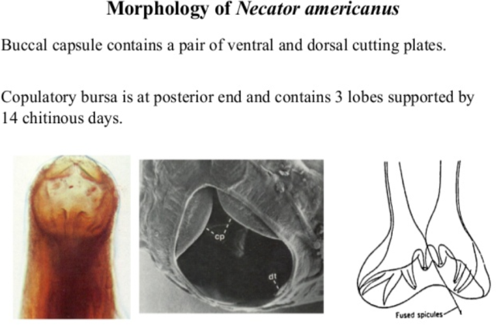

**Hookworm infection/disease depends on three factors:** 1)Number of worms present 2)Species of hookworm 3)Nutritional conditions of the infected person.

**Transmission** • Hookworm infection is contracted from contact with soil contaminated by hookworm, by walking bare foot or accidentally swallowing contaminated soil. • Children are at high risk because they play in dirt and often go bare foot.

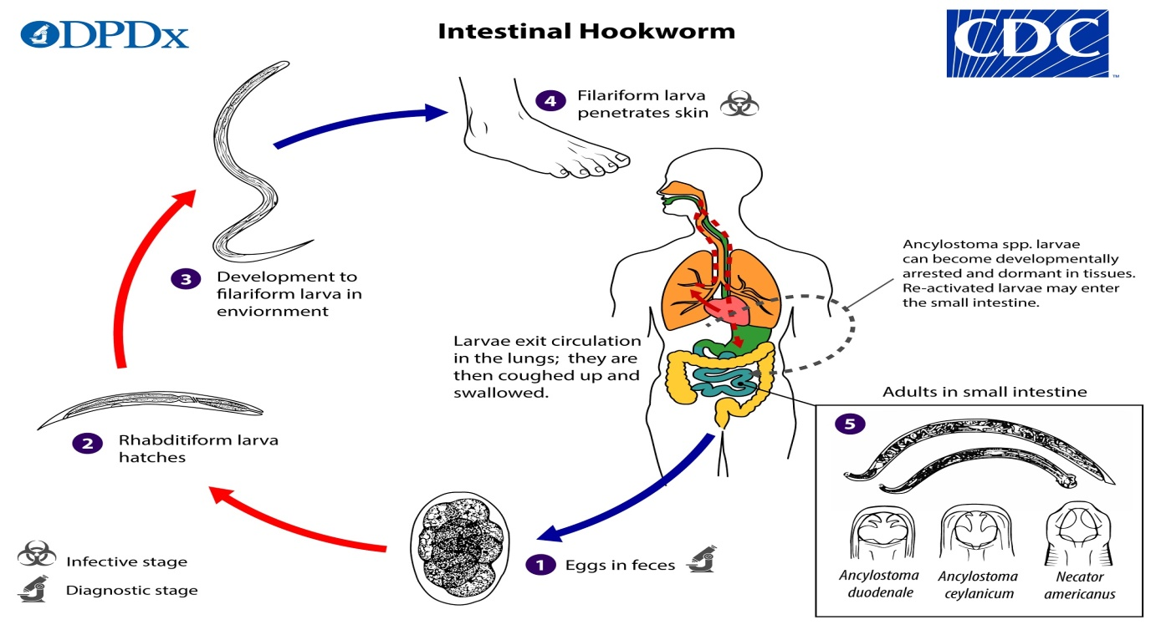

**Pathogenesis and clinical features**

1-Invasion stage: The skin, at the site of entry of filariform larva cause “ ground itch” or “dew itch” Itching, oedema.

2-Migration stage: the passage of the larvae in the lung leads to haemorrhages and pneumonia, cough, fever, eosinophilia.

3-sucking of blood by the worm (iron-deficiency anaemia ),  Severe anaemia leads to weakness. Approximately 50% of the red blood cells are hemolyzed 2) Bleeding at the site of attachment and after moving to a new site.

4- Toxic substances cause intestinal ulcers, flatulence, nausea, vomiting, diarrhoea.

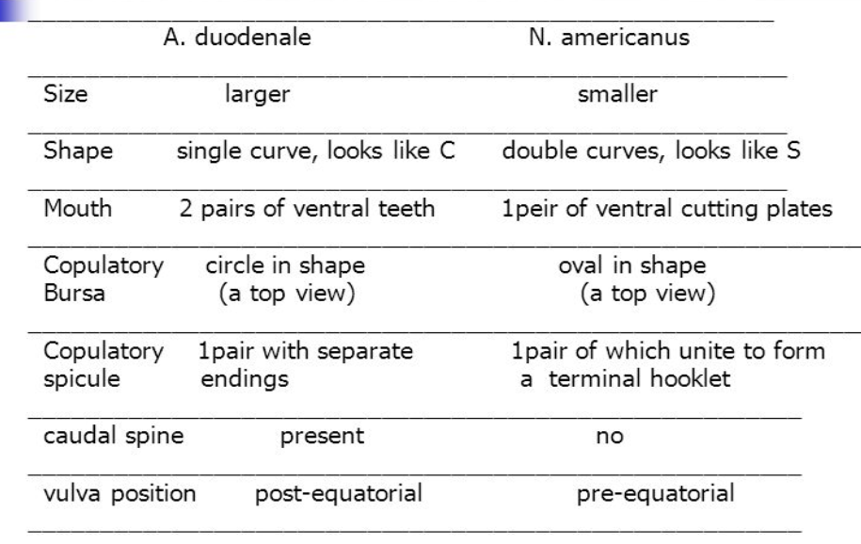

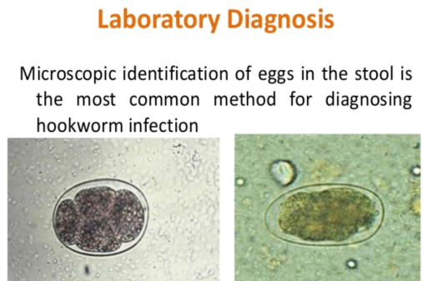 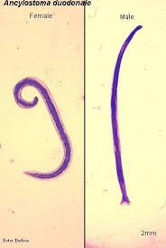 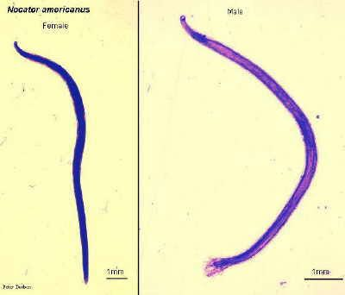

**Laboratory diagnosis** microscopic identification of eggs in the stool.

**Prevention** • Proper sanitation practices. • Appropriate fecal disposal. • Do not walk barefoot or contact with bare hands in areas where hookworms is common or there are likely to be feces in the soil or sand.

**Parasitology lecture 9 Biotechnology 3ed stage by Dr Alia Alubadi**

**Larva Migrans** **classified into cutaneous , ocular or visceral types,** depending on whether the larval migration takes place in the skin or in deeper tissues due to lose their way and wander around aimlessly, when human infection with non-human species of nematodes

1- **Cutaneous Larva Migrans** also known as creeping eruption (also called ground itch) which caused by burrowing larvae of animal hookworms. The larvae hatch from eggs passed in dog and cat feces and mature in the soil to larva stage(filariform larva) and penetrate the skin to cause infection, due to contact with contaminated soil in a human host is an accidental host for these parasites while in normal hosts such as dogs or cats develop normally in to adult in their intestine.

The most common cause is non-human species of hookworm (***Ancylostoma braziliense*** and ***A. caninum***).

**Pathogenesis,** after larvae penetrate the skin, erythematous lesions, but the larvae are unable to penetrate the basement membrane to invade the dermis, so that the disease remains connected to the outer layers of the skin.

**Clinical Features:** The larvae produce itching papules, which develop into tunnels in the epidermis due to the movements of the larva in the skin, the lesion also shifts, hence the name ‘creeping eruption’. Scratching may lead to secondary bacterial infection.

• Transient creeping eruptions may be produced sometimes by the human hookworm, *Necator americanus* and *Ancylostoma duodenale*.

**Diagnosis** is based mainly on clinical features.

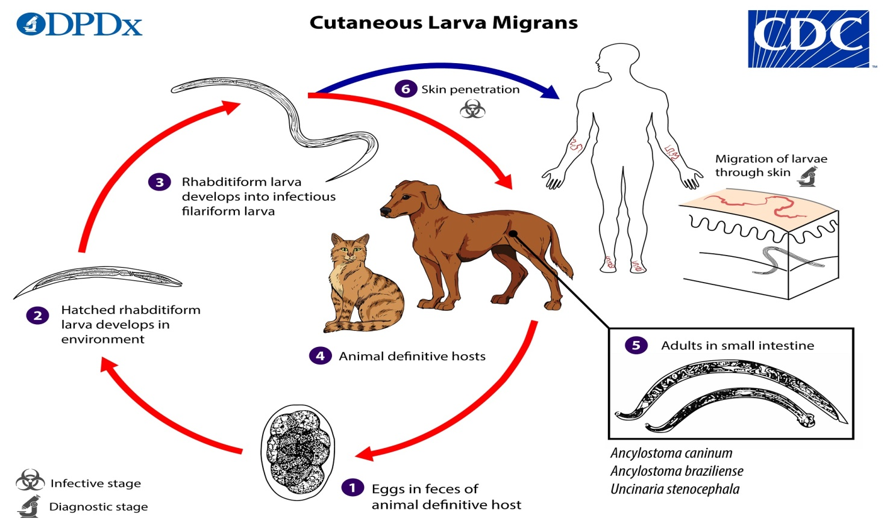

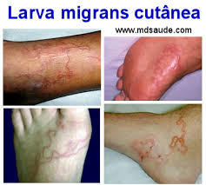 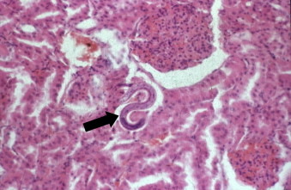 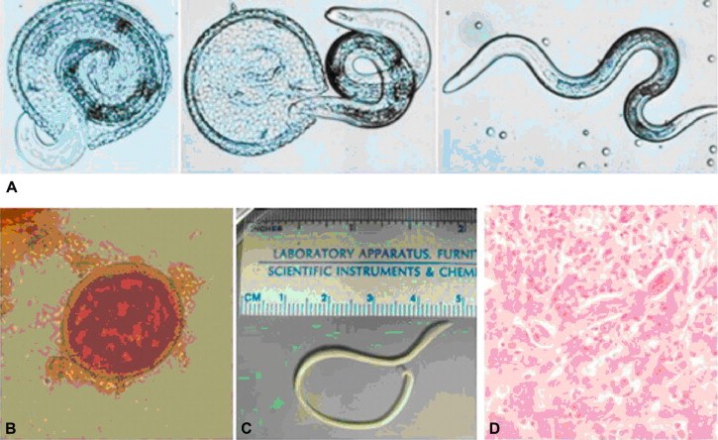

**2-Visceral Larva Migrans** caused by the migration of larvae of nonhuman species of nematodes that infect by the oral route.

The cause is the dog ascarid, ***Toxocara canis*** and cat ascarid, ***Toxocara cati***, inhuman, these nematode larvae do not develop into adult worms, but instead, migrate through host tissues.

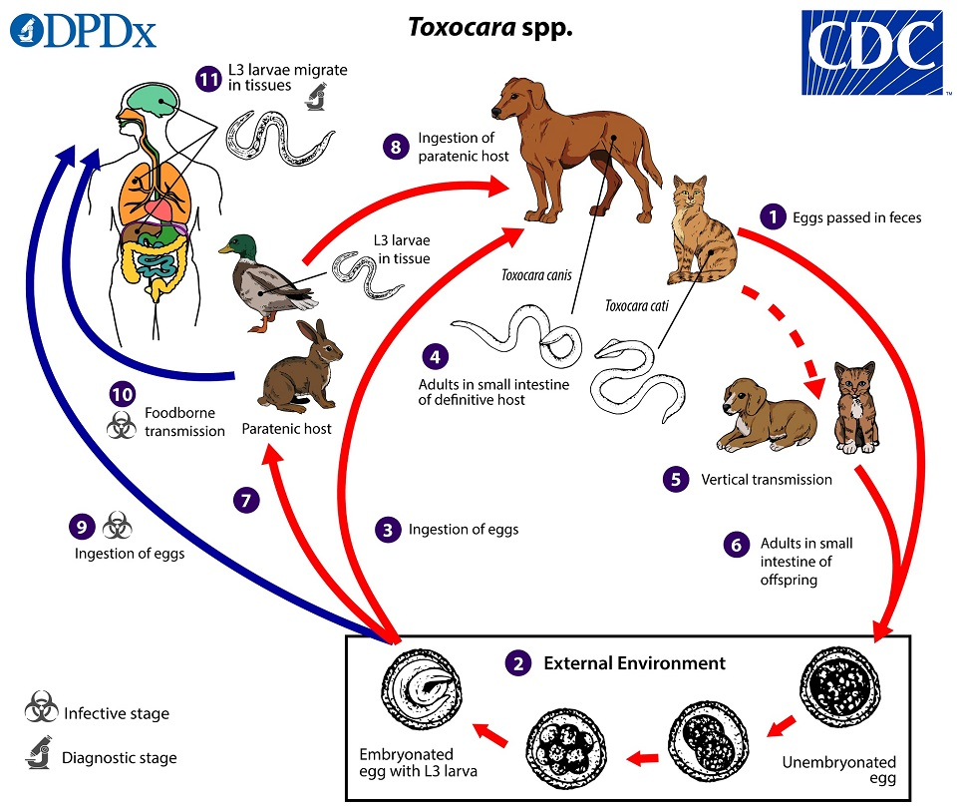

**Pathogenesis** • When **the infective eggs** present in the soil contaminated by dog and cat faeces are ingested, the larvae hatch in the small intestine, penetrate the gut wall, and migrate to the liver, which may remain there or migrate to other organs such as the lungs, brain, or eyes. In humans, they do not develop into adults but induce granulomatous lesions, which cause local damage.

**Clinical Features** • Clinical manifestations depend on the sites acted and the degree and duration of infection.

As children are more likely to swallow dirt, this condition is much more frequent in them.

Fever, hepatomegaly, pneumonitis, hyperglobulinaemia, and patients may develop neurological disturbances (neural larva migrans) and endophthalmitis (ophthalmic larva migrans).

Marked leukocytosis occurs with persistently high eosinophilia.

**Diagnosis** • Serological tests, to the diagnosis of toxocariasis (visceral larva migrans).

**Prevention** • Reduce contact with contaminated soil by wearing shoes and protective clothing and using barriers such as towels when seated on the ground.

2-**Blood and tissue filarial nematodes** are roundworms that infect humans. These organisms are transmitted via a blood-sucking arthropod vector such as a mosquito, midge, or fly. The filarial nematodes infect the subcutaneous tissues, deep connective tissues, body cavities, and lymphatic system. The life cycles of the filarial nematodes are complex. The infective larval stage resides in the insect vector with the adult worm stage, which is the pathogenic form in humans. When the arthropod vector feeds on a human blood meal, the infective larvae are injected into the bloodstream. The larvae are motile and migrate to the lymphatic vessels. The infective larvae grow and develop into the adult gravid worm in the human host over a period of months. The male and female adult worms mate in the definitive human host. The female worm produces large numbers of larvae called microfilariae. Depending on the species, the microfilariae may maintain the egg membrane as a sheath or may rupture the egg membrane, resulting in an unsheathed form. These parasites can reside in the host for many years and cause chronic, debilitating conditions and severe inflammatory responses. Identification of the various species is based on the morphology of the microfilaria, the periodicity (defined circadian rhythm), and the location within the human host.

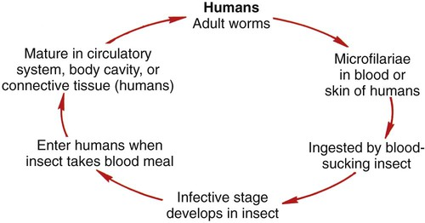

1. ***Dracunculus medinensis*** classification Phylum: Nematoda Class: Secernentea Order:Camallanida Family: Dracunculidae

**Known as guinea worm or medina worm or dragon worm**

**Disease name dracunculiasis**

**Adult worm**

•female length 60-120 cm • thickness 1-2 mm, anterior end is blunt , posterior end is tapering and is bent to form a hock , viviparious , gravid female discharge embryos in batches

• male is 10-40 mm length 0.4 mm thick , not seen mostly- dies after fertilization , posterior end male is coiled male

• larva 500-750 μm length • 5-25 μm diameter • broad anterior end • it has a slender tapering tail • larva set free only when the affected part is submerged in water

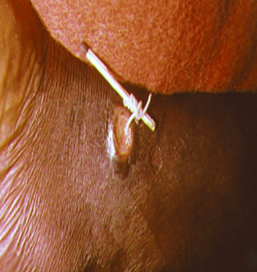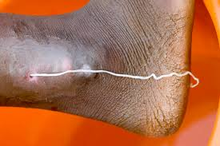 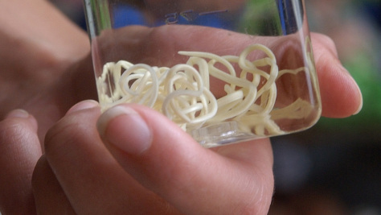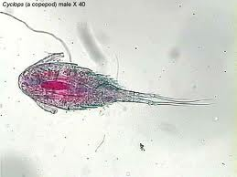

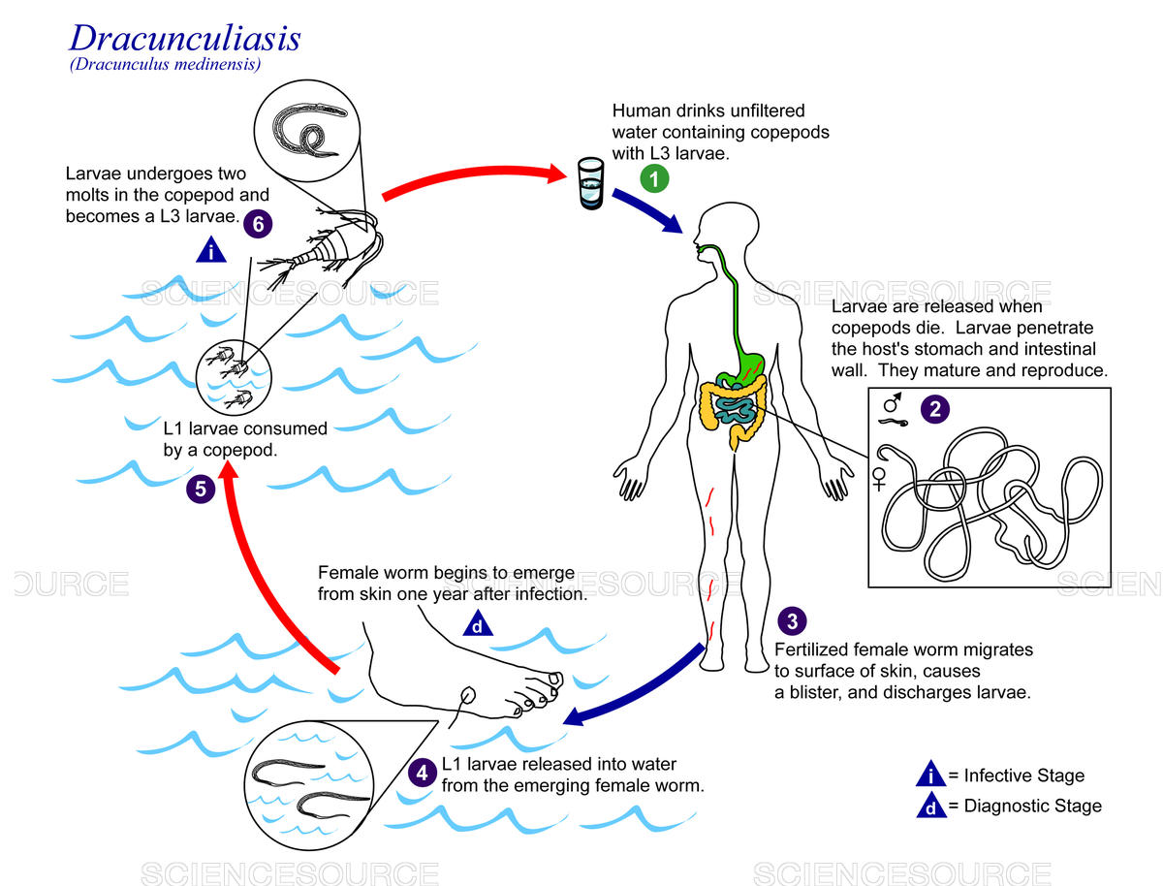

**Life cycle**

the intermediate host is cyclops the transformation to infectious third stage larvae occurs within 2 weeks, infection of man is effected when swallowing infected cyclops after 3 month the worms mate and the male dies. The female continues to grow and travel down the muscle planes. The female emerges after 10-14 months to release larvae in water and completes the cycle…

Pathogenesis • 1 year – asymptomatic • before blister symptoms • nausea, vomiting, erythema, urticarial rash & pruritis • blister – reddish papule with vesicular centre souround induration • common site – feet ankle metatarsal • secondary infection at ulcer.

**Diagnosis** • detection of adult worm: • gravid female worm appears at the surface of skin • after death may become calcified can be detected radiological

• detection of larva • contact with water – large amount of larva discharges • microscopic examination • serology

Prevention • filtering or boiling drinking water • preventing the infected person from water sourse • cyclops are killed by insecticides.

***Loa loa* cause LOIASIS known as (African Eye Worm)**

Habitat ➢ Adult worm : subcutaneous tissue

➢Microfilariae : blood

Morphological stages

1-adult worm thin ,transparent, whitish, thread like worm , anterior end tapers to a narrow head

Male worm 30-34mm in length , 0.35-0.43mm in diameter, Tail end has spicules unequal length

Female worm 40-70mm in length ,0.5mm in diameter, the vulva opens in the cervical region

2-microfilaria Sheathed with column of nuclei extending from tip of the tail, its 250-300µm : length , have diurnal periodicity to their concentration in the blood stream, peripheral blood during day time (12-2pm)

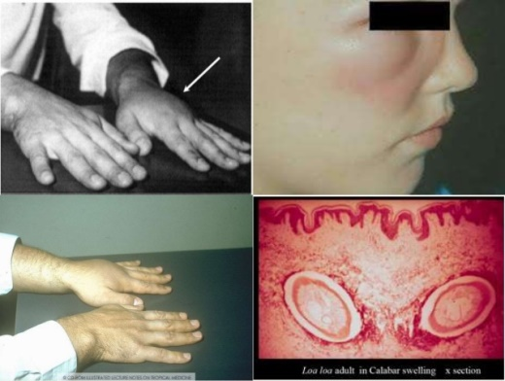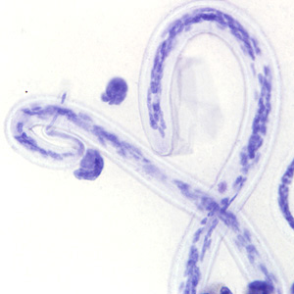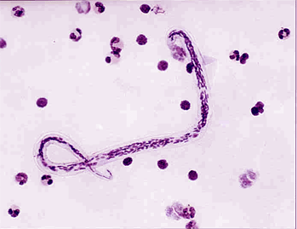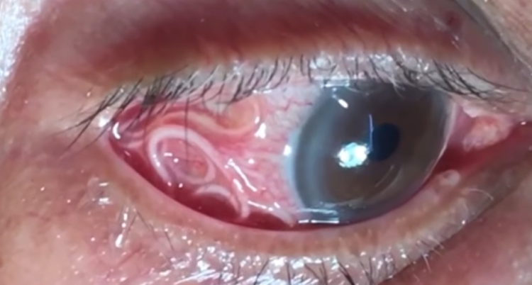

**Life cycle :** Two host • Definitive host : man • Intermediate host : Chysops (mango fly)by bite larvae are subcutaneous enter and develop into adult worms & wander through subcutaneous tissue. Female release sheathed eggs called Microfilariae travel to the spinal fluid, blood, urine, sputum & lungs. Mango fly bites human, takes blood meal containing microfilariae. Microfilariae shed their sheaths & migrate to thoracic muscle of the fly.

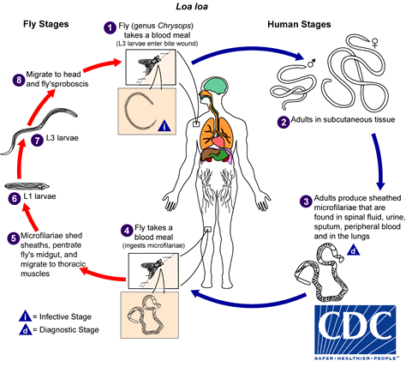

**Pathogenesis** depends upon the migratory habit of adult worm,

1- Calabar Swelling : A local edema of the subcutaneous tissue,are caused by an allergic reaction to dead worms or the metabolic products of the worms.They can occur anywhere on the body but mostly on forearms & wrists.

2-Complications May arise if worm lodges into unusual sites.Scrotal swelling , bowel obstruction ,endocarditis, arthritis, retinopathy, & neuropathy have all been seen in persons infected with loa loa.  Loa lao often increases the number of eosinophils , the immune cell that fights parastic infections, in blood.  Loa loa dose not cause serious long term damage to humans.

• Ocular lesions include ➢ Granulomata of bulbar conjuctiva ➢ Painless edema of eyelid ➢ Proptosis

**Diagnosis** Calabar swelling & the presence of a worm in the conjunctiva are main diagnostic methods.  Diagnosis is also made by visualization of the microfilariae in a blood smear.➢Isolation of adult worm from eye • 12 - 2pm (diurnal periodicity)

**Prevention** • Insect repellent • Protective clothing • Avoid visit to endemic areas

***Wuchereria bancrofti* cause of lymphatic filariasis.**

Habitat of Adult worm : **Lymphatic system** Habitat of Microfilaria: **blood**

Intermediate Host : **Anopheles**  Definitive Host : **Man**

Morphology A transparent worms with a smooth cuticle. Creamy-white in colour. In females the tail tapers gradually and is rounded at the tip. While in males the tail curves ventrally. Males and females live coiled together and is difficult to separate. Females are ovo-viviparous. Life span: 5-10 years Sizes: Female: 80-100 mm x 0.2-0.3 mm Male : 25-40 mm x 0.1 mm

Microfilariae The embryonic form of Wuchereria bancrofti (adult worm) is known as Microfilariae. Present in the peripheral blood of human, they are colourless and transparent with blunt head and pointed tails. Covered by hyaline sheath. The sheath is much longer than the embryo so that they can move within it.

nuclei appear as granules in the central axis of the embryo and extend from the head to tail-end.

Nocturnal periodicity of microfilariae 8 PM- 4 AM = best time to collect Microfilariae may not be demonstrable in peripheral blood.

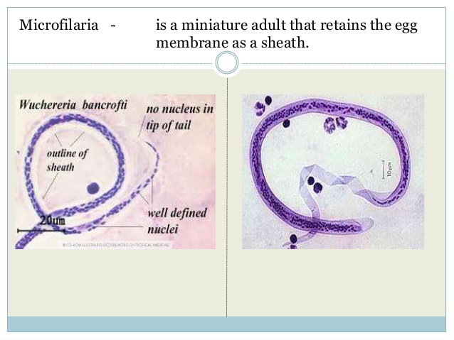

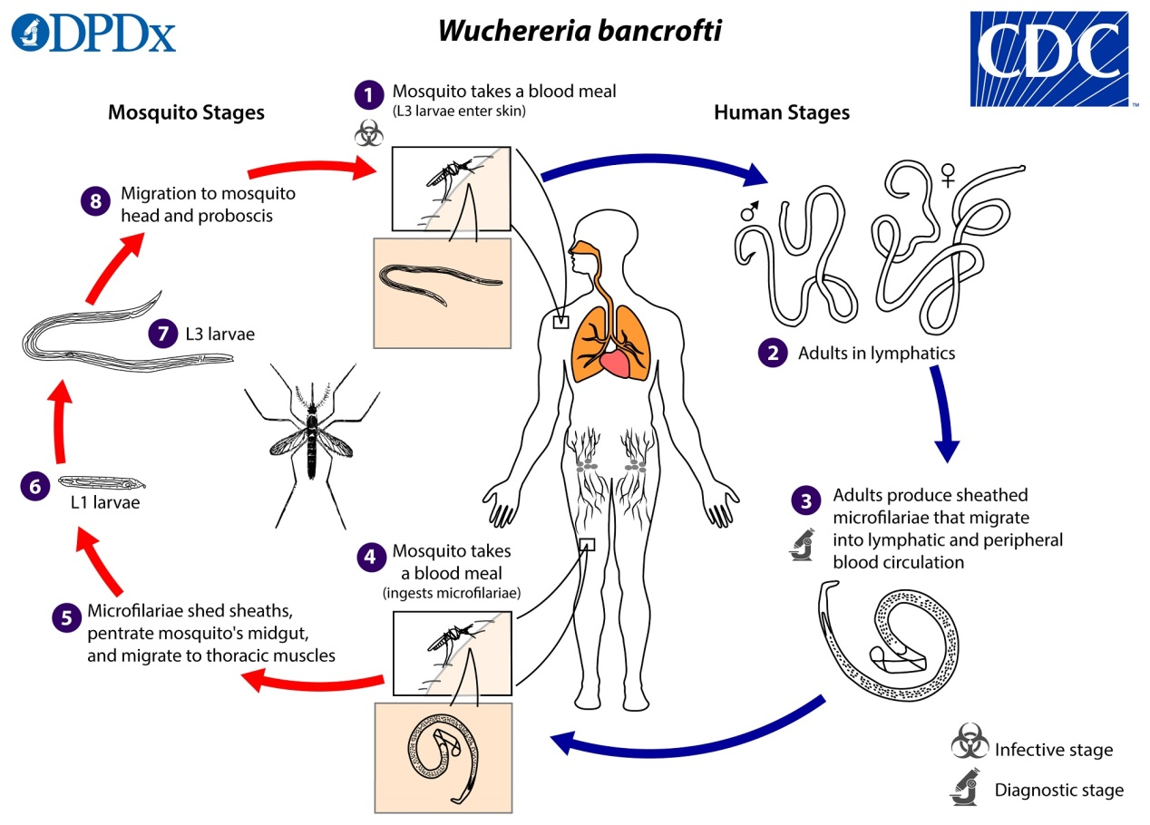

**Pathogenesis**  Lymphedema • abnormal accumulation of lymph in tissues causing swelling of arms, breasts, or genitals and cause wuchereriasis or filariasis or elephantiasis accompanied by marked thickening of the skin.

**Diagnosis** Demonstration of microfilariae in peripheral blood film, chylous urine, hydrocele fluid & lymph varix. Microfilariae appear in large numbers in peripheral blood at night.

**Prevention and Control**  Insect repellants  Use of mosquito nets  Public education.