Lab 2 MEDIA Practical Microbiology
Medium ( plural media ) :
It is the environment where the microorganisms live and get their nutrients in order to grow and reproduce in the laboratory .
Components of the Typical Media :
- Carbon source .
- Nitrogen source .
- Phosphorous source .
- Water source .
- Source of minerals e.g. Fe , Mn , Na , K , Zn , Mg… etc .
- Source of vitamins and amino acids .

Solidifying Agents :
1.Agar :
- Obtained from seaweeds.
- No nutritive value .
- Not affected by the growth of the bacteria.
- Melts at 98ºC & solidifies at 42ºC .
- 2% agar is employed in solid medium

2.Gelatin :
- Not satisfactory .
- Liquefies at 24ºC .
- Has nutritive value .
- Affected by the growth of the bacteria.

Types of Media
l.Based on Their consistency:
1.Solid media – contains 2% agar
- Colony morphology, pigmentation, hemolysis can be appreciated.
- Eg: Nutrient agar, Blood agar

2.Liquid media – no agar.
- For inoculum preparation, Blood culture, for the isolation of pathogens from a mixture.
- Eg: Nutrient broth
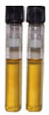

3.Semi solid medium – 0.5% agar.
Eg: Motility medium
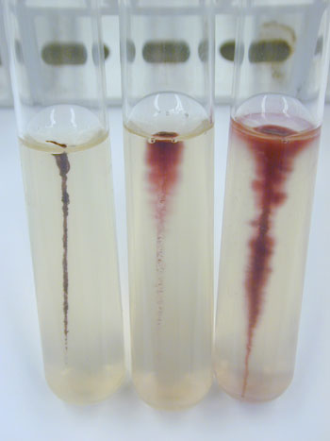

ll. Based on the constituents/ ingredients
a) simple medium
b) complex medium
c) synthetic or defined medium
d) Special media

Special media:
1.Enriched media :
Eg: Blood agar, Chocolate agar
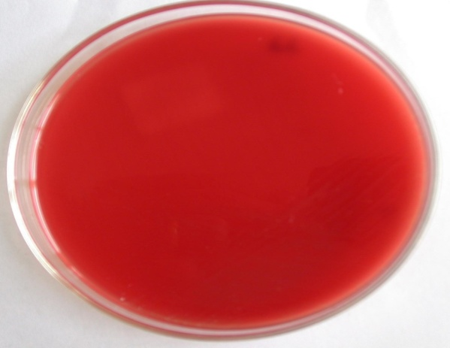

______________________________________

2.Enrichment media : Alkaline Peptone Water
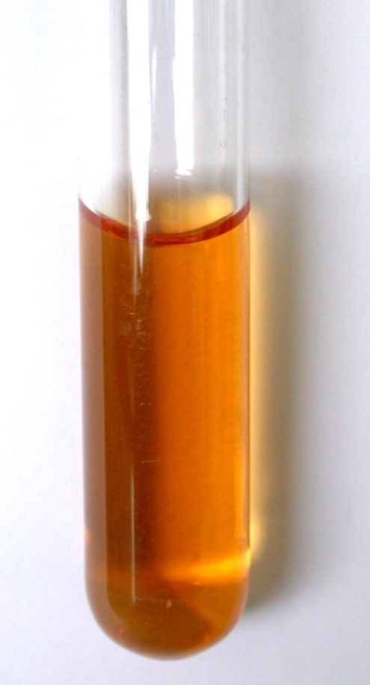
_________________________

3.Selective media: Mac Conkey’s medium
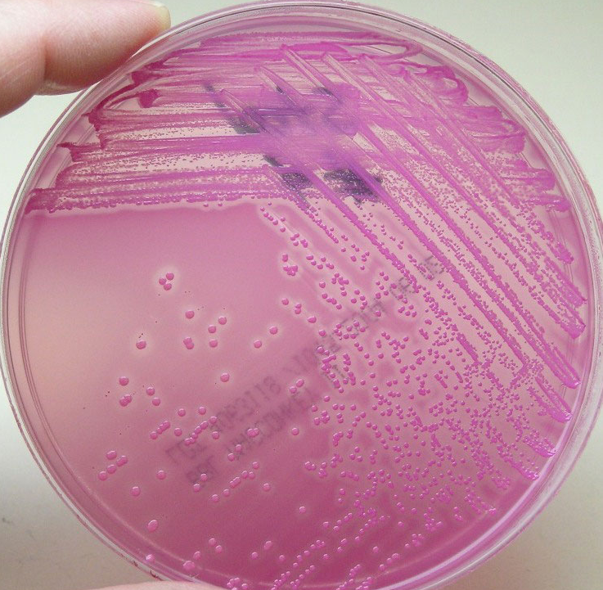

  - Indicator media

  - 4.Differential media : Blood agar
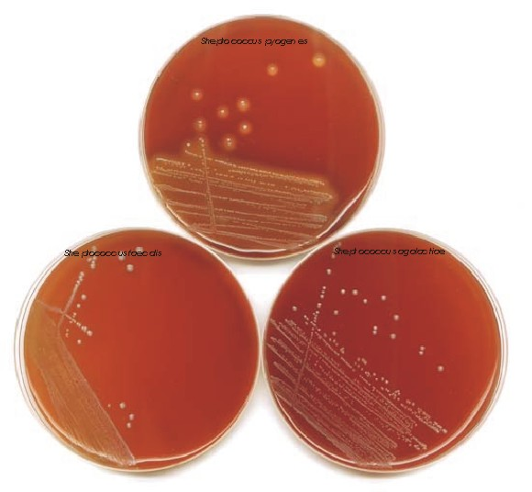
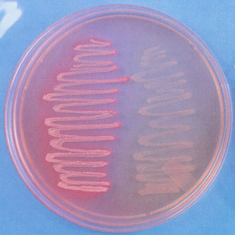

Transport media : Stuart’s medium