Lec(4) Advanced Serology
Prof.Dr.Ekhlass N. Ali
Adjuvants:
Adjuvants are used in many vaccines, but their mechanisms of action are not fully understood. Studies from the past decade on adjuvant mechanisms are slowly revealing the secrets of adjuvant activity. Adjuvants may act by a combination of various mechanisms including formation of depot, induction of cytokines and chemokines, recruitment of immune cells, enhancement of antigen uptake and presentation, and promoting antigen transport to draining lymph nodes. It appears that adjuvants activate innate immune responses to create a local immuno-competent environment at the injection site. Depending on the type of innate responses activated, adjuvants can alter the quality and quantity of adaptive immune responses.
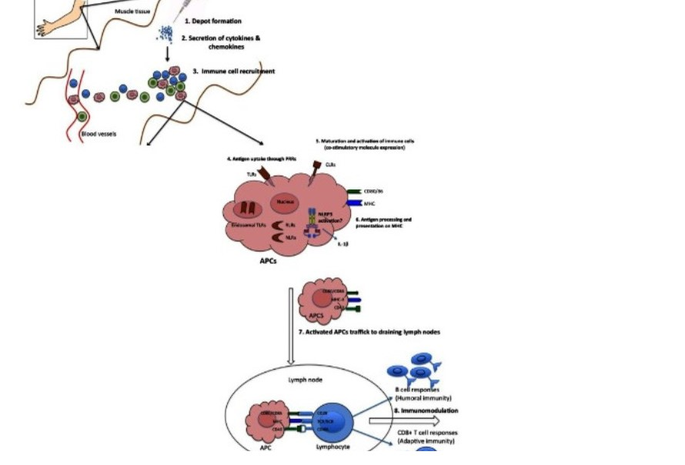

Proposed mechanisms of action of adjuvants. (1) Some adjuvants presumably form a depot at the site of injection, which is associated with slow release of antigen. (2) Other adjuvants are associated with transient secretion of cytokines and chemokines. (3) Secreted cytokines and chemokines are involved in recruitment of various immune cells to the injection site. These recruited cells secrete cytokines and chemokines, in turn attract other immune cells. All these events lead to formation of a local immuno-competent environment at the injection site. (4) The recruited APCs express various PRRs both on the surface (TLRs, CLRs) and intracellularly (NLRs and RLRs), which are recognized and/or are activated by the adjuvants. (5) This leads to maturation and activation of recruited APCs. Mature APCs up-regulate the expression of MHC and co-stimulatory molecules. (6) They are also characterized by increased capacity for antigen processing and presentation. (7) Mature APCs then migrate to the draining lymph nodes to interact with antigen-specific B or T cell to (8) activate potent antibody secreting B cells and/or effector CD8+ T cell responses.
Need for Adjuvants
Vaccines, one of the most successful medical inventions against various infectious diseases, (Hillman), sometimes require a molecule in conjugation that augments its immune response. Previously, antibodies used to be made in response to proteins, carbohydrates, complex lipids and nucleic acids isolated from natural sources. However, the antigens today, are made using modern chemical, biosynthetic and rDNA techniques; a majority of which are weak immunogens due to the lack
of an innate immune stimulus . Small polypeptides (<10 kDa) and nonprotein antigens need to be conjugated to a large immunogenic carrier protein to become good immunogens. It is therefore expedient to co-administer these with an adjuvant to ensure a high quality/high quantity, memory-enhanced antibody response.
Adjuvants can be subjected to various uses such as
1. To bolster the immune response of any antigens by delivering in native form.
2. To reduce the multiple immunization protocol for protective immunity. In particular to develop single step vaccination coverage that can reduce the vaccination costs.
3. To enhance the immune response of immune compromised adults and weakened immune system of children, to elicit

cytotoxic T lymphocytes response and generate local immune response .
Classification of Adjuvants
The adjuvant property of a molecule increases with the length of the sugar side chain and the HLB value have high hydrophile–lipophile balance (HLB) value . However, adjuvants are conventionally classified into the following categories: Mineral compounds, Bacterial products, Oil-based emulsions, ISCOMs and Liposomes. Of these, the aluminium based mineral compounds are the most widespread and the most preferred for humans .
Aluminium based minerals
Aluminium based adjuvants, like Aluminium hydroxide and Aluminium phosphate have been known to induce early, long lasting,high titre, protective immunity . However, aluminium is a weak adjuvant for antibody induction to recombinant protein vaccines .
Oil-based emulsions
These are popular immune potentiators for inactivated vaccines .
Saponins: Saponins are steroid or triterpenoid glycosides, which occur in many plant species, in both wild plants and cultivated crops. In cultivated crops the triterpenoid saponins are generally predominant ,whereas steroid saponins are common in plants used as herbs or for their health-promoting properties. Saponin-based adjuvants have the unique ability to stimulate cell-mediated immunity, as well as to enhance antibody production. Research on certain traditional Chinese medicinal herbs such as Panax ginseng, Astragalus species,Panax notoginseng have gained attention as candidates for plant derived saponins . Quillaja saponaria extract as adjuvants, first described in the 1930s have been the most prominent of the saponins used as adjuvants .
Bacterial products
Due to their potent immunostimulatory capacity, bacterial products are considered a good source of immunological adjuvants. Bacterial flagellin is an effective adjuvant for CD4+ T cells in vivo .
Heat shock proteins (HSPs) are conserved proteins that are highlyimmunogenic and function as adjuvants that may play a crucial role in integrating innate and adaptive immunity .
Complete Ajuvant & incomplete Adjuvantjust oil& oil and killed mycobacterium tuberculosis)
Cytokines
Cytokines like IFN- gamma or GM-CSF have been popular for over a decade as effective adjuvant molecules . Induction of local delayed
hypersensitivity (DTH) is commonly observed after the use of Pro inflammatory
cytokines IL-1, TNF- , IFN- , IFN- , IL-6, IL-8 .
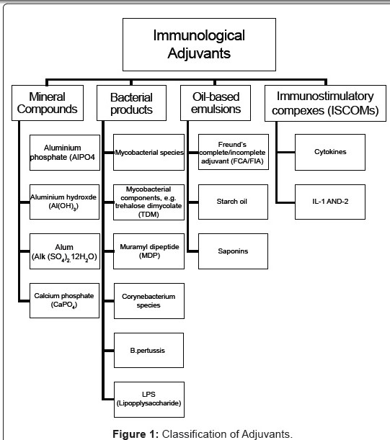
Selection of Adjuvants
Immunological adjuvants accelerate, prolong or enhance antigen antigen specific
immune responses if used in combination with specific vaccine antigens. Ideally an adjuvant is assumed to possess long shelf life with undiminishing stability, biodegradability, low cost of production, theability to not induce immune responses against itself and to promote the required immune response. However, observations have been made of differences in adjuvant efficacy with the route of administration e.g. between mucosal and parenteral routes. Therefore, the adjuvant should be selected by considering the various factors involved For example, it was discovered that subunit vaccine responses can be enhanced relative to soluble antigen/adjuvant or alum formulations . Kreuter and Haenzel observed that the particle size of the polymer adjuvant was found to be an important prameter for adjuvant activity.
Mode of Action of Adjuvants
Vaccines based on highly purified antigens will require specific adjuvants to elicit the required response . Targeting of vaccines to specific immune cells is very promising. However, it may be difficult to develop effective vaccines without blocking immune regulatory pathways thus hampering the CMI response. Adjuvants have significant effects on the immune responses, and can tip the immune system in favour of Th1 or Th2 type response .To sustain an Ab response, a supply of Ag is needed. One way an adjuvant may aid the immune response is by forming a depot of Ag at the injection site resulting in the sustained release of small quantities of Ag over a long period of time. Even with an adjuvant that forms a depot of Ag, at some point in time the quantity of Ag is diminished and the
Ab titer declines. At this time a second injection of Ag (a booster dose)may be given. When an animal that has responded maximally is given a booster dose of Ag too soon, suppression rather than enhancement of the immune response may ensue.
Alternatively, an adjuvant can work is to serve as a vehicle to help deliver the Ag to the spleen and/or lymph nodes where Ag is trapped by the follicular dendritic cells and where most of the necessary cell to cell interactions take place to generate plasma cells (the Ab-secreting cells). For example, microdroplets of oil containing Ag, such as those formed in an oil-in-water adjuvant emulsion, are readily ingested by macrophage and taken to draining lymph nodes or spleen. Ag-loaded tissue dendritic cells rapidly emigrate via lymphatics to draining lymph nodes. Additionally, emulsions aid tissue dendritic cells in their capture of Ag.
A third way an adjuvant can work is to activate the various cells
involved in the immune response, either directly or indirectly.Surfactants, components of all emulsion adjuvants, may serve this function as well as helping to stabilize oil-water emulsions. Also, many bacteria contain substances that activate cells of the immune system ,particularly the macrophage. The activated macrophage in turn helps activate T and B cells. Thus some adjuvants contain bacteria, bacterial products, or derivatives of bacterial products. Although the activation of macrophages indeed aids in the antibody response, excessive activation of macrophages also causes excessive inflammation, so that bacterial
components cannot be used in excess. In recent years, a number of bacterial products have been modified in ways that maximize their desirable activation potential and minimize their inflammatory potential with the goal of finding ideal adjuvant components. For example, some of the new generation adjuvants incorporate a chemical variant of endotoxin called monophosphoryl lipid A [MPL] or a modified muramyl dipeptide [thr-MDP] or other “detoxified” cell wall
constituents of bacteria .
Advancements
Adjuvant formulations can be tailored to enhance the required immune response (antibody, cell mediated, mucosal immunity) specific to individual causative infectious agents .
The Matrix Immune Modulator (MIM) was developed to overcome real and perceived disadvantages of classical mineral salt adjuvants.It not only potentiated the immune response to antigens but also increased antibody production in chickens and mice, thus suggesting MIMs as a potential substitute for mineral based adjuvants .Baldwina compared a stable oil-in-water emulsion (SE)
and a stable oil-in-water emulsion incorporating glucopyranosyl lipid adjuvant, a synthetic TLR-4 agonist (GLA-SE), each together with a
recombinant protein, ID93. Their study highlighted the emphasis on
administering effective adjuvants along with the subunit vaccines for
treatment against tuberculosis.BAE, or biologically active molecules purified from a Brazilian palm-tree fruit- the babassu, have been shown to possess potential
adjuvant properties. Research suggests that it could be administered in
association with or without aluminium compounds, for the preferential
induction of Th1-dependent immune responses against different
antigens in distinct murine strains and animal species .
Adjuvants are being studied for the treatment of cutaneous
melanoma. Oncogenic BRAF inhibitors such as vemurafenib have been
proposed to be used in the adjuvant setting [21].
The immunologic enhancement mediated by a polysaccharide (PPSB) from the fruits of Physalis alkekengi yielded results which indicated that both humoral immunity and cellular immunity were mediated by the polysaccharide. It is hence a promising adjuvant eliciting both Th1 and Th2 responses to help improve the efficacy of vaccine .
Software that Aids Adjuvant Selection
Adjuvant softwares have been developed to provide an estimate of whether or not to receive systemic adjuvant therapy for cancer depends on weighing the benefit (in terms of overall survival) against the cost and risk associated with such therapy.
The most popular software ‘Adjuvant!’ uses data from national databases and other sources to estimate a patient’s baseline prognoses.It requires an experienced health professional to enter the data on the website and obtain the results and the toxicity review sheets for the adjuvant regimens .
The Search for Additional Adjuvants
Since adjuvants have to be tailor made for the vaccine and due to the
Tant amount importance on the safety associated with its administration,
a search has arisen for adjuvants which are capable of inducing:
1. Broader immune responses covering multiple serotypes.
2. Strong T-cell responses that are needed against infections such
as hepatitis C virus and human immunodeficiency virus (HIV)
3. Responses which stimulate an immune response early in life.
4. Potent mucosal immunity
5. Immune responses to poor immunogenic antigens .
Over the last decades very few adjuvants have been licensed for prophylactic vaccines due to toxic properties detected during preclinical or clinical studies (Progress in understanding adjuvant immune toxicity mechanisms Alexander Batista). The advent of recombinant technology in formulation of vaccines has only exalted the demand for adjuvants. Therefore, immense research is required to find a suitable adjuvant for a particular vaccine with maximum safety and efficacy.

