Lecture topics:
- Atmospheric processes - role of aerosols
- Characterization of aerosol particles
- Forces and interactions
- Instrumentation and measurements
- Health effects of particles
- Applications
- Standards and guidelines
- Aerosols in indoor and outdoor environment
- Motor vehicle emissions.
Why study environmental aerosols?
Reason 1: Because particles constitute one of the most important pollutants affecting human health. Evans et al 1984: "We are of the opinion that the cross-sectional studies reflect a causal relationship between exposure to airborne particles and premature mortality... However, we are in the minority in taking this view." Dockery et al 1993: ".... Quote from indoor air paper: the unknowns
Reason 2: Approaches taken in environmental aerosol studies could be used in any other area of environmental studies or in any other type of interdisciplinary studies.
Reason 3: Understanding of aerosol processes and interactions can be used in the most advanced areas of industry and technology such as material synthesis, microelectronics, and pharmacy.
Reason 4: For the challenge of it - if you do not do it, the others might do it, or nobody will do it!

  - Classification of airborne pollutants
- According to chemical composition or their properties Sulphur, nitrogen, carbon containing substances, toxic substances, etc. Volatile (VOC) and semi-volatile organic compounds (sVOC), includes polynuclear aromatic compounds (PAH), aldehydes, organic acids, etc. Sulphur dioxide (SO2), Nitrogen oxides (NOx), Carbon monoxide (CO), Carbon dioxide (CO2), Photochemical oxidants, Hydrocarbons (CH4, C4H10, C3H8, etc.), Hydrogen sulphide and fluoride: (H2S) and (HF).
- According to physical properties, whether these pollutants occur in a gaseous form, particle form (solid or liquid), or are even as radioactive compounds.
- According to formation mechanisms:
Primary pollutants: emitted directly from sources; e.g.: nitric oxides, hydrocarbons, etc. Secondary pollutants: formed in the atmosphere by chemical interactions among primary pollutants and normal atmospheric constituents; e.g.: ozone, photochemical aerosols, etc. as in figure 1-1
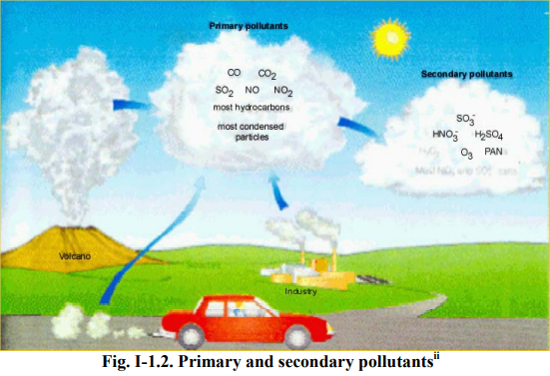

I - 2. Dynamic nature of atmospheric processes
1-2-1Gases are produced by:
- Chemical processes in the atmosphere
- Biological activity
- Volcanic exhalation
- Radioactive decay
- Human activity
1-2-2 Gases are removed from the atmosphere by:
- Chemical reactions in the atmosphere
- Biological activity
- Physical process in the atmosphere
- By deposition and uptake by the oceans and earth
1-2-3 Atmospheric pollutant concentration units are:
• µg/m3
• parts-per-million by volume (ppm)
Parts-per-million by volume is defined as the species i mass concentration and can be calculated as follows:
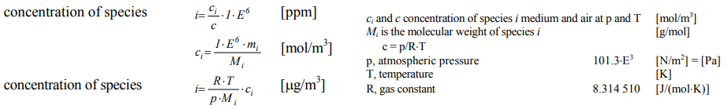

1-2-4 Atmospheric cycles involve physical, chemical and biological processes;
the main global cycles are:
- Water cycle (evaporation from the sea 85%, transpiration from land 14.5%, run off 6%, precipitation 36%, evaporation on land 0.001%, movement of water vapour 5%);
- Sulphur cycle (of biogenic and anthropogenic origin; e.g., fossil fuel combustion; volcanic activity, etc.);
- Nitrogen cycle (of biogenic and anthropogenic origin; e.g., agriculture, etc.);
- Carbon cycle (of biogenic and anthropogenic origin; e.g., fossil fuel combustion; volcanic activity, etc.);
- Halogen compounds cycle (biogenic and anthropogenic origin; e.g., industry, volcanic activity, etc.);
- Phosphorous cycle (of biogenic and anthropogenic origin; e.g., industrial agriculture, etc.);

  - Air pollution – classical view of chemical pollutants
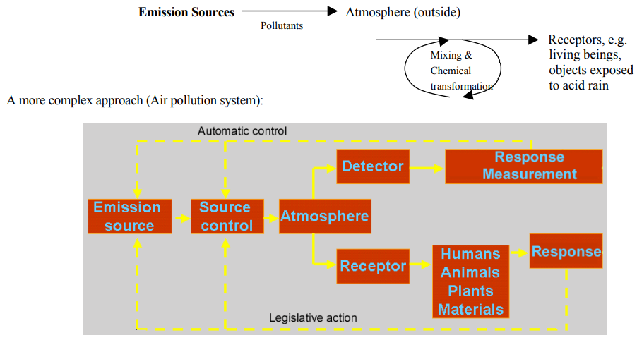

1-3-1 Air pollution sources:
- Transportation
- Electric power generation
- Refuse burning
- Industrial and domestic fuel burning
- Industrial processes
- Consumer products
1-3-2Classification of air pollutants - according to physical state:
- gaseous form
- particulate form (solid or liquid particles)
- According to chemical composition (Major groupings include):
- sulphur-containing compounds
- nitrogen-containing compounds
- carbon-containing compounds
- halogen-containing compounds
- toxic substances
- radioactive compounds
- According to formation mechanisms:
- Primary pollutants emitted directly from sources; e.g.: nitric oxide and hydrocarbons.
- Secondary pollutants formed in the atmosphere by chemical interactions among primary pollutants and normal atmospheric constituents; e.g.: ozone, organic nitrates, oxidized hydrocarbons and photochemical aerosol.

