***Lab 3***

***Verify Hooke’s law and determine the force constant******of the spring***

**Aim:**

To verify Hooke's law for spring, and determine the extension per gram of added load.

Or, to find the force constant of a helical spring by plotting a graph between weight (load) and extension.

**Tools :**

* 1. Spiral spring to which pointer is attached at its beginning and lower end.
  2. Stand and Clamp.
  3. Metric ruler.
  4. Weight stand.
  5. Weights Set.

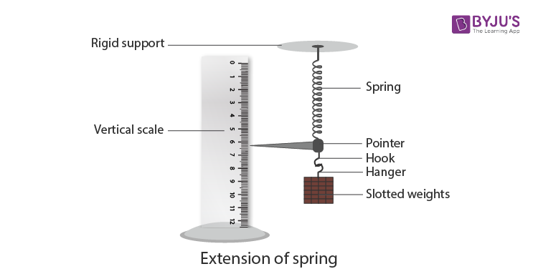

**Theory:**

The extension that occurs in spring as a result of the force acting on it is subject to Hooke's law. Hooke's law can be written: -

F = - k L ------------------------ (1)

The negative sign indicates that the reference force is in the opposite direction of the extension.

Where (F) is the force and (L) is the extension length. (k) is the force constant, or "spring constant. The force constant (k) is defined as the force required to extend or compress the spring and its units (N/m) and is given by the equation:

(2) ------------------

If different weights are placed in the Weight stand and the corresponding spring extension is measured and a graphic relationship is drawn between the weights (m) on the x-axis and the difference in length or extension (L) on the y- axis, the result of the drawing is a straight line with a slope equal to:

(3) ---------------------------

(4) ------------------------

***Method or Procedure:***

1. The spring, with the Weight stand, and the metric ruler are placed vertically so that the pointer attached to the end of the spring moves on the metric ruler, then record the length of the spring without weights (L0).
2. Put a weight ) 20 g( and record the length of the spring (L1).
3. Add load or Increasing the weights (20 g) in each reading and recording the corresponding length of the spring (L1, L2, L3, L4, L5) where the number of readings should not be less than five. (When increasing the length of the spring)
4. Remove load or Remove one weight, the pointer moves up and records the corresponding length of the spring.
5. Repeat step (4) and record the corresponding length of the spring , (When decreasing the length of the spring)
6. Record your reading as given below in the table.

|  |  |  |  |  |
| --- | --- | --- | --- | --- |
| Extension | Mean | Spiral spring length | | Weights g |
| load decreasing  (L") | Load increasing (L) |
|  |  |  |  |  |

1. Plot a graphic relationship between the weights on the x-axis and extension on the y- axis, the result of the graph is a straight line passing through the origin point, finding its slope, and then finding the value of (k) from the equation (3).

Q1/ What is Hooke’s Law?

Stress and strain take different forms in different situations. Generally, for small deformations, the stress and strain are proportional to each other, and this is known as Hooke’s Law.

Hooke’s law states that the strain of the material is proportional to the applied stress within the elastic limit of that material.

Q2/ A spring is displaced by 5 cm and held in place with a force of 500 N. What is the spring constant of the spring?

Q3/Does Hooke’s Law apply to all materials?

Hooke’s spring law applies to any elastic object of arbitrary complexity, as long as a single number can express the deformation and the stress.

Q4/ Is Hooke’s Law linear?

Hooke’s Law is linear. Hooke’s law states that the restoring force is proportional to the displacement.

Q5/ When does Hooke’s Law fail?

Hooke’s law applies to a perfectly elastic material and does not apply beyond the elastic limit of any material.

Q6/ When is Hooke’s Law negative?

In Hooke’s law, the negative sign on the spring’s force means that the force exerted by the spring opposes the spring’s displacement.

Q7/ Why do we need Hooke’s Law?

Hooke’s Law is essential because it helps us understand how a stretchy object will behave when stretched or compacted.

Q8 / Give the unit of spring constant.

The unit of spring constant is newton per meter squared (N /m)