**Lab One :.**

The Preparation of Buffers and Solutions **:**

**Buffer:** A solution which tends to maintain a constant pH when excess acid or base is added.

Buffers are solutions that contain mixtures of weak acids and bases that make them relatively resistant to pH change

1. **Molecular Weight** : is simply the weight of all the atoms in a substance. A molecule is a stable group of two or more atoms and is electrically neutral.

Example : How do you calculate the molecular weight of H2O?

**M. wt = 1×2 + 1×16**

**= 18** **grams/mole**

What is the molecular weight of octane, C8H10?  
Answers: The molar mass of octane is just 8 times the mass of carbon plus 10 times the mass of hydrogen:   
(8 × 12.01) + (10 × 1.01) = **106.18 grams/mole**.

**Moles = $\frac{weight }{molecular weight }$**

1. **Molarity(M):** A concentration unit (M); defined as the number of moles of solute divided by liters of solution.

M= $\frac{Wt}{M.Wt}×\frac{1000}{V}$ OR Molarity = $\frac{moles of solute }{liters of solution}$

Example : Determine the molarity when 3.0 moles of sucrose are dissolved to make 2.0 liters of solution.

$$\frac{3.0 mol}{2.0 liters}=X=1.5 M$$

**Example**: Attended solution a 0.2M of sodium chloride (NaCl) and the volume of 500mL, note that the molecular weight 58.5 for salt???

M= $\frac{Wt}{M.Wt}×\frac{1000}{V}$

0.2= $\frac{Wt}{58.5}×\frac{1000}{500}$ Wt= 5.85 gm

**Example:** If you have 10.0 grams of NaCl, table salt, and dissolve it in 500 ml of water, what is the Molarity of the solution?

First, work out the number of moles of salt. NaCl has a molecular weight of 58.43 g/mole, so we have

10.0 g/58.43 g/mole = 0.171 moles of NaCl

Next, convert the volume to liters, since it is in milliliters

500 ml * 1 liter/1000 ml = 0.500 liter

Now simply use the equation above

molarity (*M*) = moles solute/liters of solution

***M* = 0.171 moles/0.500 L = 0.342 *M***

1. **Normality** : Normality is a measure of concentration equal to the gram equivalent weight per liter of solution. Gram equivalent weight is the measure of the reactive capacity of a molecule.

N= $\frac{Wt}{Eq.Wt}×\frac{1000}{V}$

**Equivalent Weight of acid :.\*\*\***

Eq.Wt of acid= $\frac{M.wt of acid}{No.of H2 group}$

*** **Equivalent Weight of base**

**Eq.Wt of base= $\frac{M.wt of base}{No.of OH group}$**

**Example:** Attended a solution of Mg (OH)2 with Normality 0.2N and the volume of 200mL note that weight Molecular = 58**.**

N= $\frac{Wt}{Eq.Wt}×\frac{1000}{V}$ 0.2= $\frac{Wt}{58/2}×\frac{1000}{200}$

Wt=1.16gm

**There is a very simple relationship between normality and molarity:**

***N* = *n* × M**

**n= number of equivalents.**

When the point of equality, the number of equivalent weights affair for the first solution is equal to the number of equivalent weights affair for the second solution , in other words:

M1V1=M2V2

N1V1=N2V2

C1V1=C2V2

**Percentages:.**

1. W/W $=\frac{Wt of solute}{Wt of solution}×100$

**Example:** Solution consists of dissolving 10 grams of sodium hydroxide per 100 gram of water. Calculate the percentage of sodium hydroxide? Block solution **10+100=110grams.**

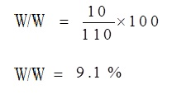

1. Wt/V(%)= $\frac{ Wt. of solute}{Volum of solvent}×100$

For example, when it is said that a solution of sugar in water concentration . This means that 10 gm of sugar dissolved in 100mL of water

1. V/V= $\frac{Volum of solute}{volum of solution}×100$

For example, when it is said that a certain solution consists of alcohol and water and the concentration of alcohol 40%(v/v), this means that in every 100mL of solution is that there is alcohol 40mL and 60mL water.

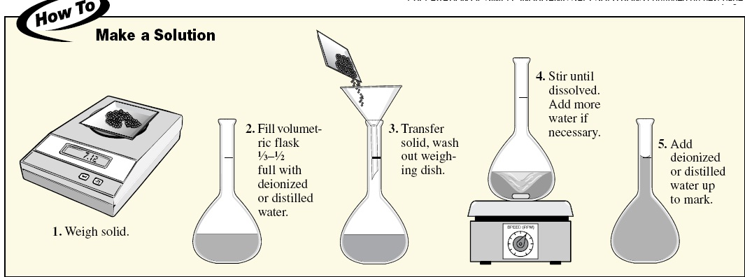

Home Work:

* How many uL of 1 M Tris-HCl pH 8.0 would you use to make 5 mL at 50 mM?