**LAB 9**

Kingdom: Animalia

Phylum: Platyhelminthes

Class: Trematode

Order: Prostomata

4-Family: Schistosomatida

1-Genus: ***Schistosoma haematobium***

2- Genus: ***Schistosoma mansoni***

3- Genus: ***Schistosoma japonicum***

The Schistosomes are **blood flukes**. They differ from other trematodes in

that they have separate sexes. The cuticle of the male is covered with

minute papillae While the female only possess these at the anterior and

posterior end as the middle section being covered by the male body. Oral

and ventral suckers are present, with the ventral one being lager serving

to hold the worms in place.

Definitive host: Human

Intermediate host: Snail

Infective stage: Cercaria (forked tailed)

Diagnostic stage: Egg

The Schistosome life cycle is very similar, with the exception that different species differ in the final location where the adult worms prefer to reside within the human body.



(The Schistosome life cycle)

1-***Schistosoma heamatobium***

Disease name: Urinary Schistosomiasis

Site of infection: Bladder, Ureters or Kidneys

**Morphology:**

**The adult** males measure up to 15 millimeters in length and females up to10μm*.* The male is actually flat has (3-5) testes but the sides roll up forming the canal in which the cylindrical female resides. The female has ovary in the dorsal part.

**The ova** are relatively large , They have an elongated ellipsoid shape with a prominent terminal spine.

2-***Schistosoma mansoni***

Disease name: Intestinal Schistosomiasis

Site of infection: Large intestine (the plexus of veins draining the rectum

and colon, and in branches of the portal vein in the liver

**Morphology**:

**The adult** male has (7-8) testes and female ovary in the front part.

**The ova** of *S. mansoni* are light yellowish brown, elongate and possess a

lateral spine.

3-***Schistosoma japonicum***

Disease name: Oriental Schistosomaiasis

Site of infection: Small intestine.

**Morphology:**

**The adult** worms are longer and narrower than the *S. mansoni* worms

males have (6-7) testes females ovary in the center.

**The ova** are more round with a minute lateral spine or knob (vague spine).

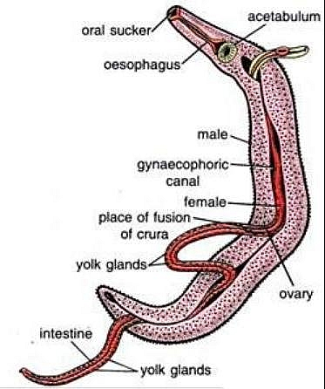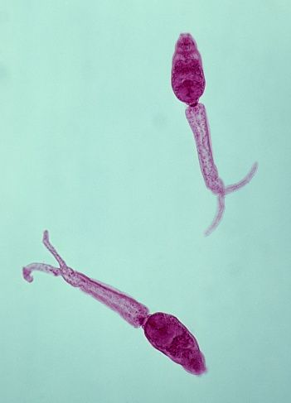

The adult worms (male and female) and Cercaria (forked tailed)

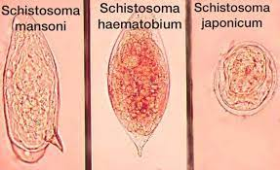

The ova (egg) of *Schistosoma* sp.

**Symptoms:**

The main lesions are again due to the eggs, occurring in the intestine and

liver. The eggs which are sequesters in the intestine mucosa or

sub mucosa granulomatous reactions, resulting in the formation of

Pseudo Tubercle.

**Laboratory Diagnosis:**

**-Microscopy**

Laboratory confirmation of infection can be made by finding the eggs in

the feces after an iodine stained, formal-ether concentration method for

*Schistosoma mansoni* and  *Schistosoma japonicum.* When eggs cannot be

found in the feces, a rectal biopsy can be examined, While *Schistosoma*

*hematobium* found in urine or feces.

**-Serology**

Serological tests are of value in the diagnosis of schistosomiasis when

eggs cannot be found. An enzyme linked immunosorbent assay (ELISA)

using soluble egg antigen.