Lab (6)
Kingdom: Protista
Subkingdom: Protozoa
Phylum: Sarcomastigophora
Class: Ampicomplexa (sporozoa)
Order: Eucoccida
Family: Plasmodidae
Genus: Plasmodium vivax (benign tertian malaria)
Plasmodium malaria (quartian malaria)
Plasmodium ovale (ovale tertian malaria)
Plasmodium falsiparm (malignant tertian malaria)

Disease name: Malaria
Site of infection: Red blood cell and Liver tissue cell

Plasmodium requires two hosts:
-Definitive invertebrate host: (vector Anopheles mosquitoes female).

-Intermediate vertebrate host: (mammals, birds and lizards).

Morphology:
 | P.falciparum | P.malaria | P. vivax | P.ovalae
Trophzoite | ring forms | band form | amoeboid form | compact rings in cells
Schizont | (8 – 36) merozoites. | (6–12) large  merozoites | (16). merozoites | (6-12) merozoites
Microgametocyte | Larger than RBC,  kidney shaped with blunt round ends | Smaller than RBC, round compact | Fills  enlarged RBC, small round or oval, compact with central nucleus | Of the size of RBC  round, compact
Macrogametocyte | more slender and longer than the  male | Round or oval with peripheral nucleus | large round or oval with peripheral nucleus | Round or oval with peripheral nucleus

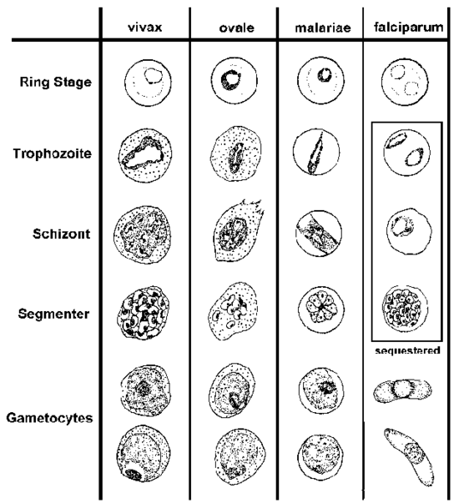

Life cycle:
Sexual cycle
Occurs in mosquito (9-21 days), fusion of micro and macrogametes are infective for mosquito→ zygote→ Ookinete (~24 houre) → Oocyst
Asexual replication (sporogony) → sporozoites released → migrate through hemocoel→ invade salivary glands

Asexual cycle
1-Exoerythrocytic schizogony (Liver stage)
Sporozoites injected during mosquito feeding→ merozoites (uninucleate asexual stages) invade liver cells. After this initial replication in the liver (Exo-erythrocytic schizogony) the parasites undergo asexual multiplication in the erythrocytes.

2-Erythrocytic schizogony (Blood stage)
Merozoites infect red blood cells and forms the ring stage in it and transform into trophozoites that mature into schizonts (multinucleated asexual stages) , which rupture releasing merozoites . Some parasites differentiate into asexual erythrocytic stages (gametocytes) repeated erythrocytic schizogony (48hr.) in Pf., Pv, Po.and (72 hr.) in Pm.
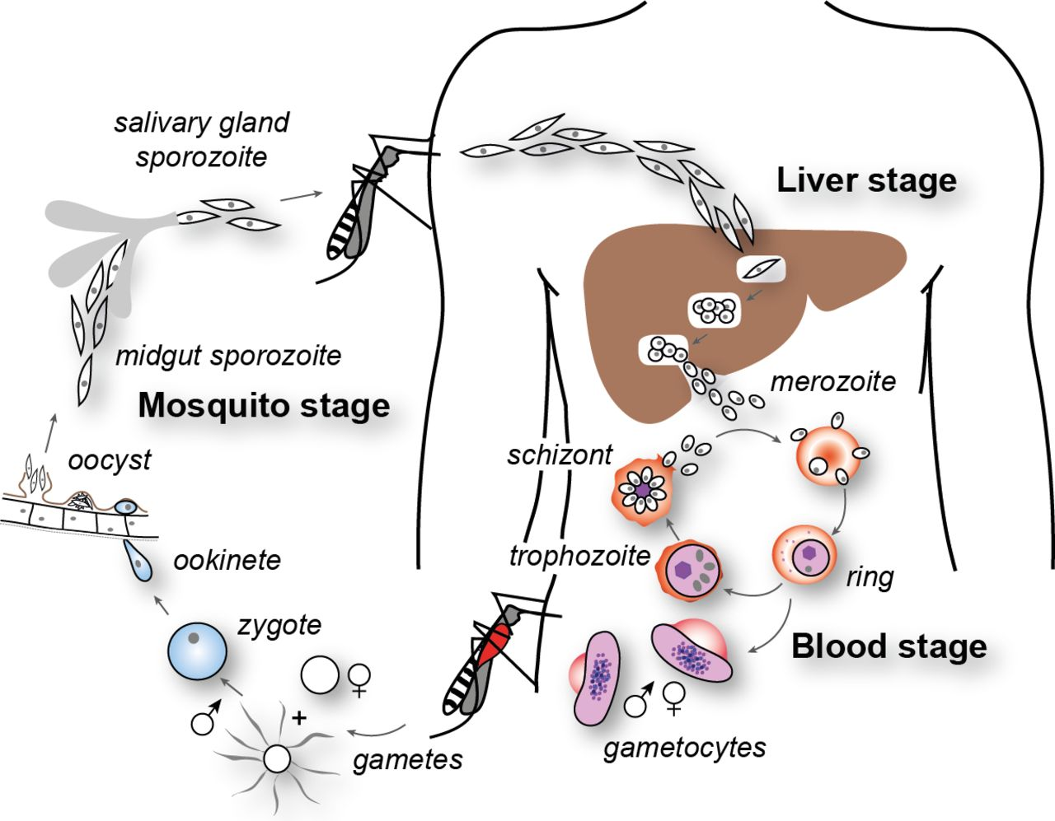

Symptoms:
- Fever: Often irregular. The regular pattern of fever does not occur until the illness has continued for a week or more.
-Anemia: The anemia is hemolytic in type. It is more severe in infections with
P. falciparum because in this infection cells of all ages can be invaded
-Splenomegaly: The spleen enlarges early in the acute attack of malaria.
-Jaundice: Amild jaundice due to hemolysis may occur in malaria.
Diagnosis:
1- Thin blood films stained with Giemsa stain.
2- Antibody test.

