**Horizontal Gene Transfer**

**Horizontal gene transfer ,** the transmission of [DNA](http://www.britannica.com/science/DNA) between different genomes , occur between different species . Acquisition of DNA through horizontal gene transfer is distinguished from the transmission of genetic material from parents to offspring during reproduction, which is known as [vertical gene transfer](http://www.britannica.com/science/vertical-gene-transfer). Horizontal [gene](http://www.britannica.com/science/gene) transfer is made possible in large part by the existence of mobile genetic elements, such as [plasmids](http://www.britannica.com/science/plasmid) (extrachromosomal genetic material), [transposons](http://www.britannica.com/science/transposon) (“jumping genes”), and bacteria-infecting viruses ([bacteriophages](http://www.britannica.com/science/bacteriophage)). These elements are transferred between organisms through different mechanisms, which in prokaryotes include [transformation](http://www.britannica.com/science/transformation-biology), [conjugation](http://www.britannica.com/science/conjugation-sexual-process), and [transduction](http://www.britannica.com/science/transduction-microbiology). In transformation, prokaryotes take up free fragments of DNA, often in the form of plasmids, found in their environment. In conjugation, genetic material is exchanged during a temporary union between two cells, which may entail the transfer of a plasmid or transposon. In transduction, DNA is transmitted from one cell to another via a bacteriophage.

In horizontal gene transfer, newly acquired DNA is incorporated into the genome of the recipient through either [recombination](http://www.britannica.com/science/recombination-genetics) or insertion. Recombination essentially is the regrouping of genes, such that native and foreign (new) DNA segments that are homologous are edited and combined. Insertion occurs when the foreign DNA introduced into a cell shares no homology with existing DNA. In this case, the new genetic material is embedded between existing genes in the recipient’s genome.

**1. Conjugation**

Bacterial conjugation is the transfer of genetic material between [bacterial cells](https://en.wikipedia.org/wiki/Bacteria) by direct cell-to-cell contact or by a bridge-like connection between two cells. Discovered in 1946 by [Joshua Lederberg](https://en.wikipedia.org/wiki/Joshua_Lederberg) and [Edward Tatum](https://en.wikipedia.org/wiki/Edward_Tatum).

In most cases, this involves the transfer of plasmid DNA, although with some organisms chromosomal transfer can also occur. As with other modes of gene transfer in bacteria.

In the simplest of cases, conjugation is achieved in the laboratory by mixing the two strains together and after a period of incubation to allow conjugation to occur, plating the mixture onto a medium that does not allow either parent to grow, but on which a transconjugant that contains genes from both parents will grow. Plasmid transfer can be readily detected even if only, say, 1 in 106 recipients have received a copy of it.

Conjugation is most easily demonstrated amongst members of the Enterobacteriaceae and other Gram-negative bacteria (such as Vibrios and Pseudomonads).



Direct contact between two conjugating bacteria is first made via a pilus.

[Czura, Microbial Genetics,Chapter 8)

Several genera of Gram-positive bacteria possess reasonably well-characterized conjugation systems; these include Streptomyces species, which are commercially important as the major producers of antibiotics, the lactic streptococci, which are also commercially important because of their application to various aspects of the dairy products industry, and medically important bacteria such as *Enterococcus faecalis* .

The most obvious significance of conjugation is that it enables the transmission of plasmids from one strain to another. Since conjugation is not necessarily confined to members of the same species, this provides a route for genetic information to flow across wide taxonomic boundaries. One practical consequence is that plasmids that are present in the normal gut flora can be transmitted to infecting pathogens, which then become resistant to a range of different antibiotics.

**F plasmid**

The F plasmid was originally discovered during attempts to demonstrate genetic exchange in *E. coli* by mixed culture of two auxotrophic strains, so that plating onto minimal medium would only permit recombinants to grow. It was shown quite early on that the recombinants were all derived from one of the parental strains and that a one-way transfer of information was therefore involved, from the donor (‘male’) to the recipient (‘female’). The donor strains carry the F plasmid (F‏) while the recipients are F-­­­­­­­­­­­­­ . One feature of this system which must have seemed curious at the time is that co-cultivation of an F‏ and an F - strain resulted in the ‘females’ being converted into ‘males’. This is due to the transmission of the F plasmid itself which occurs at a high frequency, in contrast to the transfer of chromosomal markers which is very inefficient with an F‏ donor.

since transfer does not start from a defined point on the chromosome. The combination of the partial transfer of chromosomal DNA with the ordered transfer of genes made conjugation an important tool in the mapping of bacterial chromosomes, Integration and excision of F: formation of F plasmids Integration of the F plasmid occurs by recombination between a sequence on the plasmid and a chromosomal site.

The lac operon has therefore become incorporated into the plasmid (at the same time generating a deletion in the chromosome) and will be transferred with the plasmid to a recipient strain. This is one mechanism where by

a plasmid can acquire additional genes from a bacterial chromosome and transfer them to another strain or species.



Genetic map of the F plasmid of *Escherichia coli****.***

Before the advent of gene cloning, F plasmids were useful in a number of ways, including the isolation of specific genes and their transfer to other host strains.

**Mechanism of conjugation**

**Formation of mating pairs**

In the vast majority of cases, the occurrence of conjugation is dependent on the presence, in the donor strain, of a plasmid that carries the genes required for promoting DNA transfer. In *E. coli* and other Gram-negative bacteria, the donor cell carries appendages on the cell surface known as pili. These vary considerably in structure – for example the pilus specified by the F plasmid is long, thin and flexible, while the RP4 pilus is short, thicker and rigid. The pili make contact with receptors on the surface of the recipient cell, thus forming a mating pair.

The pili then contract to bring the cells into intimate contact and a channel or pore is made through which the DNA passes from the donor to the recipient

Interestingly, this mechanism has much in common with a protein secretion system which is used by some bacteria to deliver protein toxins directly into host cells.

**Transfer of DNA**

The transfer of plasmid DNA from the donor to the recipient is initiated by a protein which makes a single-strand break (nick) at a specific site in the DNA, known as the origin of transfer (oriT). A plasmid-encoded helicase unwinds the plasmid DNA and the single nicked strand is transferred to the recipient starting with the 5- end generated by the nick. Concurrently, the free 3- end of the nicked strand is extended to replace the DNA transferred, by a process known as rolling circle replication which is analogous to the replication of single stranded plasmids and bacteriophages.The nicking protein remains attached to the 5- end of the transferred DNA. DNA synthesis in the recipient converts the transferred single strand into a double stranded molecule. Note that this is a replicative process. Thus although there is said to be a transfer of the plasmid from one cell to another, what is really meant is a transfer of a copy of the plasmid. The donor strain still has a copy of the plasmid and can indulge in further mating with another recipient. It is also worth noting that after conjugation the recipient cell has a copy of the plasmid and it can transfer a copy to another recipient cell. The consequence can be an epidemic spread of the plasmid through the mixed population.

**Mobilization and chromosomal transfer**

Not all plasmids are capable of achieving this transfer to another cell unaided; those that can are known as conjugative plasmids. In some cases a conjugative plasmid is able to promote the transfer of (mobilize) a second otherwise nonconjugative plasmid from the same donor cell. This does not happen by chance and not all non-conjugative plasmids can be mobilized.

In order to understand mobilization the plasmid ColEI can be taken as an example . Mobilization involves the mob gene, which encodes a specific nuclease, and the bom site (¼oriT, the origin of transfer), where the Mob nuclease makes a nick in the DNA. ColE1 has the genes needed for DNA transfer but it does not carry the genes required for mating-pair formation. The presence of another (conjugative) plasmid enables the donor to form mating pairs with the recipient cell and ColE1 can then use its own machinery to carry out the DNA transfer.

Some plasmids which can be mobilized do not carry a *mob* gene. Mobilization then depends on the ability of the Mob nuclease of the conjugative plasmid to recognize the bom site on the plasmid to be mobilized. This only works if the two plasmids are closely related. On the other hand, the bom site is essential for mobilization. This is an important factor in genetic modification as removal of the bom site from a plasmid vector ensures that the modified plasmids cannot be transferred to other bacterial strains .

In most cases, the DNA that is transferred from the donor to the recipient

consists merely of a copy of the plasmid. However, some types of plasmids can also promote transfer of chromosomal DNA. The first of these to be discovered, and the best known, is the F (fertility) plasmid of *E. coli*, but similar systems exist in other species, notably *Pseudomonas aeruginosa*.

However, in many cases chromosomal transfer occurs without any stable association with the plasmid, possibly by a mechanism analogous to mobilization of a non-conjugative plasmid.

When a plasmid is transferred from one cell to another by conjugation, the complete plasmid is transferred. In contrast, chromosomal transfer does not involve a complete intact copy of the chromosome. One reason for this is the time required for transfer. The process is less efficient than normal DNA replication and transfer of the whole chromosome would take about 100 min (in *E. coli*). The mating pair very rarely remains together this long. In contrast, a plasmid of say 40 kb is equivalent to 1 per cent of the length of the chromosome, thus the transfer of the plasmid would be expected to be completed in 1 min.

DNA synthesis by the rolling circle mechanism replaces the transferred strand in the donor, while the complementary DNA strand is made in the recipient. Therefore, at the end of the process, both donor and recipient possess completely formed plasmids. For transfer of the F plasmid then, an F-containing cell, which is designated F+, can mate with a cell lacking the plasmid, designated F-, to yield two F+ cells.

The F plasmid is an episome, a plasmid that can integrate into the host chromosome . When the F plasmid is integrated into the chromosome, the chromosome becomes mobilized and can lead to transfer of chromosomal genes. Following genetic recombination between donor and recipient, lateral

gene transfer by this mechanism can be very extensive. Cells possessing an unintegrated F plasmid are called F+. Those that have a chromosome-integrated F plasmid are called Hfr (for high frequency of recombination).

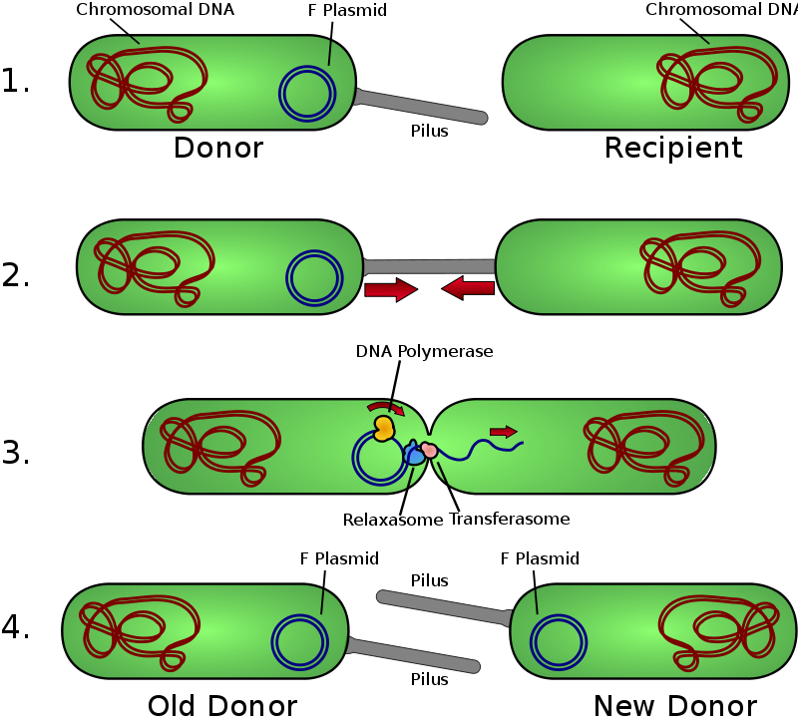

Schematic drawing of bacterial conjugation[Czura, Microbial Genetics,Chapter 8)