INRODUCTION Lec1

Metabolism-Metabolism constituents all the chemical transformations occurring in the cells
of living organisms and these transformations are essential for life of an organism.
Metabolites-End product of metabolic processes and intermediates formed during metabolic
processes is called metabolites
Primary metabolites
A primary metabolite is a kind of metabolite that is directly involved in normal growth, development, and reproduction. It usually performs a physiological function in the organism(i.e. an intrinsic function). A primary metabolite is typically present in many organisms or cells. It is also referred to as a central metabolite, which has an even more restricted meaning
(present in any autonomously growing cell or organism). Some common examples of primary metabolites include: ethanol, lactic acid, and certain amino acids.
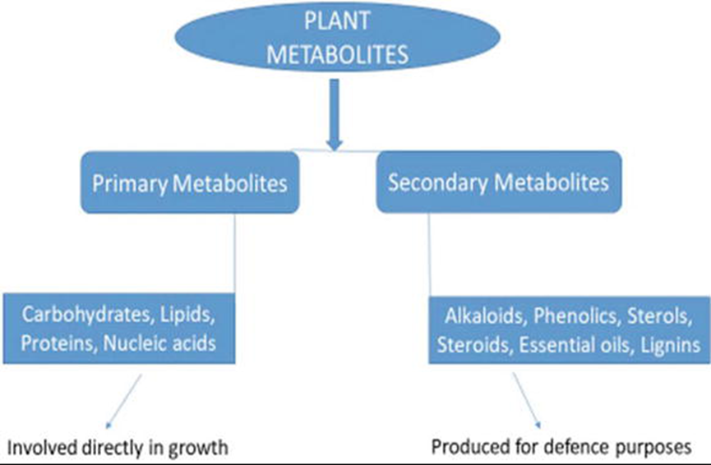

Secondary compounds have no apparent function in a plant's primary metabolism but often have an ecological role; they are
- pollinator attractants, represent chemical adaptations to environmental stresses, or serve as
- chemical defenses against microorganisms, insects and higher predators,
- and even other plants (allelochemics).

Secondary metabolites are frequently accumulated by plants in smaller quantities than are primary metabolites. In addition, secondary metabolites, in difficult. As a result, secondary metabolites that are used commercially as biologically active compounds (pharmaceuticals, flavors, fragrances, and pesticides) are generally higher value-lower volume products than the primary metabolites,
Thus, compared to primary metabolites (bulk chemicals), many secondary metabolites can be considered as specialty materials or fine chemicals. Secondary metabolites are often large organic molecules that require a large number of specific enzymatic steps for production

In higher plants such compounds are often concentrated in seeds and vegetative storage organs and are needed for physiological development because of their role in basic cell metabolism.
As a general rule, primary metabolites obtained from higher plants for commercial use are high volume-low value bulk chemicals. They are mainly used as
- industrial raw materials,
- foods, or food additives and include products such as vegetable oils, fatty acids (used for making soaps and detergents),
- and carbohydrates (for example, sucrose, starch, pectin, and cellulose).
However, there are exceptions to this rule. For example, myoinositol and ß-carotene are expensive primary metabolites because their extraction, isolation, and purification are difficult.

Secondary metabolites
Secondary metabolites are not essential as primary metabolites as these are not directly involved in growth, development and reproduction of organisms. They are organic compounds which are not directly involved in survival of plants but they produce some produces which aid them in their normal growth and development. Secondary metabolites are compounds biosynthetically derived from primary metabolites but more limited in distribution in the plant kingdom, being restricted to a particular taxonomic group
- species, genus,
- family, or closely related group of families.

- terpenoids and steroids
- phenolic compound
- alkaloids
- fatty acid-derived substances and polyketides

- nonribosomal polypeptides
- enzyme cofactors
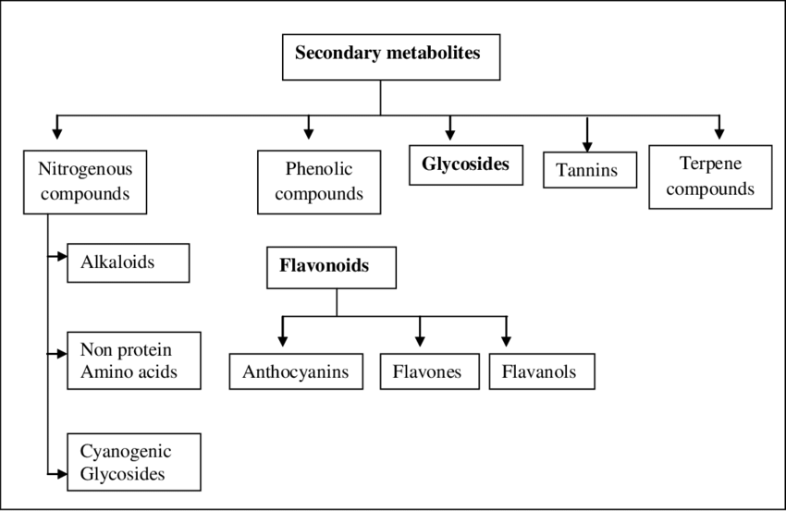
Schematic diagram representing integration of primary and secondary metabolism.
Classification of secondary metabolites
Over 2,140,000 secondary metabolites are known and are commonly classified according to their vast diversity in structure, function, and biosynthesis.
There are classes of secondary metabolites: such as
phenylalanine and cinnamic acids and their derivatives (simple phenols, phenolic acids, coumarins, lignans, and phenyl propane derivatives).There are over 12,000 known compounds of alkaloids, and their basic structures consist of basic amine group and are derived biosynthetically from amino acids.

3. Alkaloids
alkaloids constitute another large and diverse group of SM that includes molecules isolated primarily from vascular plants. Plants generally produce a complex mixture of alkaloids, in which a significant constituent dominates. the concentration of alkaloids varies considerably from one part to another of the same plant, and even in some parts it may not contain those at all. Alkaloids are also found in fungi, bacteria, and animals. They include an atom of nitrogen in their structure, are toxic compounds and respond to common precipitation reactions. Even when there is no uniform classification of alkaloids, several criteria have been used in order to classify them:
- biosynthetic origin,
- presence of basic heterocyclic nucleus in the structure,
- pharmacological properties, and distribution in plant families.
Among these criteria, the biosynthetic origin of the alkaloids has been used quite frequently. According to this criterion the alkaloids are classified as
- true alkaloids,
- protoalkaloids
- pseudoalkaloids.

The majority of the alkaloids found in plants belong to this group. They contain an intracyclic nitrogen, have basic character and are compounds of high reactivity, even in small quantities. In plants, they can be found free,
1.Terpenoids and steroids
They are major group of substances derived biosynthetically from isopentenyl diphosphate. Currently, over 35,000 known terpenoid and steroid compounds are identified. Terpenoids have different variety of unrelated structures, while steroids have a common tetracyclic carbon skeleton and are modified terpenoids that are biosynthesized from the triterpene lanosterol.
From the chemical point of view, they are nonsaponifiable lipids since fatty acids do not intervene in their formation. They are also known as isoprenoids, since the basic structural unit that forms them is the isoprene molecule.
Many plants contain terpenes in their flowers and fruits as mixtures of volatile compounds with specific odors; among them, we can mention lemon, mint, eucalyptus, ginger, and great basil. Terpenes have several biological functions and participate in both the primary metabolism and the secondary metabolism of plants. In the central metabolism they are photosynthetic pigments (carotenes), electron carriers.

2. Phenolic compounds
They are chemical compounds containing a hydroxyl group directly attached to an aromatic hydrocarbon. Chemically, phenolic compounds are a very diverse group of SM. The simplest representative of this class
is phenol. Phenolic compounds are synthesized in plant cells by the
shikimic acid pathway or the malonate/acetate pathway (or both, for example, flavonoids). The shikimic acid pathway provides the synthesis of
Functions of secondary metabolites
The major functions of the secondary metabolites including antibiotics are:
1. competitive weapons against other livings such as animals, plants, insects, and microorganisms
2. metal transporting agents
3. agents for symbiotic relation with other organisms
4. reproductive agent
5. differentiation effectors
6. agents of communication between organisms
The other functions include interference in spore formation (not obligatory) and germination. Predominantly, the secondary metabolites are used for variety of biological activities like antimicrobial and antiparasitic agents, enzyme inhibitors.
although they predominate as salts. The precursor compounds of the true alkaloids are amino acids (L-ornithine, L-lysine, L-tyrosine,L-tryptophan, L-histidine, and L-arginine).

The main roles of alkaloid are:
- to defend the plant against insects and herbivores due to its toxicity and deterrent capacity.
- to protect the plant from predators or microorganisms (toxic or repellent substances),
- to compete with other plant species in a given habitat (allelopathic substances)

- Fatty acid-derived substances and polyketides
Around 10,000 compounds are identified and are biosynthesized from simple acyl precursors such as propionyl CoA, acetyl CoA, and methylmalonyl CoA.
- Nonribosomal polypeptides
These amino acids derived compounds are biologically synthesized by a multifunctional enzyme complex without direct RNA transcription.
- Enzyme cofactors
Enzyme cofactors are non-protein, low-molecular enzyme component that increases the rate of a chemical reaction

