Lec(7)
Prof. Dr.Ekhlass N. Ali Immunology
3rd grade / Biotechnology
Adaptive Immunity:
Can be divided into two type ( humoral immunity & Cell mediated immunity)
Humoral immunity: is mediated by antibodies and is the arm of the adaptive immune response that functions to neutralize and eliminate extracellular microbes and microbial toxins. Humoral immunity is also the principal defense mechanism against microbes with capsules rich in polysaccharides and lipids, because antibodies can be produced against polysaccharides and lipids but T cells cannot respond to non protein antigens. Antibodies are produced by B lymphocytes and their progeny. Naive B lymphocytes recognize antigens but do not secrete antibodies, and activation of these cells stimulates their differentiation into antibody-secreting plasma cells.
Q/ How is the process of B cell activation regulated so that the most useful types of antibodies are produced in response to different types of microbes?

The activation of B lymphocytes results in the proliferation of antigen-specific cells, leading to clonal expansion, and in their differentiation into plasma cells, which actively secrete antibodies and are thus the effector cells of humoral immunity (Fig. 1). Naive B lymphocytes express two classes of membrane-bound antibodies, immunoglobulins M and D (IgM and IgD), that function as receptors for antigens. These naive B cells are activated by antigen binding to membrane Ig .The antibodies secreted in response to an antigen have the same specificity as the surface receptors on naive B cells that recognize that antigen to initiate the response. One activated B cell may generate a few thousand plasma cells, each of which can produce copious amounts of antibody molecules, in the range of several thousand per hour. In this way, humoral immunity can keep pace with rapidly proliferating microbes. During their differentiation, some B cells may begin to produce antibodies of different heavy-chain isotypes (or classes), which mediate different effector functions and are specialized to combat different types of microbes. This process is called heavy-chain isotype (or class) switching. Repeated exposure to a protein antigen results in the production of antibodies with increasing affinity for the antigen. This process is called affinity maturation, and it leads to the production of antibodies with improved capacity to bind to and neutralize microbes and their toxins.
antigens, including proteins, polysaccharides, lipids, nucleic acids, and small chemicals.
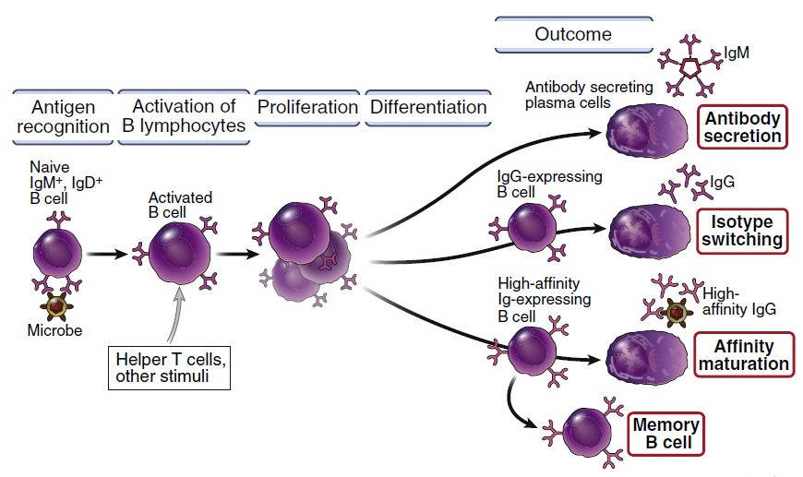
FIGURE 1: Phases of humoral immune responses. Naive B lymphocytes recognize antigens, and under the influence of helper T cells and other stimuli (not shown), the B cells are activated to proliferate, giving rise to clonal expansion, and to differentiate into antibody-secreting plasma cells. Some of the activated B cells undergo heavy-chain isotype switching and affinity maturation, and some become long-lived memory cells.
Antigen-Presenting Cells
The common portals of entry for microbes—the skin, gastrointestinal tract, and respiratory tract—contain specialized antigen-presenting cells (APCs) located in the epithelium that capture antigens, transport them to peripheral lymphoid tissues, and display (present) them to lymphocytes. This function of antigen capture and presentation is best understood for a cell type that is called dendritic cells because of their long surface membrane processes. Dendritic cells capture protein antigens of microbes entering through the epithelia and transport the antigens to regional lymph nodes, where the antigen-bearing dendritic cells display portions of the antigens for recognition by T lymphocytes. If a microbe has invaded through the epithelium, it may be phagocytosed and presented by tissue macrophages. Microbes or their antigens that enter lymphoid organs may be captured by dendritic cells or macrophages that reside in these organs and presented to lymphocytes. Dendritic cells are the most effective APCs for initiating T cell responses.
Cells that are specialized to display antigens to T lymphocytes have another important feature that gives them the ability to stimulate T cell responses. These specialized cells respond to microbes by producing surface and secreted proteins that are required, together with antigen, to activate naive T lymphocytes to proliferate and differentiate into effector cells. Specialized cells that display antigens to T cells and provide additional activating signals sometimes are called professional APCs. The prototypic professional APCs are dendritic cells, but macrophages, B cells, and a few other cell types may serve the same function in various immune responses.
Less is known about cells that may capture antigens for display to B lymphocytes. B lymphocytes may directly recognize the antigens of microbes (either released or on the surface of the microbes), or macrophages lining lymphatic channels may capture antigens and display them to B cells.
• Dendritic cells are the principal inducers of such responses, because these cells are located at sites of microbe entry and are the most potent APCs for activating naive T lymphocytes.
• One important type of APC for effector T cells is the macrophage, which is abundant in all tissues. In cell-mediated immune reactions, macrophages phagocytose microbes and display the antigens of these microbes to effector T cells, which activate the macrophages to kill the microbes.
• B lymphocytes ingest protein antigens and display them to helper T cells within lymphoid tissues; this process is important for the development of humoral immune responses .
TYPES OF T CELL–MEDIATED IMMUNE REACTIONS
Two main types of cell-mediated immune reactions eliminate different types of microbes: CD4+ helper T cells secrete cytokines that recruit and activate other leukocytes to phagocytose (ingest) and destroy microbes, and CD8+ cytotoxic T lymphocytes (CTLs) kill any infected cell containing microbial proteins in the cytosol, eliminating cellular reservoirs of infection (Fig1). Microbial infections may occur anywhere in the body, and some infectious pathogens are able to infect and live within host cells. Pathogenic microbes that infect and survive inside host cells include (1) many bacteria, fungi, and protozoa that are ingested by phagocytes but resist the killing mechanisms of these phagocytes and thus survive in vesicles or cytosol, and (2) viruses that infect phagocytic and non phagocytic cells and replicate in the cytosol of these cells .The different classes of T cells recognize microbes in different cellular compartments and differ in the nature of the reactions they elicit.
In general, CD4+ T cells recognize antigens of microbes in phagocytic vesicles and secrete cytokines that recruit and activate leukocytes that kill the microbes, whereas CD8+ cells recognize antigens of microbes that are present in the cytosol and destroy the infected cells.
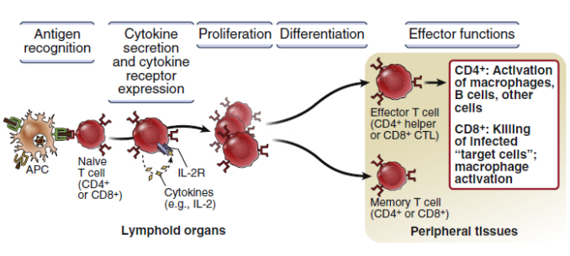

Fig 2: Steps in the activation of T lymphocytes. Naive T cells recognize major histocompatibility complex (MHC)–associated peptide antigens displayed on antigen-presenting cells and other signals (not shown). The T cells respond by producing cytokines, such as interleukin-2 (IL-2), and expressing receptors for these cytokines, leading to an autocrine pathway of cell proliferation. The result is expansion of the clone of T cells that are specific for the antigen. Some of the progeny differentiate into effector cells, which serve various functions in cell-mediated immunity, and memory cells, which survive for long periods. Other changes associated with activation, such as the expression of various surface molecules, are not shown. APC, Antigen-presenting cell; CTL, cytotoxic T lymphocyte; IL-2R, interleukin-2 receptor.
Cell-mediated immunity against pathogens was discovered as a form of immunity to an intracellular bacterial infection that could be transferred from immune animals to naive animals by cells (now known to be T lymphocytes) but not by serum antibodies .
As already mentioned, CD4+ T cells are mainly responsible for this classical type of cell-mediated immunity, whereas CD8+ T cells can eradicate infections without a requirement for phagocytes.
T cell–mediated immune reactions consist of multiple steps . Naive T cells are stimulated by microbial antigens in peripheral (secondary) lymphoid organs, giving rise to effector T cells whose function is to eradicate intracellular microbes.
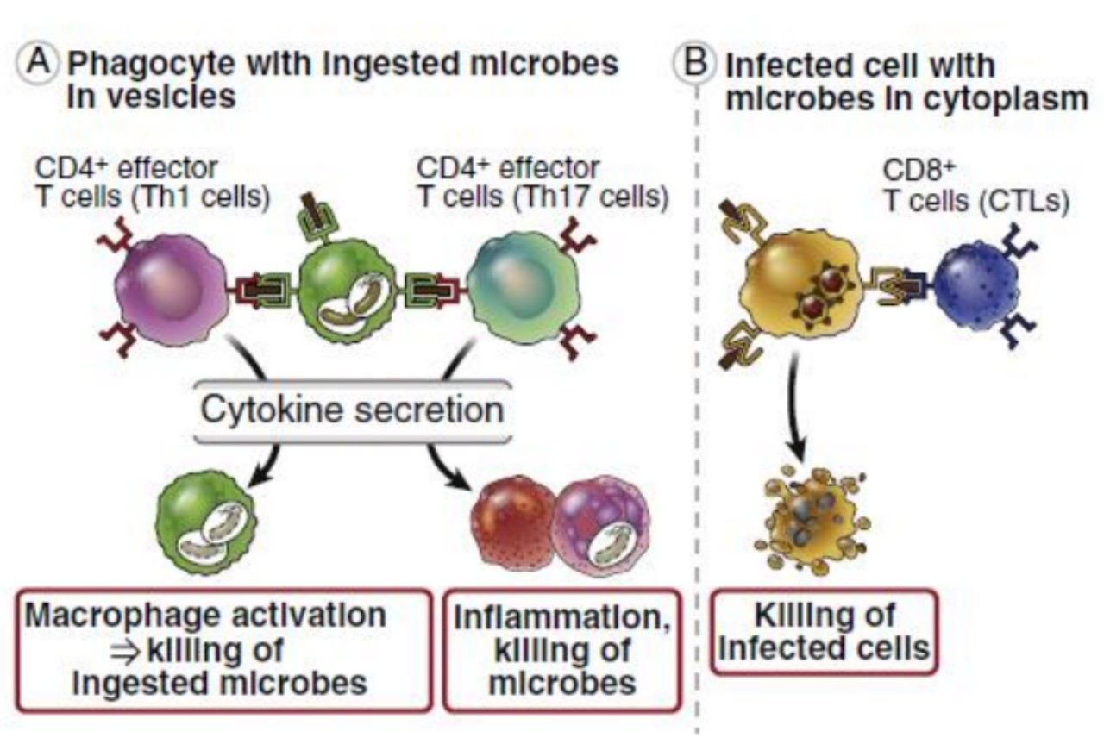
FIGURE 3: Cell-mediated immunity. A, Effector T cells of the CD4+ Th1 and Th17 subsets recognize microbial antigens and secrete cytokines that recruit leukocytes (inflammation) and activate phagocytes to kill the microbes. Effector cells of the Th2 subset (not shown) function in the eradication of infections by helminthic parasites. B, CD8+ cytotoxic T lymphocytes (CTLs) kill infected cells with microbes in the cytoplasm. CD8+ T cells also produce cytokines that induce inflammation and activate macrophages (not shown).
The differentiated effector T cells then migrate to the site of infection. Phagocytes at these sites that have ingested the microbes into intracellular vesicles display peptide fragments of microbial proteins bound to cell surface class II MHC molecules for recognition by CD4+ effector T cells.
Peptide antigens derived from microbial proteins in the cytosol of infected cells are displayed by class I MHC molecules for recognition by CD8+ effector T cells.
Antigen recognition activates the effector T cells to perform their task of eliminating the infectious pathogens. Thus, in cell-mediated immunity, T cells recognize protein antigens at two stages. First, naive T cells recognize antigens in lymphoid tissues and respond by proliferating and by differentiating into effector cells .
Second, effector T cells recognize the same antigens anywhere in the body and respond by eliminating these microbes.
CD4+ helper T lymphocytes and CD8+ CTLs employ distinct mechanisms to combat infections, We conclude by describing how the two classes of lymphocytes may cooperate to eliminate intracellular microbes
CD8+ T lymphocytes activated by antigen and other signals differentiate into CTLs that are able to kill infected
cells expressing the antigen. Naive CD8+ T cells can recognize antigens but are not capable of killing antigen-expressing cells. The differentiation of naive CD8+ T cells into fully active CTLs is accompanied by the synthesis of molecules involved in cell killing, giving these effector T cells the functional capacity that is the basis for their designation as cytotoxic. CD8+ T lymphocytes recognize class I MHC–associated peptides on infected cells and some tumor cells.
Q/ What are the mechanisms by which T cells activate macrophages, and what are the responses of macrophages that result in the killing of ingested microbes?
The sources of class I–associated peptides are protein antigens synthesized in the cytosol and protein antigens of phagocytosed microbes that escape from phagocytic vesicles into the cytosol .In addition, some dendritic cells may capture the antigens of infected cells and tumors, transfer these antigens into the cytosol, and thus present the ingested antigens on class I MHC molecules, by the process known as cross-presentation
CD8+ CTLs recognize class I MHC–peptide complexes on the surface of infected cells and kill these cells, thus eliminating the reservoir of infection. The T cells recognize MHC-associated peptides by their T cell receptor (TCR) and the CD8 co receptor. (These infected cells also are called targets of CTLs, because they are attacked by the CTLs.) The TCR and CD8, as well as other signaling proteins, cluster in the CTL membrane at the site of contact with the target cell and are surrounded by the LFA-1 integrin. These molecules bind their ligands on the target cell, which firmly holds the two cells together, forming an immune synapse into which the CTLs secrete cytotoxic proteins. Antigen recognition by CTLs results in the activation of signal transduction pathways that lead to the exocytosis of the contents of the CTL’s granules into the immune synapse between the CTL and the target cell (Fig.3)
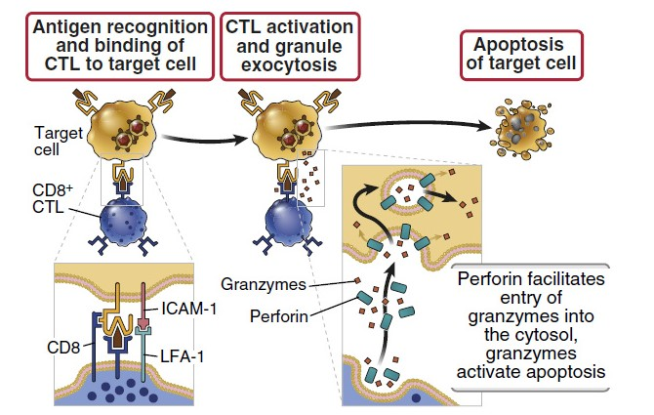

FIGURE 3: Mechanisms of killing of infected cells by CD8+ cytotoxic T lymphocytes (CTLs). CTLs recognize class I MHC–associated peptides of cytoplasmic microbes in infected cells and form tight adhesions (conjugates) with these cells. Adhesion molecules such as integrins stabilize the binding of the CTLs to infected cells (not shown). The CTLs are activated to release (exocytose) their granule contents (perforin and granzymes) toward the infected cell, referred to as the target cell. Granzymes are delivered to the cytosol of the target cell by a perforin-dependent mechanism. Granzymes then induce apoptosis. ICAM-1, Intercellular adhesion molecule 1; LFA-1, leukocyte function–associated antigen 1.
Q/ How do CD8+ CTLs kill cells infected with viruses?
Differentiated CTLs do not require co stimulation or T cell help for activation, they can be activated by and are able to kill any infected cell in any tissue. CTLs kill target cells mainly as a result of delivery of granule proteins into the target cells. Two types of granule proteins critical for killing are granzymes (granule enzymes) and perforin. Granzyme B cleaves and thereby activates enzymes called caspases (cysteine proteases that cleave proteins after aspartic acid residues) that are present in the cytosol of target cells and whose major function is to induce apoptosis. Perforin disrupts the integrity of the target cell plasma membrane and endosomal membranes, thereby facilitating the delivery of granzymes into the cytosol and the initiation of apoptosis.
Although we have described the effector functions of CD4+ T cells and CD8+ T cells separately, these types of T lymphocytes may function cooperatively to destroy intracellular microbes (Fig. 4). If microbes are phagocytosed and remain sequestered in macrophage vesicles, CD4+ T cells may be adequate to eradicate these infections by secreting IFN-γ and activating the microbicidal mechanisms of the macrophages. If the microbes are able to escape from vesicles into the cytoplasm, however, they become insusceptible to T cell–mediated macrophage activation, and their elimination requires killing of the infected cells by CD8+ CTLs.
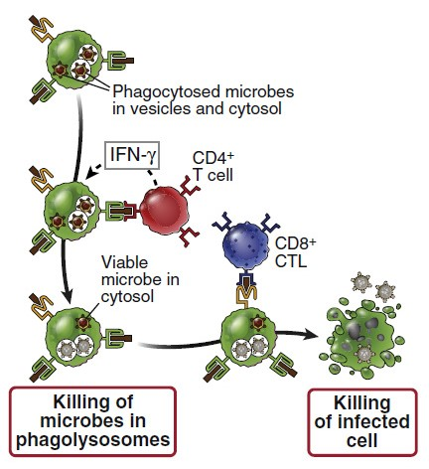
FIGURE 4: Cooperation between CD4+ and CD8+ T cells in eradication of intracellular infections. In a macrophage infected by an intracellular bacterium, some of the bacteria are sequestered in vesicles (phagosomes), and others may escape into the cytosol. CD4+ T cells recognize antigens derived from the vesicular microbes and activate the macrophage to kill the microbes in the vesicles. CD8+ T cells recognize antigens derived from the cytosolic bacteria and are needed to kill the infected cell, thus eliminating the reservoir of infection. CTL, Cytotoxic T lymphocyte; IFN, interferon.

