Lec 7 Dr AmnaAl Hashimi
Metabolic path way of Secondary Metabolites of Bacteria
Introduction
Metabolism is a constant and collective biochemical process that occurs in every single or multicellular organism lifelong. The biochemical process largely can be classified into catabolism and anabolism. The end-products of these pathways are used for the formation of intermediates and substrates for other metabolic pathways and are known as ‘metabolites.’ Metabolites exhibit several biological properties, which are of pharmaceutical, nutritional, and agricultural importance
The secondary metabolite-producing microorganisms synthesize these bioactive and complex molecules at the late phase and stationary phase of their growth (Figure 1). The production of secondary metabolites is triggered during the exhaustion of nutrients, environmental stress, and limited growth conditions. The secondary metabolites frequently are found in bacteria, fungi, plants, and marine organisms. These organisms have the capability to produce several metabolites with various biological functions, including
- antibacterial agents,
- toxins, metal-transporting agents,
- sex hormones,
- pigments, anticancer agents,
- pesticides,
- immunomodulating agents,
- immunosuppressants,
- receptor agonists,
- antagonists
Secondary metabolic pathway reactions are conducted by an individual enzyme or multienzyme complexes. Intermediate or end-products of primary metabolic pathways are channeled from their systematic metabolic pathways that lead to the synthesis of secondary metabolites.
The genes encoding these synthetic pathway enzymes generally are present in chromosomal DNA and often are arranged in clusters. For example, Streptomyces griseus and Streptomyces glaucescens chromosomal DNA contains 30 or more str/sts and blu genes that participate in streptomycin biosynthesis. Chapters Release of Energy (Aerobic) to Production of Secondary Metabolites – Fungi cover several aspects of metabolic pathways. The Effect of Secondary Metabolites on Food Products and Foodborne Illness

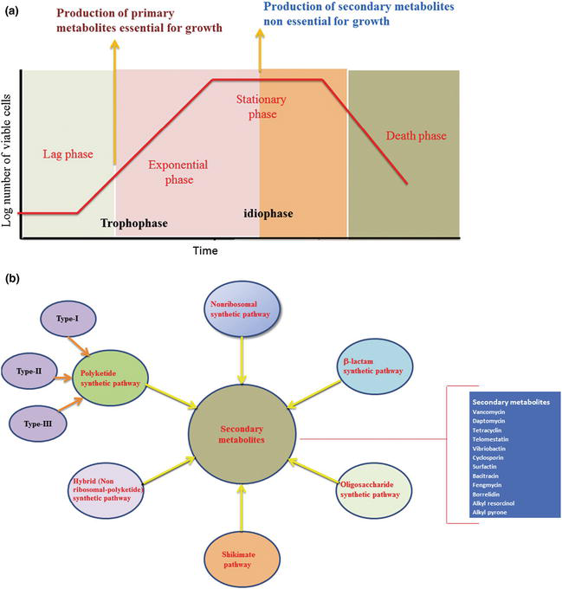

The Effect of Secondary Metabolites on Food Products and Foodborne Illness
The secondary metabolites exhibit several beneficial effects in pharmaceutical, cosmetic, food agricultural, and animal food industries, but certain secondary metabolites cause deleterious effects in humans and animals and also destroy certain food types. For example, several pathogenic bacteria have evolved with synthesizing and secreting toxins (secondary metabolites) in the immediate environments. The secreted toxin contaminate foods, food products, and water that enter the food chain. In addition, pathogenic bacteria also secrete toxins inside the host. The other route of toxin contamination is poorly packed canned foods, packed meats, and dairy products, in which certain bacteria grow anaerobically and secrete toxins. The consummation of toxin via contaminated food, food products, and water causes severe illness. The secreted toxin either kills the host or interferes with normal cellular functions.

This toxic substance can be classified into two types:
(1) exotoxins that usually are secreted by bacteria, and
(2) endotoxins that are part of the cellular component of the bacteria (cell wall component).
Some of the bacterial toxins are assembled by bacterial secondary metabolic pathways. For example, in poorly packed canned food products, Clostridium botulinum colonize anaerobically and secret exotoxins, which cause paralytic illness and respiratory failure. The secreted toxin acts on the peripheral nerve system. Vibrio cholerae is a Gram-negative and facultative bacteria that colonizes in the small intestine. In the host, certain strains of V. cholerae cause disease by secreting exotoxins and virulence factors, which are toxic to intestinal mucosa and epithelial cells. Most of the Escherichia coli strains are nonpathogenic bacteria, but few serotypes secrete exotoxins and cause food poisoning by ingesting the contaminated foods.
Beneficial Effects of Bacterial Secondary Metabolites
The microbial reductions are achieved by using bacteriocins and other antibacterial agents in food products. Bacteriocins are assembled by NRPS (Lactobacillus sake and Carnobacterium piscicola), and they have been used as a food additive agents to reduce the pathogenic bacterial load (Listeria monocytogenes, B. cereus, C. botulinum, or Staphylococcus aureus) and to improve the quality and safety of foods. Bacteriocins act as antibacterial agents for Gram-positive as well as Gram-negative bacteria. Lactococcus lactis is a Gram-positive bacterium used extensively in the dairy industry. This bacterium assembles nisin and subtilin antibiotics, which belong to the nonribosomal peptide (NRP) family. Nisin is used as a food preservative, because it has bactericidal properties and prevents the pore formation in C. botulinum and B. cereus.
This metabolite has been used as an antioxidant, food additive, cosmetic, pharmaceuticals, rubber and electrical transformer oil, and industrial chemical. In agricultural setup, in particular, in animal farming and aquaculture, antibiotics are largely used in feed to prevent the infection as well as to promote growth.

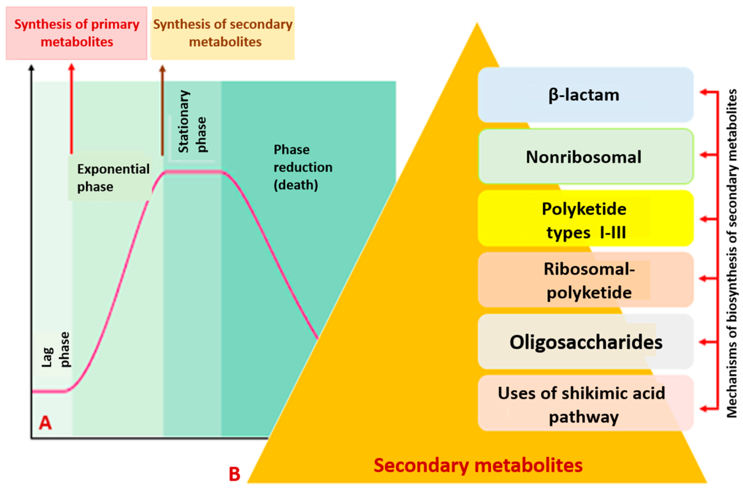
1.Nonribosomal Peptide Synthesis Pathways
NRPs are natural products assembled by NRPS enzymes. The antimicrobial peptides – bacitracin, ramicidin, polymyxin B, and vancomycin – are products of nonribosomal peptide synthesis pathways (NRPSP). The NRPS enzymes generate NRP molecules containing unique structures by using building blocks of L-chiral and D-chiral centers and nonproteinogenic and modified amino acids as substrates. NRPS enzymes generate structural diversity by modifying NRP molecules by linking fatty acids, methyl groups, phosphate groups, and oligosaccharides at the N-terminal end. Furthermore, to generate sophisticated structural diversity and rigidity,
A majority of the lipopeptide containing NRP molecules are produced by Streptomyces spp. The largest genes to produce antibiotics against bacteria, fungi, and parasitic infections. For example, Streptomyces coelicolor, Streptomyces roseoporus, Streptomyces fradiae, and Actinoplanes friuliensis produce calcium-dependent antibiotic,.
Polyketide Synthase Pathways Polyketides
(PK) are natural products that display diverse functions with clinical applications. Polyketides are assembled by polyketide synthase (PKS) enzymes. PKS enzymes operate similarly to fatty acid synthase to generate a diverse range of PKs. PKS enzymes begin the PK assembly by priming the starter molecule to the catalytic residue, and then it employs an extender unit for the chain elongation. On the basis of structural architecture and variation in enzymatic mechanism, PKS enzymes have been classified into three types:
(1) type I PKS,
(3) type III PKS.
Shikimate Pathway
The shikimate pathway contributes to assemble the basic building blocks for the range of aromatic metabolites and aromatic amino acids. Metabolites that are derived from aromatic compounds provide ultraviolet protection, electron transport, and signaling molecules, and they serve as antibacterial agents.
The shikimate pathway enzymes employ erythrose4-phosphate and phosphoenol pyruvate (primary metabolites) as substrates to initiate the aromatic building block synthesis. In this pathway, the first seven enzymes catalyze the chemical reactions in a sequential manner to generate chorismate. In the bacterial system, two enzymes have the capacity to transfer a complete enolpyruvoyl moiety to a metabolic pathway. In the shikimate pathway, 5-enolpyruvoyl shikimate 3-phosphate synthase is one of them. The next enzyme in this pathway is chorismate synthase, which requires a reduced cofactor, flavin mononucleotide, for its activation. Certain microorganisms have evolved to assemble various secondary metabolites by employing aromatic building blocks. Pseudomonas, Burkholderia, Brevibacterium, and Streptomyces have the capacity to synthesize phenazine compounds. Phenazine serves as a virulence factor and undergoes oxidation–reduction reactions, which result in the accumulation of toxic-free radicals in the target cells.
b-Lactam Ring Synthetic Pathways
Cephalosporins belong to the b-lactam family of antibiotics. These antibiotics have been used to treat bacterial infections for more than 40 years. Gram-positive bacteria, Gram-negative bacteria, and fungi are the major sources of b-lactam antibiotics. The Gram-positive Streptomyces clavuligerus is capable of producing both clavulanic acid and cephamycin. The Gram negative bacterium Lysobacter lactamgenus produces cephabacins. Two hypotheses have been put forward for b-lactam biosynthesis: (1) horizontal gene transfer (HGT) from bacteria to fungi and (2) vertical descent (originated from a common ancestor). Building blocks for b-lactam biosynthesis include L-a-aminoadipic acid, L-cysteine, and L-valine.
Genes that are responsible for b-lactam biosynthesis always are clustered in the DNA of all reproducing bacteria. Bacterial species capable of producing b-lactam antibiotics have an ecological advantage. In contrast, b-lactam– producing bacteria show low sensitivity to b-lactams on their own, or they have evolved to inactivate b-lactam antibiotics by b-lactamase enzymes.
