Ministry Of Higher Education and Scientific Research
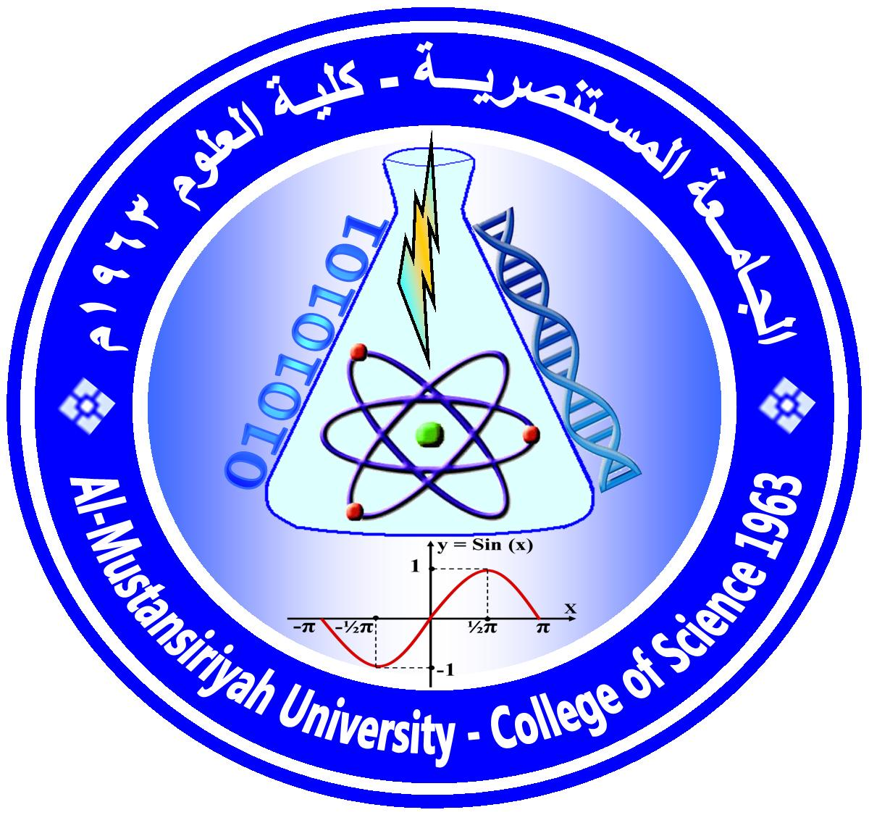
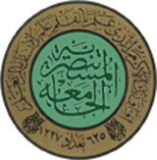
Mustansiriyah University/College of Science/Department of Biology
( Clinical Analysis )
Course Plan

Course No.:1
Course Name: Clinical Analysis | Time Division:3hr.Theoretical and 2hr. Practical
Course Website: | Semester & Year: First , 2022 /2023
Course Description
5 credit hours, Prerequisite [5084413]

Clinical Analysis course give the student of Biology/ fourth class/ basic information about how body systems work in normal situation and the diseases that effects certain area in these systems mainly that caused by microorganisms (Bacteria ,Parasites ,Virus ,Fungi) and how to collect different samples from patients e.g.(Urine ,Stool ,Blood ,Sputum ,CSF, Seminal fluid…) and diagnose these infection in lab. and the antibiotic sensitivity of these microbes. Final step reporting the results ,which help doctors to give the suitable drugs that helps in controlling the infection and recovery from the disease. Other laboratory tests to blood ,semen and SCF.

Course Intended Outcomes:
At the end of the Course, students are expected to learn
- How to identify the infectious agents that affect the body.
- How to collect different samples from patients.
- How to prepare the samples for diagnosing.
- How to do different biological and chemical tests on different samples.
- How to report the result to doctor.

Course Outline:
Week | Topes Covered  (Theoritical) | (Practical)
1 | Introduction to urine analysis | GUE Macroscopic Examination
2 | Chemical examination of Urine | GUE Microscopic Examination
3 | Introduction to stool analysis | Stool Macroscopic examination
4 | Microscopic examination of stool | Stool Microscopic examination
5 | First Examination | First Examination
6 | Blood analysis | Blood tests
7 | Common blood tests | ESR & PCV tests
8 | The Serological tests | Hb tests.
9 | The Serological tests | WBCs Count
10 | Second Examination | RBCs Count
11 | Laboratory diagnosis of microorganisms | Second Examination
12 | Laboratory diagnosis of cerebrospinal fluid infections (CSF) | Semen fluid Examination
13 | Laboratory diagnosis of respiratory tract infections | Sputum Examination
14 | Laboratory diagnosis of sexually transmitted diseases | Third Examination
15 | Third Examination | Blood grouping
16 | End of the course
17 | Half – year break
18
19
20
21
22
23
24
25
26
27
28
29
30
31
32

Textbooks
- Immunology : Overview and laboratory manual (2021)
- Medical Microbiology ( 2021)
- Clinical Pathology (2021)

Suggested references:
- Guides to laboratory analysis
- Medical Microbiology
- Medical bacteriology
- Hematology

Marking:

First Semester |  |  |  | Second Semester |  |  |  | Final Exam
1st exam | 2nd exam | Practical | Activity | 1st exam | 2nd exam | Practical | Activity
12 | 12 | 12 | 4 |  |  |  |  | 60

Assignments and/ or Projects:

Assignment/ Project | Description | Due Date | Marking
Reports | In subjects that interest the student | At semester end | 1 Mark
Quizzes | In lectures or in subjects related to study subject. | During the course | 1 Mark

Instructor(s) information[معلومات الأستاذ]
Section : 1 |  | Lecture Room: [301] | Office No.: 5
Instructor's Name: Dr.Khetam Habeeb Rasool E-Mail: khetamhabeeb112@yahoo.com
Office Hours: | : Dr. Nadheema Hamood Hussen E-Mail:nadheema_a@yahoo.com  Tuesday AND Thursday : (8:30 – 2 : 00)  NOTES:  -Office Hour: Other office hours are available by appointment.  -The content of this syllabus not be changed during the current semester.  Lecturer Signature Chairman Signature

