Ministry Of Higher Education and Scientific Research
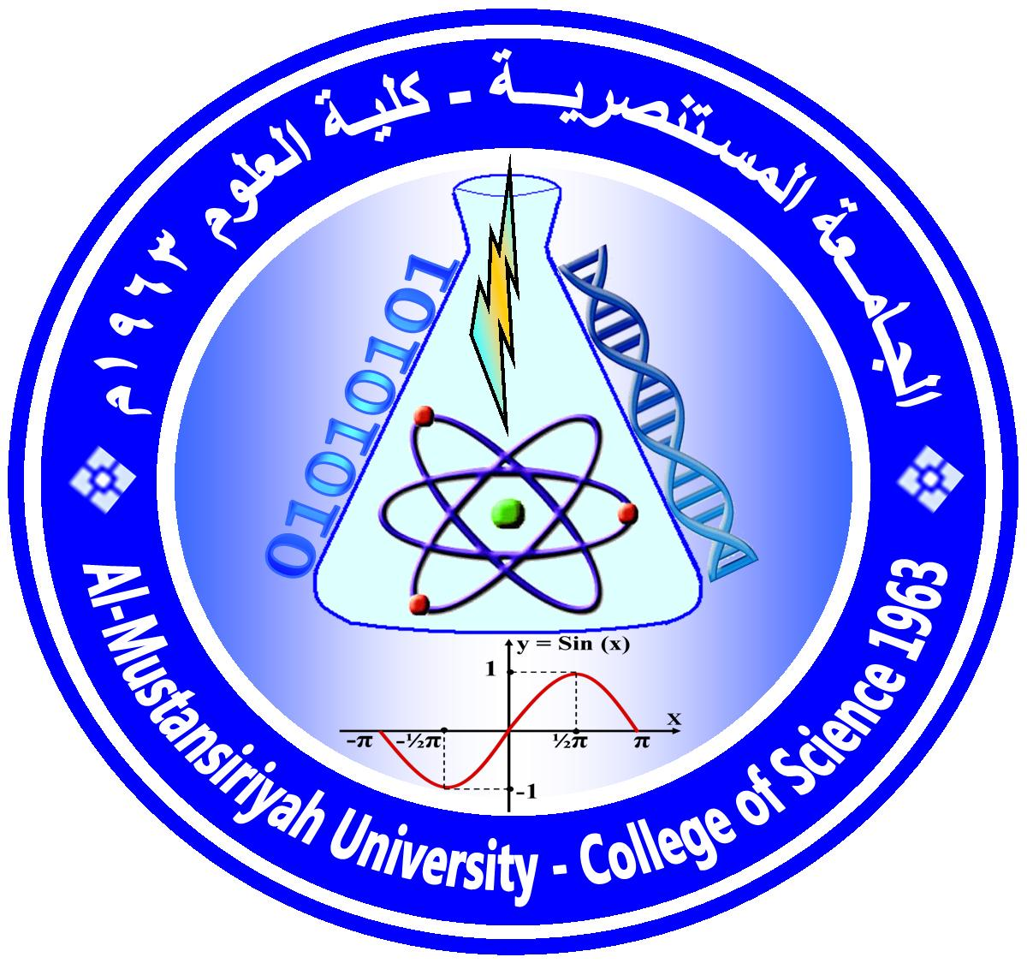
Mustansiriyah University/College of Science/Department of Mathematic
(الخطة الدراسية للمساق)
Course Plan

Course No.1: 54453124
Course Name: Theory of Differential EquationsI | Time Division: 4hr Theoretical and 1hr Practical
Course Website:ان وجد | Semester & Year: First , 2022/2023
Course Description
( 5 credit hours, Prerequisite [ Calculus2, Advance Calculus, Methods for solving ordinary differential equations]

Course Intended Outcomes:
At the end of the Course, students are expected to learn
1) Existence of a unique solution of an ordinary diff. equations of 1st ,2nd and n^{th} order
2) Existence of a unique solution of a system of ordinary diff. equations of 1st order and finding the solutions for a
linear homogeneous and nonhomogeneous systems.
3) Laplace transform for solving a system of diff. eqs. with constants coefficients.
Course Outline:
Week | Topics Covered
1 | System of diff. eqs, Reducing the diff. eq. of n^{th} to a system of 1st order eqs.
2 | Linear homogeneous systems, Nonlinear system of 1st order eqs.
3 | The existence and uniqueness theorem
4 | solution matrix and Fundamental matrix solution
5 | Calculation of a fundamental matrix, The exponential matrix method
6 | Eigenvalues and eigenvectors method
7 | First Exanimation
8 | Linear nonhomogeneous systems and their solutions, Liouville theorem
9 | Existence theory of standard form of a 1st order diff. eq., Lipschitz condition
10 | existence of the solutions
11 | Uniqueness of the solutions, dependence on initial condition
12 | Existence solution on largest interval, Continuation of solutions.
13 | Existence theory for systems of 1st order eqs. and higher-order eqs.
14 | Gronwall inequality , linear systems and linear homogeneous systems
15 | Laplace transform and its inverse, applications to the linear equations with constants coefficients.
16 | Second examination

Textbooks:
[1] A First course of Ordinary Differential Equations by F. Brauer and J. A. Nohel
Suggested references:
[1] Any Reference titling by “The Theory of Differential Equations”
Marking:

First Semester |  |  |  | Second Semester |  |  |  | Final Exam
1 st exam | 2 nd exam | Practical | Activity | 1 st exam | 2 nd exam | Practical | Activity
10 | 10 | 5 | 5 |  |  |  |  | 70

Assignments and/ or Projects:

Assignment/ Project | Description | Due Date | Marking
Home work | Some important exercises | 14-11-2017 | 5
Home work | Some important exercises | 15-12-2017 | 5

Instructor(s) information[معلومات الأستاذ]
Section: 01 |  | Lecture Room: [ A203, A402 ] | Office No.: (07 )
Instructor's Name: Nabaa Najdi Hasan E-Mail: alzaer1972@uomustansiriyah.edu.iq

Office Hours: | Sun. : ( 11:40 -1:30 ), thu. .: (10:10-11)  NOTES:  -Office Hour: Other office hours are available by appointment.  -The content of this syllabus not be changed during the current semester.  Lecturer Signature Chairman Signature

