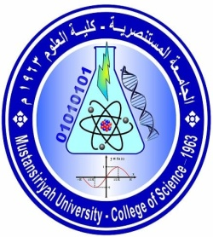
Ministry of Higher Education and Scientific Research
Mustansiriyah University /College of Science
Department of ..........................
(الخطة الدراسية للمساق)
Course Plan

Course No.: Time Division: ……. hr Theoretical and ……hr Practical
Course Name: Semester & Year: First, 2022 / 2023
Course Website:

Course Description:
This subject presents the --------------------

Course Intended Outcomes:
------------------

Course Outline:

Week | Description depends on the Timing table (Theoretical & Practical)
1
2
3
4
5
6
7
8
9
10
11
12
13
14
15

Textbooks:
[1]:
[2]:

Suggested references:
[1]:
[2]:

Marking:

First Semester |  |  |  | Final Exam
1st exam | 2nd exam | Practical | Activity

Assignment/ Project | Description | Due Date | Marking
test | written exam | 1/12/2018 | 3
--- | ---

Instructor(s) information [معلومات الأستاذ]

Section: (Mathematics) ; Lecture Room:[ ] , ; Office No.: ( )

Instructor's Name: Dr.
E-Mail:

Office Hours : Tue.:[ : – : ]
Wed.:[ : – : ]

NOTES:
-Office Hour:Other office hours are available by appointment.
-The content of this syllabus not be changed during the current semester.

Lecturer Signature Chairman Signature

