Lab. Meteorological Statistics ........ Fourth stage

(First Semester)
Department of Atmospheric Sciences
2022 – 2023

Lecturers: A.Prof . Zahraa Salah , L. Ruaa mazin ,
L. Luma Mahdi , L. Salwa salman

Preparing by: L. Ruaa mazin , L. Luma mahdi
C- The standard deviation
The standard deviation of a set of N values 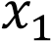,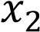, is denoted ( S )
1- Calculation the Standard deviation for unclassified data:

SD = $\sqrt{\frac{\sum{{(x_{i}-\overline{x})}^{2}}}{N}}$

For example\\ calculate the standard deviation of the following data?
( 2,3.5,4,4.5,5)
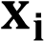 |  | 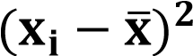
3 | 3-4=-1 | 1
3.5 | 3.5-4= -0.5 | 0.25
4 | (4-4) = 0 | 0
4.5 | (4.5-4 )= 0.5 | 0.25
5 | (5-4)= 1 | 1
 |  | 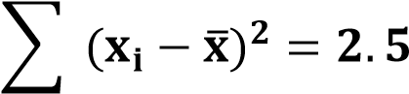

SD = $\sqrt{\frac{\sum{{(x_{i}-\overline{x})}^{2}}}{N}}$ $\sqrt{\frac{2.5}{5}}$=$\sqrt{0.5}$

H.W \\ find the standard deviation from the following data :
( 2,8,3,7,6,4)

2-Calculation the standard deviation of the classified data:
The standard deviation some times called root mean square deviation ( Rms ) if 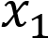,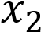, is mid point of classes and 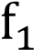,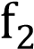, is frequency the standard deviation can be by :
SD = $\sqrt{\frac{\sum{f_{i}{(x-\overline{x})}^{2}}}{\sum{f_{i}}}}$
For example\\ calculate The Standerd deviation of the following data?
Class | 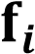 | 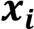 | 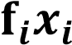
15-19 | 3 | 17 | 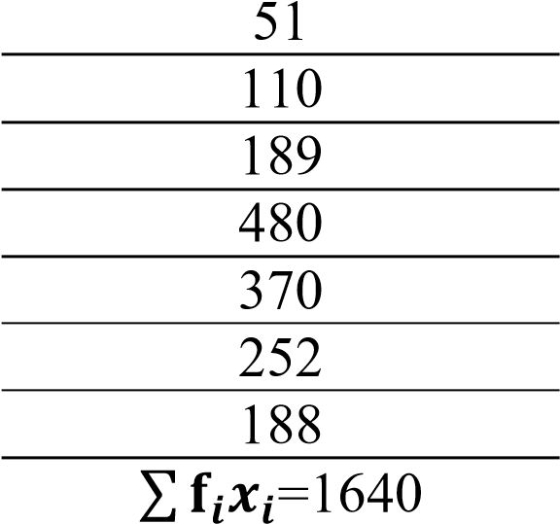
20-24 | 5 | 22
25-29 | 7 | 27
30-34 | 15 | 32
35-39 | 10 | 37
40-44 | 6 | 42
45-49 | 4 | 47
 | 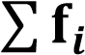 =50

SD = $\sqrt{\frac{\sum{f_{i}{(x-\overline{x})}^{2}}}{\sum{f_{i}}}}$

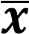 = 32.8
Class | 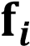 | 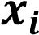 | 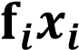 |  | 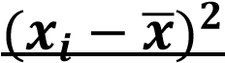 | 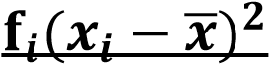
15-19 | 3 | 17 | 51 | -15.8 | 249.64 | 748. 92
20-24 | 5 | 22 | 110 | -10.8 | 116.64 | 583.2
25-29 | 7 | 27 | 189 | -5.8 | 33.64 | 235.48
30-34 | 15 | 32 | 480 | -0.8 | 0.64 | 9.6
35-39 | 10 | 37 | 370 | 4.2 | 17.64 | 176.4
40-44 | 6 | 42 | 252 | 9.2 | 84.64 | 507.8
45-49 | 4 | 47 | 188 | 14.2 | 201.64 | 806.56
 | 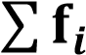=50 |  | 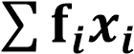=1640 |  |  | 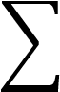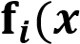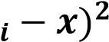  =3068

SD = 