Lec1 Fungal taxonomy Dr. Hamzia Ali
Mycology - the study of fungi
General characteristics of true fungi
1. All are eukaryotic: Possess membrane-bound nuclei (containing chromosomes) and a range of membrane-bound cytoplasmic organelles (e.g. mitochondria, vacuoles, endoplasmic reticulum…..).
2. Most of fungi are filamentous: Composed of individual microscopic filaments called hyphae, which exhibit apical growth and which branches to form a network of hyphae called mycelium.
3. Some of fungi are unicellular: Some fungi consist of one cell containing all organles such as yeasts.
4. Protoplasm of hyphae or a rigid wall surrounds cell of fungi: Consists of primarily of glucans and chitin, although the cellulose enters in walls composition of some species.
5. Many of fungi reproduce both sexually and asexually: Production of spores in fungi formed as a result of sexual and asexual reproduction in most cases.
6. Fungal nuclei are typically haploid and hyphal compartments are often multinucleate: Although the diploid nuclei present in Oomycota and in some yeasts.
8. Nutrition categories of fungi are chemoheterotrophic (chemo organotrophic): They utilize organic sources of carbon in their environment as carbon source and the energy from biochemical reactions of organic compounds oxidation, they require for growth and energy
9. Storage compounds: Food storage is generally in the form of lipids glycogen and sugar alcohols.
10. May be free-living or may form intimate relationships with other organisms: i.e. may be free-living, parasitic or mutualistic (symbiotic).

Morphology of fungi :-
Fungi exist in two fundamental forms; the filamentous (hyphal) and single celled budding forms (yeast). But, for the classification sake they are studied as:
1. Moulds (Molds): Filamentous type of growth Ex: Aspergillus sp.,
2. Yeasts: Single celled cells that buds Ex: Saccharomyces cerviciae
3. Yeast like: Similar to yeasts but produce pseudohyphae (chains of conidia binding together) Ex: Candida albicans
4. Dimorphic: Fungi existing in two different morphological forms at two different environmental conditions. They exist as yeasts in tissue and in vitro at 37º C and as moulds in their natural habitat and in vitro at room temperature. Eg: Histoplasma, Blastomyces . Candida albicans

Mold
Their basic cellular units described as hyphae (singular: hypha). Hyphae of fungi may be branched and their dense mass called as mycelium. Hypha form is usually a tubular cell developed from growing spore and surrounded by a rigid, chitin-containing cell wall. The hypha extends by tip growth, and multiplies by branching, creating a fine network called a mycelium. Hyphae contain all organs including nuclei, mitochondria, ribosomes, Golgi and membrane-bound vesicles within a plasma membrane bound cytoplasm. The sub-cellular structures supported and organized by microtubules and endoplasmic reticulum.
Each hypha is essentially a tube consisting of a rigid wall and containing protoplasm .Tapered at its tip - this is the region of active growth (i.e. the extension zone).
Septa (cross-walls), if present, usually been observed down a light microscope. Some fungi possess septa (that divide the hyphae into separate cells) at regular intervals along the lengths of their hyphae. In others, cross-walls form only to isolate old or damaged regions of a hypha or to isolate reproductive structures. Some septa possess one of more pores – such septa divide the hyphae into a series of interconnected hyphal compartments, rather than separate, discrete cells. Coenocytic hyphae lack septa .
Inner to the cell wall is the plasma membrane that is a typical bi-layered membrane in addition to the presence of sterols. Fungal membranes possess ergosterol in contrast to cholesterol found in mammalian cells.
Mycelium are of three kinds:
1. Vegetative mycelium are those that penetrates the surface of the medium and absorbs nutrients.
2. Aerial mycelium are those that grow above the agar surface
3. Fertile mycelium are aerial hyphae that bear reproductive structures such as conidia or sporangia.

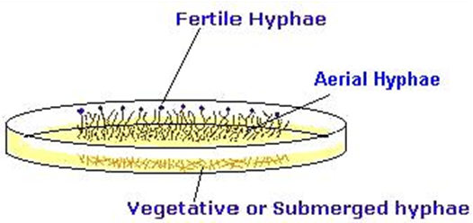
Since hypha is the structural unit of mould, the mycelium imparts colour, texture and topography to the colony .
A-Those fungi that possess melanin pigments in their cell wall are called phaeoid or dematiaceous and their colonies are coloured grey, black or olive. Examples, Cladosporium,
B-Those hyphae that don't possess any pigment in their cell wall are called hyaline.
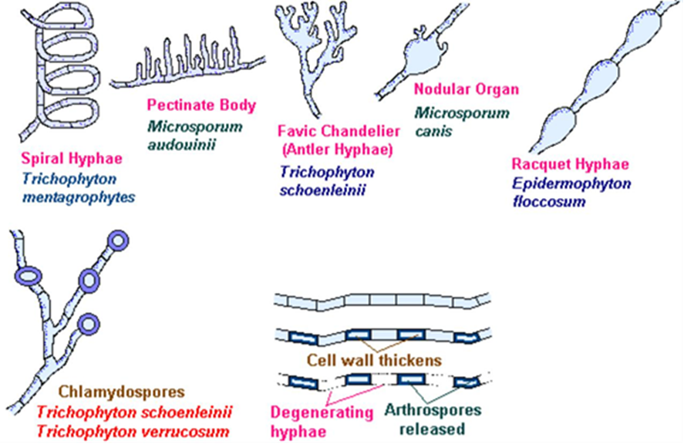

Yeast
Yeasts are unicellular spherical to ellipsoid cells. They reproduce by budding, which result in blastospore (blastoconidia) formation. In some cases, as the cells buds the buds fail to detach and elongate thus forming a
chain of elongated hyphae like filament called pseudohyphae. This property is seen in Candia albicans. The same species also have the ability to produce true hypha, which is seen as germ tube. The difference between the two is that there is a constriction in psueudohyphae at the point of budding, while the germ tube has no constriction.
True yeasts such as Saccharomyces cerviciae don't produce pseudohyphae. Yeast-like fungi may be basidiomycetes, such as Cryptococcus neoformans or ascomycetes such as Candida albicans.

Reproduction in fungi:
Fungi reproduce by asexual, sexual and parasexual means.
Asexual reproduction
Asexual reproduction is the commonest mode in most fungi with fungi participating in sexual mode only under certain circumstances. The form of fungus undergoing asexual reproduction is known as anamorph (or imperfect stage) and when the same fungus is undergoing sexual reproduction, the form is said to be teleomorph (or perfect stage). The whole fungus, including both the forms is referred as holomorph. (Taxonomically, the teleomorph or the holomorph is used, but practically it is more convenient to use the anamorph.)
Asexual reproduction: Asexual propagules are termed either spores or conidia depending on their mode of production. Asexual spores are produced following mitosis where as sexual spores are produced following meiosis.
Types of asexual spore
Fungi produce two major types of asexual spore: Sporangiospores and Conidia.
Sporangiospores characteristic:
1.Endogenous - formed and contained within a sporangium .
2.They formed because of the cleavage of protoplasm around nuclei.
3.Formation of a wall around each nucleate portion of protoplasm follows in some cases.
4.A characteristic of fungi belongs to the zygomycetes ,chytridiomycota, oomycota and hyphochytridiomycota.
5.They include two main types. They are zoospores (motile) and aplanospores (non-motile).
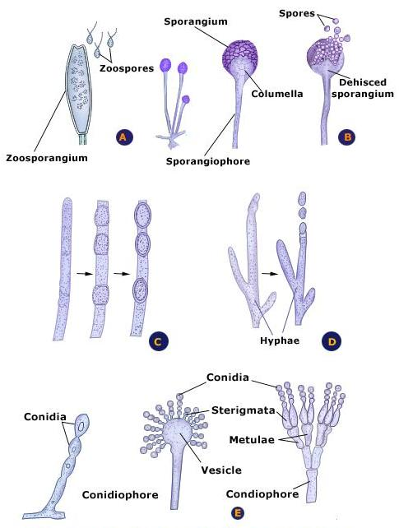
Figure: Asexual reproduction of fungi, A:zoospore,B:sporangiospore,C:chlamydospore, D:oidia , E: conidia
Conidia:
Conidia are Exogenous - often formed at the tip of supporting hyphae called conidiophores Develop in a variety of ways. Conidia characteristics include mitosporic fungi and fungi belonging to the ascomycota and basidiomycota. It includes two main types-Thallic and Blastic.
Thallic Conidia
This type characterized by:
1. Originate from septation and fragmentation of a hypha.
2. May develop in an intercalary (central) position of the hypha or develop at the tip of a hypha.
3. In both cases, all layers of the hyphal wall are involved in spore formation.
Blastic Conidia characterized by:
1.Develop by a budding or swelling process.
2.They may develop as single spores or in succession to form a chain of spores containing the following forms.
a) Blastospores: characterized by:
1.Blastospores formed by budding of a hypha or yeast cell.
2.Both wall layers are involved. The spore may remain attached and bud further blastospores- giving rise to a branched chain of spores.
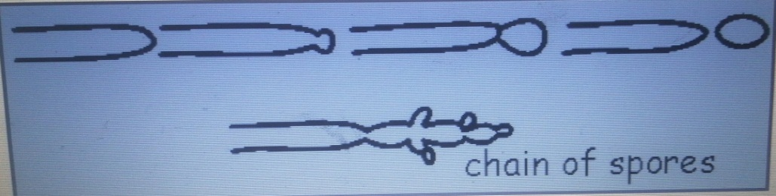
Figure: Blastospores formation.
b) Porospores: characterized by
1. The developing spore emerges through a distinct ‘pore’ in the hyphal wall .
2. The inner layer of the hyphal wall is only involved in spore development.
3. The new spore then develops its own new inner wall layer.
4. The outer spore wall is often thickened and pigmented.
5. A scar is usually obvious at the point of detachment from the hypha (conidiophore).

Figure: Porospores formation.

