YERSINIOSIS
(Yersinia enterocolitica)
Yersinia enterocolitica is a Gram-negative rod, zoonotic bacterium within the family Enterobacteriaceae. genus Yersinia include 11 species and 5 biovars are recognized, including Y. pestis, the cause of plague. The species of primary interest in foods is Y. enterocolitica. First isolated in New York State in 1933 by M.B. Coleman, Facultatively anaerobic is somewhat unique in that it is motile below 30C⁰ but not at 37°C. Growth of Y. enterocolitica has been observed over the temperature range -2°C to 45°C, with an optimum between 22°C and 29°C. For biochemical reactions, 29°C appears to be the optimum. Growth occurs in milk and raw meat at 1C0, but at a slower rate. Cells can grow in 5% NaCl and at a pH above 4.6 unable to grow at 9.0. Cells are sensitive to pasteurization.
Y. enterocolitica is a normal inhabitant of intestines of food animals and birds, pets, wild animals, and humans. Clinical disease caused by Y. enterocolitica is termed yersiniosis. Y. enterocolitica is known for its role as a human enteric and foodborne pathogen, but it also commonly infects wildlife and domestic mammals
Human carriers do not show any disease symptoms. Different types of food can be contaminated from these sources. are widely distributed in the terrestrial environment and in lake, well, and stream waters, which are sources of the organisms to warm-blooded animals.

Toxins
Not all strains can produce yersiniosis. Most strains isolated from the environment are nonpathogenic. Pathogenic strains are predominant in pigs. Both the pathogenic and nonpathogenic strains produce a heat-stable enterotoxin (ST) that survives 100 0C for 20 minutes. It is not affected by proteases and lipases and has a molecular weight of 9,000 to 9,700 daltons, ; thus, toxin production is not directly related to the ability of a strain to cause yersiniosis. Pathogenic strains also carry an invasive factor that enables the cells to colonize intestinal epithelial cells and lymph nodes. Only after colonization is the heat-stable toxin capable of causing the disease. The pathogenic strains vary in serological characteristics . The most commonly occurring Y. enterocolitica
serovars (serotypes) in human infections are 0:3, 0:5,27, 0:8, and 0:9. . In the U.S., the most common serovar implicated in yersiniosis is 0:8.

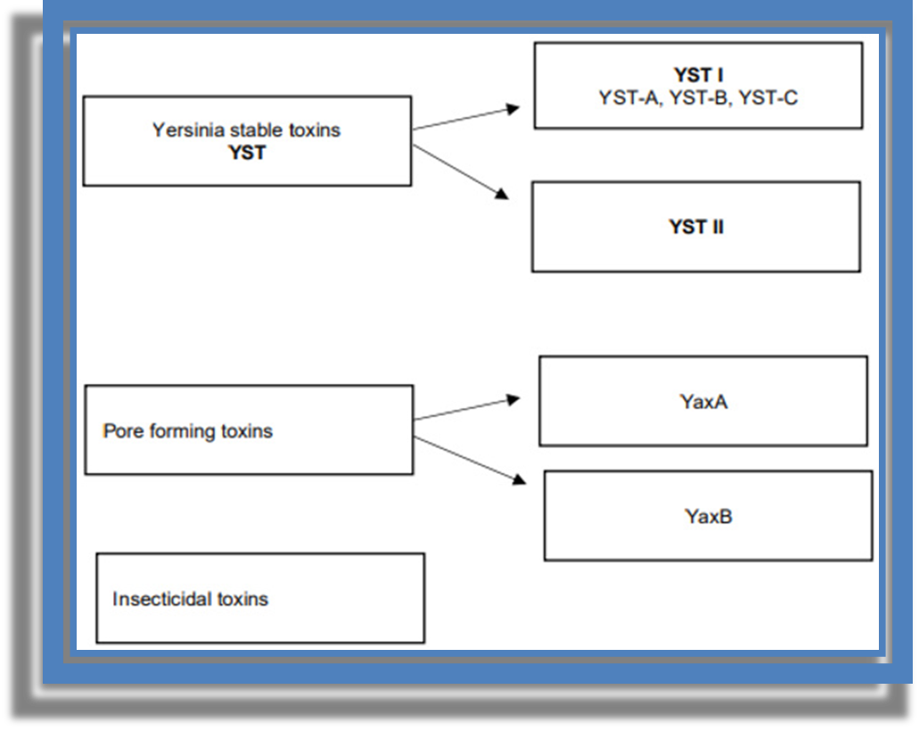

Research has shown that YST I enterotoxins produced by Y. enterocolitica are biologically and antigenically analogous to STI (Shiga Toxin I) enterotoxins (STa and STb) produced by E. coli. STI enterotoxins cause similar changes in cell cultures and rely on the same mechanism of action by stimulating the activation of guanylate cyclase, which increases the concentration of cyclic guanosine monophosphate (cGMP) in epithelial cells and leads to fluid accumulation in the intestine. YST I and STI enterotoxins have the same molecular weight and analogous resistance to temperature and acids. Enterotoxins provoke diarrhea, which is the main cause of mortality in yersiniosisYaxA and YaxB toxins form pores in the membrane of host target cells and cause osmotic lysis, which plays a very important role in systemic infections. In experiments performed on animals, the most severe damage was observed in the spleen. Interestingly, full lytic activity occurs only when YaxA and YaxB work together. The mechanisms underlying the production and functions of YaxA and YaxB remain insufficiently investigated. They could be released spontaneously as a result of bacterial lysis, or they could be released from bacteria through outer membrane vesicles. YaxA and YaxB can bind nonspecifically to host cells through cholesterol, which is a universal component of cell membranes. The presence of cytotoxins YaxA and YaxB may be caused by the death of bacterial cells at the site of infection. This may lead to changes in the cytokine expression, thus influencing the innate immune response of the host, which may facilitate the survival of the remaining bacteria.

Yersinia stable toxin (YST enterotoxin) is an equally important virulent factor. This enterotoxin is soluble in methanol, and it can survive boiling for 10 min. In bacterial cells, the production of YST enterotoxin is controlled by yst chromosomal genes. It is believed that YST enterotoxin plays a key role in the etiology of diarrhea.

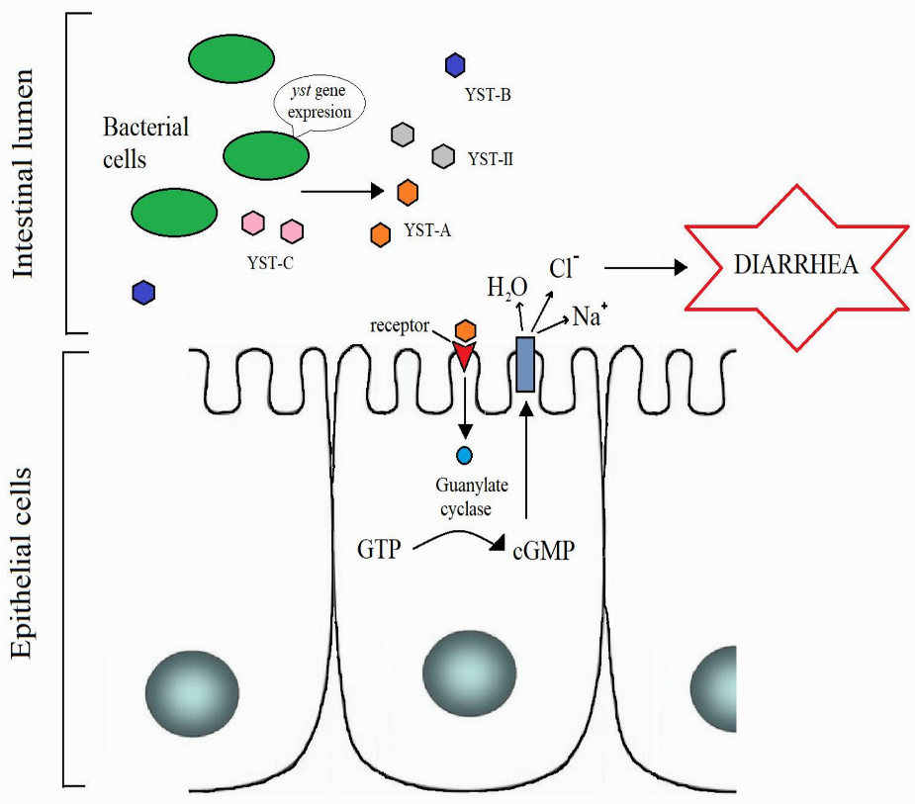

Disease and Symptoms
Foodborne yersiniosis was first confirmed in the U.S. in 1976 following an outbreak among a large number of school children from the consumption of chocolate milk contaminated with Yersinia enterocolitica. In many other countries, foodborne yersiniosis was recorded earlier.
Young children are more susceptible to foodborne yersiniosis. Generally, a high dose (ca. 10⁷cells) is required for the disease. The two most important aspects about the organism and the disease are that Y. enterocolitica is a psychrotroph and can grow at 0C⁰, and its symptoms include a sharp abdominal pain with fever, mimicking an appendicitis. Symptoms are severe abdominal pain at the lower quadrant of the abdomen, diarrhea, nausea, vomiting, and fever. Symptoms generally appear 24 to 30 h following consumption of a contaminated food and last 2 to 3 d. The disease can be fatal in rare cases.
Because Y. enterocolitica strains are found in the environment, many foods can harbor the organism. It has been isolated from raw milk, processed dairy products, raw and improperly cooked meats, fresh vegetables, and improperly chlorinated water. Foods implicated in yersiniosis include raw and pasteurized milk, ice cream, and improperly cooked meats. Because the cells are heat sensitive, a properly pasteurized or heated food can have this pathogen from recontamination following heat treatment. A food can also be contaminated from a human carrier or a pet. As the cells can grow at refrigerated temperature, even a low initial load can reach a high level during extended storage of refrigerated foods. Because Yersinia species are siderophilic (iron-loving) bacteria, people with hereditary hemochromatosis (a disease resulting in high body iron levels) are more susceptible to infection with Yersinia (and other siderophilic bacteria). In fact, the most common contaminant of stored blood is Y. enterocolitica.

Prevention
Because the strains are psychrotrophs, refrigeration cannot be used to control their growth. Good sanitation at all phases of handling and processing and proper heat treatment are important to control the occurrence of yersiniosis. Consumption of raw milk or meat cooked at low temperatures should be avoided.

