Lec(1) Immunotechnology
Prof.Dr.Ekhlass Noori Ali

Immunotechnology: it is an introduction to various techniques commonly used in diagnosing human disease or, rather, assays to evaluate the competence or incompetence of the immune system. Finally, it will serve as an introduction to the many new techniques emerging in the past several years that have widened our knowledge of the complex relationship of microbe–host interactions in human disease
ELECTROPHORESIS
Electrophoresis is the migration of charged solutes or particles in an electrical field. Using this principle, charged molecules can be made to move and different molecules can be separated if they have different velocities in an electrical field.
The electrical field is applied to a solution with oppositely charged electrodes. Charged particles in this solution begin to migrate. Positively charged particles (cations) move to the negatively charged (−) electrode; negatively charged particles (anions)migrate to the positively charged (+) electrode (Fig. 1).
Serum proteins are often separated by electrophoresis.Serum electrophoresis results in the separation of proteins into five fractions using cellulose acetate as a support medium (Fig. 1). This separation is based on the rate of migration of these individual components in an electrical field.Electrophoresis is a versatile analytic technique. Immunoglobulins are separated by electrophoresis using agarose as a support medium. The immunologic applications of electrophoresis include
identification of monoclonal proteins in serum or urine.
IMMUNOELECTROPHORESIS
Immunoelectrophoresis (IEP) involves the electrophoresis of serum or urine followed by immunodiffusion.
Passive Immunodiffusion Procedures
Immunodiffusion is a laboratory method for the quantitative study of antibodies (e.g., radial immunodiffusion [RID]) and rocket electrophoresis or for identifying antigens (e.g.,Ouchterlony technique). Single diffusion preceded radial
immunodiffusion. In the single diffusion procedure, antigen was layered on top of a gel medium and, as the antigen moved down into the gel, precipitation occurred and migrated down a tube in proportion to the amount of antigen present. In radial
immunodiffusion (RID) (Fig. 3) antibody is uniformly distributed in the gel medium
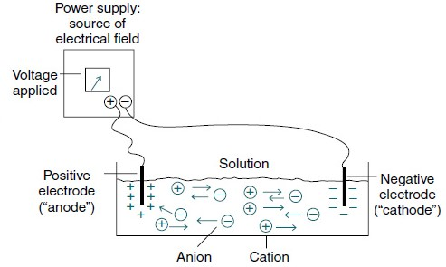

Fig1: Application of electrical field to a solution of ions makes the ions move

and antigen is added to a well cut into the gel. As the antigen diffuses from the well, the antigen antibody combination occurs in changing proportions until the
zone of equivalence is reached and a stable lattice network is formed in the gel. The area of the visible ring is compared with standard concentrations of antigens. A variation of this principle is rocket immunoelectrophoresis (Fig. 4).The classic Ouchterlony double diffusion technique (Fig. 5). performed on a gel medium is used to detect the presence of antibodies and determine their specificity by visualization of lines of identity, or precipitin lines. The reaction of antigen-antibody combination occurs by means of diffusion.The size and position of precipitin bands provide information regarding equivalence or antibody excess. Proteins are differentiated not only by their electrophoretic mobility, but also by
their diffusion coefficient and antibody specificity. Although double immunodiffusion produces a separate precipitation band for each antigen-antibody system in a mixture, it is often difficult to determine all the components in a complex mixture.

Principle
Immunoelectrophoresis is a combination of the techniques of electrophoresis and double immunodiffusion. IEP separates the antigen mixture by electrophoresis before performing immunodiffusion. In the first phase, electrophoresis, serum is
placed in an appropriate medium (e.g., cellulose acetate or agarose)and then electrophoresed to separate its constituents according to their electrophoretic mobility—albumin; α1-, α2-,β-, and γ-globulin fractions After electrophoresis, in the second phase, immunodiffusion,the fractions are allowed to act as antigens and to interact with their corresponding antibodies. Antiserum (polyvalent or monovalent) is deposited in a trough cut into the gel to one side and parallel to the line of separated proteins. Incubation 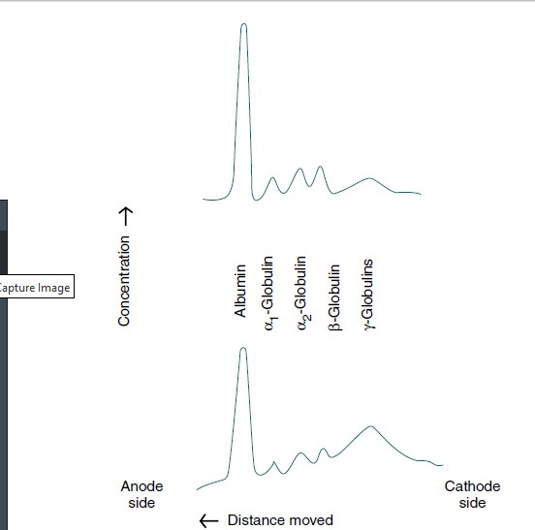
Fig2: Example of the effect of disease (hepatic cirrhosis) on serum protein electrophoresis pattern.

allows double immunodiffusion of the antigens and antibodies.
Each antiserum diffuses outward, perpendicular to the trough,and each serum protein diffuses outward from its point of electrophoresis.When a favorable antigen-to-antibody ratio exists (equivalence), the antigen-antibody complex becomes visible as precipitin lines or bands. Diffusion is halted by rinsing the
plate in 0.85% saline. Unbound protein is washed from the agarose with saline and the antigen-antibody precipitin arcs are stained with a protein-sensitive stain.
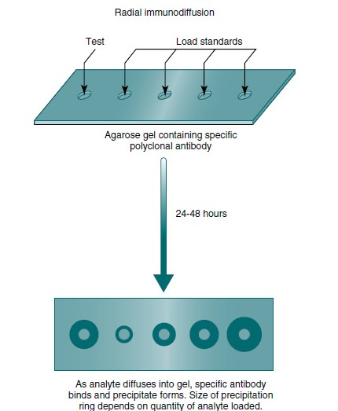
Fig3: Measurement of immune-related proteins by a radial immune diffusion.

Each line represents one specific protein (Fig. 6). Proteins are thus differentiated by their diffusion coefficient and antibody specificity as well as electrophoretic mobility. Antibody diffuses as a uniform band parallel to the antibody trough. If the proteins are homogeneous or of like composition,the antigen diffuses in a circle and the antigen-antibody precipitation line resembles a segment, or arc, of a circle. If the antigen is heterogeneous or not uniform in composition, the antigen-antibody line assumes an elliptical shape. One arc of precipitation forms for each constituent in the antigen mixture.
This technique can be used to resolve the protein of normal serum into 25 to 40 distinct precipitation bands. The exact number depends on the strength and specificity of the antiserum used.
Normal Appearance of Precipitin Bands
Immuno precipitation bands should be of normal curvature,symmetry, length, position, intensity, and distance from the antigen well and antibody trough. In normal serum, immunoglobulin G (IgG), IgA, and IgM are present in sufficient concentrations of 10 mg/mL, 2 mg/mL, and 1 mg/mL, respectively,to produce precipitin lines. The normal concentrations of IgD and IgE are too low to be detected by IEP.A normal IgG precipitin band is elongated, elliptical,slightly curved, and clearly visible in undiluted serum and 1:10 diluted serum. An IgG band is located cathodic to the antigen well in the alpha (α) area of the electrophoretogram.
If monospecific serum is used, it is fused with a thin precipitin line positioned midway between the antigen well and antibody trough and extending into the beta (β) area. The IgM and IgA bands are visible in undiluted serum but disappear
at a 1:10 dilution of serum. The IgA band is a flattened,thin arc, slightly cathodic to the well in the α-β position. The IgM line is a barely visible thin line, slightly cathodic to the antigen well

Clinical Applications
Immunoelectrophoresis is most often used to
- determine qualitatively the elevation or deficiency of specific classes of immunoglobulins.Also,
- IEP is a reliable and accurate method for detecting structural abnormalities 3-concentration changes in proteins. It is possible to identify the absence of a normal serum protein (e.g., congenital deficiency of complement component) or alterations in serum proteins. This method can be used to screen for circulating immune complexes, characterize cryoglobulinemia and pyroglobulinemia, and recognize and characterize antibody syndromes and the various dysgammaglobulinemias. The most common application of IEP is in the diagnosis of a monoclonal gammopathy,
Sources of Error
The prozone phenomenon is an incomplete precipitin reaction caused by antigen excess (antigen-to-antibody ratio too high). Prozoning should be suspected if a precipitin arc appears to run into a trough,
Abnormal Appearance of Precipitin Bands
The size and position of precipitin bands provide the same type of information regarding equivalence or antigen-antibody excess as double immunodiffusion systems. The position and shape of precipitin bands in the IEP assay of serum are relatively stable and reproducible; almost any deviation is abnormal . These abnormalities can be detected by evaluating the following features of the precipitin bands:
• Position of the band in relation to electrophoretically
identified protein fractions
• Position of the band between the antigen well and antibody trough
• Distortion of the curvature or arc formation
• Thickening (density) and elongation of a band
• Shortening (inhibition), thinning, or doubling of a band
Position of Band
The precipitin band may be displaced compared with its normal position in the control serum because molecular charges in the abnormal protein may affect its speed of migration in the electrophoresis phase of IEP. A precipitin band may form a line of fusion or partial fusion with another protein, indicating the presence of
proteins immunologically similar but electrophoretically distinct.A distinct abnormality in the position of the band is seen in cases of monoclonal IgA gammopathy. The monoclonal IgA band is closer to the antibody trough than normal IgA.
Polyvalent and Monovalent Antisera
Polyvalent antiserum confirms the presence or absence of major protein fractions. Monovalent antiserum for specific individual immunoglobulins identifies only the corresponding proteins.
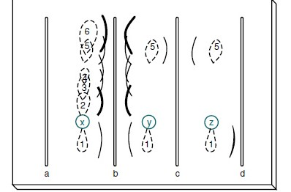
Fig4: Configuration for immunoelectrophoresis. Sample wells are punched in the agar-agarose, sample is applied, and electrophoresis is carried out to separate the proteins in the sample. Antiserum is loaded into the troughs and the gel is incubated in a moist chamber at 4° C (39° F) for 24 to 72 hours. Track x represents the shape of the protein zones after electrophoresis; tracks y and z show the reaction of proteins 5 and 1 with their specific antisera in troughs c
and d. Antiserum against proteins 1 through 6 is present in trough b.

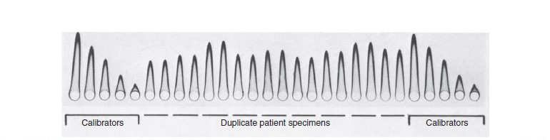
Fig5: Rocket immunoelectrophoresis of human serum albumin. Patient samples were applied in duplicate. Calibrators were placed at opposite ends of the plate.
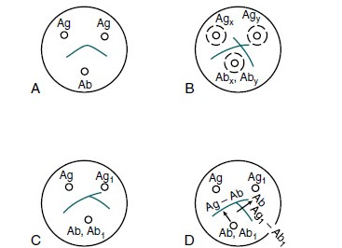
Fig6: Double immunodiffusion in two dimensions by theOuchterlony technique. A, Reaction of identity. B, Reaction of nonidentity.C, Reaction of partial identity. D, Scheme for spur formation.

