Lec(8) Immunotechnology
Prof. Dr. Ekhlass Noori Ali
CLINICAL HISTOCOMPATIBILITY TESTING
Appreciation of the beneficial role of HLA matching and the detrimental role of antibody to HLA proteins on graft survival provided the impetus for development and application of specialized testing to aid in the selection of the most appropriate donors for patients needing transplantation.Histocompatibility laboratories provide specialized testing for both solid-organ and stem cell transplantation programs. Two main activities are carried out by these laboratories in support of transplantation, HLA typing, and
HLA antibody screening/identification.
HLA Typing
HLA typing is the phenotypic or genotypic definition of the HLA antigens or genes in a transplant candidate or donor.For clinical HLA testing, phenotypes or genotypes of the classical transplant antigens or genes are determined (HLA-A, B,
Cw, DR, DQ). This information is used to find the most suitable donor–recipient combination from an immunologic standpoint. It must be stressed that other considerations go into the choice of a particular donor for any given patient, be
it a solid-organ or stem cell transplant.
HLA Phenotyping
The classic procedure for determining the HLA phenotype is the complement-dependent cytotoxicity (CDC)test. Panels of antisera or monoclonal antibodies that define individual or groups of immunologically related HLA antigens
are incubated with lymphocytes from the individual tobe HLA typed. Purified T lymphocytes are used for HLAclass I typing, while purified B lymphocytes are used forHLA class II typing. After incubation with the antisera, complement is added. In the presence of bound antibody, which occurs only if the lymphocyte expresses the HLA antigen targeted by the antisera, complement is activated and cells are killed. A vital dye is then added that distinguishes live cells from dead when they are viewed microscopically. Using this assay, an extensive array of HLA antigens can be defined(Table 1).There are several limitations to the CDC method forHLA typing. Viable lymphocytes must be used, which demands timely performance of the assay. Separation of T and B lymphocytes is required for definition of class Iversus class II antigens. The source of antisera for HLA typing
is not always consistent or reliable. Thus, reagents can vary in quality or quantity over time. Finally, the level of resolution (i.e., the ability to distinguish two closely related yet distinct HLA antigens) is limited. The limits of resolution don’t significantly impact the role of this technology for matching solid-organ donors and recipients. However,for unrelated stem cell transplantation, a higher level of
resolution is required. DNA-based (molecular) HLA typing methods are now commonly employed in histocompatibility laboratories, because they address the limitations of CDC-based methods and are amenable to higher throughput formats.
HLA Genotyping
Molecular-based HLA genotyping methods use polymerase chain reaction (PCR)–based amplification of HLA genes followed by analysis of the amplified DNA to identify the specific HLA allele or group of alleles. The most common approaches for analysis include PCR amplification of HLA genes with panels of primer pairs, each of which amplifies specific alleles or related allele groups. Amplification is
detected by agarose gel electrophoresis (Fig. 1). Only those primer pairs that bind to the target gene result in detection of an amplification product. The HLA type is then identified by determining which primers resulted in amplification.
A second common approach for HLA genotyping is to perform a single PCR reaction that will amplify all HLA gene variants at a specific locus (referred to as a generic
Table1: Approximate number of HLA antigens and Alleles defined at the six classical transplant loci.

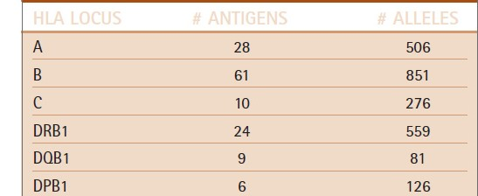

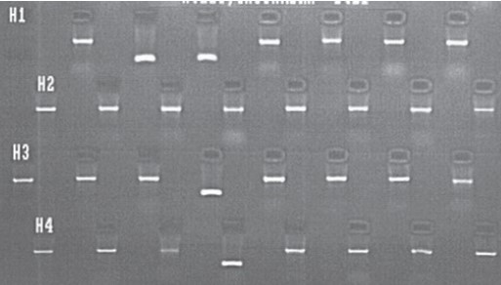
Fig1: An example of a PCR with sequence-specific primers (PCR-SSP) analysis of the HLA-DQB1 locus. Each lane of this ethidium bromide stained agarose gel contains the amplification product of an individual PCR reaction. Each reaction contains primers to aubiquitous gene and should demonstrate amplification (the larger band in each lane). This serves as an internal control to document successful amplification in each reaction. Each reaction also contains primers specific for various HLA-DQB1 alleles. An amplification product of small size is seen in several lanes, indicating the presence of the target HLA-DQB1 gene for those specific primers. The particular pattern of amplified primers is assessed to determine the HLA- DQB1type of the sample. (Color Plate 13).

amplification). The amplified gene is then subjected to hybridization with a panel of DNA probes, each specific fora unique HLA allele or allele group. Only those probes that specifically hybridize to the amplified DNA will be detected.
The HLA genotype is determined by assessing which probes hybridized. A third common method for HLA genotyping is sequencing of PCR-amplified HLA genes.
HLA genotyping overcomes the limitation of CDC based HLA phenotyping. Cells do not need to be viable in order to obtain DNA for HLA genotyping. Typing reagents are chemically synthesized; thus, there is no reliance on human donors of antisera. HLA genotyping can provide varying levels of resolution that can be tailored to the specific clinical need. DNA-based typing can provide results at a level of resolution comparable to CDC-based typing (antigen equivalent) or can provide allele-level results (required for matching of unrelated stem cell donors and recipients). Allele-level HLA typing has demonstrated the incredible extent of polymorphism within the HLA loci (Table 1).

HLA Antibody Screening and Identification
Antibodies to HLA antigens can be detected in candidates and recipients of solid-organ transplants. These antibodies develop in response to multiple blood transfusions; to prior HLA-mismatched transplants; and, in women, to multiple
pregnancies. Because of the potential adverse impact HLA antibodies can have on graft survival, patients awaiting solid organ transplantation are screened periodically for their presence. If detected, the specificity (which HLA proteins
they bind) of the antibodies is then determined so that donors possessing those HLA antigens can be eliminated from consideration for donation to that patient. Patients are tested monthly for the presence of HLA antibodies while they are waiting for an organ offer. Antibody screening and identification is also performed post-transplantation to aid in the diagnosis of antibody-mediated rejection and to assess the effectiveness of therapy for antibody-mediated rejection.
The methods used for antibody detection and identification have changed significantly in recent years. The CDC method used for HLA typing is also used for HLA antibody detection and identification. In this case, panels of lymphocytes
with defined HLA phenotypes are incubated with the patient’s serum. If the serum contains HLA antibodies, they will bind to those lymphocytes in the panel that express the cognate HLA antigen. Binding is detected by addition of complement and a vital dye to assess cell death microscopically.In some scenarios, the level of antibody in a patien tserum may be below a level detectable by the CDC assay.
In these cases, antihuman globulin (AHG) may be added to the CDC assay to increase the test’s sensitivity. The AHGCDC assay can detect lower levels of antibody as well as isotypes of bound antibody that don’t activate complement
and thus wouldn’t normally be detected in the standard CDC assay. The proportion of lymphocytes in the panel (usually 30 to 60 unique lymphocyte preparations are
included in the panel) that are killed by the patient’s serum is referred to as the percent panel reactive antibody (%PRA).In addition, the specificity of the antibodies can be determinedby evaluating the phenotype of the panel cells.
Enzyme-linked immunosorbent assay (ELISA) has been developed in recent years as a substitute for CDC-based HLA antibody testing. ELISA assays utilize purified
HLA antigens bound to the wells of microtiter plates.Patient serum is added to the wells of the plate, and if HLA-specific antibody is present, it will bind. Bound
antibody is detected by addition of an enzyme-labeled anti immunoglobulin reagent. Addition of substrate results in a color change in the wells that have bound antibody. The wells of the ELISA plate may contain a pool of HLA antigens,
thus serving as a qualitative screen for the presence of HLA antibody in a serum. Alternatively, each well may contain HLA antigens representing a single donor and thus can be used in a fashion analogous to a CDC-based analysis,allowing %PRA and specificity to be determined.Another approach for antibody detection and identification is flow cytometry. Antibody in patient serum can be incubated with latex beads that are coated with HLA antigens,
either from a single donor or a single purified HLA protein. Patient serum is incubated with the beads, andbound antibody is detected by adding an FITC-labeled anti-IgG reagent (Fig. 2). A more recent version of flow cytometry–based antibody detection is the multiplex bead array system that can assess binding of up to 100 different HLA antigens in a single tube using a dedicated flow-based detection system. Flow cytometry–based methods are the most sensitive technology for detecting HLA antibodies. In addition, they can provide the most specific determination of the specificity of HLA antibodies when beads coated with a single HLA antigenic type are used .Once a donor has been identified for a particular patient ,a donor–recipient cross match test is performed to confirm the absence of donor-specific antibody. Donor lymphocytes are incubated with recipient serum in a CDC assay to verify a lack of binding as detected by microscopic analysis after addition of a vital dye. Alternatively, binding of antibody can be detected by flow cytometry using an FITC-labeled anti-IgG reagent. As for antibody screening and identification, the flow cytometric cross match is the most sensitive method for detecting donor-specific antibody.
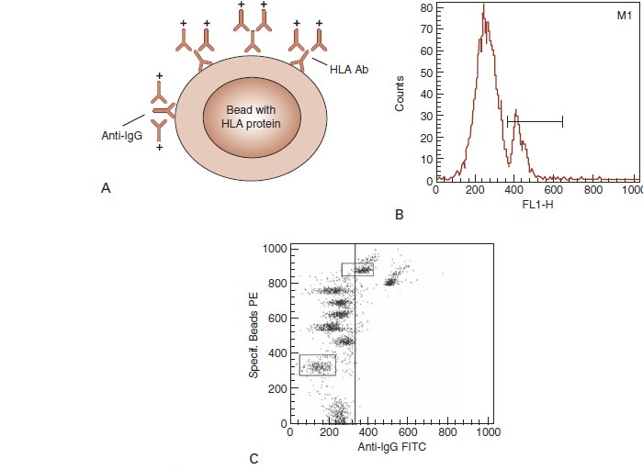
Fig2: (A) Flow cytometric detection and identification of HLA antibodies employs latex beads that are coated with HLA proteins from individual donors or single HLA molecules. For qualitative determination of thepresence of HLA antibodies, multiple beads, each coated with the product of an individual donor, are pooledtogether so as to represent the majority of common HLA antigens. They are then incubated with patient serum. Todetermine the specificity of HLA antibodies in a serum sample, beads coated with a single HLA protein species can
be incubated with patient serum. Once incubated with serum, both bead types are then incubated with an FITClabeled anti-IgG reagent that will detect the presence of antibodies bound to the ead. (B) Single-parameter histogram display of an HLA class I antibody screen. A pool of HLA-coated beads was incubated with a patient serum, washed, and then incubated with an FITC-labeled anti-IgG reagent. Unbound FITC-labeled reagent was washed away and the beads analyzed for fluorescence on a flow cytometer. The large peak represents beads with no bound antibody, while the smaller peak to the right indicates the presence of HLA antibody bound to approximately 19 percent of the HLA class I coated beads. This represents a positive HLA class I antibody screen.
(C) Nine individual clusters of latex beads, each coated with a single HLA class I antigen species, are identified in the dual parameter dot plot of the serum from (B). The HLA antigen coated on each bead is indicated to the right of thebead. The bead coated with HLA-A11 has shifted to the right relative to the other beads, indicating that the HLA antibodies in this patient’s serum are specific for the A11 antigen.

