Lec (2) Sera & Vaccines
Prof. Dr. Ekhlass Noori Ali
S.N. | Characteristics | Innate Immunity | Adaptive immunity
1. | Presence | Innate immunity is something already present in the body. | Adaptive immunity is created in response to exposure to a foreign substance.
2. | Specificity | Non-Specific | Specific
3. | Response | Fights any foreign invader | Fight only specific infection
4. | Response | Rapid | Slow (1-2 weeks)
5. | Potency | Limited and Lower potency | High potency
6. | Time span | Once activated against a specific type of antigen, the immunity remains throughout the life. | The span of developed immunity can be lifelong or short.
7. | Inheritance | Innate type of immunity is generally inherited from parents and passed to offspring. | Adaptive immunity is not passed from the parents to offspring, hence it cannot be inherited.
8. | Memory | Cannot react with equal potency upon repeated exposure to the same pathogen. | Adaptive system can remember the specific pathogens which have encountered before.
9. | Presence | Present at birth | Develops during a person’s lifetime and can be short-lived.
10. | Allergic Reaction | None | Immediate and Delay hypersensitivity
11. | Used Against | For microbes | Microbes and non-microbial substances called antigens
12. | Memory | No memory | Long term memory
13. | Diversity | Limited | High
14. | Speed | Faster response | Slower response
15. | Complement system activation | Alternative and lectin pathways | Classical pathway
16. | Anatomic and physiological barriers | Skin, Mucous membranes, Temp, pH, chemicals, etc. | Lymph nodes, spleen, mucosal associated lymphoid tissue.
17. | Composition | The innate immune system is composed of physical and chemical barriers, phagocytic leukocytes, dendritic cells, natural killer cells, and plasma proteins. | Adaptive immune system is composed of B cells and T cells.
18. | Development | Evolutionary, older and is found in both vertebrates and invertebrates. | Adaptive immunity system has been developed recently and is found only in the vertebrates.
19. | Example | White blood cells fighting bacteria, causing redness and swelling, when you have a cut. | Chickenpox vaccination so that we don’t get chickenpox because adaptive immunity system has remembered the foreign body.
Specific immunity is developed as a result of exposure to a variety of agents capable of inducing an immune response (immunogens) such as:
1- Vaccines.
2- Microbes that colonize the body.
3- Macromolecules in the diet.
Specific Immune responses:
I- Antibody mediated (Humoral) immune responses:
a. Primary immune response.
b. Secondary immune response.
S.N. | Primary immune response | Secondary immune response
1. | This occurs as a result of primary contact with an antigen. | This occurs as a result of second and subsequent exposure of the same antigen
2 | Responding cell is naïve B-cell and T-cell. | Responding cell is memory cell.
3 | Lag phase is often longer (4-7 days), sometimes as long as weeks or months. | Lag phase is shorter (1-4 days) due to the presence of memory cell.
4 | Level of antibody reaches peak in 7 to 10 days. | Level of antibody reaches peak in 3 to 5 days.
5 | It takes longer time to establish immunity. | Takes shorter time to establish immunity.
6 | First antibody produced is mainly IgM. Although small amount of IgG are also produced. | Mainly IgG antibody is produced. Although sometimes small amount of IgM are produced. Other immunoglobulins such as IgA and in the case of allergy IgE are produced.
7 | Amount of antibody produced depends on nature of antigen. Usually produced in low amount. | Usually 100-1000 times more antibodies are produced.
8 | Antibody level declines rapidly. | Antibody level remain high for longer period.
9. | Affinity of antibody is lower for its antigen. | Antibodies have greater affinity for antigen.
10 | Primary response appears mainly in the lymph nodes and spleen. | Secondary response appears mainly in the bone marrow, followed by the spleen and lymph nodes.
11 | Both Thymus dependent and Thymus independent antigen gives primary immune response. | Only Thymus-dependent antigen gives secondary immune response.

Types of Vaccines:
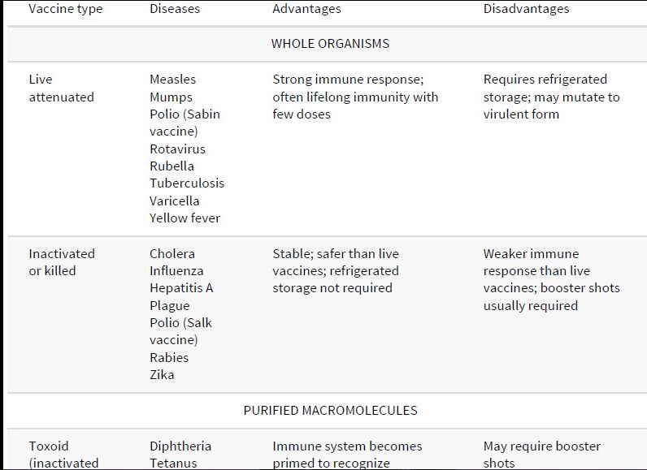
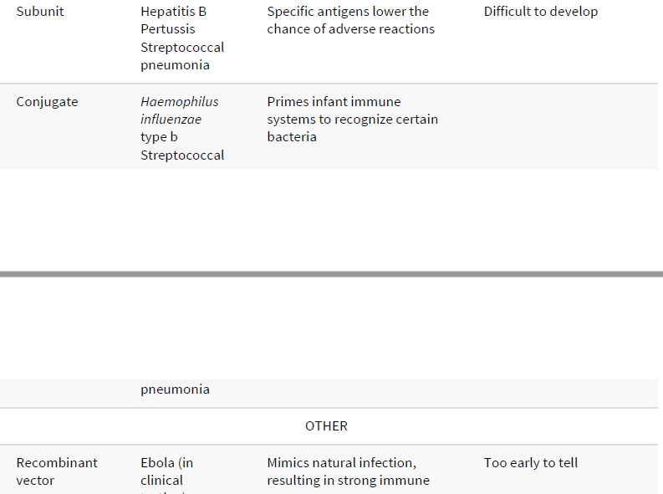
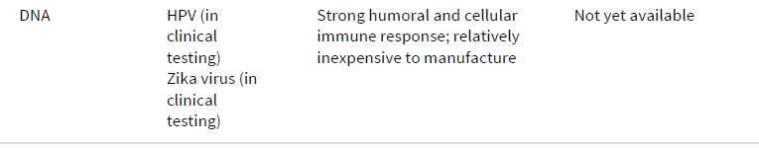
mRNA Corona virus SARAS-2
Pfizer vaccine
Live attenuated Vaccines
In terms of a matched exposure to the real thing, live attenuated vaccines produce the
most robust response, although not without risk. For these vaccines, microorganisms
are attenuated (disabled) so that they lose their ability to cause significant
pathogenicity (disease) but retain their capacity for slow and transient growth within an inoculated host. This allows the immune system a taste of the real thing, but also the
upper hand against a pathogen-like organism with only temporary residency. Some agents are naturally attenuated by virtue of their inability to cause disease in a given host, even while having the ability to immunize. The first vaccine used by Jenner is of this type: vaccinia virus (cowpox) inoculation of humans confers immunity to smallpox but does not cause smallpox.
Attenuation can often be achieved in the laboratory by growing a pathogenic
bacterium or virus for prolonged periods under abnormal culture conditions. This selects mutants that are better suited for growth in the abnormal culture conditions than in the natural host. For example, an attenuated strain of Mycobacterium bovis,called bacillus Calmette-Guérin (BCG), was developed by growing M. bovis on a medium containing increasing concentrations of bile. After 13 years, this strain had adapted to growth in strong bile and had become sufficiently attenuated that it was suitable as a vaccine for tuberculosis. Because of variable effectiveness, relatively low prevalence, and difficulties in follow-up monitoring, a new weakened form of Plasmodium falciparum is
being used as a vaccine for malaria (called PfSPZ). In clinical trials conducted in Mali,Africa aimed at testing this vaccine during high transmission periods, only 66% of vaccinees contracted malaria after five doses of the vaccine, compared with 93% of control subjects: a modest but significant improvement.
Attenuated vaccines have obvious advantages. Because of their capacity for growt h,even transient growth, such vaccines provide prolonged immune system exposure to the epitopes (immunogens) on the attenuated organism and more closely mimic the growth patterns of the “real” pathogen. This often results in increased immunogenicity and more efficient production of highly effective memory cells. Thus, these vaccines often require only a single immunization, a major advantage in developing countries, where studies show that a significant number of individuals fail to return for boosters. This ability of attenuated vaccines to replicate within host cells thus makes them particularly suitable for inducing cell-mediated responses.
One good example of a live attenuated vaccine that has been in use for decades
worldwide is the oral polio vaccine (OPV) designed by Albert Sabin.
In its original form, OPV consists of three attenuated strains of poliovirus and is administered orally to children in regions where risk of polio is still relatively high. The attenuated viruses colonize the intestine and induce production of secretory IgA, an important defense gainst naturally acquired poliovirus. The vaccine also induces IgM and IgG classes of antibody and ultimately protective immunity to all three strains of virulent poliovirus.
Unlike most other attenuated vaccines, OPV requires boosters, because the three
strains of attenuated poliovirus can interfere with each other’s replication in the
intestine (although there are now also mono- and divalent forms of OPV without this drawback). With the first immunization, one strain will predominate, inducing immunity to that strain. With the second immunization, the immunity generated by the previous immunization will limit the growth of the previously predominant strain in the vaccine, enabling one of the two remaining strains to colonize the intestines and induce immunity. Finally, with the third immunization, immunity to all three strains is typically achieved. the major disadvantage of attenuated vaccines is that these live forms can sometimes mutate and revert to a more virulent form in the host—a major drawback. In the case of polio, this can therefore risk paralytic disease in the vaccinated individual, or in unprotected individuals who come in contact with these
more virulent forms shed in feces. The rate of reversion of the OPV to a virulent form is extremely low: about 1 case in 2.4 million doses of vaccine Attenuated vaccines also may be associated with complications similar to those seen
in the natural disease. A small percentage of recipients of the measles vaccine, for example, develop post vaccination encephalitis or other complications, although the risk of vaccine-related complications is still significantly lower than risks from infection In addition to culturing methods, genetic engineering provides a means to attenuate a virus irreversibly, by selectively removing genes that are necessary for virulence or for growth in the host. This has been done with a herpes virus vaccine for pigs, in which the thymidine kinase gene was removed. Because thymidine kinase is required for the virus to grow in certain types of cells (e.g., neurons), removal of this gene rendered the virus incapable of causing disease. A live attenuated vaccine against influenza has been developed under the name FluMist. For this, the virus was grown at
lower-than-normal temperatures until a cold-adapted strain, unable to grow at human body temperature of 37°C, arose. This live attenuated virus can be administered intra nasally and causes a transient infection in the upper respiratory tract, sufficient to induce a strong immune response. The virus cannot spread beyond the upper respiratory tract because of its inability to grow at the elevated temperatures of the inner body.

