**Experiment No. (1)**

**Human Classifications )) )(**

This laboratory aims to study the climate on humans, which authorized the launch of the characterization of human climatic classifications, some of which aimed to study the Climate pressure ( stress ) on man and its impact on his thinking and productivity and its impact on human comfort (Human comfort ) Including also to study the relationship between climate and human health and the spread of diseases. There is a study of comfort regions in Iraq based on Thom's study and Spile and Passel .

Thom's study is based on the calculation of the temperature and humidity index ( Temperature Humidity Index ) ( THI ) Which was derived in light of the following mathematical formula:



Whereas:

Convenience guide. THI:

Temperture . T :

$T^{°}$ = Dry air temperature $T_{d}$.

$T^{°}w$: Moist air temperature $T_{w}$.

And that the comfort limits lie between (15-20), and outside these two limits, the feeling of discomfort begins.

Thom relied on the elements of heat and humidity only. Therefore, this is considered a deficiency if it does not take into account the movement of air and its ability to change these limits. That is, the winds at their different speeds reduce or increase the feeling of the effect of heat and humidity together.

The simplest evidence of this is that Iraqis in general feel using fans only in the month of April and do not use fans alone with the increase in temperature in June, July and August, but rather support them with air conditioners or coolers.

This indicates that the feeling of heat increases when the air movement inside the room increases. Unless it is accompanied by another type of conditioning. Therefore, it must use the wind's cooling capacity using the Siple and Pasel equation Which calculates the ability of the surface of the earth to absorb the amount of heat within one meter, which takes the formula:



Whereas:

$K_{°}$: Wind cooling capacity = $\frac{حرارية سعرة}{ساعة مربع متر}$

(V) : Wind speed (m/s).

(T): Dry air temperature $C^{°}$

(33): normal body temperature

**Application :**



The ideal comfort boundary can be divided, which includes three types of comfort zone.

1- classification THI

2- classification K

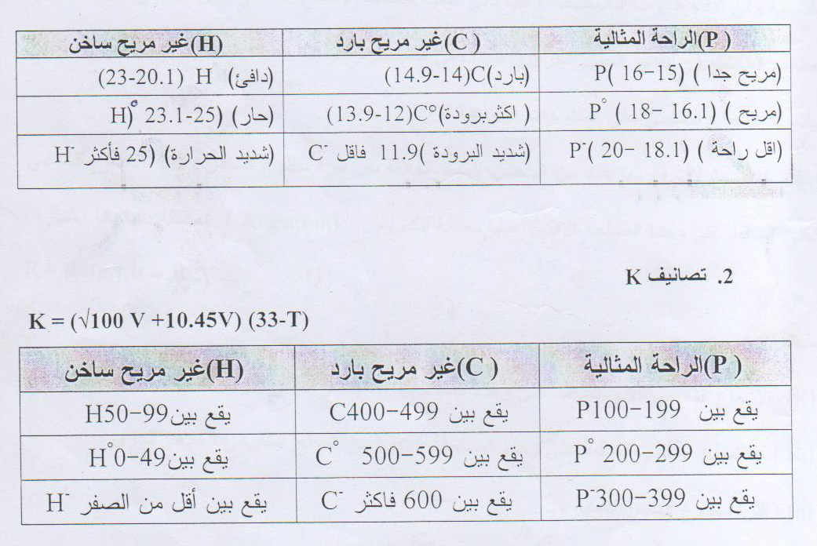

**Table representing values**

