9- Coulomb’s Law:
During the 18th century a French scientist, Charles A. Coulomb, studied fields of force that surround charged bodies. Coulomb discovered that charged bodies attract or repel each other with a force that is directly proportional to the product of the charges, and inversely proportional to the square of the distance between them. Today we call this Coulomb’s Law of Charges. Simply put, the force of attraction or repulsion depends on the strength of the charred bodies, and the distance between them.
9-1 Current:
Electricity is the flow of free electrons in a conductor from one atom to the next atom in the same general direction. This flow of electrons is referred to as current and is designated by the symbol “I”. Electrons move through a conductor at different rates and electric current has different values. Current is determined by the number of electrons that pass through a cross-section of a conductor in one second. We must remember that atoms are very small.
It takes about 1,000,000,000,000,000,000,000,000 atoms to fill one cubic centimeter of a copper conductor. r. This number can be simplified using mathematical exponents. Instead of writing 24 zeros after the number 1, write 10²⁴. Trying to measure even small values of current would result in unimaginably large numbers. For this reason, current is measured in amperes which is abbreviated “amps”. The letter “A” is the symbol for amps. A current of one amp means that in one second about 6.24 x 10¹⁸ electrons move through a cross-section of conductor. These numbers are given for information only and you do not need to be concerned with them. It is important, however, that the concept of current flow be un-stood.
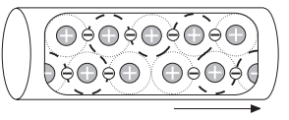

9-2 Units of Measurement:
The following chart reflects special prefixes that are used when dealing with very small or large values of current:

Prefix | Symbol | Decimal
1 kiloampere | 1 kA | 1000 A
1 milliampere | 1 mA | 10⁻³ A
1 microampere | 1 $μ$A | 10⁻⁶ A

9-3 Direction of Current Flow:
Some authorities distinguish between electron flow and current flow. Conventional current flow theory ignores the flow of electrons and states that current flows from positive to negative. To avoid confusion, this book will use the electron flow concept which states that electrons flow from negative to positive.
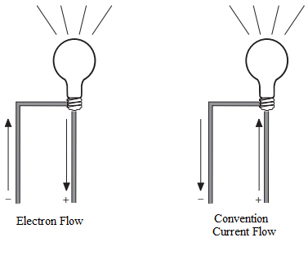

9-4 Voltage:
Electricity can be compared with water flowing through a pipe. A force is required to get water to flow through a pipe. This force comes from either a water pump or gravity. Voltage is the force that is applied to a conductor that causes electric current to flow.
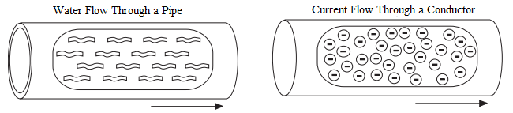
Electrons are negative and are attracted by positive charges. They will always be attracted from a source having an excess of electrons, thus having a negative charge, to a source having a deficiency of electrons which has a positive charge. The force required to make electricity flow through a conductor is called a difference in potential, electromotive force (emf), or more simply referred to as voltage. voltage is designated by the letter “E”, or the letter “V”. The unit of measurement for voltage is volts which is also designated by the letter “V”.

9-4-1 Voltage Sources:
An electrical voltage can be generated in various ways. A battery uses an electrochemical process. A car’s alternator and a power plant generator utilize a magnetic induction process. All voltage sources share the characteristic of an excess of electrons at one terminal and a shortage at the other terminal. This results in a difference of potential between the two terminals.

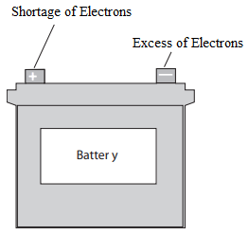
9-4-2 Voltage Circuit Symbol:
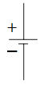
The terminals of a battery are indicated symbolically on an electrical drawing by two lines. The longer line indicates the positive terminal. The shorter line indicates the negative terminal.

9-4-3 Units of Measurement:
The following chart reflects special prefixes that are used when dealing with very small or large values of voltage:

Prefix | Symbol | Decimal
1 kilovolt | 1 kV | 1000 V
1 millivolt | 1 mV | 10⁻³ V
1 microvolt | 1 $μ$V | 10⁻⁶ V
9-5 Resistance
A third factor that plays a role in an electrical circuit is resistance. All material impedes the flow of electrical current to some extent. The amount of resistance depends upon composition, length, cross-section and temperature of the resistive material. As a rule of thumb, resistance of a conductor increases with an increase of length or a decrease of cross-section. Resistance is designated by the symbol “R”. The unit of measurement for resistance is ohms (Ω).

9-5-1 Resistance Circuit Symbols
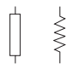
Resistance is usually indicated symbolically on an electrical drawing by one of two ways. An unfilled rectangle is commonly used. A zigzag line may also be used.
Resistance can be in the form of various components. A resistor may be placed in the circuit, or the circuit might contain other devices that have resistance.

9-5-1 Units of Measurement:
The following chart reflects special prefixes that are commonly used when dealing with values of resistance:
Prefix | Symbol | Decimal
1 kilohm | 1 kΩ | 1000 Ω
1 megohm | 1 MΩ | 1,000,000 Ω

