University of Al-Mustansiriyah
College of Science/ Department of Biology
Course : Botany
Lecture: 3
Tissues
**Tissues: are a group of cells that perform similar function.
** Any plant organ may be composed of several different tissues, and each tissue may classified
according to its structure, origin, or function.
**types of tissues in plant cells:
1/ meristematic tissues
2/ tissues produced by meristems: A// simple T. B// complex T.

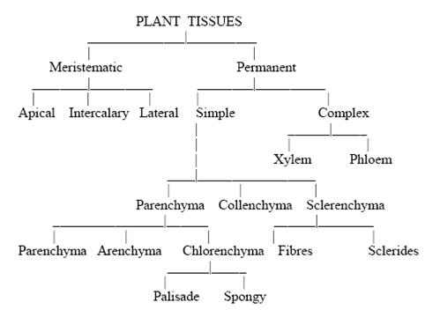

**meristematic tissues: plants have permanent region of growth called meristems, where cells actively divide, and new cells are produced, they are small, six-sided, boxlike structure, large nucleus near the center, tiny or no vacuoles.

***Types of meristems:
1/ apical meristem
2/ lateral meristem
- vascular cambium
- cork cambium
5/ intercalary meristem

*Apical meristem: are meristems found at, or near the tips of roots and shoots, they increase in length as the apical meristems produce new cells, this type of growth is called as primary growth.

One of the region produced by apical meristem is the primary meristem, which are in three types:
1-protoderm 2-ground meristem 3- procambium

*lateral meristem: it produces tissues that increase the girth of roots and stems, such growth is called secondary growth. Example for lateral meristem is vascular cambium and cork cambium.

*vascular cambium: often called cambium, produces secondary tissues that function in support and conduction. It responsible of increase in girth of plant.

*cork cambium: is in form of a thin cylinder that runs the length of roots and stems of woody plants, it lies outside the vascular cambium, and inside the outer bark, which it produces.
**the tissues that formed by vascular and cork cambium are called secondary tissues, since they are produced after the primary tissues have matured.

*intercalary meristems: is a meristematic tissue formed near node areas on stems of grass and related plants, it develop at intervals along stems and give length to stems.

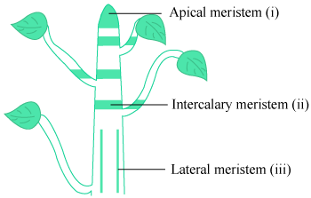

(Apical Shoot meristems)

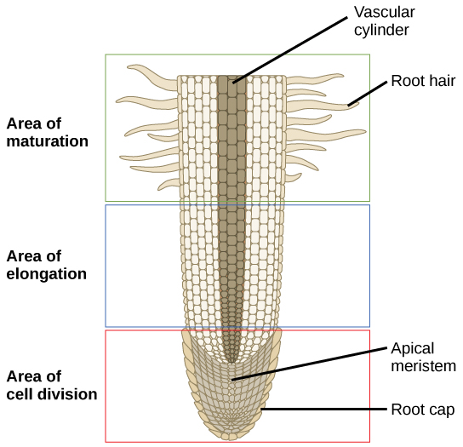
(Apical root meristem)
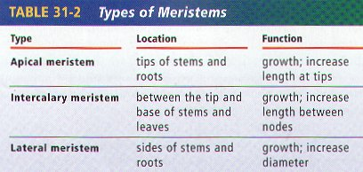
**Tissues produced by meristems:
A/ Simple tissues: 1/ Parenchyma 2/ Collenchyma 3/ Sclerenchyma 4/ Fibers

***parenchyma: it’s the most abundant tissue and are found in almost all major parts of higher plants.

**characteristics of parenchyma cells:
1/ have various shapes and sizes
2/ have thin primary walls
3/have large vacuoles
4/ have intercellular spaces
5/remain life for long time
6/ keep their meristematic ability to divide (this is important in repair of tissues).

- aerenchyma : This type of parenchyma tissue with extensive connected air spaces is referred to as aerenchyma. ( e.g. water liliy).
- Parenchyma cells containing numerous chloroplasts (as found in leaves) are collectively referred to as chlorenchyma tissue.
- Some parenchyma cells develop irregular extensions of the inner wall that greatly increase the surface area of the plasma membrane. Such cells, called transfer cells, it is found in nectaries of flower.
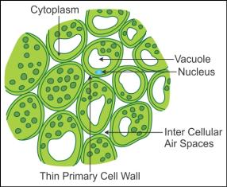

(Parenchyma Tissue)
***Collenchyma:
--Characteristics of collenchyma tissue:
1-live for long time.
2-un even thickness in primary cell wall.
3-its found under the epidermis.
4-their walls pliable and strong.
5-they provide support for growing and mature organs (e.g. leaves and floral parts).

**Justify the unevenness in collenchyma tissue walls?
Answer= due to extra primary wall in the corners of cells.

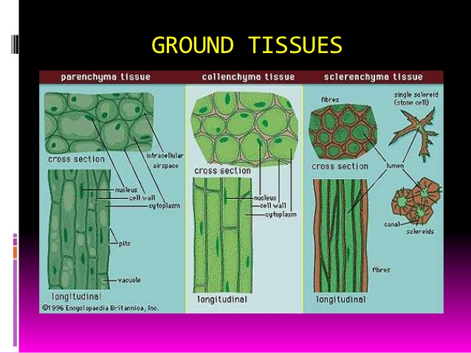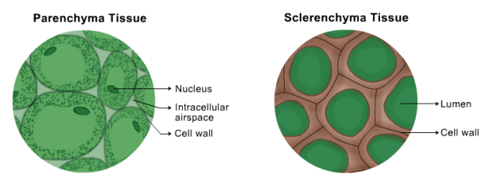

***Sclerenchyma:
*characteristics of sclerenchyma tissue:
- tissue consists of cells that have thick, tough, secondary walls, normally impregnated with lignin .
- 2-function in support.

**types of sclerenchyma: 1/ Sclereids 2/ Fibers

Justify: the gritty texture of pears?
Answer= due to the presence of groups of sclereids (stone cells).

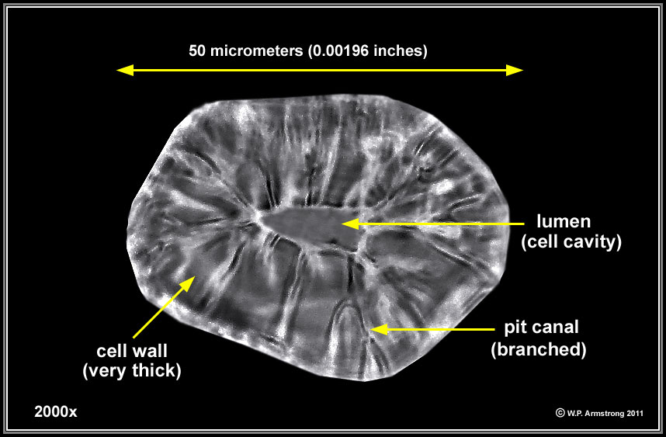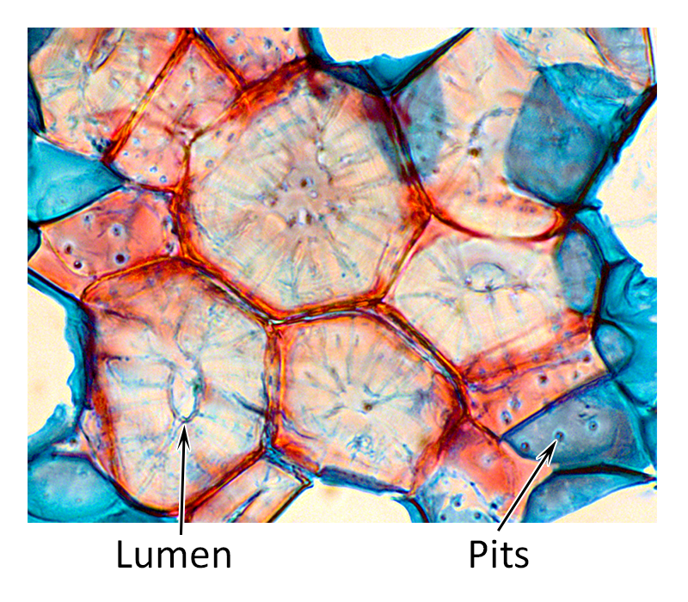

(stone cells in pears / sclerenchyma tissue)

B/ colmplex tissues: 1-xylem 2-phloem

**complex tissue: are tissues that composed of two or more kinds of cells.
Xylem: is an important component of the conducting and storage systems of a plant and is the chief conducting tissue throughout all organs for water and minerals absorbed by the roots.
**xylem tissue consist of the following kinds of cells:
1/ parenchyma cells 2/ fibers 3/ vessels 4/ tracheids 5/ ray cells

Vessels : are long tubes composed of individual cells called vessel elements that are open at each other.
that is characterized by being made up of a series of cells arranged in a way that enables water and mineral conduction

Tracheids: are dead cells at maturity and have relatively thick secondary cell walls, are tapered at each end, the ends overlapping with those of other tracheids, they don’t have openings like in vessels, but they do have pairs of pits present wherever two tracheids are in contact with one another.

** In cone-bearing trees ( gyminosperms) and certain other non-flowering plants, the xylem is composed almost entirely of tracheids.
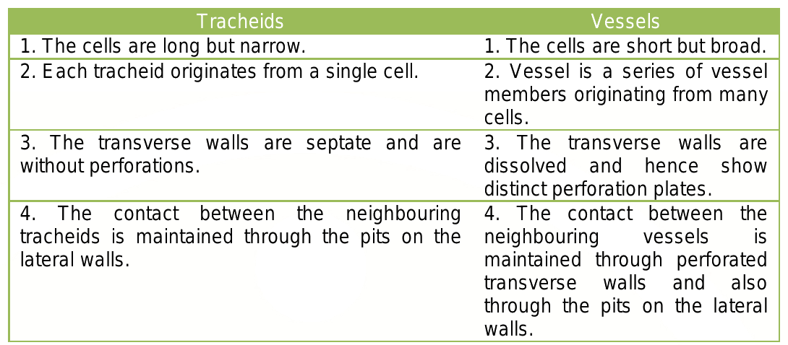

Phloem: it conducts dissolved food materials produced by photosysnthesis throughout the plant.
Phloem tissue composed of the following kinds of cells:

1-sieve tubes 2-companion cells 3-fibers 4-parenchyma cells 5-ray cells

Sieve tubes: they are relatively large, more or less cylindrical, and they are like vessels elements are laid end to end forming sieve tubes, and the end walls have no large openings; instead, the walls are full of small pores, which the cytoplasm extends from cell to cell. These pore regions of sieve tube members are called sieve plates.

Companion cells: narrower and more tapered than sieve elements and they are closely associated to sieve elements.
**sieve tube members have no nuclei at maturity, even though their cytoplasm is very active in conduction of food materials in solution throughout the plant.
Justify : even though the sieve tube members have no nuclei at maturity, their cytoplasm still active in conduction function?
Answer: the adjacent companion cells form a very close relationship with the sieve tubes next to them and aid in the conduction of the food.
***in ferns and cone-bearing trees (gyminosperms), the sieve cells are similar to sieve tube members but tend to overlap at their ends rather than form continuous tubes, and like sieve tube members they have no nuclei at maturity, but they do not have companion cells(they have adjacent albuminous cells , which function like the companion cells).

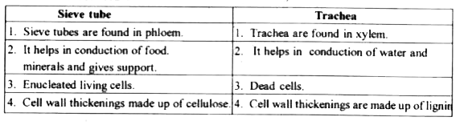

Distinguish between vessels and sieve tubes.
Vessels | Sieve tube
It is used for water transport. | It is used for transport of organic nutrients.
The wall is thick. | The wall is thin.
The wall is lignified. | Lignification is absent.
The end walls between adjacent cells are completely dissolved. | The end walls are perforated with pores called sieve pits.

Distinguish between Sieve cell and sieve tube member.
Sieve cell | Sieve tube member
1. Companion cells are absent. | These are usually associated with companion cells.
2. The end wall is broad. | The end wall is broad.
3. These are found in pteridophytes and gymnosperms. | These are found in angiosperms.
4. The pores are smaller but more numerous. | The pores are comparatively larger and fewer.

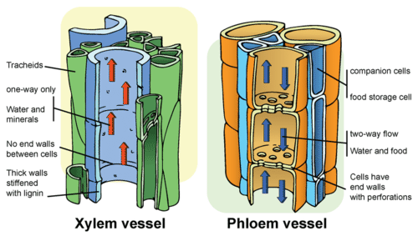

Epidermis: it’s the outer layer of cells that cover all young plant organs, and it’s in direct contact with the environment, so it is subject to modification by the environment.

**most epidermal cells secrete a fatty substance called cutin.
Cutin: is a fatty substance secreted from the epidermal cells within and on the surface of the outer walls, it works as a protective layer called cuticle.
**the thickness of the cuticle determine how much water is lost through the cell walls by
evaporation.
The function of /or importance of cuticle layer:
1- Protection layer.
2- Prevent the plant from losing too much water during evaporation.
3- Cuticle layer is resistant to bacteria and other disease organisms

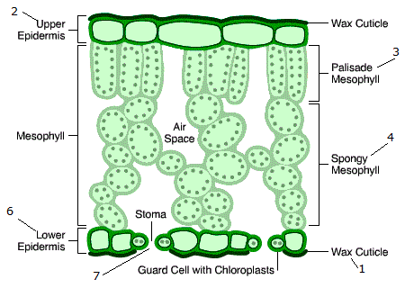
( leaf cross section)

