**University of Al-Mustansiriyah**

**College of Science/ Department of Biology**

**Course : Botany**

**Lecture:** 4

**External plant parts**

**Plant organs:** it represents the external plant structures like leaves, stems, roots, flowers, fruits and seeds. Each organ is an organized group of tissues that work together to perform a specific function.

**plant organs divide into two groups:

1-sexual reproductive

2-vegetative

**sexual reproductive: it produces seed, they include flower buds, flowers, fruit and seeds.

**vegetative parts: it include roots, stems, shoots, nodes, buds and leaves, they are not directly involved in sexual reproduction. And they are often used in **asexual** forms of reproduction.

**kinds of asexual reproduction forms in plants:

1-cutting 2-budding 3-grafting

**The Root Structure**

Young roots reveals four regions of develops, three of them are not sharply defined and it extent varies considerably depending on the species involved.

**The function of roots:**

1-anchor the plant into the soil.

2- Prevent soil degradation.

3- Absorb water and minerals from soil.

4- storage, the roots serve as storage organs for water and carbohydrates.

5- specialized roots have other functions such as photosynthesis, aerating, etc.

**\*\*\*Root regions:**

1-Root cap

2-the region of cell division

3-the region of elongation

4-the region of maturation

**Root cap:** it composed of a thimble-shaped mass of parenchyma cells covering the tip of each root. (Root cap is absent in stems).

**Functions**

1. Protect the root from damage.
2. The dictyosomes of the root cap’s outer cells secrete and release a slimy substance that facilitates the root tip’s movement through the soil.
3. This mucilaginous lubricant also provides a medium favorable to the growth of beneficial bacteria that add to the nitrogen supplies available to the plant.

***the apical meristem in both root and stem is subdivided into three meristematic areas:

**1-Protoderm:** give rise to an outer layer of cells( epiderm).

**2-ground meristem:** it’s to the inside of protoderm, it produces parenchyma cells of the cortex.

**3-procambium**: it appears as a solid cylinder in the center of the root, produces primary xylem and primary phloem.

**The pith:** it’s a parenchyma tissue produced by the ground meristem, found in stems but its absent in most dicot roots ( monocot and grass root plants have pith).

**region of cell division:** it composed of an apical meristem in the center of the root tip which produce the surrounding root cap (most of cell divisions take place next to the root cap at the edges.

**\*\*the region of elongation:** its merges with the apical meristem, usually extends about 1 centimeter or less from the tip of the root, the cells here become longer and wider.



**\*\*\*the region of maturation**: (its also region of differentiation or root hair zone) here most of the cells mature and differentiate into distinctive cell types of the primary tissues in this region.

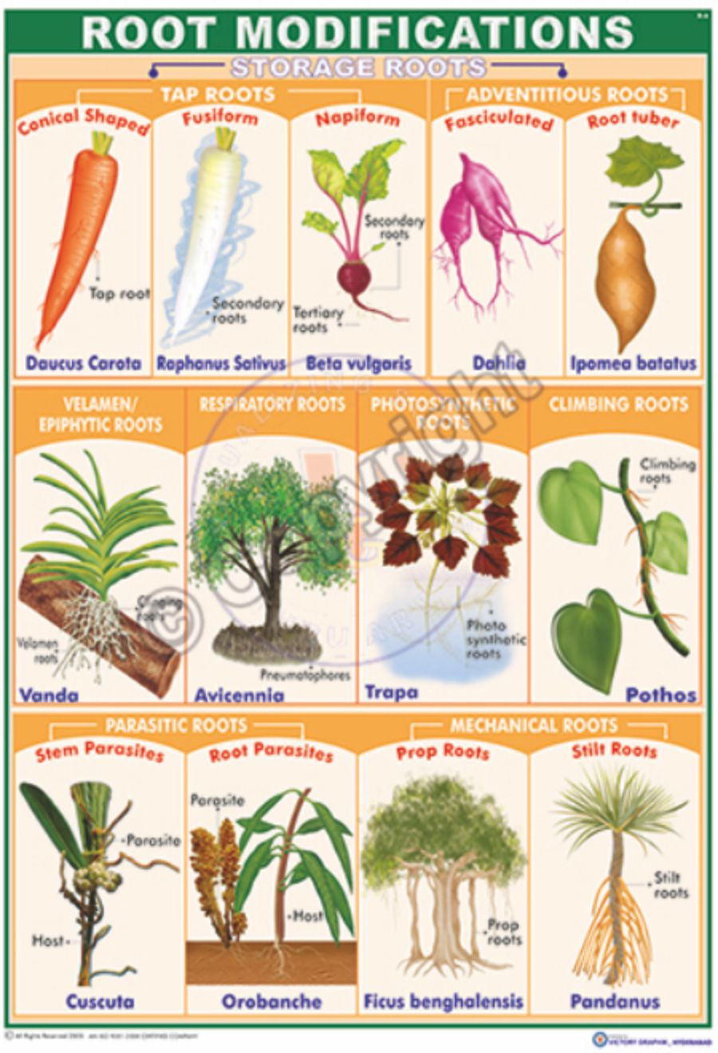

**SPECIALIZED ROOTS**

Some plants, however, have roots with modifications that adapt them for performing specific functions as well as the absorption of water and minerals in solution.

1. **Food-Storage Roots**

* **Function:** store large quantities of starch and other carbohydrates.
* **Example:** sweet potatoes and yams.

1. **Water-Storage Roots**

* **Function:** water-storage roots , the water in the roots is apparently used by the plants when the supply in the soil is inadequate
* **Example:** Pumpkin Family (Cucurbitaceae), calabazilla plant.

1. **Propagative Roots**

* **Function:** produce **adventitious buds** along the roots that grow near the surface of the ground. which develop into aerial stems called *suckers,* and rootlets. The rooted suckers can be separated from the original root and grown individually.
* **Example:** roots of rice-paper plants and tree-of heaven.

1. **Pneumatophores**

* **Function:** extend above the water’s surface and enhance gas exchange between the atmosphere and the subsurface roots to which they are connected
* **Example:** swamp plants , black mangrove.

1. **Aerial Roots (***Velamen roots)*

* **Function:** aided in the absorption of rain water. Some tropical plants, including the screw pines and various mangroves, produce sizable prop roots extending for several feet above the surface of the ground or water.
* **Example:** the tropical figs or banyan trees produce roots that grow down from the branches until they contact the soil. Once they are established, they continue secondary growth and look just like additional trunks (Fig. 5.12).



**Figure 5.12** A banyan (*Ficus*) tree with many large prop roots that have developed from the branches.

1. **Contractile Roots**

* **Function:** pull the plant deeper into the soil
* **Example:** herbaceous dicots and monocots, lily bulbs.

1. **Buttress Roots**

* **Function:** produce huge, buttresslike roots toward the base of the trunk, giving them great stability.
* **Example:** tropical fig tree.



Buttress roots of a tropical fig tree.

1. **Parasitic Roots**

* **Function:** They parasitize their host plants via peglike.
* **Example:** dodders, broomrapes, and pinedrops.

**MYCORRHIZAE**

It is fungi associated (mutualistic) with the roots of plant, which, both the fungus and the root benefit from it.

* **Function:** The fungus is able to absorb and concentrate phosphorus much better than it can be absorbed by the root hairs.
* **Example:** Orchid seeds will not germinate until mycorrhizal fungi invade their cells.



**Figure 5.16** Mycorrhizae. *A.* A longitudinal drawing of a root with ectomycorrhizae (visible on the right outside of the root).

**ROOT NODULES**

* **Function:** The nodules contain large numbers of nitrogen-fixing which produce enzymes with which they can convert nitrogen into nitrates and other nitrogenous substances readily absorbed by roots.
* **Example:** *Rhizobium* bacteria in root of peas, beans.



**Figure 5.17** Root nodules on the roots of bur clover (*Medicago polymorpha*). The somewhat popcornlike nodules contain bacteria that convert nitrogen from the air into forms that can be used by the plant.