**University of Al-Mustansiriyah**

**College of Science/ Department of Biology.**

**Course : Botany**

**Lecture: 5**

**The stems**

All stems have *nodes, internodes,* and *axillary buds*; these features distinguish them from roots and leaves

**Function**

1. support the leaves.
2. conduct water and minerals to the leaves to use it in photosynthesis.
3. transport the products of photosynthesis from leaves to other parts of plant.

In a [vascular plant](https://en.wikipedia.org/wiki/Vascular_plant), the **stele** is the central part of the [root](https://en.wikipedia.org/wiki/Root) or [stem](https://en.wikipedia.org/wiki/Plant_stem) containing the tissues derived from the procambium. These include [vascular tissue](https://en.wikipedia.org/wiki/Vascular_tissue), the types of stele are:

* ***protostele****,* consists of a solid core of conducting tissues in which the phloem usually surrounds the xylem.
* ***Siphonosteles,***which are tubular with pith in the center.
* ***eusteles***in which the primary xylem and primary phloem are in discrete *vascular bundles.*
* Flowering plants develop from seeds that have either one or two “seed leaves,” called **cotyledons** attached to their embryonic stems . The seeds of pines and other cone-bearing trees have several (usually eight) cotyledons. The cotyledons usually store food needed by the young seedling until its first true leaves can produce food themselves.

Flowering plants that develop from seeds having two cotyledons are called **dicotyledons** (usually abbreviated to **dicots**), while those developing from seeds with a single cotyledon are called **monocotyledons** (abbreviated to **monocots**). Dicots and monocots differ from one another in several other respects, a summary of these and other differences in these two classes of flowering plants is given in Table below.

**Some Differences Between Dicots and Monocots**

|  |  |
| --- | --- |
| **DICOTS** | **MONOCOTS** |
| Seed with two cotyledons (seed leaves | Seed with one cotyledon (seed leaf) |
| . Flower parts mostly in fours or fives or multiples of four or five | . Flower parts in threes or multiples of three |
| Leaf with a distinct network of primary veins | . Leaf with more or less parallel primary veins |
| Vascular cambium, and frequently cork cambium, present | Vascular cambium and cork cambium absent |
| Vascular bundles of stem in a ring | Vascular bundles of stem scattered |
| Pollen grains mostly with three apertures (thin areas in the aperture wall—see Figures 23.6 and 23.7) | Pollen grains mostly with one aperture |

**Monocotyledonous Stems**

Most monocots (e.g., grasses, lilies) are herbaceous plants that do not attain great size. The stems have neither a vascular cambium nor a cork cambium and thus produce no secondary vascular tissues or cork. As in herbaceous dicots, the surfaces of the stems are covered by an epidermis, but the xylem and phloem tissues produced by the procambium appear in cross section as discrete vascular bundles scattered throughout the stem instead of being arranged in a ring (Fig. 6.12). Each bundle, regardless of its specific location, is oriented so that its xylem is closer to the center of the stem and its phloem is closer to the surface. In a typical monocot such as corn, a bundle’s xylem usually contains two large vessels with several small vessels between them .



**Typical dicot stem shows following characters**:

* presence of well- defined epidermis with cuticle.
* cortex has collenchyma tissue as a layer under the epidermis or as discontinuous patches.
* vascular bundles are open model and arranged in a ring surrounding pith.
* the center of pith is formed from of parenchyma tissue.

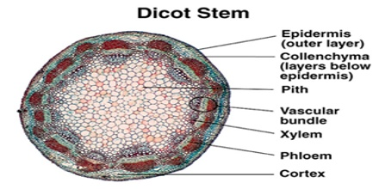

**SPECIALIZED STEMS**

1. **Rhizomes**

horizontal stems that grow below ground, often near the surface of the soil.

* **Function:** food-storage organ.
* **Example:** irises

1. **Runners and Stolons:**

Theyare stems grow above ground; they also have long internodes.

* **Function:** Adventitious buds appear at nodes along the runner or stolon which produce new plants, it can be separated and grown independently.
* **Example:** strawberries.

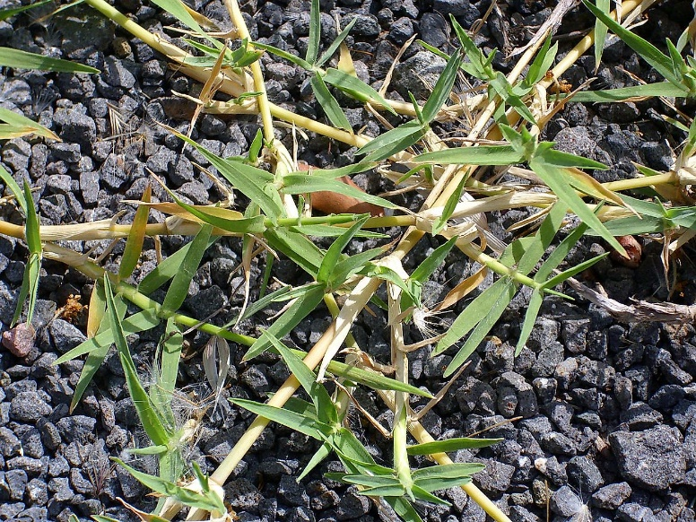

1. **Tubers**

* **Function:** accumulate of food.
* **Example:** Irish or white potato.

1. **Bulbs**

* **Function:** stores food.
* **Example:** onions, lilies, hyacinths, and tulips.

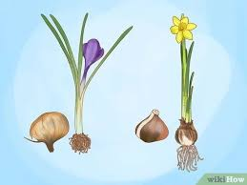

1. **Corms**

* **Function:** store food.
* **Example:** crocus and the gladiolus.

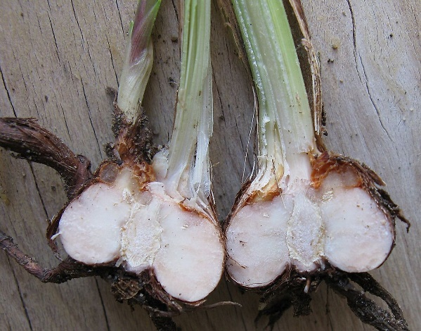

1. **Cladophylls**

**Function:** resemble leaves in function and appearance.

**Example:** greenbriers, certain orchids, prickly pear cacti.

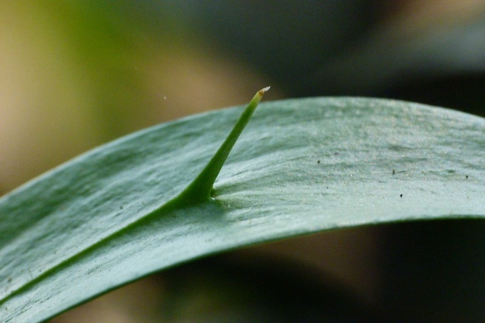

1. ***Thorns****:* are sharp, hard or woody pointed structure.

* **Function:** protect themselves from hungry animals.
* **Example:** Bougainvillea, Duranta, and climbing rose.

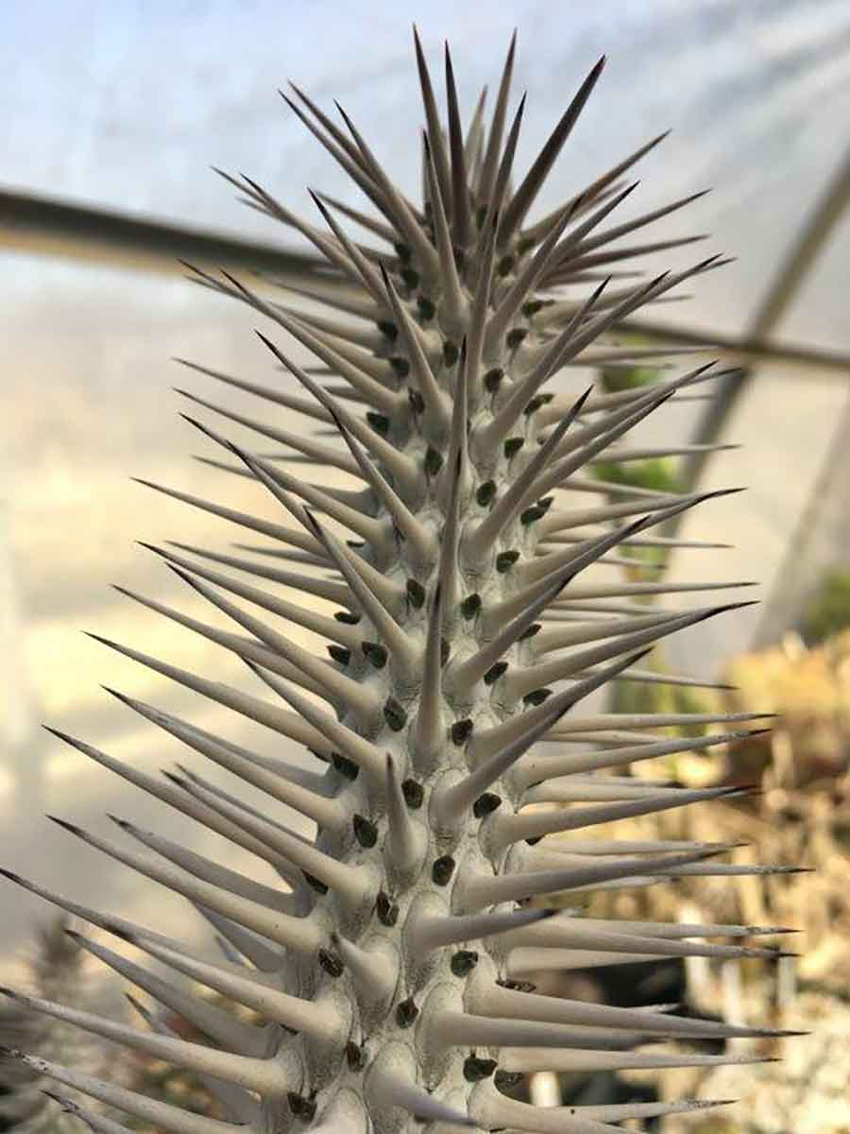

stem of Alluaudia ascendens, in the Desert Garden, showing multiple sharp thorns

1. ***Prickles*** *:* originate from the epidermis.

* **Function:** protect themselves from hungry animals.
* **Example:** raspberries and roses.

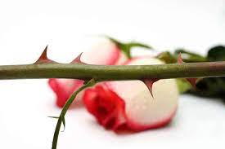

1. **bulbils:**aerial bulblets in the leaf axils along the stem.

* **Function:** used topropagate the plant**.**
* **Example:** Tiger lilies produce.

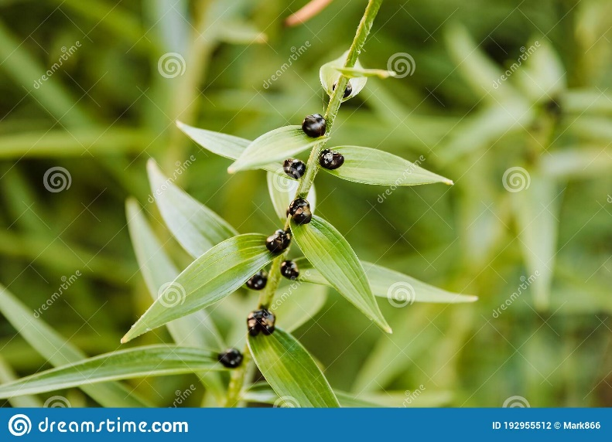

1. ***Ramblers****,* simply rest on the tops of other plants,

* **Function:**  climb by hooking their thorns, leaves or branches onto other objects.
* **Example:** Rambler roses.