**University of Al-Mustansiriyah/**

**College of Science/ Department of Biology**

**Course : Botany**

**Lecture: 7**

**The flower**

The flower: is the part of a plant which is often brightly colored, grows at the end of a stem, it represent the reproductive organ in plant, and it survive only for a short time.

**Flower parts:**

1. **peduncle**: this is the stalk of the flower.
2. **receptacle**: the part of the flower to which stalk is attached to, its small and found at the center of the base of the flower.
3. **sepals:** small, leaf-like parts growing at the base of the petals, they form outer layer that protect the flower, generally they green colored, and collectively they called **calyx.**
4. **petals:** it lies above the sepals, often bright colored, their main function is to attract pollinators such as insects, the petals are collectively known as the **corolla.**
5. **stamens**: these are male parts of a flower. Many stamens collectively called **Androcium**, they are structurally divided into two parts: **1/filament 2/ anthers.**
6. **pistil:** this form the female parts of a flower. A collection of pistils is called the **Gynoecium**. Pistil consists of four parts: 1-stigma 2-style 3-ovary 4-ovules.



**The fruit**

A **fruit** is any ovary and its accessory parts that has developed and matured. It also usually contains seeds.

**Parts of fruit:** fruit has three regions these regions collectively are called the **pericarp.**

1/ epicarp: the outer layer

2/ mesocarp: middle layer, fleshy, edible portion of fruit.

3/endocarp: inner layer, rough portion where the seeds is accommodated.



**Classification of Fruits**

1. On basis of the [number](https://www.toppr.com/guides/maths/knowing-our-numbers/operations-on-numbers/) of ovaries
2. **1-simple:** one fruit has developed from the ovary of a single flower (ex: fleshy like tomato, dry like coconut).
3. **Aggregate Fruits:** it is derived from a single flower with several to many pistils. The individual pistils develop into tiny drupes or other fruitlets, Ex. raspberries, blackberries, and strawberries.
4. **Multiple Fruits:** formed from a cluster of flowers, the inflorescence, Ex. mulberries, Osage oranges, pineapples, and figs.

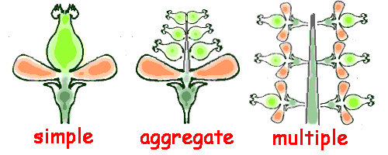

1. base on basis pericarp structure
2. ***Fleshy Fruits***

Fruits whose mesocarp is at least partly fleshy at maturity are classified as fleshy fruits.

1. A **drupe** is a simple fleshy fruit with a single seed enclosed by a hard, stony endocarp, or pit (e.g., apricots, cherries, peaches, plums, olives, and almonds).
2. **Berries** develop from a compound ovary and commonly contain more than one seed. The entire pericarp is fleshy it include:

* **A *true berry***has thin skin and a pericarp and soft at maturity. Ex: tomatoes, grapes, persimmons, peppers, and eggplants.
* ***Pepos***are berries has thick rinds. Ex: pumpkins, cucumbers are pepos.
* The ***hesperidium***: has leathery skin containing oils. Ex. oranges, lemons.

1. **Pomes** are simple fleshy fruits with a cartilaginous endocarp derived from an inferior ovary, with the bulk of the fleshy tissue from the outer, as in Malus (apple) and Pyrus (pear).

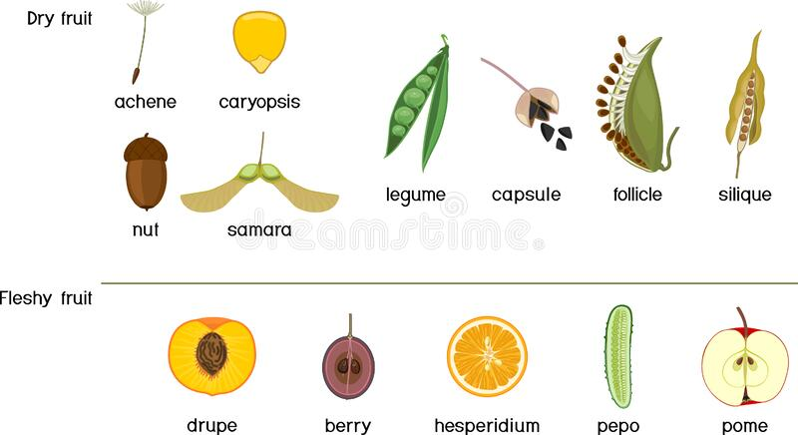

1. ***Dry Fruits***

Fruits whose mesocarp is definitely dry at maturity are classified as *dry fruits.*

1. **Dry Fruits That Split at Maturity (Dehiscent Fruits)** :
2. The **legume** splits along two sides or seams (Legume Family).
3. **Siliques** split along two sides or seams, but the seeds are borne on a central partition, which is exposed when the two halves of the fruit separate ex: Mustard Family (broccoli, cabbage, radish)..
4. **Capsules:** split along the partitions between the carpels, or by: cavities in the carpels, a cap or pores. Ex. include orchids, lilies.

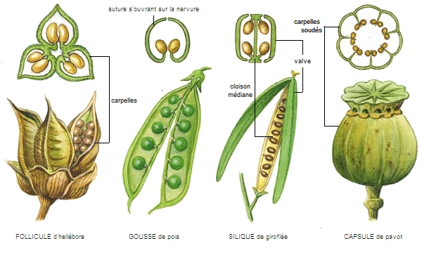

1. **Dry Fruits That Do Not Split at Maturity (Indehiscent Fruits)**
2. **achene** : sunflower “seeds” buttercup, and buckwheat.
3. **Nuts** acorns, hazelnuts (filberts), and hickory nuts.
4. **grain** (**caryopsis;** plural: **caryopses**) corn, wheat, rice, oats, and barley, produce grains.
5. **Samaras:** maples, samaras are produced in pairs, ashes, elms, and the tree of heaven,.
6. a **schizocarp :** carrots, anise, caraway, and dill.