Lec(2) Immunotechnology MSc Biotechnology
Prof. Dr. Ekhlass Noori Ali
Immunoglobulins & Immunoglobulin Genes
Immunoglobulin proteins are the critical ingredients at every stage of a humoral acquired immune response. When expressed on the surfaces of resting B lymphocytes, they serve as receptors that can detect and distinguish among the vast array of potential antigens present in the environment. On binding their cognate antigens, surface immunoglobulins can initiate a cascade of molecular signaling events that may culminate in B-cell activation, clonal proliferation, and the generation of plasma cells. The immunoglobulins that are secreted as a result then function as antibodies, traveling through the tissue fluids to seek out and bind to the specific antigens that triggered their production.
The two hallmarks of immunoglobulins as antigen-binding proteins are the specificity of each for a particular epitope target and their diversity as a group. In addition to antigen binding, however, immunoglobulins also possess secondary biologic activities that are critical for host defense. These include, for example, the ability to function as opsonins, to activate the complement cascade, or to cross the placental barrier. Immunoglobulin proteins are heterogeneous with respect to these latter activities, which are determined by structural features independent of those that dictate antigen specificity. In this chapter, we first consider how the structures of immunoglobulins account for their specificity, diversity, and secondary biologic activities. We then examine the remarkable genetic mechanisms that give rise to these proteins.
IMMUNOGLOBULIN PROTEINS
Organization & Diversity of Immunoglobulin Proteins
The immunoglobulins are an enormous family of related, but nonidentical glycoproteins. It has been estimated that each person is capable of producing at least 10⁸ different antibody molecules, each with its own distinct properties. Though carbohydrate may account for up to one fifth of an antibody's mass, almost all of its significant biologic attributes are determined by its polypeptide components. Antibodies are bifunctional molecules in that they bind specifically to antigens and also initiate a variety of secondary phenomenaâ€”such as complement activation, opsonization, or signal transductionâ€”that are unrelated to their antigen-binding specificity. As we shall see, these two independent aspects of immunoglobulin function reside in separate regions of each protein.
The sheer diversity of immunoglobulins was for a long time a major barrier to understanding their structures. A serum specimen from any normal person contains a tremendous number of different antibody molecules, each of which is present in only minute amounts and (owing to its unique structure) has its own distinctive set of physical properties, such as molecular weight and isoelectric point. When a serum specimen is fractionated by electrophoresis, for example, most immunoglobulins are found to migrate as a broad band (called the gamma-globulin fraction) that reflects the presence of innumerable different proteins, each with slightly different electrophoretic properties. This extreme diversity made it virtually impossible to isolate sufficient amounts of any single antibody protein from a normal donor to permit a thorough biochemical analysis.
A series of key discoveries beginning in the 1950s finally opened up the field of immunoglobulin protein chemistry. The first was the finding that enzymes and reducing agents could be used to digest or dissociate immunoglobulins into smaller components. This revealed that diversity was largely confined to specific regions of the immunoglobulin molecules; other regions were much more uniform and could be isolated in pure form that made them accessible for structural analysis. A second breakthrough came with the realization that patients who had certain types of B-lymphoid cancers (eg, multiple myeloma) contained in their blood and urine large amounts of a single, homogeneous type of immunoglobulin protein secreted by a single malignant B-cell clone. Purification of such myeloma proteins made it possible to study individual antibodies and permitted (by 1969) the determination of the first complete amino acid sequence of an immunoglobulin. The development,
in 1975, of laboratory methods for immortalizing individual clones of antibody-secreting cells gave birth to monoclonal antibody technology (see later section) and made it possible to obtain homogeneous antibodies of virtually any specificity in unlimited quantities. At about the same time, the isolation and analysis of immunoglobulin genes revolutionized the study of this protein family by making it relatively easy to isolate, modify, and even design immunoglobulin proteins of all types. Information gleaned from all these approaches forms the basis for our current, detailed understanding of immunoglobulin protein structure.
The Four-Chain Basic Unit
Every immunoglobulin molecule is made up of two different types of polypeptides. The larger, heavy (H) chains are roughly twice as large as the smaller, light (L) chains. Every immunoglobulin contains equal numbers of heavy- and light-chain polypeptides and can be represented by the general formula (H₂L₂)n. The chains are held together by noncovalent forces and also by covalent interchain disulfide bridges to form a bilaterally symmetrical structure as depicted in Figure 7-1. All normal immunoglobulins conform to this basic structure, although some, as we shall see, are composed of more than one of these four-chain units.

The heavy and light polypeptide chains are both composed of folded globular domains, each of which is 100â€“110 amino acids long and contains a single intrachain disulfide bond (see Figure 7-1). Although the amino acid sequences of the individual domains vary, they fold into very similar three-dimensional conformations (a roughly cylindrical assembly of Î² strands known as the immunoglobulin barrel), owing in part to the fairly constant location of the intrachain disulfide. Light chains always contain two of these domains, whereas heavy chains contain either four or five.
All of the light chains and all of the heavy chains in any single immunoglobulin protein are identical. When compared among different immunoglobulins, however, the sequences of these chains vary widely. In both heavy and light chains, this variability is most pronounced in the N-terminal domain, whereas the sequences of the other domains remain relatively constant. For this reason, the N-terminal domain in a
heavy- or light-chain polypeptide is called the variable region, abbreviated V_{H} or V_{L}, respectively. The other domains are collectively termed the constant region, abbreviated C_{H} or C_{L}. Light-chain polypeptides contain only a single C_{L} domain, but heavy chain C_{H} regions comprise three or more domains that are numbered sequentially (C_{H}1, C_{H}2, etc) beginning with the domain closest to V_{H}.
Within an immunoglobulin unit, the heavy and light chains are aligned in parallel as shown in Figure 7-1. Each V_{H} domain is always positioned directly beside a V_{L} domain, and this pair of domains together forms a single antigen-binding site. Each basic four-chain unit thus contains two separate but identical antigen-binding sites and so is said to be divalent with respect to antigen binding. The antigen specificity of a given protein is determined by the combined sequences of its V_{H} and V_{L} domains and for this reason varies widely among immunoglobulins. Each C_{H}1 domain interacts closely with the C_{L} domain, and in most types of immunoglobulins the two are linked covalently by one or more disulfide bridges. Each of the remaining C_{H} domains is aligned with its counterpart on the opposite heavy chain and may be linked to it by disulfide bonds. Overall, the protein has a T- or Y-shaped configuration when viewed schematically. The region at the base of each arm in the T or Y, located between the C_{H}1 and C_{H}2 domains, is called the hinge region; in most immunoglobulins, it has a loose secondary structure that makes it flexible, enabling the two arms to move relatively freely with respect to each other.
Enzymatic Digestion Products of Immunoglobulins
Immunoglobulins are rather resistant to proteolytic digestion but are most susceptible to cleavage near the hinge region (see Figure 7-1), which usually lies adjacent to the site of interchain disulfides linking the two heavy chains together. The enzyme papain happens to cleave this region on the N-terminal side of the inter-heavy-chain disulfides, and so splits an immunoglobulin into three fragments of roughly similar size. Two of these are identical to each other, consisting of an entire light chain along with the V_{H} and C_{H}1 domains of one heavy chain; these fragments thus contain the antigen-binding sites of the protein, and so are called Fab fragments (ie, antigen-binding fragments).

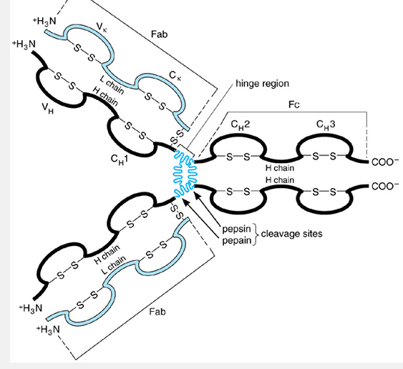

Figure 7-1. Schematic model of an IgG1 (Îº) human antibody molecule showing the basic four-chain structure and domains (V_{H}, C_{H}1, etc). Sites of enzymatic cleavage by pepsin and papain are shown.

Each Fab fragment is monovalent with respect to antigen-binding activity. The third fragment comprises the carboxy-terminal portions of both heavy chains held together by disulfides. The structure of this third fragment is identical for many different immunoglobulin molecules, so that fragments of this type can often be crystallized even if they are derived from a heterogeneous antibody population. Hence, this third fragment is designated the crystallizable, or Fc, fragment. Most of the secondary biologic properties of immunoglobulins (eg, the ability to activate complement) are determined by sequences in the Fc region of the protein. This is also the region that is recognized by the Fc receptors found on many types of cells.
A somewhat different pattern of cleavage occurs with the enzyme pepsin, which cleaves on the carboxy-terminal side of the inter-heavy-chain disulfides. This yields a single large fragment called an F(ab)â€²2 fragment, which roughly corresponds to two disulfide-linked Fab fragments and has divalent antigen-binding activity. The Fc region, on the other hand, is extensively degraded by pepsin, and usually does not survive as an intact fragment.
Characterization of these proteolytic fragments in the 1960s was an important step toward understanding antibody structure because it provided the first evidence that the antigen-binding and secondary functions of antibodies reside in separate regions of the protein. Such fragments are still used today when it is necessary to dissociate different aspects of antibody function for diagnostic or research purposes.
Classification of Immunoglobulins & Their Constituent Chains
Immunoglobulins are composed of heavy and light chains. The N-terminal domain (V region) in both types of chains is highly variable and mediates antigen binding. The remaining portion (C region) of each chain, by comparison, is far less variable. Nevertheless, every normal person produces several alternative forms of heavy and light chains that each have distinctly different C-region amino acid sequences (Table 7-1). These alternative forms of the immunoglobulin chains can be distinguished from one another by their physical properties (eg, molecular weight) or serologically by using antibodies (usually obtained from animals that have been immunized with human Fc fragments) that recognize specific features in the various human C regions. Although these normal variations in sequence of the C_{L} region have no effect on immunoglobulin function, those in the C_{H} region significantly affect the secondary biologic properties of immunoglobulins.
Light-Chain Types and Subtypes
All light chains have protein molecular weights of approximately 23,000 but can be classified into two distinct types, called kappa (Îº) and lambda (Î»), on the basis of their C_{L}-region sequences. No known functional differences exist between these two types, and each can associate with any of the various classes of heavy chains. Nevertheless, expression of two distinct light-chain types is common among mammals. Indeed, the amino acid sequence similarities between human and mouse kappa chains are much greater than those between the kappa and lambda chains within each speciesâ€”indicating that the primordial kappa and lambda genes separated from one another during evolution prior to the divergence of these mammalian species.
The C regions of all Îº light chains produced by an individual are essentially identical. In contrast, a single person may express as many as six slightly different

forms of the Î» C region. These various subtypes of Î» differ from one another only slightly in C-region amino acid sequences and are functionally identical, though each is encoded by a separate chromosomal locus.
A given immunoglobulin molecule always contains exclusively Îº or one of the Î» chains, never a mixture. Similarly, any given B-lineage cell produces only one type of light chain. When the entire population of serum immunoglobulins (or of B-lineage cells) in an individual is considered, the proportion of kappa to lambda chains produced varies from species to species; in humans, the ratio is about 2:1.

Heavy-Chain Classes and Subclasses
Humans express five different classes (or isotypes) of immunoglobulin heavy chains, which differ considerably in their C_{H}-region sequences and in their physical and biologic properties. All of the heavy chains in any given immunoglobulin are identical. The five classes of heavy chains are designated Âµ, Î´, Î³, Î±, and Îµ, and immunoglobulins that contain these heavy chains are designated the IgM, IgD, IgG, IgA, and IgE classes, respectively. The Î³ and Î± classes are further divided into subclasses (Î³1, Î³2, Î³3, Î³4, Î±1, and Î±2) based on relatively minor differences in C_{H} sequence and function; the corresponding immunoglobulin subclasses are denoted IgG1, IgG2, and so on. Heavy chains representing the various subclasses within a class are much more similar to one another than to the other classes. Normal individuals express all nine classes and subclasses, because each is encoded by a separate genetic locus and is inherited independently.
The heavy-chain polypeptides range in molecular weight from about 50,000 to 70,000. The Âµ and Îµ chains are made up of five globular domains apiece (one V_{H} and four C_{H}), whereas Î³, Î±, and Î´ chains each contain only four (one V_{H} and three C_{H}). The Î´ chain has an intermediate molecular weight attributable to an enlarged hinge region. The Î³3 chain also has a large hinge that consists of about 60 amino acid residues; of these, 14 are cysteines, which accounts for the large number of inter-heavy-chain disulfide bonds in IgG3 (see the section on IgG). In some mammalian species, the charge characteristics of the various IgG subclasses differ sufficiently to permit their separation by electrophoretic techniques, but this is not true of humans.

Composition of Immunoglobulin Classes and Subclasses
The class of the H chain determines the class of the immunoglobulin. Thus, there are five classes of immunoglobulins: IgG, IgA, IgM, IgD, and IgE. A given molecule in any of these classes may contain either Îº or Î» light chains. For example, two Î³ chains (of any of the four subclasses), combined with either two Îº or two Î» L chains, constitute an IgG moleculeâ€”the most abundant class of immunoglobulins in sera from adults. Similarly, two Âµ chains together with two L chains form an IgM monomer unit of the type found on the surfaces of many B cells. The secreted form of IgM, however, is a pentameric macroglobulin, which consists of five of these basic four-chain units along with an additional polypeptide called J chain (Figure 7-2). Each IgM pentamer contains ten identical antigen-binding sites and so has polyvalent binding activity. IgA accounts for only about 10â€“15% of serum immunoglobulin but is the predominant class of antibody found in body secretions. The membrane-bound or circulating form of IgA is a single four-chain unit, but the secreted form can polymerize to form assemblages comprising two to five of these basic units along with J chain and (in secreted IgA) yet another polypeptide called secretory component (see Figure 7-2). The properties of the individual chains are summarized in Table 7-1, and those of the immunoglobulin classes are compared in Table 7-2.
One noteworthy structural difference among the immunoglobulin classes or subclasses lies in the number and arrangement of interchain disulfide
bridges within each four-chain unit (Figure 7-3). In IgA2, for example, the L chains are covalently linked to each other rather than to the H chains, so that Lâ€“H binding is entirely due to noncovalent forces. In other subclasses, the Lâ€“H bond may be situated either close to the junction of the V_{H} and C_{H}1 domains (as in IgG2 or IgA1) or, alternatively, near the junction between C_{H}1 and C_{H}2 (as in IgG1).

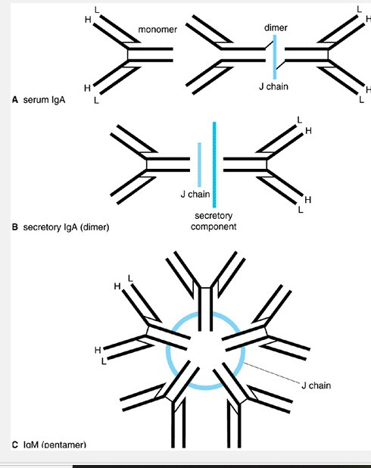

Figure 7-2. Highly schematic illustration of polymeric human immunoglobulins. Polypeptide chains are represented by thick lines; disulfide bonds linking different polypeptide chains are represented by thin lines.

Membrane and Secreted Immunoglobulins
Immunoglobulins of all classes can exist in either membrane-bound or secreted forms. The membrane forms always exist as individual four-chain units and have on their heavy chains an additional carboxyterminal sequence of approximately 40 amino acid residues. This sequence consists of a highly acidic region of 12â€“14 residues, followed by a strikingly hydrophobic sequence of about 26 residues. The hydrophobic portion is the transmembrane component, which anchors the heavy chain (and, hence, the entire four-chain unit) into the cell membrane. It is similar in hydrophobicity and length to known transmembrane segments of other proteins and probably forms a single membrane-spanning Î± helix. The acidic portion of the membrane segment shows little amino acid sequence conservation among heavy-chain classes, but the hydrophobic sequences tend to be quite similar. This reflects the requirement that membrane-bound heavy chains of all classes must associate with the same pair of integral membrane proteins, called Ig-Î± and Ig-Î², in order to transduce signals into the cell (see Chapter 8). The direct anchoring of immunoglobulins into surface membranes occurs

only in B-lineage cells and should not be confused with the indirect association that results when soluble antibodies bind to Fc receptors found on many cell types.

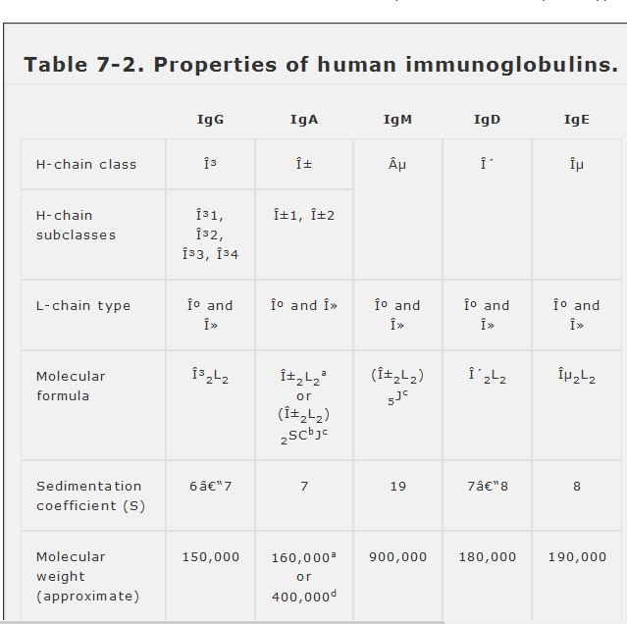

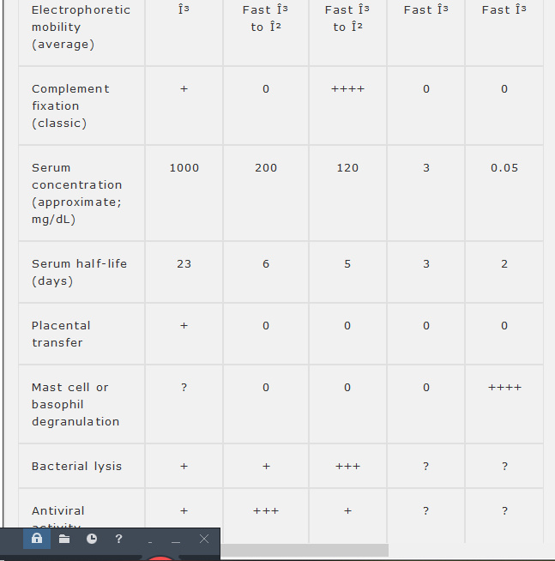

ªFor monomeric serum IgA.
^{b}Secretory component.
^{c}J chain.
^{d}For secretory IgA

Table 7-1. Properties of human immunoglobulin chains and related polypeptides.
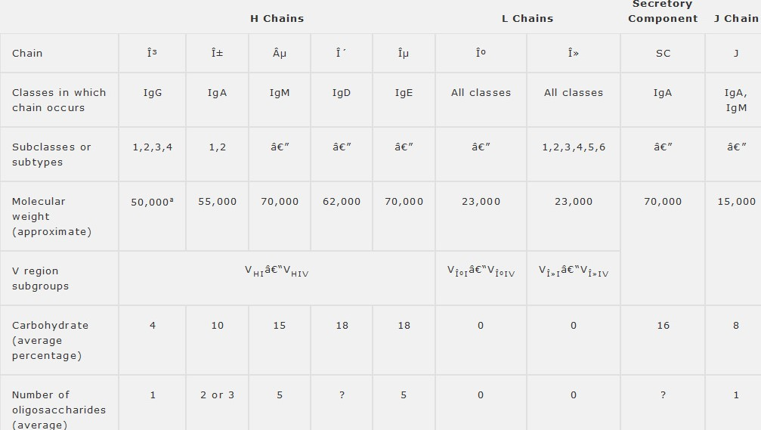

Secreted immunoglobulins lack the terminal transmembrane segment as a result of alternative RNA splicing (see later discussion). In its place, the secreted forms of Âµ and Î± (but not of the other classes) contain a short terminal sequence, called the tail segment, that mediates polymerization of four-chain units and also serves as contact site for the J chain.

Allotypic (Allelic) Forms of Heavy and Light Chains
The heavy-chain classes and subclasses and the light-chain types and subtypes are each encoded by separate genetic loci, so that all are normally present in a single haploid genome. Some of these individual loci, however, exist in more than one form within the population; the alternative forms (alleles) generally differ from one another by only one or, at most, a few amino acid substitutions. Such minor alternative forms at a given immunoglobulin locus are called allotypes. In humans, allotypes have been found for Î³, Î±, and Îµ H chains and for Îº L chains. Thus far, allotypic forms of Î» L chains or of Âµ and Î´ H chains have not been observed.
Allotypic variation has no effect on immunoglobulin function and is primarily of interest because the variant C-region sequences can be immunogenic in some circumstances. For example, mothers may become immunized during the course of pregnancy against paternal allotypic determinants expressed on fetal immunoglobulins. Alternatively, immunization may result from blood transfusions. In addition, patients with rheumatoid arthritis can develop rheumatoid factorsâ€”antibodies that are directed against normal IgGâ€”which occasionally recognize allotypic determinants.

J Chain and Secretory Component
As noted earlier, the secreted forms of IgM and IgA generally exist as polymers of the basic four-chain unit that include a single additional polypeptide called the J chain. The J chain is a small (MW 15,000) acidic protein that is structurally unrelated to heavy and light chains but is synthesized by all plasma cells that secrete polymeric immunoglobulins. In these polymeric assemblies, the J chain is disulfide-bonded to the penultimate cysteine residue in the tail segment of the Î± or Âµ chains. Its function seems to be to facilitate proper polymerization.
Secretory component is a single glycopeptide with a peptide molecular weight of approximately 70,000 and a high carbohydrate content. It is associated only with IgA and is found almost exclusively in body secretions. Its amino acid sequence is invariant and shows no resemblance to the J chain or to any of the immunoglobulin polypeptides. Secretory component can exist either in free form or bound to dimeric or polymeric (but not monomeric) IgA molecules; the latter interaction is usually noncovalent, but disulfide bonds have been implicated in a small proportion of human IgA. Free secretory component can even be observed in secretions from individuals who lack measurable IgA in their serum or secretions.
Secretory component is not synthesized by lymphocytes
but rather by mucosal epithelial cells that overlie Peyer's patches and other submucosal lymphoid tissues . Such epithelial cells take up IgA that is secreted from the lymphoid cells beneath them, link it with secretory component, and transport the resulting complex across the epithelial barrier into secretions. Linkage with secretory component is presumed to facilitate the transepithelial passage of IgA.

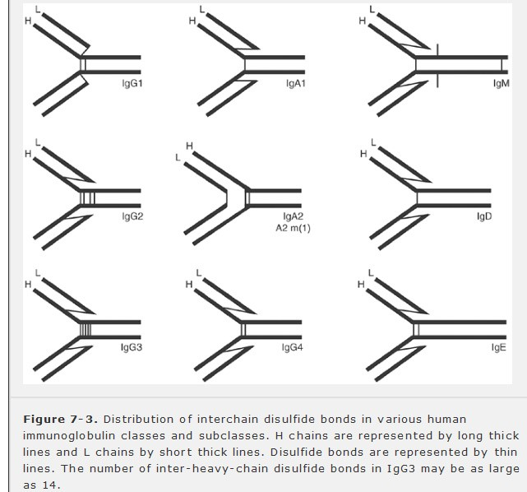

Biologic Activities of Immunoglobulins
As previously noted, immunoglobulins are bifunctional molecules that bind antigens and, in addition, initiate other biologic processes that are independent of antibody specificity. These two kinds of activities are each localized to a particular part of the protein: antigen binding to the combined V_{H} and V_{L} domains, and the other activities to the C_{H} domains (particularly those of the Fc segment). The latter activities, some of which are summarized in Table 7-2, are considered in this section.

Immunoglobulin G
Immunoglobulin G (IgG) accounts for approximately 75% of the total serum immunoglobulin in normal adults and is the most abundant antibody produced during secondary humoral immune responses in the blood. Within the IgG class, the relative concentrations of the four subclasses are approximately as follows: IgG1, 60â€“70%; IgG2, 14â€“20%; IgG3, 4â€“8%; and IgG4,
2â€“6% (Table 7-3). These values vary somewhat among individuals; it appears that the propensity to produce IgG antibodies of one subclass or another is at least partly an inherited trait
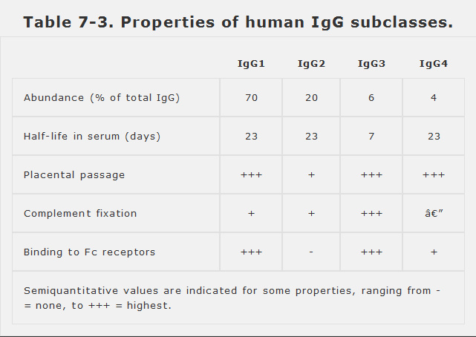

IgG is the only class of immunoglobulin that can cross the placenta in humans, and it is responsible for protection of the newborn during the first months of life.The subclasses are not equivalent in this respect, IgG2 being transferred less efficiently than the others, but the biologic significance of this inequality, if any, is unknown.
Antigen-bound IgG is also capable of fixing (ie, binding and activating) serum complement, and once again the subclasses do so with unequal efficiency (IgG3 > IgG1 > IgG2). IgG4 is completely unable to fix complement by the classical pathway, which requires binding of a protein called C1q, but it may be active in the alternative pathway (see Chapter 12). The C1q binding site on the other IgG proteins appears to reside in the C_{H}2 domain.
Macrophages and certain other cell types express surface receptors that bind the Fc regions of IgG molecules. These interact principally with C_{H}2 domains and bind IgG1 and IgG3 with much higher affinity than the other subclasses. The properties of these receptors are considered in a later section.
Immunoglobulin A
Immunoglobulin A (IgA) is the predominant immunoglobulin produced by B cells in Peyer's patches, tonsils, and other submucosal lymphoid tissues. Thus, although it accounts for only 10â€“15% of serum immunoglobulin, it is by far the most abundant antibody class found in saliva, tears, intestinal mucus, bronchial secretions, milk, prostatic fluid, and other secretions. On B-cell surfaces or in the blood, IgA exists as a monomer (MW 160,000) comprising only one four-chain unit. In secretions, it multimerizes to form disulfide-linked polymers of up to five such units that are associated with one molecule each of J chain and (in secretions) secretory component. The predominant secreted forms of IgA are dimers and trimers (see Figure 7-2). The two subclasses, IgA1 and IgA2, are expressed at a 5:1 ratio in the blood and have similar properties. High-affinity Fc receptors specific for IgA have been identified.
Immunoglobulin M
Immunoglobulin M (IgM) constitutes approximately 10% of normal serum immunoglobulins and is normally secreted as a J-chain-containing pentamer with a molecular mass of approximately 900 kilodaltons. IgM antibody predominates in early primary immune responses to most antigens, although it tends to become less abundant subsequently. IgM (often accompanied by IgD) is the most common immunoglobulin expressed on the surfaces of B cells, particularly naive B lymphocytes. IgM is also the most efficient complement-fixing immunoglobulin: A single molecule of antigen-bound IgM suffices to initiate the complement cascade. Fc receptors specific for IgM have been characterized.
Immunoglobulin D
The immunoglobulin D (IgD) molecule is a monomeric four-chain unit with a molecular mass of approximately 180 kilodaltons. Although IgD is commonly found on the surfaces of B lymphocytes that also bear surface IgM, it is rarely secreted in significant amounts, and only traces of it are normally found in the blood. In cells that coexpress IgD and IgM, both classes of heavy chains are produced by alternative splicing of a single RNA (see later discussion) and have identical antigen specificity. The IgD on these cells can bind antigen and transmit signals to the cell interior, with consequences that appear identical to those produced by IgM. When such B cells become activated, surface IgD expression ceases.
The physiologic function of IgD is unknown. It is relatively labile to degradation by heat or proteolytic enzymes. There are isolated reports of IgD with antibody activity toward insulin, penicillin, milk proteins, diphtheria toxoid, nuclear components, or thyroid antigens. Its presence on many mature naive lymphocytes has suggested an as-yet-unproven role in B-cell differentiation or tolerance.
Immunoglobulin E
Although it normally represents only a minute fraction (0.004%) of all serum antibodies, immunoglobulin E (IgE) is extremely important from the clinical standpoint because of its central involvement in allergic disorders. Two specialized types of inflammatory cells involved in allergic responsesâ€”the mast cell and the basophilâ€”carry a unique, high-affinity Fc receptor that is specific for IgE antibodies. Thus, despite the very low concentration of IgE (roughly 10⁻⁷ M) in blood and tissue fluids, the surfaces of these cells are constantly decorated with IgE antibodies, adsorbed from the blood, that serve as antigen receptors. When its passively bound IgE molecules contact an antigen, the mast cell or basophil releases inflammatory mediator substances that produce many of the acute manifestations of allergic disease (see Chapters 13 and 27). Elevated levels of serum IgE may also signify infection by helminths or certain other types of multicellular parasites (Chapter 48). Like IgG and IgD, IgE exists only in monomeric form. Fc receptors appear to recognize primarily the C_{H}3 domain of the Îµ chain.

Immunoglobulin Variable Regions
The V regions, which coincide with the N-terminal domains of light and heavy chains, mediate antigen binding and are by far the most heterogeneous portions of these proteins. Indeed, no two human myeloma proteins from different patients have ever been found to have identical V-region sequences. Some clear patterns can be discerned, however. V_{H} regions show significantly more resemblance to one another than to V_{L} regions, whereas V_{Îº} and V_{Î»} sequences each have characteristic features that distinguish them from each other and from V_{H}. Thus, V_{H}, V_{Îº}, and V_{Î»} sequences can be recognized as separate groups that each associate with their own characteristic constant regions. There is never any mixing: a given V_{H} sequence, for example, may be found on heavy chains of any class (Âµ, Î´, Î³, Î±, or Îµ), but is never found on a light chain.

Framework and Hypervariable Regions
Variable regions within any single group are not uniformly variable across their entire 110-amino-acid spans. Instead, they consist of relatively invariant stretches (called framework regions) of 15â€“30 amino acids, separated by shorter regions of extreme variability (called hypervariable regions) that are each 9â€“12 amino acids long. V_{H} and V_{L} regions each contain three hypervariable regions, whose approximate locations are depicted in Figure 7-4. Antigen binding is mediated by noncovalent interactions that primarily involve amino acids in the hypervariable regions of each chain; hence, the sequences of these regions are the primary determinants of antigen specificity. Hypervariable regions are also called complementarity-determining regions (CDRs), and within each chain are designated CDR1, CDR2, and CDR3, beginning with the one nearest the amino terminus. CDR3 is usually the longest and most variable of the three, as specialized genetic mechanisms act to increase sequence diversity in this region .
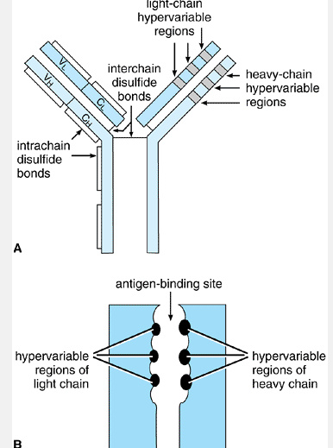
Figure 7-4. A: Schematic depiction of an IgG molecule showing the approximate locations of the hypervariable regions (also called complementarity-determining regions [CDRs]) in the heavy and light chains. Each CDR is roughly 9â€“12 residues long and is centered on residues 30â€“33, 56, or 94â€“98 of the polypeptide chain. B: Schematic depiction of how the three CDRs in each heavy- and light-chain pair form an antigen-binding site.

V-Region Subgroups
When sequences of many variable regions from any one type of chain (V_{H}, V_{Îº}, or V_{Î»}) are compared, they are found to form subgroups that are more similar to one another than to the remaining V regions in the group. For example, human V_{Îº} regions have been classified into four subgroups, and similar subgroups exist for the V_{H} and V_{Î»} regions. The subgroups differ from one another principally in the length and position of amino acid insertions and deletions within their framework regions.

Idiotypes
The term idiotype refers to the unique V-region amino acid sequences of the homogeneous immunoglobulin molecules produced by a single B-cell clone. Thus, there are as many idiotypes as there are B-cell clones (perhaps about 10⁸ in an adult).
The concept of idiotype (which means â€œself-typeâ€) was first derived from experiments in which inbred animals were inoculated with purified antibody proteins that had been raised against a particular antigen in genetically identical animals. The inoculated animals mounted an antibody response against the injected immunoglobulin, implying that some sequences within it were recognized as foreign, but these antibodies would not react with other immunoglobulins from the same strain of animal. The antiserum produced in such a response was called an antiidiotype antiserum. It was soon observed that the reaction between an antihapten antibody and its corresponding antiidiotypic antiserum could, in some cases, be inhibited by the hapten, indicating that the idiotypic determinants were close to or within the antigen-binding site. It is now known that antiidiotype antibodies specifically recognize sequences in the hypervariable regions of the target antibody, which are unique to that antibody and determine its antigen specificity. Thus, in current usage, the term idiotype refers to the global characteristics of the antigen-binding site in a given immunoglobulin, which are determined by the hypervariable sequences of its particular V_{H} and V_{L} domains.

The Three-Dimensional Structure of Immunoglobulins
The complete three-dimensional structures of many immunoglobulin molecules have been deduced from x-ray crystallographic studies. Such studies provided conclusive evidence that all of the individual globular domains in heavy and light chains share a common folded structure, despite the considerable differences in their amino acid sequences. Each domain is folded into a rigid, roughly cylindrical scaffold made up of seven to nine strands of antiparallel Î² sheets that are aligned like the staves of a barrel (Figure 7-5). In V_{H} and V_{L} domains, the three hypervariable sequences each occupy a position between individual Î² strands and form relatively flexible
loops that project outward from one â€œrimâ€ of the barrel to participate in antigen binding. A single antigen-binding site is formed by the apposition of six hypervariable loops: three from V_{H} and three from V_{L}.

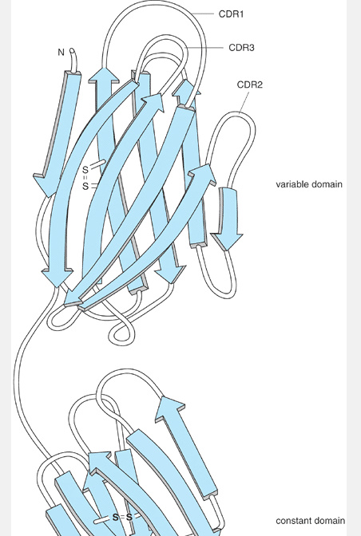

Figure 7-5. Three-dimensional structure of a light chain. In this ribbon diagram tracing the polypeptide backbone, Î² strands are shown as wide ribbons, other regions as narrow strings. Each of the two globular domains consists of a barrel-shaped assembly of seven to nine antiparallel Î² strands. The three hypervariable regions (CDR1, CDR2, and CDR3) are flexible loops that project outward from the amino-terminal end of the V_{L} domain.

Complete crystallographic structures have also been obtained for antibodies or Fab fragments complexed with their target antigens or with haptens. These structures confirm the expectation that antigen binding is mainly carried out by residues in the hypervariable regions (especially CDR3) but demonstrate that nearby residues in the framework regions can also participate in binding. In general, haptens tend to bind by nestling into small (10â€“15 Ã…) crevices in the antigen-binding site, whereas macromolecular antigens interact over larger regions on the surface of the site. For example, 16 separate residues in lysozyme were found to interact with nearly 20 residues spread over a 20 Ã— 30 Ã… surface formed by the six CDR loops of one antilysozyme Fab fragment.
Structural studies also reveal the strong tendency of immunoglobulin domains to adhere to one another laterally through noncovalent (especially hydrophobic) interactions (Figure 7-6). Thus, pairs of heavy and light chains are held together side by side not only by disulfide bonds but also by extensive noncovalent interactions between the C_{H}1 and C_{L} domains. Similarly, the heavy chains within each four-chain unit adhere to one another in part through strong hydrophobic contacts between C_{H}3 domains. These interdomain interactions are mediated by hydrophobic residues that occupy one lateral face of the barrel and that tend to be relatively conserved among all immunoglobulin domains.

The Immunoglobulin Supergene Family
The repetitive domain structure of immunoglobulin polypeptides reflects the manner in which their genes evolved. It is thought that the common ancestor of all immunoglobulin proteins was a small primordial gene that encoded a single copy of the barrel-like polypeptide domain. In light of the tendency of modern immunoglobulin domains to adhere to one another noncovalently, it could be speculated that the protein product of this gene originally served to mediate some useful proteinâ€“protein interaction inâ€”or, perhaps, cell-cell interactions amongâ€”the ancestral cells that expressed it. Over evolutionary time, this single progenitor gene appears to have been reduplicated many times at the DNA level, so that additional copies were produced at both nearby and distant chromosomal locations. The sequences of individual copies then diverged as a result of random mutations and natural selection. Every modern immunoglobulin light chain can thus be viewed as a tandemly duplicated descendant of the primordial domain, whereas heavy chains each represent four or five tandem variants of this domain.
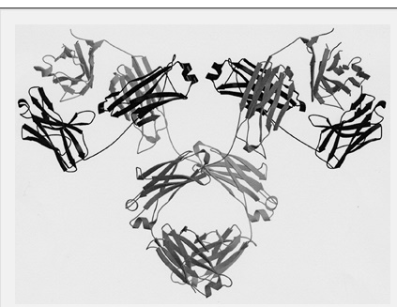
Figure 7-6. Three-dimensional structure of an immunoglobulin molecule. (Redrawn by L. Brinen, with permission, from Silverton EW et al: Three-dimensional structure of an intact human immunoglobulin. Proc Natl Acad Sci U S A 1977;74:5140.)

The descendants of this hypothetical primordial domain can be found not only in immunoglobulins but also in many other types of proteins (Table 7-4). Although their sequences have diverged greatly, the single or multiple immunoglobulin-like domains in each of these proteins can be recognized by their size and three-dimensional shape, by the characteristic position of the intrachain disulfide bond, and by a
few other conserved features. In recognition of their common ancestry, these proteins (or their corresponding genes) are known collectively as the immunoglobulin gene superfamily. Most, but not all, are integral membrane proteins. In any given member of this family, the immunoglobulin-like domains may be found in association with other unrelated types of domains that confer specialized activities, such as transmembrane signaling. Superfamily members are found at widely scattered chromosomal locations, are expressed in diverse cell types, and subserve many different functions, but in each case the immunoglobulin-like sequences appear to retain their ancestral function of interacting with other immunoglobulin-like domains in the same or other proteins.

Table 7-4. The immunoglobulin gene superfamily.
Immunoglobulin heavy and light chains
T-cell receptor Î±, Î², Î³, and Î´ chains
CD3 complex Î³, Î´, and Îµ chains
MHC proteins: class I Î± and Î²₂-microglobulin, and class II Î± and Î²
T-cell differentiation antigens CD2, CD4, CD7, and CD8
B-cell signal transducers Ig-Î± and Ig-Î²
Costimulatory surface proteins (B7.1 and B7.2) and their receptor (CD28)
Fc receptor Î± chains: FcÎ±RI, FcÎµRI, FcÎµRII (CD23), FcÎ³RI (CD64), FcÎ³RII (CD32), and FcÎ³RIII (CD16)
Killer inhibitory receptors (KIRs) on natural killer cells
Complement receptors: CR1 (CD35) and CR2 (CD21)
Adhesion proteins: VCAM-1 (CD106), ICAM-1 (CD54), ICAM-2 (CD102), LFA-3 (CD58), and NCAM
Other CD proteins: eg, CD1, CD5, CD19, CD22, CD31, CD33, CD48, and CD56
Cytokine receptors for IL-1, IL-6 family, M-CSF, G-CSF, stem cell factor (SCF), and platelet-derived growth factor (PDGF)
Poly-Ig receptor
Thy-1
Carcinoembryonic antigen
Myelin protein Po
Abbreviations: VCAM-1 = vascular cell adhesion molecule type 1; ICAM-1 and -2 = intercellular adhesion molecule types 1 and 2; LFA-3 = leukocyte functional antigen type 3; NCAM = neural cell adhesion molecule; M-CSF = monocyte colony-stimulating factor; IL = interleukin.

ANTIBODY TECHNOLOGIES
The diversity and specificity of antibodies make them potentially invaluable reagents for diagnostics and research. Early serologists discovered, for example, that antiserum from an animal immunized against a particular microbe could be used to detect that microbe in blood or tissue specimens to diagnose infections. Even today, antisera raised in this way against snake venom proteins are widely used to treat snake bites, and antisera against human T cells have been used to suppress rejection of transplanted tissues. But this approach has serious limitations: Even when a well-defined immunogen is used, the antiserum obtained is a complex mixture of structurally diverse antibodies recognizing multiple epitopes on the immunogen, and its composition fluctuates unpredictably over the life of the animal. Moreover, the supply of antiserum from any single animal is limited, and there is no way of ensuring that antiserum obtained from a different animal would have identical properties.
To harness the full potential of antibodies, it was necessary to devise a way of obtaining abundant, pure preparations of homogeneous immunoglobulin directed against any desired antigen. This was first accomplished in 1975 by Kohler and Milstein, who discovered that fusing a normal B cell with an immortal, malignant plasma cell could give rise to a hybrid cell line that proliferated indefinitely while secreting the immunoglobulin encoded by the parental B cell. An immortal, antibody-producing clone of hybrids obtained in this way is called a hybridoma, and the antibody it produces is termed a monoclonal antibody. The production of hybridomas (Figure 7-7) is now routine and typically uses one of several mouse plasma cell lines developed for this purpose that do not express immunoglobulins of their own, so that any hybrids they form secrete only antibodies derived from the B-cell parent. First, a mouse is immunized with the target antigen in order to maximize the number of cognate B cells, and a single-cell suspension of its splenic cells is then combined with plasma cells in the presence of an agent that induces cell fusion. The mixture is next treated with a combination of antibiotics that selectively kill the parental plasma cells but not B cells or hybrids. Because any unfused B cells have a short life span in culture, the only proliferating cells that remain after a few weeks are hybrids, whose nuclei contain a mixture of chromosomes from both parents in varying proportions. These can then be grown as individual clones and screened to identify those that secrete antibody with the desired properties, which can then be produced in large quantities by propagating the hybridoma in culture or in animals.
Monoclonal antibodies have revolutionized the study of immunology and cell biology and have found numerous applications in diagnosis. They are also being explored as tools for clinical imaging and therapy, especially in cancer. For example, certain radioactively labeled monoclonal antibodies that recognize tumor surface antigens can, if injected into the bloodstream, home to the tumor and reveal its location by radioactive emission. Similarly, monoclonal antibodies coupled to toxins such as ricin or diphtheria toxin (forming a so-called immunotoxin) have shown some promise as antitumor chemotherapeutic agents capable of targeting toxin activity specifically to tumor cells. Unfortunately, the use of mouse monoclonal antibodies in humans is often limited by their immunogenicity, and it can be technically difficult to obtain the immunized human B cells needed to produce useful human hybridomas. One possible solution is to isolate the heavy- and light-chain genes encoding a murine antibody of interest, use recombinant DNA techniques to alter their C-region sequences to encode proteins that more closely resemble a human antibody, and then reintroduce this humanized antibody gene into a plasma cell for expression. Even more elegant approaches have been developed using new techniques for manipulating the genes of living mice. For example, strains of mice have been created whose own immunoglobulin genes are inactivated but which instead carry genes encoding a large assortment of human H and L chains. When immunized, these mice can produce authentic human antibodies directed against the antigen and can be used to make hybridomas secreting antigen-specific human monoclonal antibodies.
Antibody diversity can also be exploited for less obvious purposes. For example, certain V regions have been found to have enzymatic activity, in that they can catalyze specific organic chemical reactions. As is true of other enzymes, such catalytic antibodies generally have affinity for a transition state intermediate along the reaction pathway, and deliberate immunization with a transition-state analog offers one approach to obtaining monoclonal antibodies that promote a particular reaction. But catalytic antibodies also occur spontaneously; among the anti-DNA
antibodies produced by patients with autoimmune disorders, for example, one can identify rare antibodies that catalyze cleavage of the DNA strand! The study of catalytic antibodies is in its infancy, but the range of reactions they can catalyze is already surprisingly broad, and it appears likely they will find many industrial and research applications.

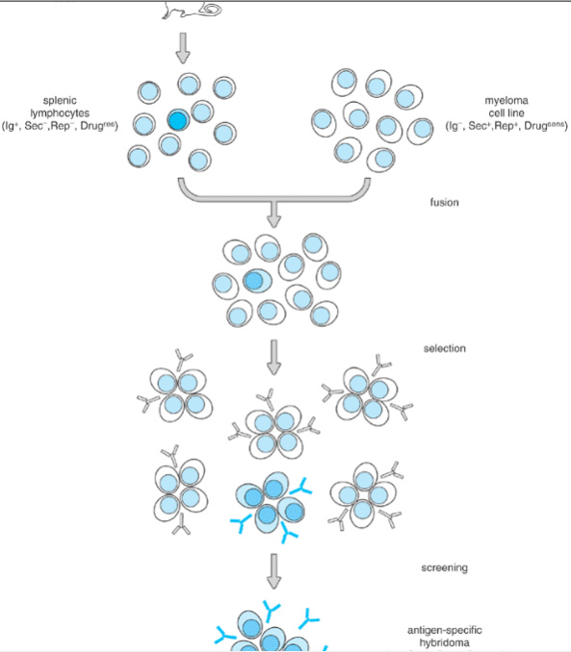

Figure 7-7. Preparation of an antigen-specific mouse hybridoma. A mouse is immunized with the antigen of interest, and its splenocytes are isolated as a source of B cells, a few of which (dark blue) express surface immunoglobulin (Ig) specific for the antigen. The B cells express Ig but do not secrete it and cannot replicate in cell culture (ie, they are Ig⁺, Sec⁻, Rep⁻). The splenocytes are fused with a myeloma cell line that replicates actively in culture and has an intact secretory apparatus but does not express endogenous Ig (ie, it is Ig⁻, Sec⁺, Rep⁺). The myeloma cells also carry a mutation (Drug^{sens}) that makes them vulnerable to killing by a drug or other conditions to which the normal B cells are resistant (Drug^{res}). The B cells and myeloma cells are fused in vitro to produce hybrid cells carrying chromosomes from both parental cells together in a single nucleus. The mixed population that results from this fusion also includes a few unfused parental cells of each type. The population is exposed to the drug for 2 weeks or more, which kills any unfused myeloma cells (Drug^{sens}). Unfused B cells (Rep⁻) also die during this time, so that the only proliferating cells that remain are hybrids with features of both parents (Rep⁺, Drug^{res}). These are then grown as individual clones and screened to identify those that secrete antibody with the desired specificity. The antigen-specific hybridomas identified in this way can be grown indefinitely in culture or as ascites tumors and produce a limitless supply of the desired monoclonal antibody.

Fc RECEPTORS
Many cell types are able to bind circulating antibodies or antigenâ€“antibody complexes using surface Fc receptors. The physiologic function of these receptors varies among cell types. Receptors have been identified for each of the heavy-chain classes, but the best studied are those for Î³ and Îµ. Three types of FcÎ³ receptors and two types of FcÎµ receptors can be distinguished based on their binding affinities, which differ from one another by one or two orders of magnitude (Table 7-5). Moreover, humans express up to three structurally different forms of a given FcÎ³ receptor, each encoded by a separate gene on chromosome 1, and each with a characteristic tissue distribution and biologic activity. Some of these receptors consist only of a single ligand-binding (Î±) polypeptide, but others are complexes containing an Î± subunit along with the CD3-Î³ or -Î¶ chains (or both). These are the same CD3-Î³ and -Î¶ polypeptides that form part of the antigen-receptor complex in T cells (see Chapters 3 and 9), and they serve an identical function in transducing signals from the Fc receptors into the cell interior. FcÎµRI also includes CD3-Î³, as well as a unique signal-transducing Î² chain.
Only the high-affinity receptors of each type (FcÎ³RI and FcÎµRI) are able to bind monomeric immunoglobulins to a significant degree at the concentrations normally found in the blood. Cells that express these high-affinity Fc receptors can therefore adsorb circulating antibodies onto their surfaces, where they may function as antigen receptors. For example, binding of unliganded IgG molecules onto FcÎ³RI receptors on macrophages or natural killer cells serves to â€œarmâ€ these cells to carry out antibody-dependent cell-mediated cytotoxicity (ADCC) (Chapter 4). On the other hand, antigen binding to FcÎµRI-associated IgE on the surface of a basophil or mast cell can stimulate these cells to degranulate, producing symptoms of allergy

Cells that carry only the low-affinity Fc receptors (FcÎ³RII, FcÎ³RIII, and FcÎµRII) cannot adsorb appreciable amounts of free antibody but instead bind their cognate immunoglobulin only in antigenâ€“antibody complexes, where its effective concentration is increased. Binding of such multivalent complexes also serves to cross-link the Fc receptors and transmit signals into the cell. Interactions of this type are responsible for facilitating phagocytosis through the phenomenon of opsonization (Chapter 2) and are also important for triggering chemotaxis and degranulation in neutrophils and other phagocytes. In addi-tion, low-affinity Fc receptors on B-lymphoid cells enable these cells to sense the presence of antigenâ€“antibody complexes, providing an important feedback-signaling pathway that limits further antibody production in the late stages of an immune response.
