Lec(6) Immunotechnology
Prof.Dr. Ekhlass N. Ali
T Lymphocytes & Natural Killer Cells

The acquired immune response relies heavily on the ability of thymus-derived (T) lymphocytes to recognize and discriminate among a wide range of different foreign antigens. As is the case with B lymphocytes, the enormous diversity of the T-cell repertoire stems from the ability of developing T cells to rearrange and modify the genes that encode their antigen receptors. An appreciation of the structure and function of the T-cell antigen receptor (TCR) is essential for understanding T-cell development and the complexities of the responses of mature T cells to antigen.
T-CELL ANTIGEN RECEPTOR

T lymphocytes do not â‌ soluble antigens, but rather recognize antigen bound to specialized molecules on the surfaces of other cells. Although some T cells recognize glycolipids and other nonprotein antigens, most T cells respond to protein antigens and recognize these antigens in the form of peptide fragments associated with class I or class II molecules of the major histocompatibility (MHC) locus. Mature T cells express one of two types of TCR: a heterodimer composed either ofα and β chains or of γand ðchains. Because T cells expressing خ±خ² receptors account for T-cell helper function and cytotoxic activity, the major focus of this chapter will be on this type of TCR. خ³d T cells, whose physiologic role is still unclear, will be reviewed later on.
The خ±خ² TCR dimer recognizes peptides bound to MHC molecules. The amino-terminal regions of the خ± and خ² chains are polymorphic, so that within the entire T-cell population a large number of different TCR خ±خ² dimers occur, each capable of recognizing a particular combination of antigenic peptide and MHC. The TCRs on individual T cells generally contain only a single type of خ±خ² dimer and, therefore, individual T cells respond only to a specific combination of antigen and MHC.
The خ±خ² dimer is associated with a complex of proteins designated CD3 (Figure 1). The CD3 chains are not polymorphic and range in size from 16 to 28 kd. They are involved in signal transduction and thus allow the TCR to convert the recognition of antigenâ€“MHC into intracellular signals for activation. Compared with TCR خ± and خ², whose intracellular regions are only several amino acids in length, the CD3 chains have large cytoplasmic domains, ranging from 45 to 55 amino acids for CD3 خµ, خ´, and خ³ to 113 amino acids for CD3.
TCR خ± & خ² GENES & THE GENERATION OF TCR DIVERSITY

To generate the diversity of TCRs required to recognize a wide spectrum of antigenic determinants, the TCR خ± and خ² genes use a strategy of recombination similar to that of the immunoglobulin genes (see Chapter 7). The germline TCR خ²-gene locus contains 20â€“30 V (variable), 2 D (diversity), and 13 J (joining) gene segments (Figure 9-2). When the TCR خ² gene rearranges early in T-cell ontogeny, one of the V_{خ²} segments is linked to one of the D_{خ²} regions and to one of the J_{خ²} segments to form a complete exon. After transcription, RNA processing combines the V/D/J exon with a C_{خ²} (constant) region to form a TCR خ²-messenger RNA that encodes a functional protein. The potential diversity generated by this combinatorial joining is equal to the product of the number of possible V segments أ— the number of D segments أ— the number of J segments. Similarly, in the TCR خ± locus, there are approximately 100 V segments and 50 J segments (but no D segments). To form a functional TCR خ±-chain gene, a V_{خ±} segment joins to a J_{خ±} segment. As in immunoglobulin genes, diversity is further enhanced by imprecise joining and by the insertion of nongermline-encoded nucleotides (N regions) between segments during the rearrangement process. These mechanisms each enhance the diversity of sequences at the junctions between V_{خ±} and J_{خ±} and between the V_{خ²}, D_{خ²}, and J_{خ²} segments (junctional diversity). N-region insertion is carried out by the enzyme terminal deoxynucleotidyltransferase (TdT), which is
expressed in the nuclei of immature T cells at the stage when V/(D)/J recombination occurs. Unlike immunoglobulin genes, TCR genes do not undergo somatic hyper mutation.
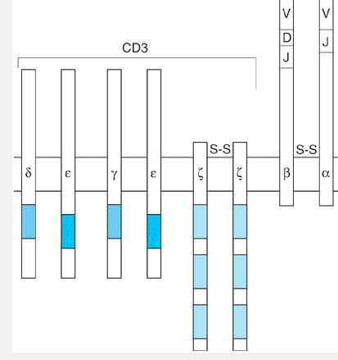
Fig1: The T-cell antigen receptor (TCR). The TCR is a complex of eight transmembrane proteins. The خ± and خ² chains form a disulfide-linked (Sâ€”S) dimer that is responsible for the recognition of antigenic peptides bound to class I and class II major histocompatability class (MHC) molecules. The amino-terminal regions of the خ± and خ² chains, which are formed through rearrangements of V, D, and J segments, are highly polymorphic. The خ±خ² dimer is noncovalently associated with the CD3 complex, which converts the recognition of antigen into transmembrane signals. The CD3 polypeptides are not polymorphic and have larger cytoplasmic domains than TCR خ± and خ². The CD3 complex consists of three sets of dimers. There are two CD3خµ chains, one paired with CD3خ³ and the other with CD3خ´. The خ¶ chain exists either as a disulfide-linked خ¶/خ¶ homodimer (as shown here) or as a heterodimer with either خ· (an alternatively spliced form of خ¶) or the خ³ chain. The functional importance of this variation in the خ¶ dimer is not understood. The cytoplasmic domains of CD3 chains contain one or more immune receptor tyrosine-based activation motifs (ITAMs), depicted here as shaded boxes.
TCR STRUCTURE & RECOGNITION OF ANTIGEN
خ±خ² TCRs recognize antigen in the form of peptides bound in the groove on the â€œtopâ€‌ of class I or class II MHC molecules. The TCR خ±خ² dimer resembles an immunoglobulin Fab fragment in its overall structure, with the hypervariable regions (or complementarity-determining regions, CDRs) forming loops that extend from the end of a barrel-like variable-region domain. X-ray crystallographic studies of خ±خ² TCR proteins bound to peptide-class I MHC complexes reveal that the TCR interacts directly with both the peptide and the MHC protein. The TCR binds so that the loops with greatest sequence diversity (ie, the CDR3 loop of each antigen-binding site) lie directly over the center of the peptide. The TCR interacts with the MHC molecule along the exposed surfaces of the two خ± helices that form the sides of the peptide-binding groove. Most contacts with the MHC molecule are formed with amino acids that are conserved in each MHC allele. Interactions with polymorphic MHC residues, however, are also critical and form the structural basis for the long-standing observation that the T-cell system is heavily biased toward recognizing peptides bound to selfâ€“MHC molecules. This â€œMHC restrictionâ€‌ results from a process of positive selection in the thymus that selectively favors the growth and survival of developing T cells whose TCRs have the potential to recognize peptides presented by self-MHC, as will be described later on.

INTERACTION OF THE TCR WITH SUPERANTIGENS

Super antigens are a class of bacterial toxins and retroviral proteins that have the ability to bind both MHC class II molecules and the TCR خ² chain. In so doing, they act as a â€œclampâ€‌ between the TCR and class II molecule, providing signals to the T cells. It is important to grasp the differences between classical antigenic peptides and superantigens. Superantigens are not processed and interact with the MHC molecule outside of the peptide-binding groove. On the T-cell side, super antigens bind to V_{خ²} segments only, without regard to the D_{خ²} and J_{خ²} regions or to any part of the TCR خ± chain (Figure 9-3). Superantigens differ in the V_{خ²} sequences they can bind, with any given super antigen binding only those encoded by one or a few V_{خ²} gene segments. Activation of T cells by individual super antigens, therefore, is selective for T cells whose TCRs express particular V_{خ²} segments.
Because superantigens only recognize the V_{خ²} segment and not the other components of the TCR خ±خ² dimer, a superantigen has the capability of activating 1â€“10% of peripheral T cells (this is orders of magnitude more than a conventional antigen). Exposure to a superantigen, therefore, can lead to massive T-cell activation, and the ensuing release of large amounts of lymphokines accounts for many of the manifestations of acute exposure to bacterial toxins that have superantigen capabilities. This likely explains the clinical features of toxic shock syndrome, which can be induced by Staphylococcus aureus toxin TSST-1, a superantigen that activates human T cells expressing V_{خ²2}. In the acute phase of toxic shock syndrome there is a marked, and selective, expansion of T cells
that bear V_{خ²2}: in one case, 70% of peripheral T cells were V_{خ²2}⁺ in the acute phase of the disease. Under other conditions, however, the activation induced by a superantigen leads to apoptosis of the activated cells, so that eventually T cells expressing the cognate V_{خ²} segment are selectively depleted from the population.
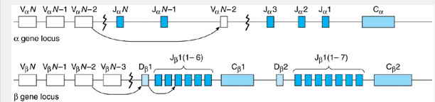
Fig2: Rearrangement of the TCR خ± and خ² genes. The TCR خ±-gene locus contains multiple V and J segments, only several of which are shown here. Similarly, the TCR خ²-gene locus contains multiple V, D, and J segments. During T-cell ontogeny, the TCR genes rearrange (arrows), so that one of the V_{خ±} segments pairs with the J_{خ±} segment and a V_{خ²} segment pairs with a D_{خ²} and J_{خ²} segment. The two C (constant) segments in the خ² gene are very similar, and differential use of C_{خ²1} and C_{خ²2} does not contribute to TCR diversity.
CD4 & CD8 CORECEPTORS
The expression of CD4 and CD8 divides mature T cells into two mutually exclusive subsets: those that recognize antigen in the context of class II MHC molecules (CD4 cells) and those that recognize antigen bound to class I molecules (CD8 cells). CD4 binds to a membrane-proximal region of MHC class II molecules that is not directly involved in peptide binding; CD8, on the other hand, binds to a corresponding region on MHC class I molecules (see Figure 6-1). It is possible, therefore, that CD4 or CD8 interacts with the same MHC molecule as the TCR during T-cell activation (Figure 9-4). There is considerable evidence to support this notion and to suggest that CD4 and CD8 are in close proximity to the TCR, functioning as co receptors.
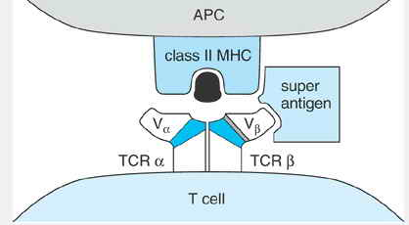
Fig3: Model of the interactions between the TCR, class II MHC molecule, and a superantigen. The superantigen interacts with the MHC molecule outside the peptide groove and binds only to the V_{خ²} segment of the TCR.
T-CELL ONTOGENY
STAGES OF THYMOCYTE DEVELOPMENT

T cells develop from bone-marrow-derived progenitor cells that undergo maturation in the thymus (Figure 9-5). Early in development, thymocytes express
P.134
several cell surface molecules, such as CD2, that are characteristic of the T-cell lineage, but they lack many others, including CD4 and CD8, and thus are known as double-negative thymocytes. Rearrangement of the TCR genes begins in the double-negative stage. Cells that are destined to become خ±خ² T cells rearrange the خ² gene first. If rearrangement at the TCR خ² locus is successful, the resulting خ²-chain polypeptide pairs with an invariant polypeptide called pTخ±. The pTخ±-TCRخ² dimer then associates with CD3 chains and is expressed on the cell surface as a pre-TCR. Expression of the pre-TCR serves to terminate further rearrangements at the TCR خ² gene locus and is required for efficient transition to the next major stage in development, when thymocytes express both CD4 and CD8 and are called double-positive cells. Rearrangement of the TCR خ± gene occurs during the double-positive stage and, if successful, leads to low-level expression of an خ±خ² TCR. As thymocytes mature into T cells, the level of TCR expression increases and the cells lose expression of either CD4 or CD8, becoming single-positive. At this stage, thymocytes have acquired the phenotype of mature peripheral T cells and soon exit the thymus.
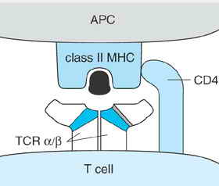
Fig4: CD4 coreceptor. CD4 binds class II MHC molecules at a membrane-proximal region not directly involved in peptide binding. In the model depicted here, the coreceptor binds the same MHC molecule that engages the TCR. CD8 plays a similar coreceptor role on T cells that recognize antigen in association with class I MHC molecules. CD8 binds a nonpolymorphic region on MHC class I molecules. Because the cytoplasmic domains of CD4 and CD8 interact with Lck, the coreceptors can bring this Src-like protein tyrosine kinase into proximity with the TCR.
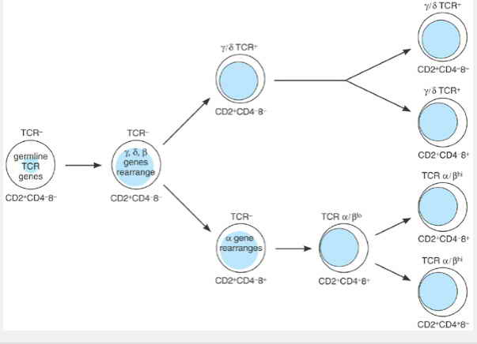
Fig5: Stages in thymocyte development. Progenitor cells migrate from the bone marrow to the thymus. At the earliest stages of development, thymocytes express several T-cell surface molecules, such as CD2, but still have germline configurations of their TCR genes. Thymocytes destined to become خ±خ² T cells pass through a critical CD4⁺CD8⁺ phase during which positive and negative selection occur.
POSITIVE & NEGATIVE SELECTION OF THYMOCYTES

The generation of TCRs is a largely stochastic process and can produce T cells with undesirable antigen specificities. For this reason, enormous selective pressures are exerted within the thymus to allow survival of only those mature T cells whose TCRs are restricted by selfâ€“MHC molecules and are not autoreactive. The great majority of thymocytes fail this process: At least 99% of developing T cells die within the thymus. Two distinct types of selection have been observed, both of which occur at the stage when thymocytes are CD4⁺CD8⁺ (double-positive) and express low levels of TCR on the cell surface. Positive selection promotes the survival of thymocytes whose TCRs have the capability of recognizing antigens bound to selfâ€“MHC molecules.
Negative selection leads to the deletion of thymocytes whose TCRs recognize peptides derived from self-proteins.
Thymocytes are programmed to die by apoptosis unless they are rescued on the basis of the ability of their TCRs to recognize antigen in association with selfâ€“MHC molecules. A remarkable feature of this positive selection is that it leads to the selection of TCRs with specificity for foreign antigens bound to selfâ€“MHC yet occurs in the absence of the foreign antigen. Positive selection takes place in the thymic cortex, where developing thymocytes encounter epithelial cells that express both class I and class II MHC molecules loaded with self-peptides (Figure 9-6). The molecular basis for positive selection remains uncertain, but clearly involves signaling through the TCR. It appears that TCR binding to self-peptideâ€“MHC complexes in the thymic cortex transmits a survival signal to the thymocyte, resulting in its positive selection. Thymocytes whose TCRs are completely unable to recognize self-peptideâ€“MHC do not receive a survival signal, fail positive selection, and die. Failure of positive selection accounts for the great majority of intrathymic death.
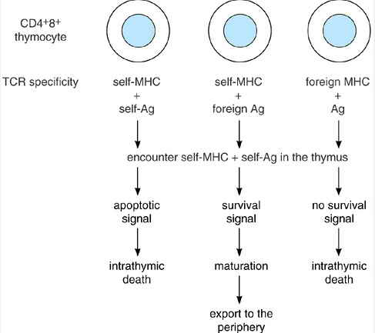

Figure 6. Positive and negative selection of thymocytes. CD4⁺CD8⁺TCR⁺ thymocytes encounter self-antigens bound to class I and class II major histocompatibility complex (MHC) molecules on epithelial cells in the thymic cortex and on macrophages and dendritic cells in the thymic medulla. In the resulting interactions, thymocytes whose T-cell receptors (TCRs) recognize self-MHC plus self-antigen will receive an apoptotic signal and undergo apoptosis in the thymus (negative selection). In contrast, thymocytes whose TCRs have specificity for self-MHC plus foreign antigens receive a survival signal that results in their positive selection. Thymocytes whose TCRs are unable to recognize antigens in association with self-MHC die of neglect (failure of positive selection). Differences in the binding affinities of TCRs for self-MHC plus self-antigen may explain these outcomes. Excessive signaling from high-affinity interactions leads to cell death, but intermediate levels of signaling from lower affinity interactions promote cell survival and rescue cells from death by neglect. The net result of thymic selections is the survival of T cells whose TCRs are restricted by self-MHC but that are not autoreactive.

Negative selection, which eliminates potentially autoreactive T cells, appears to occur primarily in the thymic medulla, where double-positive thymocytes migrate from the cortex. There, thymocytes encounter self-peptides presented in association with class I and class II MHC molecules on bone-marrow-derived dendritic cells and macrophages (see Figure 9-6). If a thymocyte recognizes these self-peptides with high affinity, it undergoes apoptosis. Thus, at this stage in T-cell development and in this context, recognition of antigen delivers signals that result in cell death rather than activation. Cells that do not receive this cell death signal mature and are exported from the thymus.
One recent hypothesis, called the avidity model of T-cell selection, proposes that, to a large extent, positive and negative selection represent qualitatively different responses to different intensities of signaling through the TCR. The overall strength of signaling in a T cell is proportional to TCR occupancy, which in
turn reflects both the number of TCRs engaged and their affinity for binding the antigenâ€“MHC complex. Below a certain level of TCR occupancy, no effective signal is transmitted. According to the avidity model, a moderate level of occupancy provides a positive signal that allows thymocyte growth and maturation, whereas excessive occupancy (above a certain, undefined threshold) causes cell death by apoptosis. Thymocytes whose receptors bind strongly to self-peptideâ€“MHC complexes in the medulla would thus be eliminated (negative selection), whereas those that give weak but perceptible binding to the same complexes in the cortex would be positively selected. We do not yet know, in biochemical terms, exactly what constitutes the critical difference between the survival signal delivered by low-avidity TCR binding and the apoptotic signal triggered by high-avidity interactions. Nevertheless, the avidity model offers a plausible schema by which TCRâ€“MHC interactions could guide both positive and negative thymic selection, and considerable evidence is accruing to support it.
For negative selection to eliminate all potentially autoreactive T cells, one might imagine that thymic medullary dendritic cells and macrophages would need to present all potential antigenic self-peptides, including those derived from proteins expressed in a highly tissue-specific fashion. To what extent this occurs is not yet clear; the array of peptides presented in the thymus is an area of ongoing investigation. It is known, however, that negative selection is not 100% effective and that some potentially autoreactive T cells do escape. Normally, these autoreactive cells are then either deleted in peripheral tissues or are rendered anergic (unresponsive to antigen). Alternatively, such cells may never encounter antigen simply because their cognate antigens are normally sequestered from the immune system. In certain pathologic states, however, one or more of these mechanisms for peripheral tolerance fails, leading to autoimmunity.
T-CELL ACTIVATION

When a T cell encounters an antigen-presenting cell (APC), the specificity of its TCR determines the outcome. Only if the TCR recognizes its particular antigenâ€“MHC combination does activation occur. The recognition of appropriately presented antigen activates T cells to proliferate, differentiate, and perform their effector functions. Activation of helper T cells leads to the production of lymphokines that promote cellular and humoral immune responses, whereas activation of cytotoxic T cells results in killing of the antigen-bearing cells. Each of these T-cell responses depends on the ability of the TCR to generate intracellular signals for activation.
SIGNAL TRANSDUCTION BY THE TCR

Key to the ability of the TCR to deliver intracellular signals is its interactions with protein tyrosine kinases (PTKs). In unstimulated T cells, Fyn, a member of the Src family of PTKs, associates with the cytoplasmic domains of CD3 chains (Figure 9-7). A second Src-like PTK, called Lck, binds to the cytoplasmic domains of CD4 and CD8 and thus can be brought into proximity with the TCR through the interactions of these coreceptors with the MHC. Stimulation of the TCR by antigen-MHC triggers the phosphorylation of tyrosine residues in the cytoplasmic domains of the CD3 chains of the receptor complex. According to a widely accepted model of TCR signaling, Lck and Fyn are responsible for these initial phosphorylation events.
The antigen-induced tyrosine phosphorylation sites lie within particular amino acid sequences, designated immune receptor tyrosine-based activation motifs (ITAMs), found in the cytoplasmic domains of CD3 molecules. ITAMs are also present in the signaling chains of the B-cell antigen receptor and of certain Fc receptors. When tyrosine-phosphorylated, the CD3 ITAMs form a recognition unit for another PTK, called ZAP-70, and thus recruit ZAP-70 to the TCR complex. ZAP-70, either alone or together with the Src-like PTKs, appears largely responsible for the phosphorylation of a number of intracellular proteins. Mutations in ZAP-70 result in immunodeficiency in humans, underscoring the importance of ZAP-70 in TCR signaling.
Key signaling molecules activated by TCR stimulation include Ras and phospholipase C (PLC)خ³-1 (see Chapter 1). The coupling of the TCR to the Ras and PLCخ³-1 pathways involves complex linker molecules such as LAT (Figure 9-8). TCR stimulation triggers the tyrosine phosphorylation of LAT, a transmembrane protein. This phosphorylation induces LAT to associate with Grb2-Sos (an initiator of Ras activation) and PLCخ³-1. The recruitment of these molecules to LAT is required for TCR-mediated activation of Ras and PLCخ³-1. Activated Ras, in turn, stimulates the MAP kinase cascade of serineâ€“threonine kinases (see Chapter 1). PLCخ³-1 hydrolyzes the membrane phospholipid called phosphatidylinositol-(4,5)-bisphosphate (PIP₂). The ensuing breakdown of PIP₂ generates two second messengers: diacylglycerol and inositol-1,4,5-tris-phosphate (IP₃). Diacylglycerol activates the protein kinase C family of serine-threonine protein kinases. IP₃ releases Ca²⁺ from internal stores into the cytoplasm, causing an increase in the concentration of cytoplasmic free calcium ([Ca²⁺]_{I}). Elevations in [Ca²⁺]_{I}, activated protein kinase C, and the Ras pathway appear to be important mediators for many of the T-cell responses, including the induction of lymphokine gene transcription and the triggering
of cytolytic activity. One consequence of the increase in [Ca²⁺]_{I} is the activation of calcineurin, a Ca²⁺-dependent serine phosphatase that plays a key role in activating the interleukin-2 (IL-2) gene. Calcineurin is the target of cyclosporin and FK506, two immunosuppressive drugs that block TCR-mediated production of IL-2. These drugs are widely used after clinical transplantation to prevent graft rejection

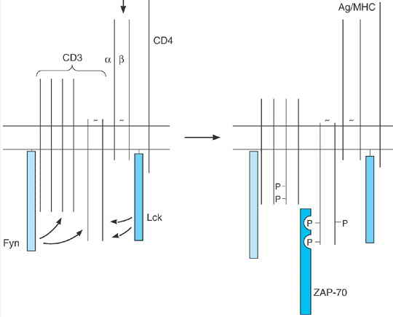
Figure 7. Model for the interactions of the T-cell antigen receptor with protein tyrosine kinases. In resting T cells, the CD3 components of the T-cell receptor (TCR) are associated with the protein tyrosine kinase Fyn, and the CD4 coreceptor is associated with Lck. On stimulation of the TCR, the CD3 chains are tyrosine phosphorylated on immunoreceptor tyrosine-based activation motifs (ITAMs), probably through the action of Fyn or Lck. The tyrosine-phosphorylated ITAMs in turn recruit a third protein tyrosine kinase, ZAP-70, to the receptor.
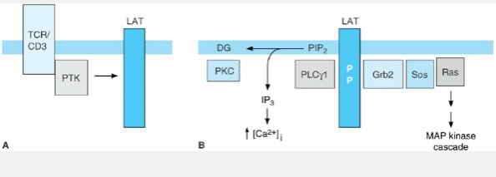
Figure 8. Activation of the phospholipase C (PLC) and Ras pathways by the T-cell receptor (TCR). A: Following TCR stimulation, protein tyrosine kinases (PTK) phosphorylate the linker protein LAT. B: Tyrosine-phosphorylated LAT then associates with phospholipase C خ³-1 (PLCخ³-1) and with Grb2-Sos. PLCخ³-1 hydrolyzes phosphatidylinositol-(4,5)-bisphosphate (PIP₂), producing two second messengers: diacylglycerol (DG), which activates the protein kinase C (PKC) family of serineâ€“threonine kinases, and inositol trisphosphate (IP₃), which triggers an increase in the concentration of cytosolic free calcium ions ([Ca²⁺]_{I}). Grb2-Sos recruits and activates Ras, leading to activation of the MAP kinase cascade.
CD45: A TYROSINE PHOSPHATASE REQUIRED FOR TCR SIGNALING

CD45 is a large (180â€“220 kd) transmembrane cell surface molecule that is expressed by all leukocytes, including all T lymphocytes. The cytoplasmic domain of CD45 has tyrosine phosphatase activity. Variants and mutants of T-cell lines that lack CD45 have been isolated in vitro. Remarkably, these CD45-negative T cells cannot respond to antigen, even though they express normal levels of the TCR. The block is at the very early steps of TCR signaling, indicating that CD45 is required for the functional coupling of the TCR and its PTKs. At first glance a positive role for a tyrosine phosphatase in TCR signaling seems counterintuitive. It appears, however, that the CD45 phosphatase removes tyrosine phosphorylations that inhibit the activation of Src-like PTKs. Phosphorylation of a tyrosine residue found in the carboxy-terminal tails of Src-like PTKs inactivates these kinases (Figure 9-9). By removing this inhibitory phosphorylation, CD45 allows these PTKs to be activated during antigen recognition.
COSTIMULATION BY CD28

Despite their complexity, the signals delivered by the TCR are insufficient to fully activate T cells. Rather, T-cell activation requires the delivery of both the TCR signals and a second set of signals generated by costimulatory molecules. In the absence of the proper costimulus, stimulation of the TCR alone can induce a T cell to enter a state in which it remains viable but is refractory to stimulation by antigen. This state, which is known as anergy, can be long-lived, persisting for weeks to months in vitro.
The best characterized (and probably the most important) costimulatory molecule is CD28, a 44-kd glycoprotein that is expressed as a homodimer on the surfaces of virtually all CD4 T cells and approximately 50% of CD8 T cells. CD28 binds two distinct cell surface molecules, B7.1 and B7.2, found on dendritic cells, macrophages, and activated B cells. The combination of TCR stimulation and the interaction of CD28 with its B7 ligands fully activates T cells and results in substantially greater lymphokine production than can be induced by TCR signals alone (Figure 9-10). This enhanced lymphokine production reflects the ability of CD28 signals to promote lymphokine gene transcription and to increase the stability of lymphokine messenger RNAs. The signaling pathways involved in costimulation by CD28 have not been defined.
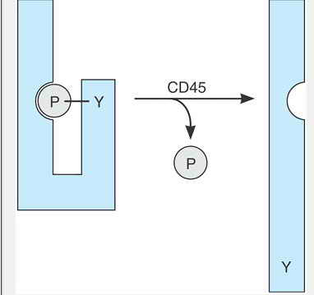
Figure -9. Regulation of Src-like protein tyrosine kinases by CD45. Src-like protein kinases, such as Lck and Fyn, can be phosphorylated (P) on a carboxy-terminal tyrosine (Y) by a kinase designated Csk. Phosphorylation at this site induces a conformational change in Src kinases that renders them catalytically inactive. The CD45 phosphatase removes the phosphate from this regulatory tyrosine and restores activity. An inability to activate Lck and Fyn likely explains the impaired TCR signaling observed in T cells that lack CD45.

Because T-cell activation requires both the TCR signals and a costimulus, costimulatory molecules such as CD28 may provide a means of manipulating the immune response to specific antigens. Indeed, in vivo blockade of B7.1 and B7.2 (which prevents CD28 from binding) results in prolongation of allograft survival in experimental animals and reverses autoimmunity in mouse models, raising the possibility that disrupting the CD28/B7 interaction may prove to be a powerful means of suppressing undesirable immune responses. The CD28 costimulus can also be exploited to enhance responses. For example, the immune response to many types of tumors, which generally lack B7.1 and B7.2, is inadequate to prevent tumor growth following implantation in mice. In certain experimental models, however, an effective antitumor immune response is initiated in animals immunized with tumor cells that have been genetically altered so that they express B7.1.

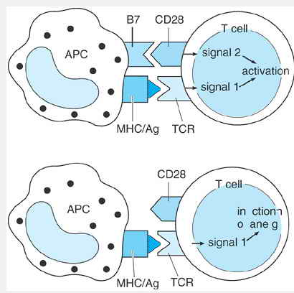
Figure 10. The role of CD28 in T-cell activation. Activation of T cells is thought to require T-cell receptor (TCR)-derived signals (signal 1) and a costimulus (signal 2). The major costimulatory molecule, CD28, binds to two cell surface molecules, B7.1 and B7.2, on antigen-presenting cells (APC). The combination of TCR signals and CD28 signals results in a substantial increase in lymphokine production over that seen with TCR stimulation alone. In the absence of the costimulus, the unopposed TCR signals can cause the T cell to enter a state of unresponsiveness known as anergy. Abbreviations: MHC = major histocompatibility complex; Ag = antigen.
T-CELL-MEDIATED IMMUNE RESPONSES

Naive T cells circulate through the bloodstream and lymphatics to the spleen, lymph nodes, and Peyer's patches, where they encounter antigens trapped by resident antigen presenting cells (APCs) or imported by dendritic cells that have migrated from their sentinel positions in other tissues. In nonimmunized individuals, the frequency of T cells specific for any particular antigen is very lowâ€”on the order of 1 in 10,000 or less. An important component of T-cell immune responses is a rapid expansion in the numbers of antigen-specific T cells. Studies of viral infections in mice, for example, have documented increases from several hundred antigen-specific cytotoxic T lymphocytes (CTLs) at the time of inoculation to nearly 10⁸ cells by day 8 of the infectionâ€”at which time antigen-specific CTLs account for 50% of T cells in the spleen. At the peak of expansion the antigen-specific CTL population doubles every 6â€“8 hours. During the expansion period, antigen-specific T cells differentiate into potent effector cells. The effector function of naive T cells is limited but evolves rapidly following initial activation. The immune response, therefore, entails qualitative as well as quantitative changes in the responding cells.
The number of antigen-specific T cells falls dramatically when an immune response terminates. Following successful clearance of virus, the number of virus-specific CTLs in a mouse can drop from 10⁸ to 10⁶â€”a decrease of 99%. The decline reflects apoptosis, perhaps triggered by cytokine withdrawal or by engagement of Fas or other members of the tumor necrosis factor (TNF) receptor family. One important negative regulator of T-cell activation is CTLA-4, a T-cell surface molecule induced on activation and not found on resting cells. CTLA-4 shares considerable sequence homology with CD28 and, like CD28, binds B7.1 and B7.2 on the APC. Unlike CD28, however, CTLA-4 delivers inhibitory signals to T cells, so that engagement of CTLA-4 tends to strongly diminish T-cell responses. CTLA-4 is also critical for maintaining T-cell homeostasis: Mice genetically engineered to lack CTLA-4 die with massive polyclonal expansion of T lymphoblasts.
The T-cell population is heterogeneous with respect to both functional capabilities and cell surface phenotypes. Broadly speaking, T cells are divided into helper cells, which promote cell-mediated and antibody responses, and cytotoxic cells, which kill antigen-bearing target cells. Helper T cells usually express CD4, and cytotoxic T cells generally express CD8. It should be emphasized, however, that expression of CD4 and CD8 primarily correlates with MHC restriction. Thus, some CD4 T cells have cytolytic activity, and certain CD8 T cells function as helper cells. In addition to the classic helper T cells and CTLs, the peripheral T-cell population contains several less well-characterized subsets, including those that express the خ³خ´ TCR and cells that share certain phenotypic features with natural killer cells (called NKT cells; .
HELPER T CELLS: THE T_{H}1 & T_{H}2 SUBSETS
Helper T cells provide signals that augment cell-mediated immune responses and that are necessary for B cells to differentiate into antibody-producing cells. When activated, helper T cells produce soluble lymphokines that can regulate the activities of T cells, B cells, monocyteâ€“macrophages, and other cells of the immune system. T-cell help for B-cell differentiation also involves direct contact between the two cell types, which exposes the B cell to high local concentrations of T_{H}-derived lymphokines and which also results in direct stimulation of B-cell surface receptors, most notably CD40. T-cell activation induces T cells to express a ligand for CD40 (called CD40L), and the interaction of CD40 with CD40L
provides critical signals for B-cell differentiation. Inherited defects in the expression of CD40L lead to a state of immunodeficiency characterized by low levels of circulating IgG and IgA with increased levels of IgM.
The lymphokine repertoire of naive helper T cells is very limited; on their initial encounter with antigen, helper T cells produce IL-2 but little in the way of other lymphokines. When activated, however, naive T_{H} cells give rise to effector T cells that can produce a considerable array of different lymphokines. Most of these mature T_{H} effector cells belong to one of two distinct subsets, designated T_{H}1 and T_{H}2 cells, that are distinguished by the particular lymphokines they produce (Table 9-1). Their divergent patterns of lymphokine expression, in turn, allow each of these T_{H} subsets to promote distinct types of immune reactions that are best suited to eliminating particular types of microorganisms.

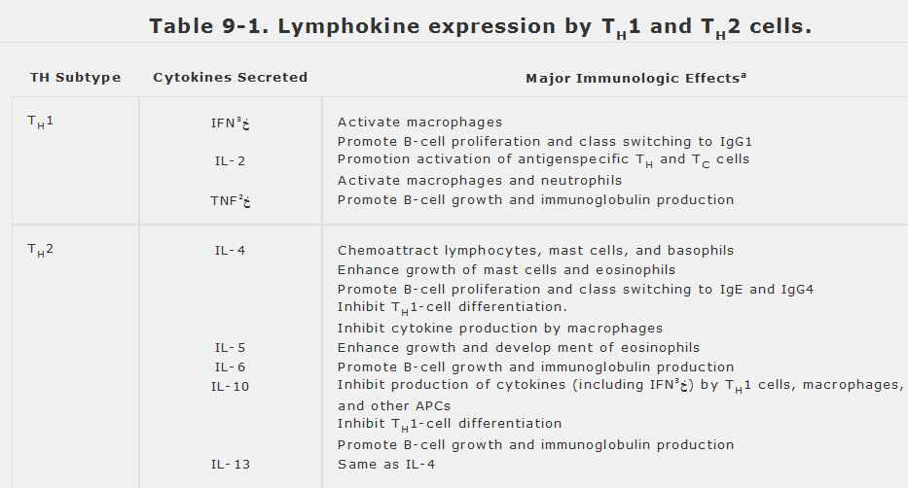
Abbreviations: IFNخ³ = interferon gamma, IL = interleukin, TNFخ² = tumor necrosis factor beta, APC = antigen-presenting cell.
ªOnly a few pertinent effects of these cytokines are listed here; a more complete discussion can be found in Chapter 10. Each of the processes listed is enhanced by the cytokine unless otherwise stated.

T_{H}1 cells produce IL-2, interferon-gamma (IFNخ³), and tumor necrosis factor beta (TNFخ², also called lymphotoxin alpha). Broadly speaking, these lymphokines promote defensive reactions that are mediated by macrophages and other phagocytes, and so involve intracellular killing of pathogens. IFNخ³, for example, potently activates macrophages by inducing nitric oxide synthase and other metabolic enzymes that increase microbicidal activity. At the same time, IFNخ³ acts on activated B cells to induce immunoglobulin class switching to IgG1â€”an isotype that binds strongly to all three classes of macrophage Fcخ³ receptors and so functions as an extremely potent opsonin. The overall effect is to potentiate both engulfment and killing by phagocytes.
T_{H}2 cells, by contrast, do not make IL-2, IFNخ³, or TNFخ² but instead secrete IL-4, IL-5, IL-6, IL-10, and IL-13. These T_{H}2-derived cytokines act together to chemoattract B cells, mast cells, basophils, and eosinophils and then to promote the growth and differentiation of those cell types at the site of an immune response. In addition, IL-4 promotes B-cell class switching to IgEâ€”the isotype bound uniquely by Fcخµ receptors on mast cells and eosinophils, and which enables those cells to recognize and respond to antigens. By these means, T_{H}2 cells cause an influx of mast cells and eosinophils and help focus their attack on an antigen. This type of defense reaction is particularly effective against large, multicellular parasites such as helminths, which can often be killed extracellularly by eosinophils but are too large to be engulfed by macrophages. Indeed, macrophages play little role in T_{H}2-mediated immune reactions, in part, because IL-10 acts to inhibit IFNخ³ production and because IL-4 selectively favors production of two immunoglobulin isotypes (IgE and IgG4) that are not recognized by macrophage Fc receptors.
T_{H}1 and T_{H}2 cells derive from common precursor cells that have the capacity to differentiate into either T_{H} type (Figure 9-11). Cytokines are the most important determinants of T_{H} differentiation. IL-12, produced by activated macrophages, causes antigen-primed naive T cells to differentiate into T_{H}1 cells which, in turn, amplify the macrophage response. In contrast, the presence of IL-4 during an immune response promotes differentiation of naive T cells into T_{H}2 cells. The source of IL-4 at the initiation of an immune response (ie, before the appearance of T_{H}2 cells) is uncertain; possibilities include memory T cells, NKT cells, mast cells, eosinophils, and basophils. Differentiation from naive cells to either T_{H}1 or T_{H}2 may involve an intermediary cell, designated T_{H}0, which is defined by its ability to secrete both IFNخ³ and IL-4.
The cytokines produced by each of the two T_{H} subsets reciprocally inhibit the development of the other. Thus, T_{H}1-derived IFNخ³ inhibits the development of T_{H}2 cells, and the IL-4 produced by T_{H}2 cells prevents development of T_{H}1 cells. Unchecked cytokine-mediated
immune responses can cause considerable damage. Transforming growth factor beta (TGFخ²) inhibits the development of both T_{H}1 and T_{H}2 cells, and regulatory T cells that produce TGFخ² (sometimes designated T_{H}3 cells) may play a role in the suppression of T_{H}1- and T_{H}2-mediated immune responses .
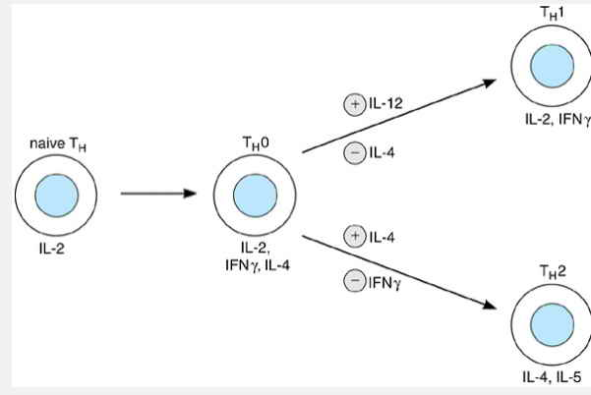

Figure 11. Differentiation of helper T cells into T_{H}1 and T_{H}2 cells. Naive T_{H} cells produce IL-2 and little in the way of other cytokines on initial activation. Repeated stimulation in the presence of IL-12, a macrophage-derived cytokine, causes T_{H} cells to differentiate into T_{H}1 cells, which produce IL-2 and IFNخ³ and are particularly effective in enhancing immune responses that involve macrophages and other phagocytes. Stimulation in the presence of IL-4, on the other hand, promotes the development of T_{H}2 cells, which produce IL-4 and other cytokines that promote mast cell- and eosinophil-mediated responses. The differentiation into either T_{H} subtype probably involves a common intermediary, designated T_{H}0, which produces IL-2, IFNخ³, and IL-4. T_{H}1 and T_{H}2 cells have the ability to mutually down-regulate the development of the other: the T_{H}1 product IFNخ³ impairs the generation of T_{H}2 cells, and the T_{H}2 cytokine IL-4 inhibits the development of T_{H}1 cells.
An immune response can become strongly polarized toward either T_{H}1 or T_{H}2 production over time, so that one subtype or the other comes to dominate. Immune responses that are chronic, such as those to parasitic infections, are especially prone to such polarization. This can be highly advantageous if it yields the optimal response against a pathogen. A well-characterized example of a T_{H}1-dominated response is the brisk cell-mediated reaction of most mouse strains against the protozoan Leishmania major. This intracellular pathogen invades macrophages, stimulating them to produce IL-12 and thus promoting T_{H}1 development. The T_{H}1 lymphokines, in turn, activate the macrophages to kill the parasites and clear the infection. For reasons that are not well understood, certain mouse strains develop a T_{H}2-dominated response to L major; this leads to a vigorous antibody response but no macrophage response. In these strains, the parasite evades killing, disseminates widely, and eventually kills the host.
The divergent effects of T_{H}1 and T_{H}2 cells are also seen in their association with deleterious immune reactions in humans. In particular, autoimmune disorders associated with the destruction of host tissues, as occurs in diabetes mellitus, multiple sclerosis, or inflammatory bowel disease, predominantly involve T_{H}1 responses. By contrast, allergic disorders (eg, seasonal rhinitis, asthma, and contact dermatitis) in which IgE, mast cells, and eosinophils play a prominent role are dominated by T_{H}2 cells. It is not yet clear to what extent the development of such disorders might reflect an inborn predisposition toward T_{H}1 or T_{H}2 responses. Nevertheless, it may someday be possible to treat or prevent these disorders by selectively influencing the development or functions of individual T_{H} subtypes. Similar approaches might also be used to promote desirable immune responses. For example, IL-12 administered at the time of vaccination has been found to enhance protective T_{H}1 reactions against certain pathogens in animals.
CYTOLYTIC T CELLS

Cytolytic T lymphocytes (CTLs) respond to antigen recognition by killing the antigen-bearing cell. These cells are usually CD8 and recognize antigen in
the context of MHC class I molecules. CTLs play a prominent role in the host defense against viral infections. Proteins from viral pathogens enter the endogenous pathway for antigen presentation, resulting in the expression of MHC class I molecules bearing viral peptides. CTLs also are involved in the response to certain intracellular bacterial pathogens, including Listeria and mycobacteria. CTLs are important in allograft rejection and may play a role in immune surveillance against malignancy.
Killing by Cytotoxic Granules
CTLs arise from naive T precursors that have limited killing capability. Differentiation into cytolytic cells results from the combination of antigen recognition and exposure to IL-2. In addition to triggering proliferation, IL-2 increases the expression of cytoplasmic granules involved in the killing of target cells (Figure 9-12). The CTL granules contain perforin (also known as cytolysin) and granzymes, a family of related serine proteases. During target cell recognition, the contents of these granules are directionally released toward the target. The perforin molecules, which are evolutionarily related to complement component C9, form 10- to 20-nm pores in the plasma membrane of the target. These perforin pores are not sufficient to kill nucleated target cells, which have the ability to repair membranes and thereby avoid osmotic lysis. Rather, the pores appear to function as a means of delivering granzymes into the target, and it is the granzymes that induce death of the target by triggering apoptosis. One important step in this process is carried out by granzyme B, which proteolytically cleaves and activates caspases in the target cell, which are components of the apoptotic pathway .

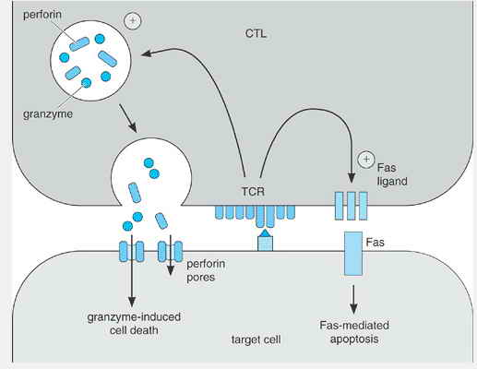

Figure 12. Mechanisms of target cell killing by cytolytic T cells (CTL). Antigen recognition by CTLs triggers the exocytosis of granules, leading to the release of perforins, which form pores in the target cell membrane and permit the entry of granzymes into the target cell. Granzymes trigger target cell death through apoptosis. CTLs also can kill targets through the Fas ligand-Fas pathway. T-cell receptor (TCR) stimulation induces the expression of Fas ligand on the cytolytic T cell. If the target cell expresses Fas, its engagement by Fas ligand transduces a signal that triggers apoptosis in the target cell.
Killing by the Fas Ligandâ€“Fas Pathway
The release of cytolytic granules is not the only means by which CTLs can kill antigen-bearing cells. Antigen recognition stimulates CTLs to express Fas ligand, a member of the tumor necrosis factor (TNF) family. The interaction of Fas ligand with Fas (a cell surface molecule related to TNF receptors) induces apoptosis in the Fas-expressing cell (see Chapter 4). The Fas death pathway is also used by CD4 T_{H}1 cells, which do not express cytolytic granules.
T cells can be activated to express Fas, and activated T cells can become susceptible to Fas-induced apoptosis. Fas-mediated death of T cells, triggered by
P.143
Fas ligand-expressing T cells, is important for immune regulation. Humans and mice with mutations that interfere with Fas expression or function develop a clinical disorder characterized by massive accumulation of T cells and by autoimmunity.
MEMORY T CELLS
A remarkable feature of the adaptive immune system is its memory; a second challenge with an antigen results in a prompter and more effective immune response than does the initial exposure to the same antigen. T-cell memory reflects antigen-induced differentiation of naive T cells into memory cells and can involve T_{H} cells and CTLs.
One important aspect of T-cell memory is quantitative; exposure to an antigen results in a prolonged increase in the numbers of T cells whose TCRs have specificity for that antigen. Unlike the short-lived naive T cells, which exist for a matter of weeks, memory T cells are either long-lived or capable of self-renewal and persist for years. Indeed, antigen-specific memory CTLs have been detected in humans as long as 30 years after vaccination. On rechallenge, therefore, up to 100 times more T cells can be available to respond to the antigen in question.
Important qualitative distinctions also exist between memory T cells and naive T cells. Memory T_{H} cells, for example, proliferate sooner and express a broader array of lymphokines after contact with an antigen and are more effective helpers. Memory and naive T cells also differ in their surface phenotypes, most notably in their expression of CD45 isoforms. Alternative splicing of CD45 mRNA gives rise to a number of different isoforms of CD45 that differ in the size and composition of their extracellular domains. Naive T cells express 205- to 220-kd isoforms designated CD45RA, whereas memory T cells express a 180-kd isoform called CD45RO. Memory T cells also express higher levels of adhesion molecules on their surfaces; this enables them to adhere more tightly to APCs and may account for their ability to respond to lower concentrations of antigens. In addition, memory and naive T lymphocytes express different types of surface homing receptors and so follow different patterns of trafficking to and within tissues
خ³خ´ T CELLS
A small subset (<5%) of mature T cells does not express a TCR خ±خ² dimer. These cells have a second form of the TCR, composed of a CD3 complex together with a dimer of polypeptides designated خ³ and خ´. The TCRخ³ and خ´ genes are highly homologous to the TCRخ± and خ² genes and, as is the case with خ± and خ², functional gene products are formed by the rearrangements of germline V and J segments (in the case of خ³) or V, D, and J segments (TCRخ´). Indeed, the TCRخ´ gene lies within the TCRخ± locus.
Interestingly, the first T cells to mature during fetal development are خ³d T cells. The development of these early خ³d T cells is highly regulated. They appear in successive waves, with each wave characterized by the use of particular Vخ³ segments. Remarkably, the initial wave of خ³d T cells in the mouse expresses an invariant TCR and, therefore, is composed of T cells that all have identical specificity for antigen. These خ³d T cells populate the epidermis, where they assume a dendritic morphology. The خ³d T cells that mature in the postnatal thymus, by contrast, use a variety of different Vخ³ segments and therefore express diverse TCRs.
Relatively little is known about how خ³d T cells recognize antigen. In terms of length, the CDR3 loops of خ³d TCRs resemble those of immunoglobulins more than of خ±خ² TCRs, suggesting a mode of antigen recognition quite different from that used by خ±خ² T cells. Indeed, with few exceptions, خ³d T cells do not recognize antigen in an MHC-restricted fashion. The relatively few antigens for خ³d T cells that have been identified fall into three categories: unprocessed proteins, small organic compounds containing alkylphosphate, and alkylamines.
The physiologic roles of خ³d T cells are also uncertain. Mature خ³d T cells are either double-negative or CD8 and constitute a major component of the T-cell populations in the epidermis and the mucosal epithelia of the tongue, intestine, female reproductive tract, and lung. Roughly 5% of peripheral blood T cells are خ³d cells. The invariant T-cell population in the epidermis responds to signals expressed by damaged keratinocytes and, when activated, produces cytokines, such as keratinocyte growth factor, that may facilitate wound healing. Thus, one function of خ³d T cells may be to protect the integrity of epithelial tissues. خ³d T cells likely have regulatory and effector functions in the response to infection, but it has been difficult to define those roles precisely. خ³d T cells have cytolytic capabilities and can produce IFNخ³ and other immunoregulatory cytokines. Substantial increases in the numbers of peripheral blood خ³d T cells can occur in certain bacterial infections, including tuberculosis, brucellosis, and listeriosis, and in several parasitic diseases, such as leishmaniasis and malaria. The ability of خ³d T cells to recognize and proliferate in response to alkylphosphates and alkylamines produced by pathogens may explain these responses.
NATURAL KILLER CELLS
Natural killer (NK) cells are large granular lymphocytes that, like CTLs, use cytoplasmic granules containing perforins to kill target cells. NK cells were

defined initially by their ability to lyse certain tumor cell lines and virally infected cells in vitro. In contrast to T cells, NK cells can lyse these cells without prior immunization, and so mediate a form of innate (or natural) immunity that is termed â€œnatural killing.â€‌
Unlike T cells, NK cells do not productively rearrange their TCR genes, and they do not express a cell surface TCR/CD3 complex. They also lack CD4, the marker for T helper cells. About half of human NK cells express CD8, the marker for cytolytic T cells, but only one form of CD8 is expressed (a homodimer of two خ± chains), and it does not appear to be required for natural killing. (It is not found on mouse NK cells.) Most NK cells express CD16 (a receptor for the Fc portion of IgG) and CD56 (a variant of neural cell adhesion molecule, NCAM). Neither of these is required for natural killing, and they are expressed at different levels in different tissues. They nonetheless serve to identify NK cells, which are generally CD16⁺, CD56⁺, CD3⁻, whereas T cells are CD3⁺, CD16⁻, CD56⁻.

DEVELOPMENT & TISSUE DISTRIBUTION OF NK CELLS

Like T and B lymphocytes, NK cells derive from a bone marrow precursor. Unlike T cells, they do not require the thymus for development, and they develop fully in mice lacking the recombinase enzymes required for rearranging the TCR or immunoglobulin genes. Similarly, patients with combined T- and B-cell immunodeficiency may have normally functional NK cells. NK cells do not, however, develop in mice lacking either IL-15 or the IL-15 receptor.
NK cells account for about 10â€“15% of blood lymphocytes. They are rare in lymph nodes and do not circulate through the lymph. Interestingly, NK cells are abundant in the pregnant uterine decidua, where they constitute most of the hematopoietic cells. The function of these uterine NK cells, however, is unknown.
NK EFFECTOR FUNCTIONS

The cell surface molecules that NK cells use to selectively recognize targets for natural killing have not been well defined. All NK cells express a surface receptor called NKp46, and blockade of this receptor impairs natural killing. Almost all NK cells also express and are activated by 2B4, a receptor that binds to CD48, which is expressed on most hematopoietic cells. These receptors may be important in natural killing, but their role is not yet fully defined.
When NK cells are stimulated by IL-2, their cytotoxic capacity is enhanced, and the range of target cells they can kill is greatly broadened. These lymphokine-activated killer (LAK) cells have been used clinically to treat tumors. Treatment, however, requires the administration of IL-2 in toxic doses, and success has been limited, so this therapy has not gained wide use. Activation by IL-2 induces NK cells to express NKp44, an activating cell surface receptor that is not expressed by resting NK cells and that may help to enhance killing.
The CD16 Fc receptor on NK cells permits them to bind and lyse cells that are coated with antibody. This antibody-dependent cell-mediated cytotoxicity (ADCC) provides a bridge between the innate and acquired immune systems. Natural killing, by contrast, occurs independently of antibodies.
NK cells also kill hematopoietic blasts, and so present a barrier against bone marrow transplantation. As discussed later on, inhibitory receptors on NK cells that recognize class I MHC antigens influence graft rejection. The preferential activation of NK cells by hematopoietic cells may account for the reduction in formed blood elements, including white cells, red cells, and platelets, that has been found in patients with abnormal proliferation of NK-like cells.
Activated NK cells produce cytokines such as IFNخ³, TNFخ±, granulocyte-monocyte colony-stimulating factor, and colony-stimulating factor-1. The production of IFNخ³ by NK cells may serve to bias a T-cell response toward T_{H}1 differentiation. NK cells are not, however, required for all T_{H}1 responses because these can also be generated through the production of IFNخ³ by T cells.
INHIBITORY RECEPTORS ON NK CELLS RECOGNIZE CLASS I MHC ANTIGENS
Unlike T cells, NK cells do not require the expression of MHC molecules on target cells for activation. Instead, NK cells are generally inhibited by the expression of class I MHC proteins on target cells. This inhibition is mediated by receptors on NK cells that specifically recognize class I antigens and deliver inhibitory signals. NK cells express inhibitory receptors that identify both self and nonself class I MHC antigens. All NK cells, however, express at least one inhibitory receptor for a self class I MHC antigen. By this means, NK cells are prevented from killing cells from their host.
The inhibitory receptors on NK cells are of two structural types: immunoglobulin-like (Ig-like) and lectin-like. The Ig-like receptors are members of the immunoglobulin gene superfamily (see Chapter 7) and are called killer inhibitory receptors (KIRs). The KIRs are encoded by a gene family on chromosome 19, and different members of the family interact with different sets of class I MHC proteins. Different KIRs recognize features that are common to large groups of class I MHC molecules, so that two KIRs, for example, identify mutually exclusive subsets
that together make up all of the HLA-C proteins. Class I recognition by KIRs is relatively unaffected by the particular peptides bound in the peptide-binding groove of the MHC protein.
Other families of KIR-like receptors are encoded on chromosome 19. These are variably expressed on different subsets of hematopoietic cells, sometimes including NK cells. For most of these, the ligands are not yet identified, although at least some of them also interact with class I MHC.
The lectin-like receptors, like the KIRs, include inhibitory receptors on NK cells, and they are also encoded in gene families, although on a different chromosome. In mice, these include the Ly-49 receptor family. Mice lack KIRs, and they instead use Ly-49 receptors to recognize class I MHC. Humans, on the other hand, lack Ly-49 receptors. Both humans and mice, however, share the expression of some lectin-like receptors. One is a receptor formed by the joining of two different lectin-like chains, called CD94 and NKG2A. The CD94/NKG2A receptor inhibits NK cells when it binds to HLA-E, a nonclassical class I MHC molecule. HLA-E has the unusual property that it is only expressed when certain classical class I proteins (HLA-A, -B, or -C) are expressed on the same cell. Most classical class I MHC proteins support the expression of HLA-E; thus, HLA-E indirectly and nonspecifically identifies cells as expressing a classical class I protein. The recognition of HLA-E by the CD94/NKG2A receptor may thus provide a â€œbackupâ€‌ to prevent NK cells from lysing targets for which they do not have an inhibitory receptor.
The finding that NK cell function is inhibited by class I MHC has given rise to the â€œmissing selfâ€‌ hypothesis. This model proposes that unlike cytotoxic T lymphocytes, which must be activated from a resting state by contact with an appropriately presented foreign antigen, NK cells are always predisposed to kill any cell they encounter, but are prevented from killing host cells because they recognize the host class I proteins. Thus, they only attack cells whose class I MHC proteins are lost or altered (missing self), as occurs frequently in malignancy or viral infection.
Our understanding of MHC-specific inhibitory receptors has been complicated by the recent discovery that the gene families encoding both KIRs and lectin-like receptors encode activating receptors for class I MHC as well as inhibitory receptors. The activating receptors are not required for natural killing because NK cells kill targets that lack class I expression. The role of these receptors is thus unclear.
ROLE OF NK CELLS IN HOST DEFENSE

The ability of NK cells to kill tumor cells has been a focus of research interest and of therapeutic trials, but there is little evidence that NK cells normally protect against the development of tumors. Instead the most important role for NK cells appears to be in host defense against infection by intracellular agents, including certain viruses, bacteria, and parasites. Selective deficiency of NK cells in humans has been associated with recurrent viral infections, particularly with DNA viruses. Similarly, in mice, NK cells have been shown to help defend against infection by cytomegalovirus. NK cells alone are insufficient protection, but they provide an early innate barrier to infection by eliminating infected host cells, and they also help activate T cells in the acquired antiviral response.
NKT CELLS
In certain strains of mice, all NK cells express the NKR-P1C (NK1.1) surface receptor. This activating receptor is also found on a small subset of T cells (<5%), and these â€œNKTâ€‌ cells have distinct properties. Similar NKT cells are found in humans, where they also express a member of the NKR-P1 receptor family, called NKR-P1A (CD161), an antigen that is also found frequently on T cells as well as on NK cells. The majority of NKT cells use the same TCR خ± chain. They differ from conventional T cells in that they do not respond to peptide antigens complexed with classical class I or class II MHC molecules, but instead respond to glycolipid antigens bound to a nonclassical class I protein called CD1d. These glycolipids include glycosylphosphatidylinositol (GPI), a glycolipid that is abundant in the cell membrane and is used to anchor a variety of proteins onto the cell surface. Although the structure of GPI is known to vary among organisms, it is not known whether NKT cells recognize pathogens by distinguishing particular forms of GPI. The most potent known stimulus to NKT cells, however, is the glycolipid خ±-galactosylceramide (خ±-GalCer). This glycolipid is derived from sponges and is not found in mammals, which instead express خ²-GalCer. Thus, it has no natural role in regulating NKT cells, but is nevertheless a very useful agent for activating them in vitro and in vivo. Activation of NKT cells through this mechanism secondarily activates NK cells as well.
NKT cells require the expression of CD1d for their development. CD1d is expressed in the thymus, and NKT development is impaired in athymic mice but it is not absent, indicating that NKT cells may develop in response to CD1 outside the thymus.
NKT cells, like NK cells, demonstrate spontaneous cytotoxicity. Of greater importance, however, may be their capacity to produce cytokines, notably IFNخ³ and IL-4. These cytokines have opposing effects
in shaping the immune response, and their production by NKT cells is currently the subject of intense investigation. NKT cells are the major source of IL-4 in mice stimulated with antibody to CD3, but their capacity to produce IFNخ³ appears to be of particular importance in shaping the immune response.
NKT cells are deficient in both numbers and function in patients with insulin-dependent diabetes or with scleroderma, as well as in certain mouse models of diabetes. IL-12 can induce the rejection of tumor cells by mice through a mechanism that involves NKT cells, and rejection of tumors can also be induced in mice by treatment with خ±-GalCer.

