Lecture-1- Introduction to Algae

General Characteristics
  - Size Criterion: picoplankton (<1-2 mm), nanoplankton (2-20 mm), microplankton (> 20 mm)
  - Most reproduce asexually

  - Both heterotrophic and autotrophic organisms exist

  - Increased importance of heterotrophy with reduced light and/or nutrients
  - Current estimates suggest that between 4,000 – 5,000 of marine phytoplankton species have been described. Freshwater diversity is probably higher!
  - Phylogeny: Occupy two domains (Bacteria and Eucarya), and at least 12 phyla.

Algal Habitat
Algae are a group of ubiquitous organisms which are present in diverse habitats such as water (aquatic algae), land (terrestrial algae), they also grow as an epiphyte, endophyte, and as well as in extreme conditions,
1-Planktonic: ‘free-floating’.

2- Attached:

A-Epipelic: On Sediment

B-Epiphytic: In Aquatic Vegetation (Macrophytes) C-Epilithic: On rocks.
D-Episammic: On sand.

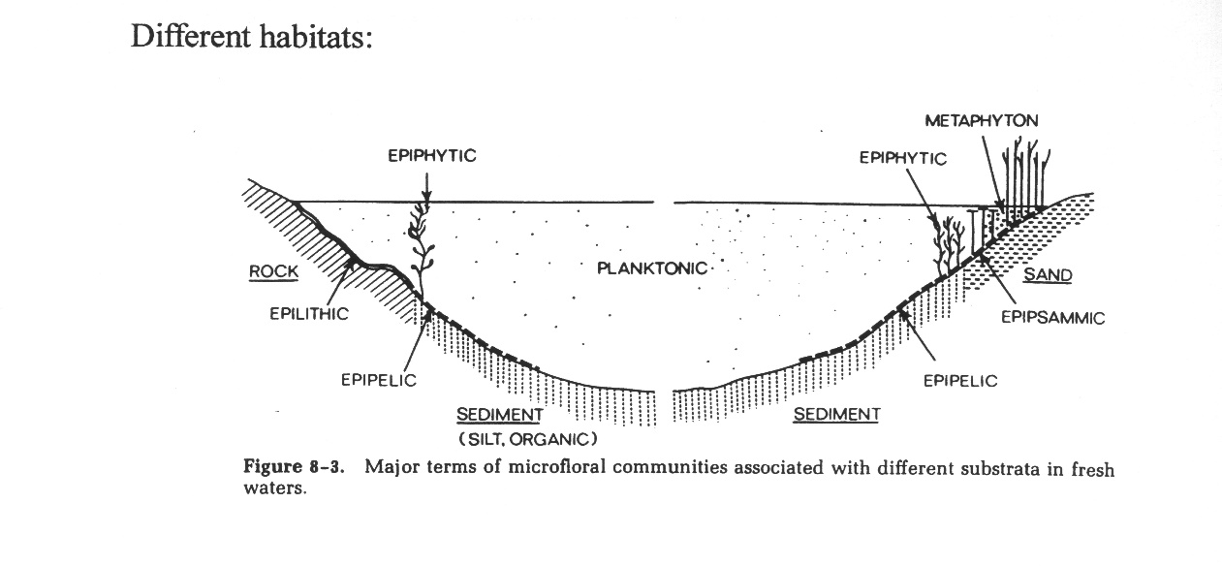

Figure 1: Different habitat of Algal Community

3-Morphology of Algae 1-Filamentous Type

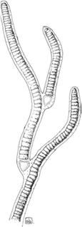

- 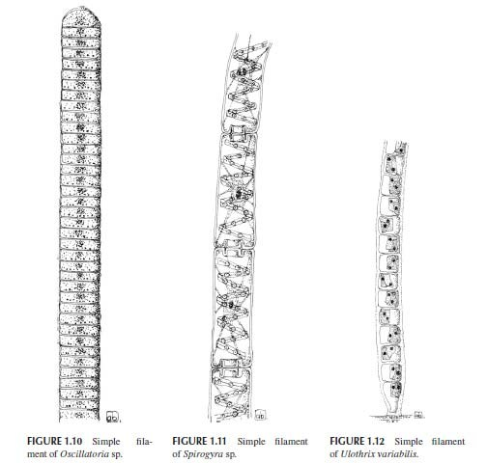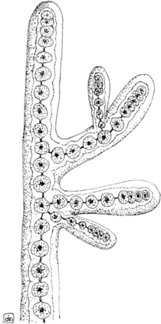Siphonocladous Type
The algae with this cytomorphological design have multicellular thalli, with a basically uniseriate filamentous, branched, or unbranched

organization, composed of multinucleate cells as a consequence of uncoupled cell division and mitosis. Despite lacking clear physical borders, This morphotype is present in members of the class Ulvophyceae (Chlorophyta) such as Cladophora sp. and Anadyomene sp.

Siphonous Type
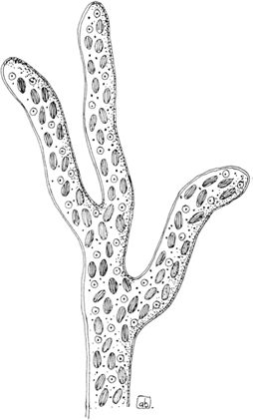
;

Figure 1: Siphonous thallus of Vaucheria sessilis.

Parenchymatous and Pseudo-Parenchymatous Type
branched filaments that collectively form the thallus, held together by mucilage, especially in red algae. Thallus construction is entirely based on a filamentous construction with little or no internal

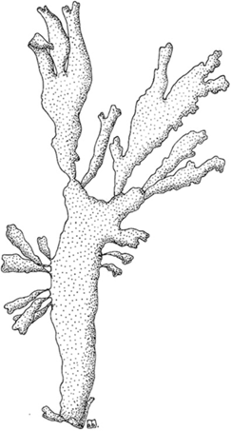

Figure 2:Pseudo-parenchymatous thallus of Palmaria palmata.

Palmelloid Type
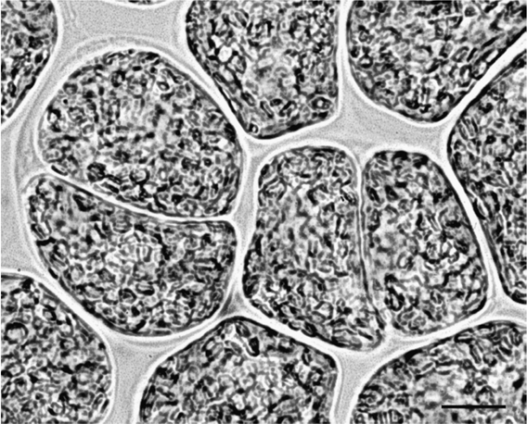

Figure 3:Palmelloid phase of Euglena gracilis.

- NUTRITION
Following our definition of the term algae, most algal groups should be considered photoautotrophs, that is, depending entirely on their photosynthetic apparatus for their metabolic necessities, using sunlight as the source of energy, and CO2 as the carbon source to produce

carbohydrates and adenosine triphosphate. Most algal divisions contain colorless heterotrophic species that can obtain organic carbon from the external environment, either by taking up dissolved substances (osmotrophy) or by engulfing bacteria and other cells such as particulate prey (phagotrophy). There also exist some algae that cannot synthesize essential components such as the vitamins of the B12 complex, or fatty acids, and have to import them; these algae are defined auxotrophic.
On the basis of their nutritional strategies, we can classify algae into four groups:
- Obligate heterotrophic algae: they are primarily heterotrophic, but are capable of sustaining themselves by phototropy when prey concentrations limit heterotrophic growth (e.g., Gymnodium gracilentum, Myzozoa);
- Obligate phototrophic algae: their primary mode of nutrition is phototrophy, but they can supplement growth by phagotrophy and/or osmotrophy when light is limiting (e.g., Dinobryon divergens, Ochrophyta);
- Facultative mixotrophic algae: they can grow equally well as photoautotrophs and as heterotrophs (e.g., Fragilidium subglobosum, Myzozoa);
- Obligate mixotrophic algae: their primary mode of nutrition is phototrophy, but phagotrophy and/or osmotrophy provide substances essential for growth (in this group, we can include photoautoxotrophic algae) (e.g., Euglena gracilis, Euglenozoa).

- REPRODUCTION

Vegetative and Asexual Reproduction A-Binary Fission or Cellular Bisection

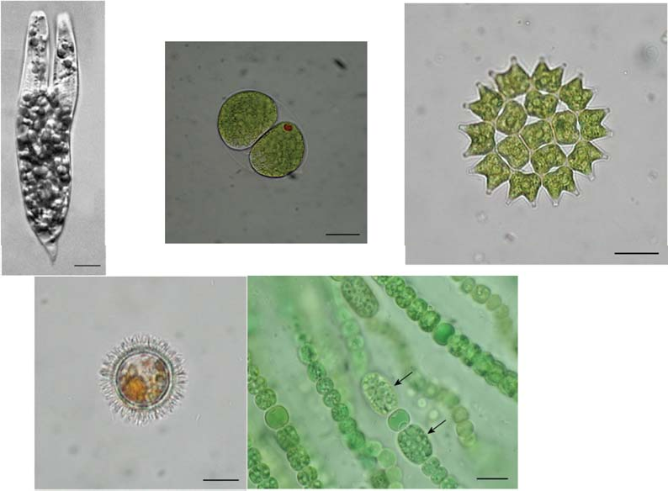

B-Zoospore, Aplanospore, and Autospore C-Autocolony Formation

D-Fragmentation
.

E-Resting Stages
- Sexual Reproduction

A-Haplontic or Zygotic Life Cycle
This cycle is characterized by a single predominant haploid vegetative phase, with the meiosis taking place upon germination of the zygote. Chlamydomonas (Chlorophyta) (Figure 1.28) exhibits this type of life cycle.

B-Diplontic or Gametic Life Cycle

This cycle has a single predominant vegetative diploid phase, and the meiosis gives rise to haploid gametes. Diatoms and Fucus (Ochrophyta) have a diplontic cycle.

C-Diplohaplontic or Sporic Life Cycles
These cycles present an alternation of generation between two different phases consisting of a haploid gametophyte and a diploid sporophyte. The gametophyte produces gametes by mitosis, and the sporophyte produces spores through meiosis.
