Lab2

Body regions

1-HEAD

External view of the head
The head have 5 segments united in one part called Cranium these segments or sclerites are:-
1-frons 2-vertex 3- clypeus 4- gena 5- sub gena
1-Frons: - It is the largest sclerite in the face lies between vertex in the top and clypeus in the bottom
2-Vertex: - It is very small sclerite in the top of head between the compound eyes
3-Clypeus: - It is the medium size lies between frons in the top and mouth part in the bottom
4-Gena and sub gena:-small sclerites in the lateral side of clypeus and frons
Posterior view of head
-Occiput : It is an inverted “U” shaped structure representing the area between the epicranium and post occiput .
-Post occiput : It is the extreme posterior part of the insect head that remains before the neck region.
-Occular sclerites : These are cuticular ring like structures present around each compound eye

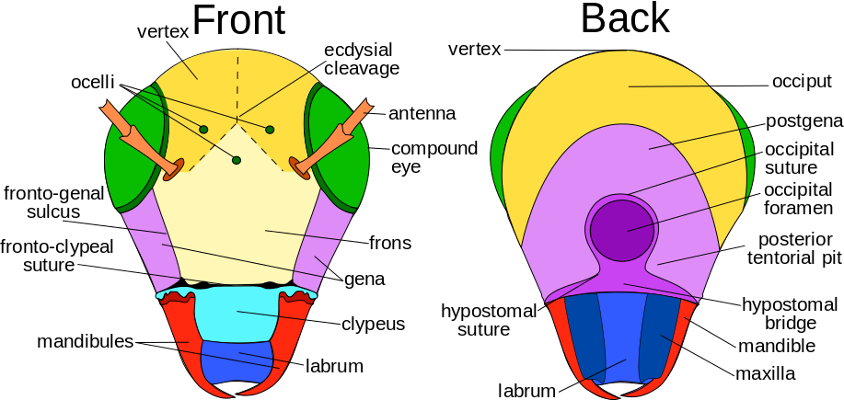
.

Sutures
The common sutures present in head are:-
1) Clypeolabral suture : It is the suture present between clypeus and labrum..
2) frontoclypal suture or epistomal suture: The suture present between clypeus and frons
3) Epicranial suture: It is an inverted ‘Y’ shaped suture distributed above the facial region extending up to the epicranial part of the head. It consists of two arms
called frontal suture occupying the frons and stem called as coronal suture.
This epicranial suture is also known as line of weakness or ecdysial suture
because the exuvial membrane splits along this suture during the process of ecdysis.
4) Occipital suture: It is ‘U’ shaped or horseshoe shaped suture between epicranium and occiput.
5) Post occipital suture: It is the only real suture in insect head. Posterior end of the head is marked by the post occipital suture to which the sclerites are attached.
As this suture separates the head from the neck, hence named as real suture.
6) Genal suture: It is the sutures present on the lateral side of the head i.e. gena.
7) Occular suture: It is circular suture present around each compound eye.
8) Antennal suture: It is a marginal depressed ring around the antennal socket.

-The head of insect are oriented in One Three Ways
1- Hypoganthous: The long axis of the head is vertical . at right angle to the long axis of the body. The mouthparts point downwards e.g. grasshopper, cockroach.
2- Prognathous: The long axis of the head is horizontal and in line with the long axis of the insects body. The mouthparts are directed forwards e.g. beetle.
3- Opisthognathos The head is reflexed ventrally so that the mouth parts are directed backwards between the coxa of the front legs e.g. Red cotton bug.

