Lab1

**ENTOMOLOGY:-** is a part from biology it deals with a type of organisms which is insects studying morphology ,physiology, taxonomy, ecology and life cycle .

**What is an Insect?**

An insect is a small [arthropod](http://carm.org/dictionary-arthropod) organism in the class of insecta.  It is a small living [invertebrate](http://carm.org/dictionary-invertebrate) that has a body divided in to three parts (head, thorax, and abdomen), six legs, and usually two pairs of wings.  Insect examples are bees, ants, butterflies, grasshoppers, moths, crickets, flies, termites, etc**.**

**GENERAL CHARACTERISTICS OF CLASS INSECTA:-**

1. Body divided in to head, thorax and abdomen

2. Possess three pairs of legs, hence the name Hexapoda

3. Presence of one or two pairs of wings

4. A pair of antennae

5. Respiration through either body surface or gills in aquatic forms and trachea & spiracles in terrestrial forms

6. The sexes nearly always separate.

7.Circulatory system is open, where the only blood vessel usually being a tubular structure

8. Possess exoskeleton made up of hard cuticle which plays important role for survival.

9. Excretion is mainly by malpighian tubules which help in maintaining ionic balance.

**Insect Collecting Equipments**

1. Collecting nets:-

Nets may easily be made at home. The necessary parts are a handle, a loop or ring to be attached to it, and a cloth bag to be hung from the loop,

a- Aireal net

used for flying insect the bag of a butterfly net is generally constructed from a light weight mesh to minimize damage to delicate butterfly wings

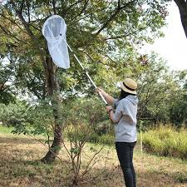

b-Sweeping net

used to sweep through vegetation to collect random insects not easily seen

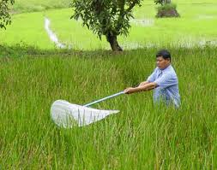

c-Water net

used for aquatic insect

1. The traps :-

a-the light traps

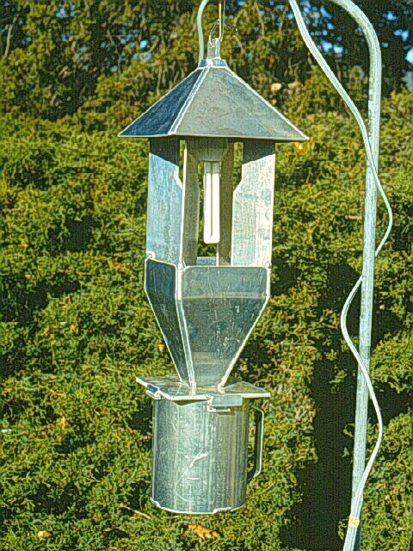

b-the baits traps

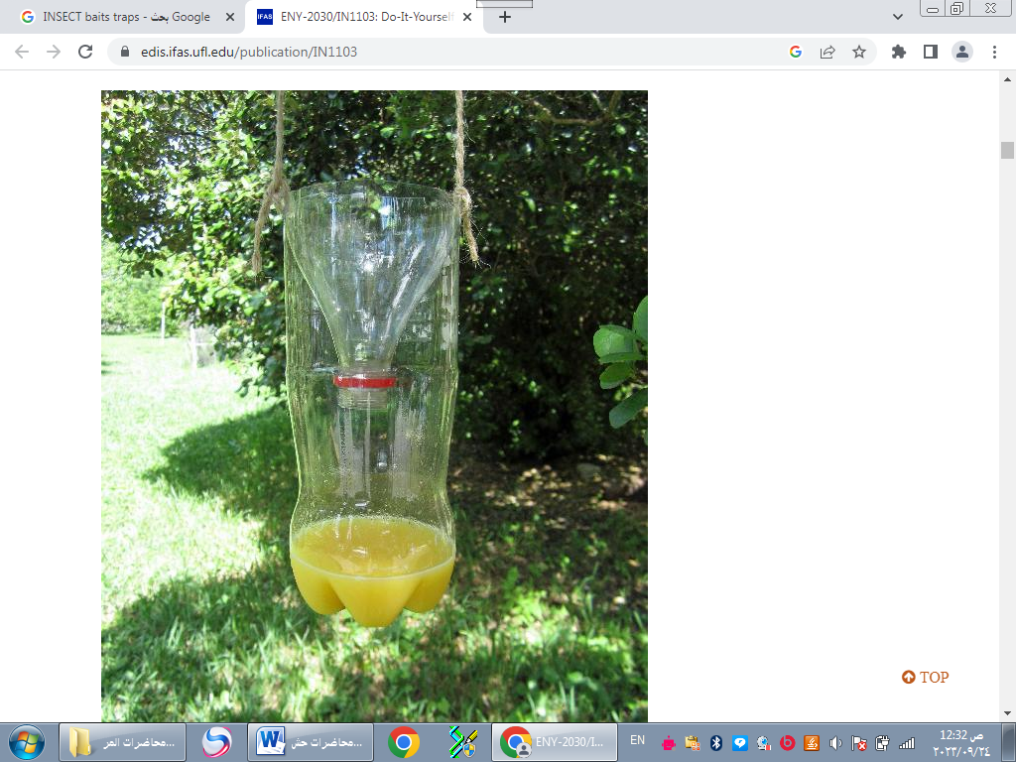

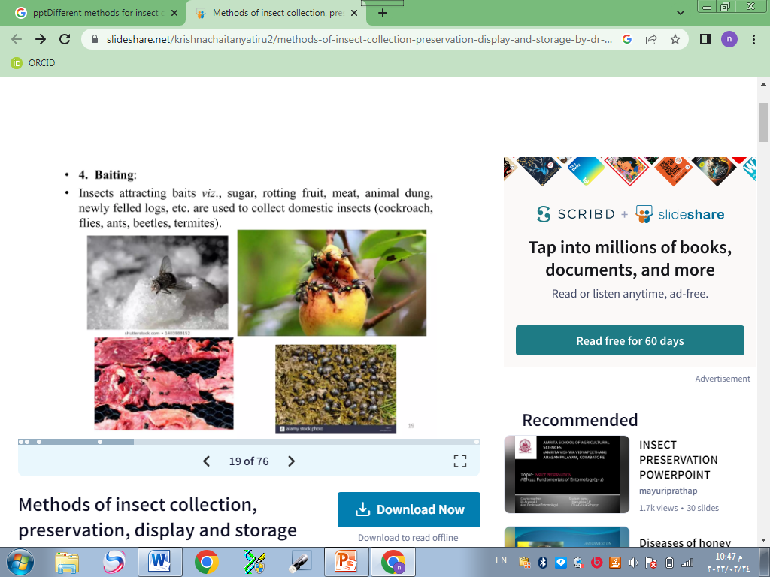

1. The Sieves:-

4-Seperater Funnel:-

5-The Aspirator:-

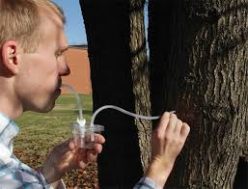

Killing insects

A- Freezing

This is a simple and efficient method that does not require any chemicals.

B- chemichals

Of all the products available, ethyl acetate is the best. It is a colorless liquid poison that is considered quite safe for humans.

C- Alchohol

insect that will displayed in alcohol may also be killed with alchohol. Larvae, soft-bodied adults and tiny beetles should be placed directly in 70% or 75% isopropyl alchohol.

**Spreading insects:-**

Entomologists depend heavily on patterns of wing venation to identify insects in the orders Odonata and Lepidoptera (butterflies and moths).  The wings of these insects must be "spread" in order to ensure that the venation is visible.

**Spreading board**:- are useful for laying the wings of insects out flat and holding them in place while the specimen dries.

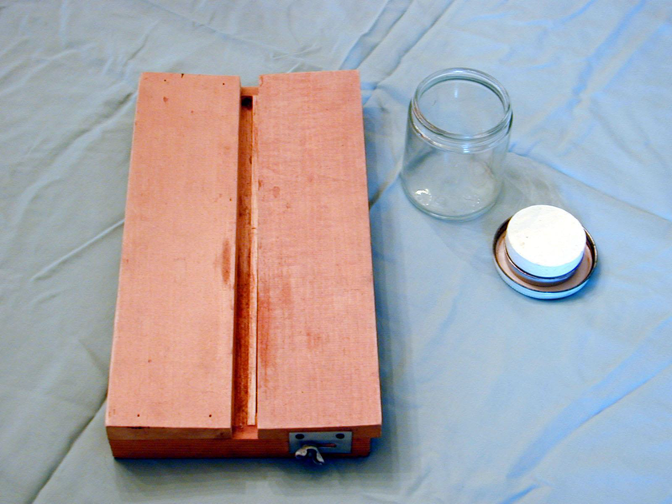

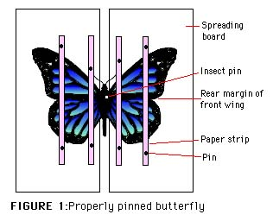

**Mounting insects**

|  |
| --- |
| **Large Insects**  Pin the insect, dorsal side up, so that precisely 10 mm of the shaft is free above the specimen.  Generally, the pin should pass through the insect's mesothorax, slightly to the right of center (see [Diagram of Pinning Locations](http://www.cals.ncsu.edu/course/ent425/course/syllabus/pinning/diagram.html) for different body types).  http://www.cals.ncsu.edu/course/ent425/course/syllabus/pinning/pinning1a.gif |

|  |
| --- |
| **Small Insects**  Small insect glued on their right sides to tiny paper triangles. Pick up the small insect carefully with forceps and mount it by touching it on its thorax (right side) to the drop of glue., then allow the glue to dry. You can also use nail polish instead.  Pins are placed as follows:  Most insects: pin through thorax to slightly to right of midline  True bugs: pin through scutellum slightly to right of midline  Beetles: pin through base of right wing cover (exit between mid and hind legs)  Butterflies, dragonflies, and damselflies: pin through middle of thorax |

## Data Labels

1. Top level -- **Date/locality label** (general to specific)
   * Lines 1 & 2:  Country, State, County, City
   * Line 3:  Date collected (day, month year in full as 1-1-2014)
   * Line 4:  Collector's name (initials and last name)
2. Second level -- **Identification label**
   * Give family name for pinned insects; order and family for insects in alcohol
3. .Third level (optional) -- **Ecological label**

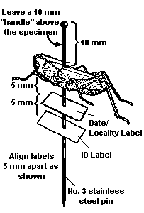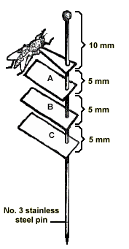

# Preserving Insects in Alcohol

Not all insects can be successfully mounted on a pin or a paper point.  Some are just too small (like thrips and lice); others are too delicate or fragile (mayflies and silverfish, for example).  Soft-bodied insects, such as aphids, and many immature stages (like maggots, white grubs, and caterpillars) will shrivel up and discolor or decompose if left to dry out on a pin.

All immature stages, all soft-bodied adults, and small insects should be preserved in 70% ethyl alcohol (ethanol) .

**Insect storage :-**

Always put naphthalene (moth balls) in your box of pinned insects to prevent contamination by ants or dermestid beetles

Lab2

|  |
| --- |
| **Body regions** |

|  |
| --- |
| **1-HEAD** |

**External view of the head**

The head have 5 segments united in one part called **Cranium** these segments or sclerites are:-

1-frons 2-vertex 3- clypeus 4- gena 5- sub gena

**1-Frons: -** It is the largest sclerite in the face lies between vertex in the top and clypeus in the bottom

**2-Vertex: -** It is very small sclerite in the top of head between the compound eyes

**3-Clypeus: -** It is the medium size lies between frons in the top and mouth part in the bottom

**4-Gena and sub gena:-**small sclerites in the lateral side of clypeus and frons

**Posterior view of head**

**-Occiput :** It is an inverted “U” shaped structure representing the area between the epicranium and post occiput .

**-Post occiput :** It is the extreme posterior part of the insect head that remains before the neck region.

**-Occular sclerites :** These are cuticular ring like structures present around each compound eye

[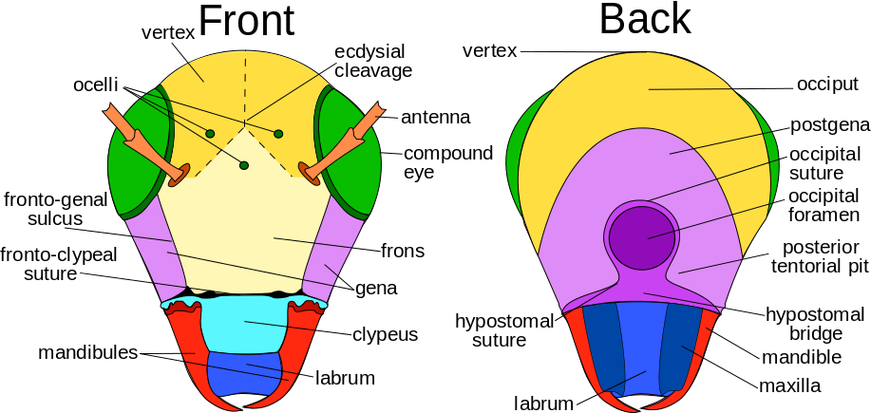](http://www.google.iq/url?sa=i&rct=j&q=&esrc=s&source=images&cd=&cad=rja&docid=KJtRqoIVBB7-OM&tbnid=OTbhnciABcQU7M:&ved=0CAUQjRw&url=http://en.wikipedia.org/wiki/Insect_morphology&ei=QSnBUqywBcqH0AXVtIHYBA&bvm=bv.58187178,d.bGQ&psig=AFQjCNH9hTTucnHree6jPQGi_bAtw384Ew&ust=1388476943293433)

.

**Sutures**

The common sutures present in head are:-

1) **Clypeolabral suture :** It is the suture present between clypeus and labrum..

2) **frontoclypal suture or epistomal suture:** The suture present between clypeus and frons

3) **Epicranial suture:** It is an inverted ‘Y’ shaped suture distributed above the facial region extending up to the epicranial part of the head. It consists of two arms

called **frontal suture** occupying the frons and stem called as **coronal suture.**

This epicranial suture is also known as **line of weakness** or **ecdysial suture**

because the exuvial membrane splits along this suture during the process of ecdysis.

4) **Occipital suture:** It is ‘U’ shaped or horseshoe shaped suture between epicranium and occiput.

5) **Post occipital suture:** It is the **only real suture** in insect head. Posterior end of the head is marked by the post occipital suture to which the sclerites are attached.

As this suture separates the head from the neck, hence named as real suture.

6) **Genal suture:** It is the sutures present on the lateral side of the head i.e. gena.

7) **Occular suture:** It is circular suture present around each compound eye.

8) **Antennal suture:** It is a marginal depressed ring around the antennal socket.

**-The head of insect are oriented in One Three Ways**

1- **Hypoganthous**: The long axis of the head is vertical . at right angle to the long axis of the body. The mouthparts point downwards e.g. grasshopper, cockroach.

2- **Prognathous**: The long axis of the head is horizontal and in line with the long axis of the insects body. The mouthparts are directed forwards e.g. beetle.

3- **Opisthognathos** The head is reflexed ventrally so that the mouth parts are directed backwards between the coxa of the front legs e.g. Red cotton bug.



**Head appendages**

Lab3

There are 2 appendages in the head

1. Antennae
2. Mouth parts

1- **Antennae**

The **antennae** are a pair of sense organs located near the front of an insect's head capsule. Although commonly called "feelers", the antennae are much more than just tactile اللمسية receptors. They are usually covered with olfactory الشم receptors that can detect odorرائحة molecules in the air (the sense حاسة of smell). Many insects also use their antennae as humidity sensors, to detect changes in the concentrationتركيز of water vapor.

Although antennae vary widely in shape and function, all of them can be divided into three basic parts:

1. [scape](javascript:void()) --the basal segment that articulates with the head capsule
2. [pedicel](javascript:void()) -- the second antennal segment
3. [flagellum](javascript:void()) -- all the remaining "segments"

[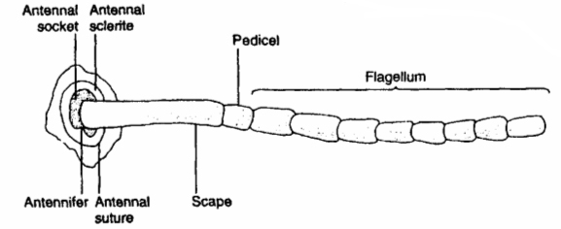](http://www.google.iq/url?sa=i&rct=j&q=&esrc=s&frm=1&source=images&cd=&cad=rja&docid=6BpW2VGMHFbyGM&tbnid=9nTicoY7RuLV3M:&ved=0CAUQjRw&url=http://www.entomology.umn.edu/cues/4015/morpology/&ei=5SsrUv7uKaiP0AXu1IGwAQ&bvm=bv.51773540,d.d2k&psig=AFQjCNGi1iJAzkHyY4dPCqkTXV9G8kRV0g&ust=1378647226615655)

|  |  |  |
| --- | --- | --- |
| **Example** |  | **Name** |
| Cockroach | Setaceous | **Setaceous** – Segments gradually decrease in size from base to apex |
| Grasshopper | http://www.cals.ncsu.edu/course/ent425/images/tutorials/external/antennae/inse025b.gif | **Filiform** -- thread-like each segment of flagellum similar in shape and size to the others |
| Termit | Moniliform | **Moniliform** -- bead-like segment in the flagellum is circular in shape |
| Stem borer beetles |  | **Serrate** – sawtoothed the segments are angled on one side giving the appearance of a saw edge |
| Butterfly | Clavate | **Clavate** -- gradually clubbed the segments become wider towards the tip of the antenna |
| Flour beetles |  | **Capitate** -- abruptly clubbed having the terminal joint forming a club, or knob |
| Scarab beetles |  | **Lamellate** -- nested plates  the segments towards the end are flattened and plate-like. This gives the appearance of a fan |
| Female Silk worm butterfly  Male Silk worm butter fly | Pectinate http://gvcocks.homeip.net/Lepidoptera/features/gvc1021c.jpg | **Pectinate** -- comb-like The segments are longer on one side. This gives the appearance of a comb  **Bipectinate** The segments are longer on two side . |
| Male Mosquitoe  Female Mosquitoe |  | **Plumose** – whorls of hairs arise from each joint of the segment each whorl contains number of hairs  Pilose:-looks like a plumose but each whorl contains less number of hairs |
| Wasp and Ants | carpant.jpg | **Geniculate** – the first segment (scape) is greatly elongated and flagellum always makes an angle with it |
| House flies |  | **Aristate** Antennae are small, microscopic3 segmented. 3rd segment enlarged and bears a bristle called **arista** on its dorsal side. |
| Horse fly | [http://www.entomology.umn.edu/museum/projects/Interactive_Keys/Intro_tutorial/GLOSSARY/Glossary_images/stylate.jpg](http://www.google.iq/url?sa=i&rct=j&q=&esrc=s&frm=1&source=images&cd=&cad=rja&docid=CsaRB7fgbTRAFM&tbnid=70QY-tjZ4MbOoM:&ved=0CAUQjRw&url=http://www.entomology.umn.edu/museum/projects/Interactive_Keys/Intro_tutorial/GLOSSARY/Stylate.html&ei=8cYwUpCABIqhtAbt0IDwDw&bvm=bv.52109249,d.Yms&psig=AFQjCNFHlm-kTFieebX6yrSM9XwrNXbUiA&ust=1379014743262216) | **Stylate** Antennae small 3-4 segmented.Terminal segment elongate into a bristle like structure called **style.** |