المختبر الثالث حذف
Lab 4
(Dogfish
) Shark Phylum : Chordata
Sub phylum : Vertebrata
Super class : Piesces
Class : Chondrichthyes
Sub class : Elasmobranchii
Order : Selachii
Genus : Squalus acanthias

The Dogfish or shark is belong to phylum Chordata meaning it has a notochord. It is a jawed vertebra in the class chondrichthyes; meaning it has a flexible skeleton made of cartilage. The shark has a graceful and streamlined body shape built for fast, long distance swimming.
1- The body is divided into the head, trunk, and tail. 2- Placoid scales (dermal denticles) are covering the skin of sharks. The snout is at the anterior end. The opening to the mouth of sharks is always on the underside. 3-The external nostrils are located on each side of the head and leads to larger internal nostrils. Eyes are large in sharks and are located at both sides of head. The shark's body is dark gray above and almost white below. 4- Sharks have 5-7 pairs of gill slits located on the sides of their heads. Unlike bony fish,
5-they do not have gill covers. 6- Some sharks have spiracles,: تعريفها :which are special gill slits appear like small openings located just behind the eyes.
(gill slits وظيفة الخياشيم )These openings allow water to pass through the gills even when the shark’s mouth is closed.

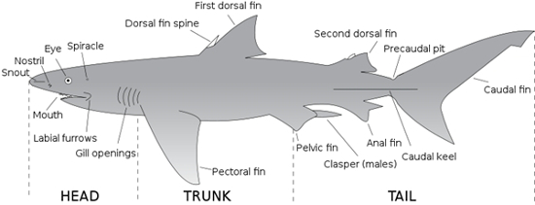
Shark's fins
Most sharks have five different types of fins, while some sharks only have four. These types of fins include:
1-Pectoral Fins الكتفية
At the front of the shark behind its head, are the pectoral fins.Sharks use these fins to lift and steer them while they swim وظيفة الزعنفة الكتفية

2-Pelvic Fins الحوضية
Behind the pectoral fins, are the pelvic fins, also found on either side of the cloaca.
In male sharks,(( the posterior parts of pelvic fins are modified into tube-like copulatory organs called claspers which are necessary for the reproduction process)).
تعريف ال clasperالسطرين باللون الاخضر

3- Dorsal Fins
Dorsal fins are the ones that most people are familiar with; these fins are often seen when a shark is at the water’s surface. Anterior dorsal fin is larger than the posterior dorsal fin. There are two spines, one immediately in front of each dorsal fin. The spines carry poisons secreted by glands at their base and are mainly used in defense.
4-Anal Fins
For some sharks, these fins are not enough to completely stabilize them. Therefore, the anal fin is present to provide additional stability to the sharks that possess them. The anal fin is located between the pelvic and caudal fins on the bottom, or ventral, part of the shark.
5-Caudal Fins
The shark having the ability to propel itself through the water, they utilize what is called the caudal fin. This fin, also known as the tail fin. The caudal fin is divided into two lobes: a larger dorsal lobe and a smaller ventral lobe. This type of tail is known as a heterocercal tail.
Shark's senses
1-Smell
Sharks have an acute sense of smell. Paired external nostrils with internal and external openings lead to ventral olfactory organs. Sharks have ability to detect minute quantities of substances such as blood in the water; also can detect a concentration as low as one part per billion of some chemicals.

2-Hearing
Shark external ears are hard to see, they are just two small openings behind and above the eyes. The ears may be small, but they’re powerful. Inside, there are cells that can sense even the tiniest vibration in the surrounding water. Sharks may track sounds over many miles.
3-Eyesight
Sharks have good eyesight for being in the water, so they can see well during the day or the night. Upper and lower eyelids also protect the eye. Sharks that live deeper in the oceans usually have larger eyes than those that live nearer the surface.
4-Taste
Many sharks rely heavily on their sense of taste. Before these sharks eat something, they will give it a "test bite" first. The sensitive taste buds clustered in the mouth analyze the potential meal to see if it's palatable. Sharks will often reject prey that is outside their ordinary diet, after this first bite.
5-Lateral line مهم جداا
The lateral line system is a series of fluid-filled canals just below the skin of the head and along the sides of the body. The canal is open to the surrounding water through tiny pores. The lateral line canals contain a number of sensory cells called neuromasts. Tiny hair-like structures on the neuromasts project out into the canal. Water movement created by turbulence, currents, or vibrations displaces these hair-like projections and stimulates the neuromasts. This stimulation triggers a nerve impulse to the brain.
وظيفة الخط الجانبي
The lateral line senses low-frequency vibrations. It functions mainly in distance perception and detecting low-frequency vibrations and directional water flow.
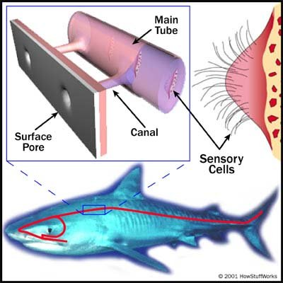
الرسم مطلوب

مطلوب الرسم Lateral line

- Ampullae of Lorenzini
The ampullae of Lorenzini form a complex and extensive sensory system around a shark's head. External pores cover the surface of a shark's head. Each pore leads to a jelly-filled canal that leads to a membranous sac called an ampulla. In the wall of the ampulla are sensory cells innervated by several nerve fibers.
Ampullae وظيفة ال
1- The ampullae detect weak electrical fields at short ranges. 2- All living organisms produce electrical fields. 3- ampullae of Lorenzini may also detect temperature, 4- changes in water pressure, 5- mechanical stimuli, and magnetic fields.
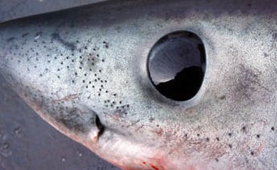
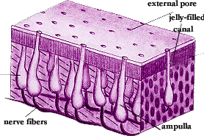

مطلوب الرسم الثاني Ampullae of Lorenzini

