Thorax
Lab5
The insect thorax is divided into three parts: the prothorax (pro=first), mesothorax (meso=middle), and metathorax (meta=last). Each segment consists of hardened plates, or sclerites. Dorsal sclerites are called nota (sing. notum) (pronotum, mesonotum, and metanotum), lateral sclerites are called pleura (sing. pleuron), and ventral sclerites are called sterna (sing. sternum) (prosternum, mesosternum, and metasternum)..
Each of the three thoracic segments contains one pair of legs. Wings are found only on the meso- and metathoracic segments.
The Thoracic Appendages

1-Legs
Most insects have three pairs of walking legs - one pair on each thoracic segment. Each leg contains five structural components (segments) that articulate with one another by means of hinge joints:
1- Coxa 2- Trochanter 3- Femur 4- Tibia 5- Tarsus
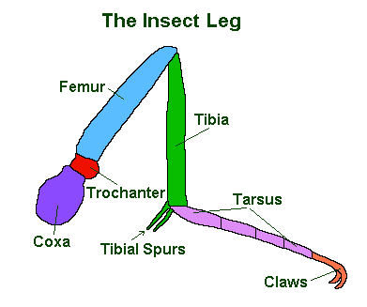
The term pretarsus refers to the terminal segment of the tarsus

Leg Adapations and Modifications:
Characteristic | Appearance | Example(s)
Walking legs-- adapted for walking | 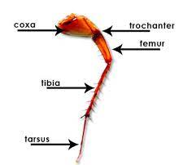 | All legs  Cockroaches
Raptorial(grasping)femur spinose and possess a central longitudinal groove.Tibia narrow, blade like spinose and fits into the groove of femur adapted for catching and holding prey | 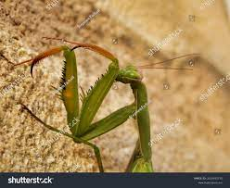 | Front legs Praying mantis
swimming legs -- Hind legs pad like. Tibia and tarsus short and broad having dense long marginal hairs. adapted for swimming | 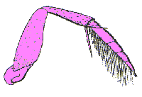 | Hind legs  Water beetles
digging legs -- Tibia and tarsus short and broad with teeth adapted for digging in soil | 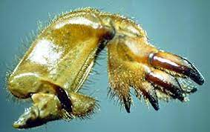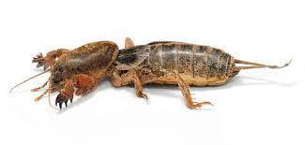 | Mole crickets
jumping legs :- Femur and tibia elongated adapted for jumping | 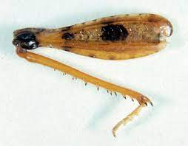 | Grasshopper
Clinging legs:- Tibia possess tibial thumb.  Tarsus single segmented and pretarsus with a single long curved claw | 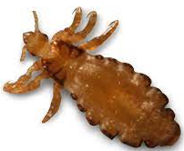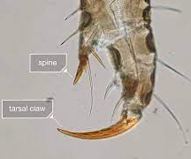 | Head louse
Cleaning legs:- Tibia possess a movable spine, and the first tarsal segment with a semicircular notch  Collecting legs:-first tarsal segment enlarged and possess short stiff hairs called pollen basket | 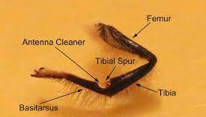  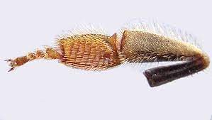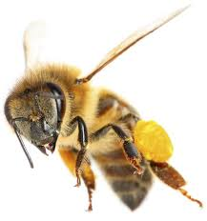 | Front leg honey bee  Hind legs honey bee

