**Microbiologic Examination tests:**

**1- KOH test:**

Potassium hydroxide (KOH) solution, being alkaline, has the ability to dissolve keratin that is scraped from the outer layer of skin, which allows the microscopic identification of organisms such as dermatophytes or scabies, helping to establish the correct diagnosis and facilitating effective treatment.

**Procedure:**

1- Place the specimen on a clean glass slide.

2- Add 1 drop of 20% KOH

3- Place the cover glass on top of the slide and gently press to get rid of any air bubbles

4- Place slide on the microscope stage and start with a low-power (10 ×) examination

5- Examine for fungal structures such as hyphae or yeast

The KOH preparation test used to find out if you have a fungal infection. This kind of infection can happen in various parts of the body, such as the skin, nails, mouth, or vagina.



Figure1:KOH test of *candida sp.*

**2-Calcofluor white stain test:**

Calcofluor white is a chemifluorescent blue dye. It functions by being able to bind to 1-3 beta and 1-4 beta polysaccharides on chitin and cellulose that is present in cell walls on fungi, plants, and algae. Due to the speed in examining the cells, the stain was replaced by Potassium Hydroxide (KOH), which is quicker used to stain fungal and parasitic elements and to observe the presence of fungal and parasitic elements under a fluorescent microscope

**Procedure**:

1- Carefully put the specimen on a clean glass slide

2- Add a drop of Calcofluor white stain to produce an intense fluorescence

3-Add one drop of 10% Potassium Hydroxide

4- Cover the specimen with a coverslip and leave it to absorb the stain for 1 minute

5- Remove excess dye with a dry paper towel by gently pressing on the stain

6- Observe the stain under ultraViolet rays at x100-x400 magnification.

Fungi, Pneumocystis cysts, and parasites appear brilliant apple-green under UV fluorescent microscope, Violet and Blue light .



**Figure2:** Calcofluor white stained: The fluorescent staining of *candida albican* with calcofluor white. It shows a vivid blue color for the cell walls.

**3- India ink test:**

A diagnostic test used to detect the cryptococcal organism such as*Cryptococcus neoformans*. A dye, called India ink, is added to a sample like Cerebrospinal fluid (CSF), and if the fungi is present, they will become visible as the dye binds to the capsule surrounding the fungus

**:Procedure**

1-place a drop of India ink on to a clean glass slide

2-Add 1 drop of the specimen or liquid culture or rub a speck of material on the slide surface just beside the ink before mixing it into the ink. Sputum or pus can be cleared with KOH and heat and then mixed with India ink

**Note:** If preparation is too dark, it may be diluted with a small drop of water

3-Place a cover slip over the smear avoiding air bubbles, press it down gently through a sheet of blotting paper so that the film becomes very thin and pale in colour

4- Examine with a high-power lens (phase-contrast microscope) for the presence of encapsulated cells.



Figure3:Microscopy of CSF( India ink)

**4- Culture test:**

1- Culture the fungus On Sabouraud’s agar medium

2- Incubated at room temperature For 21 days: Fast growers e.g, *candida sp.*, 2-3 days Slow growers e.g, *Trichophyton violaceum*, Macroscopic examination of colonies that grow on culture media and microscopic examination of slide mounts from culture often allow the identification of fungus

Culture for optimal recovery of fungal pathogen, the followings are added (Cycloheximide) is added to inhibit the growth of rapidly growing contaminating molds. An antibacterial agent (Chloramphenicol) is commonly added to control bacterial contamination.



Figure 4*:T.violaceum* on Sabouraud’s agar medium

5- **GMS test**:

Grocott-Gomori’s Methenamine Silver stain is a histological stain that is used majorly for the identification of carbohydrates in fungal microorganisms. GMS tissue staining is often used in combination with microbiologic culture for diagnosis of fungal infections in people and animals .One advantage of GMS is that it produces better staining contrast in tissues sections, and detects even degenerated and dead fungi The fungal species will stain black due to the reduction process of the silver nitrate solution. Silver nitrate solution after reduction forms silver ions which are black in color, thus producing a black stain for fungal cells.



Figure5: GMS test of *Aspergillus sp.*

**6-Giemsa stain test:**

Giemsa stain is used to obtain differential white blood cell counts It is also used to differentiate nuclear and cytoplasmic morphology of the various blood cells like platelets, RBCs, WBCs. Giemsa stain is used for staining *Histoplasma capsulatum*, *Penicillium* used in cytogenetics and for the histopathological diagnosis of malaria and other parasites.

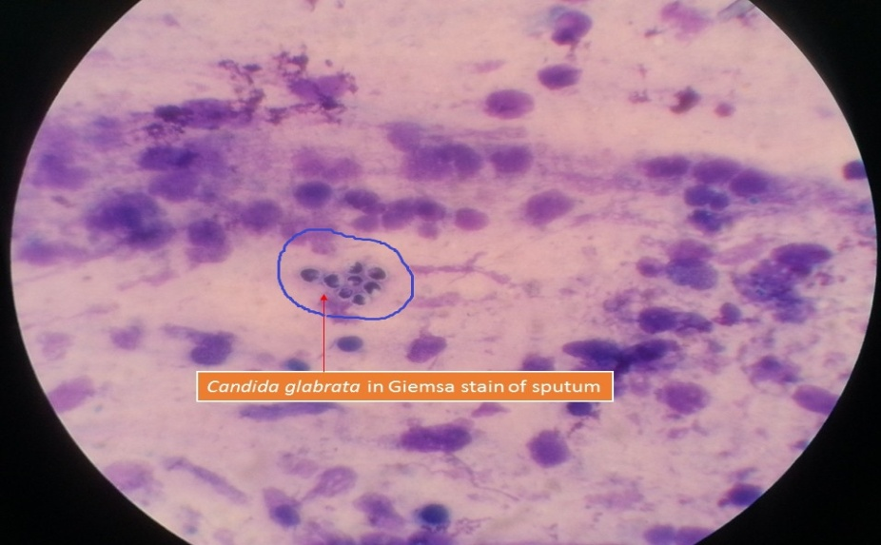

Figure (6) *Candida glabrata* in Giemsa stain of sputum

**7- Gram stain test**

Is a laboratory procedure used to detect the presence of bacteria and sometimes fungi in a sample taken from the site of a suspected infection.

Fungi (in the form of yeasts or molds) may be seen on a Gram stain and are reported. Yeast may appear as single cells that may have buds, while molds may appear as a wide variety of plant-like branches called hyphae. Further testing may be performed to identify the specific type .

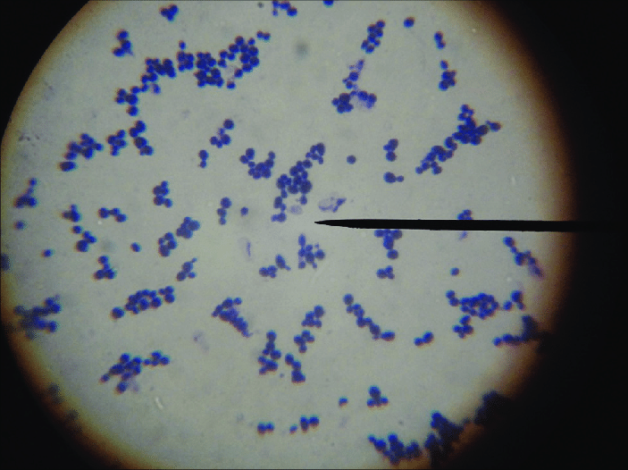

Figure (7) Gram positive budding yeast cell

8- **Periodic acid-Schiff (PAS)**

Detects glycogen in tissues, fungal walls contain large amounts of glycogen and thus PAS can be used for screening for fungal organisms .

the cell walls of fungi stain magenta; this only works on living fungi .In contrast, Grocott's methenamine silver stain (GMS) will stain both living and dead fungal organisms.

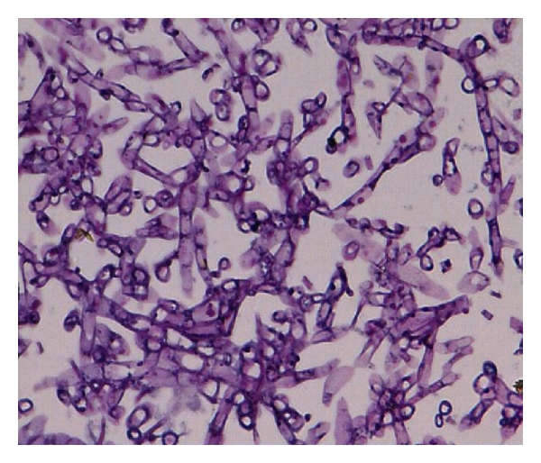

Figure (8) PAS stain show septa , fungal hyphae

9- **Hematoxylin and eosin (H&E) stain**

Used in pathology to show tissue morphology; in the case of fungal infections, this stain helps identify the inflammatory host reaction, such as multinucleated giant cells, necrotic material, most fungi can be observed with this stain, particularly the nuclei of yeast-like cells or if the fungus is naturally pigmented

All fungi show pink cytoplasm, blue nuclei .

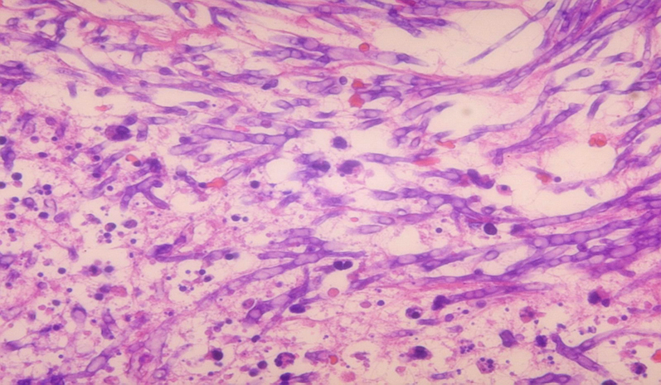

Figure (9) **(H&E) stain show some** fungal hyphae

**Another techniques like :**

• **Antibody detection • Antigen detection** typically involves measuring the level or titer of antibody. Serological tests ELISA,

• **Molecular techniques** may be used to detect the genetic material of the fungus causing the like such as DNA hybridization, PCR.