**Experiment No. (1)**

**(** psychrometer **)))**

**The theoretical part:**

The psychrometer consists of two adjacent thermometers, one of which is completely dry and is called a dry thermometer, while the other thermometer is surrounded by a piece of muslin at the end of it that is completely immersed in ice water and is called a wet thermometer. The drier the air, the greater the evaporation process, and the greater the difference between the readings of the two thermometers. One of the important factors in the evaporation process is the strength of the ventilation or the wind speed surrounding the end of the wet thermometer.

As a more clarification, the psychrometer device consists of two thermometers suspended inside a chrome cylinder, and each thermometer is surrounded by two metal tubes with one axis, where air is drawn through them at the top of the device by means of an air pump. Submerge the piece of tissue well in distilled water. Then open the switch located at the top of the device to operate by the air fan and we wait until the wet thermometer is installed, then we record a reading.

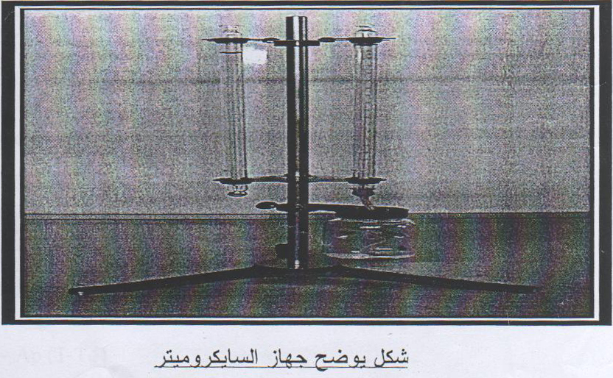

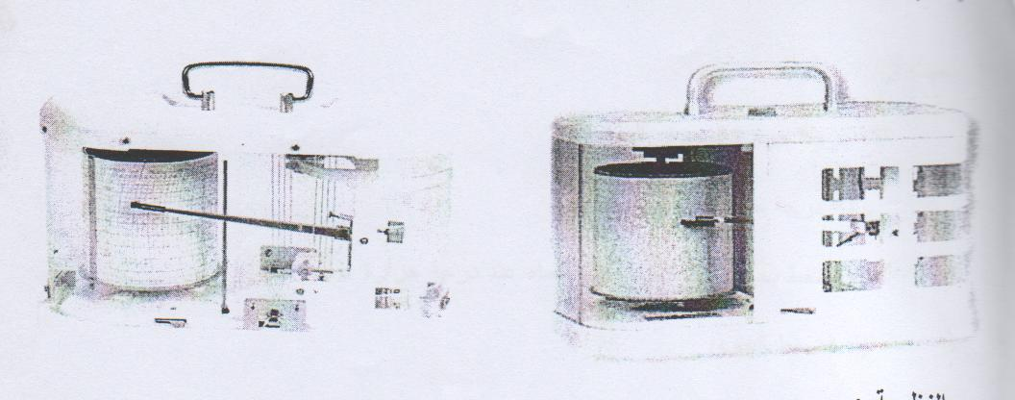

**the theory :**

The bulb temperature ($T_{W}$) is defined as the temperature to which the air cools to evaporate the water in it under constant pressure until saturation is reached. If we consider a sample of moist air composed with one gram of dry air and (W) one gram of water vapor, we can apply the following relationship from the first law of thermodynamics.



The evaporation( $d_{w}$) of a gram of water accompanied by a loss of heat gives the following equation :





And simplify the equation :



By integrating the equation, we get:



Or in terms of water vapor pressure:



**Whereas:**

T = Dry thermostat temperature.

${ T}_{w}$ = Wet thermometer temperature.

e = The pressure of saturated water vapor above water at a temperature $T_{w}$

. *P* = Atmospheric pressure

L = Latent heat of vaporization.

= Specific heat under constant pressure. $C_{p}$

E = partial pressure.

$e_{s}$ = saturated vapor pressure



For practical calculations, the following relationship can be used, assuming that 





**Common mistakes to try:**

1- The error resulting from the thermal conduction process of the thermometer.

2- As a result of the speed of ventilation.

3- If the muslin piece is thick.

4- The piece of muslin is not clean.

**Calculations and practical results:**



Saturated vapor pressure joules/Kelvin. mall . 



$${}_{}r$$

( T ) : Dry thermostat temperature.









(latent heat of adaptation ) L =



$ε$ It is the ratio between (R),(Rs) wheras $ε=0.622$

( R) = It is the gas constant, i.e. the gas constant for evaporation of water.

(Rs) = is the gas constant of saturated water vapor.

*( p* *)* = 1000mb .









**Whereas:**

mixing ratio = 

: vapor  density

 The gas constant and its value is

 **joules /degree Kelvin. mall.**



**Whereas:**

(RH) = relative humidity.