**Experiment No. (2)**

**solar map )) ))**

**:The theoretical part**

The solar map can be used to determine the path of the sun during the day, as well as to find the value of the angle of the sun's elevation and the sun's azimuth for any hour of the day and for any day of the year.

Figure No. (1) shows a solar map of the latitude north of the equator, where it is noted that the timing is determined by some curves, so that the timing of noon is in the middle and in the right before noon and in the left in the afternoon, and the circles of the center represent the angle of elevation of the sun and the gradation on the circumference circle represents the angle of the azimuth of the sun.

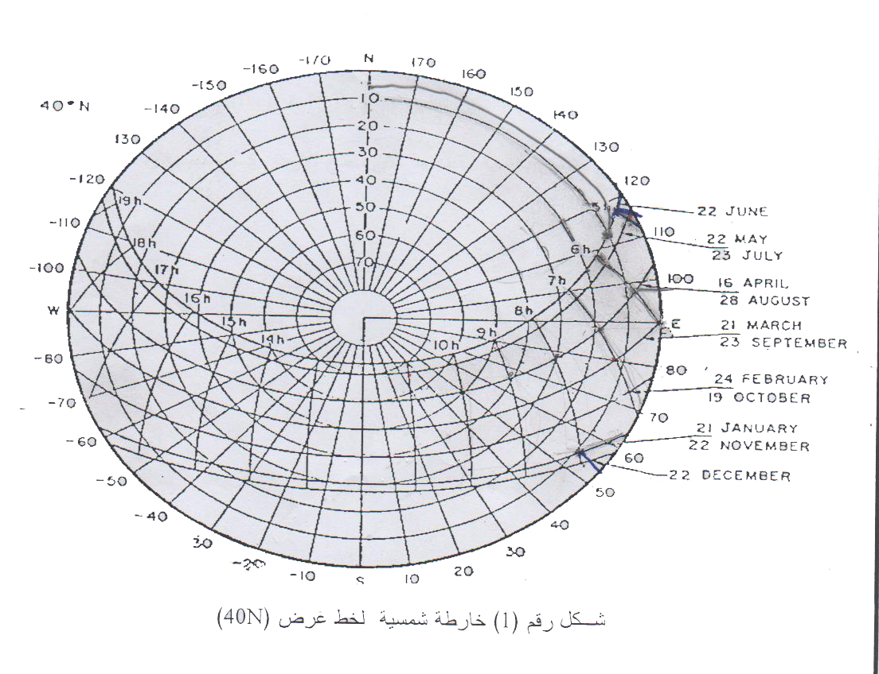

The angle of elevation of the sun is determined from the intersection of the curve representing the timing with the curve representing the path of the sun and then the angle of the azimuth of the sun is determined by connecting the center of the circle to the point of intersection and its extension on the circumference.

The angle of elevation of the sun is defined as the angle in degrees between the line connecting a point on the surface of the earth and the center of the sun and the horizontal plane that passes through the mentioned point on the surface of the earth, Its value ranges from.

As for the azimuth angle of the sun, it is defined as the angle in degrees between the line passing through the point on the surface of the earth and heading south and the horizontal projection of the line connecting the point on the surface of the earth and the sun.

As follows: The value of the azimuth angle is between

at noon 

After noon Before noon,  

Both angles determine the position of the sun in relation to a point on the Earth's surface, and it is also easy to know the amount of solar radiation received by a particular point.

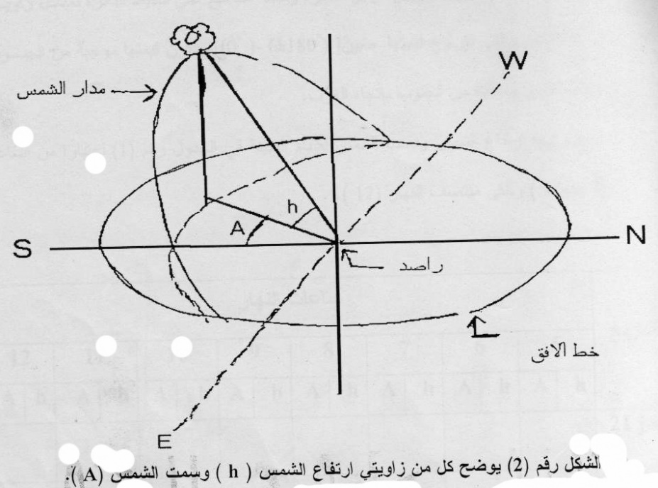

**The method of work:**

North of the equator Using the solar map of latitude

the sun's elevation angles are used (h) and marked the sun (A) And as follows:

1- We determine the solar path for the month for which the sun's elevation angle and the sun's azimuth angle is calculated.

2- Determine the point of intersection of this path with the hours of the day.

3- Determine the circles on which the point of intersection lies, which represents the angle of elevation of the sun (h) , Each circle represents (10 degrees) so that the outer circle represents (zero degrees) and then begins to increase regularly until it reaches the center of the circles (the line of intersection of the two axes), which represents (90)).

4- The extension of the straight line connecting the center of the circle and the point of intersection on the circumference of the circle represents the azimuth angle of the sun, whose value ranges between

Its value is positive from south to east and negative from south to west.

5- Finding the sun's elevation angle and sun azimuth for the days shown in Table No. (1), starting from (5 am) until midday (12).

