The Tenth Experiment
THE SPECIFIC HEAT OF SAND VERSUS WATER

The Objective of the experiment:
Explore the effect of energy on the temperature of sand and water via determining the rate of heating and cooling for both sand and water which are affected by their heat capacities in order to understand how land/sea breeze created.

The Used Equipments:
- Two pans.
- 100 ml of water.
- 100 ml of sand.
- Heat source (Desk heating lamp).
- Wireless temperature sensor.
- Stop watch

The Theoretical Part:
There is a contrast in temperature over land and water bodies, for example on the beach the temperature of water is not the same as the temperature of the sand or the rocks, why? Specific heat is the key.
The specific heat of a substance is the amount of heat needed to raise the temperature of one gram of a substance by one degree Celsius. Consequently, water has a much higher specific heat than either of these substances. Water not only heats more slowly than land, it cools more slowly as well, and so the oceans act like huge heat reservoirs. Thus, water needs to absorb a lot of energy before its temperature changes. Sand and asphalt, on the other hand, have lower specific heats. This means that their temperatures change more quickly.
During the day, the land heats more quickly than the adjacent water, and the intensive heating of the air above produces a shallow thermal low. The air over the water remains cooler than the air over the land; hence, a shallow thermal high exists above the water. The overall effect of this pressure distribution is a sea breeze that blows from the sea toward the land. Since the strongest gradients of temperature and pressure occur near the land-water boundary, the strongest winds typically occur right near the beach and diminish inland. Further, since the greatest contrast in temperature between land and water usually occurs in the afternoon, sea breezes are strongest at this time. At night, the land cools more quickly than the water. The air above the land becomes cooler than the air over the water, producing a distribution of pressure. With higher surface pressure now over the land, the wind reverses itself and becomes a land breeze: a breeze that flows from the land toward the water. Temperature contrasts between land and water are generally much smaller at night, hence, land breezes are usually weaker than their daytime counterpart, the sea breeze. In regions where greater nighttime temperature contrasts exist, stronger land breezes occur over the water, off the coast. They are not usually noticed much on shore, but are frequently observed by ships in coastal waters.

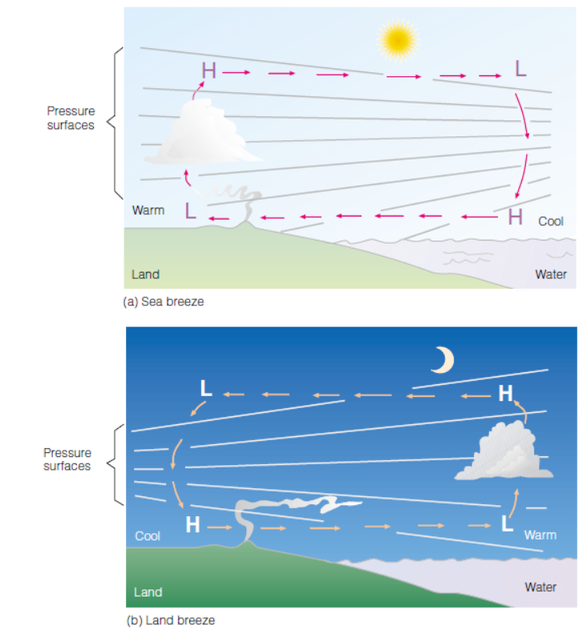

The Practical Part:

- Fill one of the pans with sand and the other with water at room temperature.
- Place the heat lamp over the sand pan.
- Set the stop watch to stop after 10 minutes and turn on the heat lamp.
- As soon as the lamp over the sand is turned on, record the temperature change observed in one-minute intervals for 10 minutes. Expect to see a variance in temperature readings. Always take the highest number when recording the temperature every minute. For example, if the temperature reading fluctuates as follows: 30, 32 and 31, then record the highest number, 32, as the current temperature. Record your data in the data section chart titled “With lamp (sand probe).”
- After 10 minutes, turn off the lamp and remove it from over the pan of sand and record the temperature change of the sand every minute for another 10 minutes. If the lamp is not completely removed, then the residual heat from the light bulb continues to heat the sand although the light is turned off. Remember to always take the highest temperature reading, as explained earlier. Record your data in the data section chart titled “Without lamp (sand probe).”
- Place the heat lamp over the water pan.
- Set the stop watch to stop after 10 minutes and turn on the heat lamp.
- As soon as the lamp over the water pan is turned on, record the temperature change observed in one-minute intervals for 10 minutes. Remember to always take the highest temperature reading, as explained earlier. Record your data in the data section chart titled “With lamp (water probe).”
- After 10 minutes, turn off the lamp and remove it from over the pan of water and record the temperature change of the water every minute for another 10 minutes. Remember to always take the highest temperature reading, as explained earlier. Record your data in the data section chart titled “Without lamp (water probe).”
- Use graph paper to create a multi-line graph to display your data, where the time on x-axis and the temperature on y-axis.

Discussion:
- Which substance heated up faster?
- Which substance cooled off faster?
- If both substances received the same amount of heat energy, why were there differences in their heating rates?
- Why are there differences between the cooling rates of sand and water?
- Discuss your results with the values of specific heat of sand and water.

Time (min) | Temperature (°C) with lamp (sand probe) | Temperature (°C) with lamp (water probe)
1
2
3
4
5
6
7
8
9
10
 | Temperature (°C) without lamp (sand probe) | Temperature (°C) without lamp (water probe)
11
12
13
14
15
16
17
18
19
20

Can we add the calculation of the amount of absorbed energy for water and sand using this equation?

Specific Heat Capacity Formula
Q = C m ∆t
Where
- Q = quantity of heat absorbed by a body
- m = mass of the body
- ∆t = Rise in temperature
- C = Specific heat capacity of a substance depends on the nature of the material of the substance.
- S.I unit of specific heat is J kg⁻¹ K⁻¹.
- Specific Heat Capacity Unit
Heat capacity = Specific heat x mass
- Its S.I unit is J K⁻¹.

Or we can ask the student to calculate the heat capacity with different values of mass

