Bacterial toxins
Bacterial toxins : are proteins capable of achieving multiple remarkable tasks. They function as separate molecular devices, targeting specific cells in an organism, punching holes in their membranes, or modifying intracellular components. Intoxication processes involve highly specialized steps of great complexity.

Methods of investigations for toxins
Methods of investigations for toxins can be divided into four axes
1. Culture method (bacteriological).
2. Biological method.
3. Immunological methods.
4. Molecular methods which includes the Polymerase chain reaction (PCR).

Exotoxin
Exotoxins : are a group of soluble proteins that are secreted by the bacterium, enter host cells, and stimulate to modification of a host cell components to change the host cell physiology. Both Gram-negative and Gram-positive bacteria produce exotoxins .
Culture method (bacteriological)
Agar well diffusion method
Agar well diffusion method is widely used to evaluate the antimicrobial activity of plants or microbial extracts .
Similarly to the procedure used in detect exotoxin.

Method
1. prepare substrate agar medium contain 1% substrate(blood , protein ,ect.) and 2.5 % nutrient agar .
2. Then ,a hole with a diameter of 6 to 8 mm is punched aseptically with a sterile cork borer or a tip.
3. a volume (20–100 mL) of sterile bacterial supernatant or ( bacterial suspention ) put into the well.
4. Then, agar plates are incubated under suitable conditions depending upon the test microorganism .
5. The exotoxin diffuses in the agar medium and degradation of substrate.

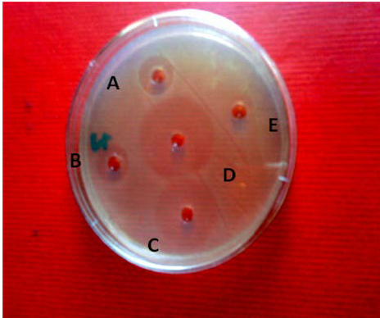
Figure (1) Agar well diffusion method

