Hemolysins

Certain bacterial species produce extracellular enzymes that lyse red blood cells in the blood agar (hemolysis). These hemolysins (exotoxin) radially diffuse outwards from the colonies causing complete or partial destruction of the red cells (RBC) in the medium and complete denaturation of hemoglobin within the cells to colorless products.

Blood Agar and Hemolysis

- Blood agar is an enriched nutritious medium that supports the growth of fastidious organisms by supplementing it with blood or as a general medium without the blood.
- The blood added to the base provides more nutrition to the medium by providing additional growth factors required for these fastidious organisms.
- The blood also aids in visualizing hemolytic reactions of different bacteria. The hemolytic reactions, however, depend on the type of animal blood used.
Hemolysis is the lysis of red blood cells in the blood due to the extracellular enzymes produced by certain bacterial species. Types of hemolysis are:

1. Alpha hemolysis
- Alpha hemolysis is defined by a greenish-grey or brownish discoloration around the colony as a result of the partial lysis of the red blood cells.
- Some of the α-hemolytic species are a part of the human normal flora, but some species like Streptococcus pneumonia cause pneumonia and other such severe infections.

2. Beta hemolysis
- Beta hemolysis is defined by a clear zone of hemolysis under and around the colonies when grown on blood agar.
- The clear zone appears as a result of the complete lysis of the red blood cells present in the medium, causing denaturation of hemoglobin to form colorless products.
- β-hemolytic bacteria include group A streptococci like S. pyogenes and group B streptococcus like S. agalactiae, both of which are associated with severe infections in humans.

3. Gamma hemolysis
- Gamma hemolysis is also called non-hemolysis as no lysis of red blood cells occurs.
- As a result, no change of coloration or no zone of hemolysis is observed under or around the colonies.

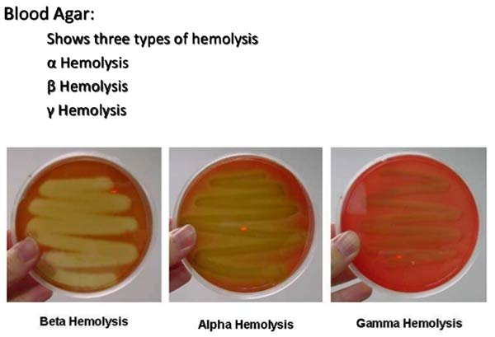

Preparation of Blood Agar
- About 40 grams of the prepared medium is added to 1000 ml distilled or deionized water.
- The suspension is heated up to boiling to dissolve the medium completely.
- It is then sterilized by autoclaving it at 15 lbs pressure and 121°C for about 15 minutes.
- The medium is then taken out of the autoclaved and cooled to about 40-45°C.
- To this, 5% v/v sterile defibrinated blood is added aseptically and mixed well.
- The media is then poured into sterile Petri plates under sterile conditions.
Hemolysin production from bacterial isolates
1 .Plate Method (agar medium)
1.Bacterial suspensions in sterile saline matching to 1.5 x 108 CFU/ml were done from 18 h cultures of bacteria.
2.10μl of each suspension was dropped on the surface of the blood agar medium and was incubated at 37°C for 16h.
3.After 16 h, the hemolysis was examined.

2.Spectrophotometric Method (liquid medium)
1.The hemolysin production was detected in liquid medium by spectrophotometric method described .
2.Produced hemolysin over-night in Nutrient broth 37ºC. 3.Twenty μl of bcteria was compared to 0.5 McFarland was added to 1980 μl of Nutrient broth and incubated at 37 ºC for 24 h

Red blood cells suspension were prepared :
1.by washing (2 ml of blood) with(8ml PBS buffer) 3 times in centrifugation at 3000 rpm for 5 min,
2.then the sediment suspended in PBS buffer (0.8 ml RBC were added to 9.2 ml PBS buffer) for hemolysin presence, collect the supernatants, and the hemolysin production was measured by spectrophotometer at 571 nm .
3.sample compared to (OD) for Complete hemolysis of RBC,(Complete hemolysis of RBC was carried out by adding 1% Triton X-100).

