Terminology - Bacteriology 3rd Lecture
Dr. Mohammed AboKsour

Microbiologists and other scientists use a lot of terms to explain and identify one organism from another and to group organisms that are similar based on factors that are important to them.
There are a lot of different reasons why germs are put into groups. Bacteria can be put into groups using a lot of different typing methods because they are so different. We will try to understand most of the terms used to describe bacteria and their traits in this lesson.
- Biochemical characteristics:
A lot of the time, the way bacteria respond in a series of biochemical tests is used to identify and classify them. Some tests, like oxidase, nitrate reduction, amino acid degrading enzymes, fermentation, or utilization of carbohydrates, are used all the time for a lot of different types of bacteria. Other test, like the coagulase test for staphylococci is only used for one family, genus, or species.

- Gram positive or negative bacteria:
The Gram stain is the only one that has passed the test of time among all the different ways to classify things. A lot of clinically important bacteria can be put into two groups: Gram-positive and Gram-negative. This is done by looking at their shape and how they colour differently.
Gram-positive bacteria stain as blue-purple bacteria, and Gram-negative bacteria stain as red bacteria.
It is thought that the difference between the two groups is because Gram positives have a much bigger peptidoglycan (cell wall). So, the shape and staining qualities of bacteria can be used to tell them apart.
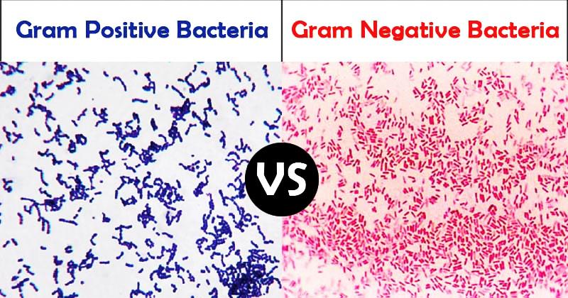

- Cocci and Bacilli:
Based on their shape, bacteria are mainly classified into four main groups. coccus, bacillus, spirilla, and vibrio.

A) Cocci: These varieties can stay as a single cell or stick together in different ways. Here are some of them:
- Monococcus: like Micrococcus sp.
- Diplococcus: like Diplococcus pneumonia
- Streptococcus: like Streptococcus pyogenes
- Tetracoccus: like Gaffkya tetragena
- Staphylococcus: Staphylococcus aureus.
- Sarcina: Sarcina lutea.
B) Bacilli: These are bacteria that are rod-shaped or cylinder-shaped and stay alone or in pairs. Bacillus cereus is an example.

C) Vibro: vibro bacteria are bent and shaped like commas. They are grouped into a single genus. Vibro cholerae.

D) Spirilla: These bacteria are spiral-shaped and have tails at the ends. Spirillum volutans.
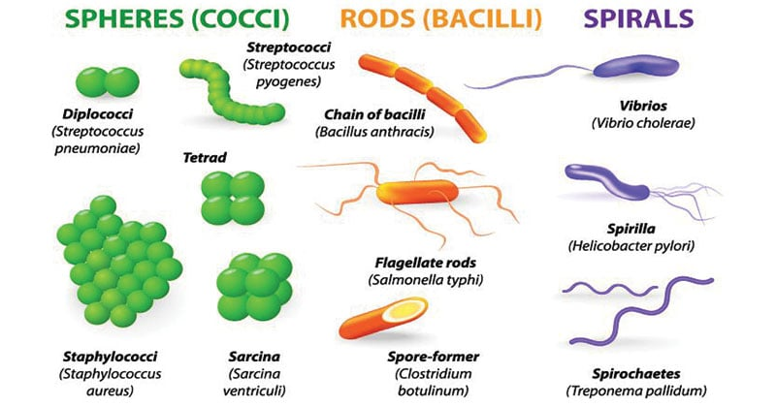

- Mode of Nutrition:
A: Phototrophs: They are bacteria that get their energy from light.
B: Chemotrophs: These bacteria get their energy from chemical substances. It is not possible for them to do photosynthesis.
C: Autotrophs: These bacteria get all the carbon they need from carbon dioxide, which is also their food source.
D: Heterotrophs: They are bacteria that get their carbon from organic compounds. They are not able to fix CO₂.Most pathogenic bacteria that can make people sick are heterotropic type.

- Temperature Requirement:
A: Psychrophiles:
Bacteria that can grow at 0°C or below but the optimum temperature of growth is 15 °C or below and maximum temperature is 20°C.

B: Psychrotrops:
Those bacteria that can grow even at 0°C but optimum temperature for growth is (20-30) °C.

C: Mesophiles:
Those bacteria that can grow best between (25-40) C but optimum temperature for growth is 37C. Most of the human pathogens are mesophilic in nature.

D: Thermophiles:
Those bacteria that can best grow above 45C.

E: Hypethermophiles:
Those bacteria that have optimum temperature of growth above 80C.
- Oxygen Requirement:
A: Obligate Aerobes:
- Require oxygen to live.
- Example: Pseudomonas, common nosocomial pathogen.
- Facultative Anaerobes:

B: Facultative Anaerobes:
- Can use oxygen, but can grow in its absence.
- They have complex set of enzymes.
- Examples: E. coli, Staphylococcus, yeasts.
C: Obligate Anaerobes:
- Cannot use oxygen and are harmed by the presence of toxic forms of oxygen.
- Examples: Clostridium bacteria that cause tetanus and botulism.
- pH of Growth
A: Acidophiles:
- These bacteria grow best at an acidic pH.
- The cytoplasm of these bacteria are acidic in nature.
B: Alkaliphiles:
- These bacteria grow best at an alkaline pH.
- Example: Vibrio cholerae optimum ph of growth is 8.2.
C: Neutrophiles:
- These bacteria grow best at neutral pH (6.5-7.5).
- Most of the bacteria grow at neutral pH.
- Example: E. coli
Dr. Mohammed AboKsour

