Boolean Algebra and Logic Gates
1 Definition
Useful mathematical system for specifying and transforming logic functions. We study Boolean algebra as the foundation for designing and analyzing digital systems.

Boolean Function Evaluation
A binary variable can take the value of 0 or 1. A Boolean function is an expression formed with binary variable, the two binary operators OR and AND, the NOT operator, parentheses, and equal sign. The value of a function maybe 0 or 1, depending on the values of variables present in the Boolean function or expression. For example, if a Boolean function is expressed algebraically as: F = AB′C
Then, when A = 1, B = 0, and C = 1, the value of F will be 1. For other values of A, B, and C, the value of F is 0.
Boolean functions can also be represented by truth tables. A truth table is the
the tabular form of the values of a Boolean function according to all possible values of its variables. For an n number of variables, 2n combinations of 1s and 0s are listed (from 0 to 2n - 1), and one column represents function values according to the different combinations. For example, for three variables, the Boolean function (F = AB + C) truth table can be written as shown below:
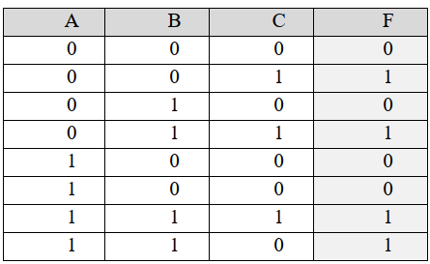

For example, the following Boolean functions:-
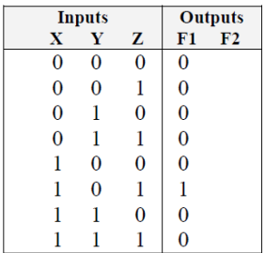
The truth table for the above functions:
The Boolean function can be transformed to logic diagram
composed of AND, OR and NOT gates.
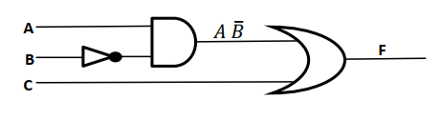

2 Rule of Boolean Algebra
Rule 1: X + 0 = X | X X+0  0 0+0=0  1 0+1=1
Rule2: X + 1 = 1 | X X +1  0 0 +1=1  1 1+1 =1
Rule3: X + X= X | X X +X  0 0+0 =0  1 1+1 =1
Rule 4: X + $\overline{X}$= 1 | X X + $\overline{X}$  0 0+1=1  1 1+0=1
Rule5: $\overset{̿}{X}$ = X | X $$\overline{X}$$ $\overset{̿}{X}$  0 1 0  1 0 1
Rule6: X . 1= X | X X . 1  0 0 .1=0  1 1 .1 =1
Rule7: X . 0 = 0 | X X . 0  0 0 .0=0  1 1 .0=0
Rule8: X . X= X | X X . X  0 0 .0=0  1 1 .1 =1
Rule9: X . $\overline{X}$= 0 | X X . $\overline{X}$  0 0 .1=0  1 1 .0 =0
Rule10: X⊕ 0= X | X X⊕ 0  0 0 ⊕ 0=0  1 1 ⊕ 0 =1
Rule11: X⊕ 1= $\overline{X}$ | X X⊕ 1  0 0 ⊕1=1  1 1 ⊕1 =0
Rule12: X⊕ X= 0 | X X⊕ X  0 0 ⊕ 0=0  1 1 ⊕ 1=0
Rule13: X⊕ $\overline{X}$= 1 | X X⊕ $\overline{X}$  0 0 ⊕ 1=1  1 1 ⊕ 0=1

Prove that X+X=X
X + X = (X+X).1
= (X+X).(X + $\overline{X}$) rule 4
= X + X$\overline{X}$
=X + 0 rule 9
=X

3 Laws of Boolean Algebra
The manipulation of algebraic expressions is based on fundamental laws. Some of these laws extend to the manipulation of Boolean expressions. For example, the commutative law of algebra which states that the result of an operation is the same regardless of the order of operands holds true for Boolean algebra too.
Commutative law X + Y= Y + X X.Y= Y.X
Associative law (X+Y)+Z= Y+(X+Z) (X.Y).Z= Y.(X.Z)
Distributive law X(Y+Z)=X.Y+X.Z X+YZ=(X+Y).(X+Z)

Many students of algebra are frustrated by problems requiring simplification. Sometimes it feels as if extrasensory perception is required to see where the best path to simplification lies. Unfortunately, Boolean algebra is no exception. There is no substitute for practice. Therefore, this section provides a number of examples of simplification in the hope that seeing them presented in detail will give you the tools you need to simplify the problems on your own.
- X + 0 = X | 9) X . $\overline{X}$= 0
- X + 1 = 1 | 10) X⊕ 0= X
- X + X= X | 11) X⊕ 1= $\overline{X}$
4) X + $\overline{X}$= 1 | 12) X⊕ X= 0
5) $\overset{̿}{X}$ = X | 13) X⊕ $\overline{X}$= 1
6) X . 1= X | 14) X+XY=X
7) X . 0 = 0 | 15) X. $\overline{X}Y$=X+Y
8) X . X= X | 16) (X+Y).(X+Z)=X+YZ

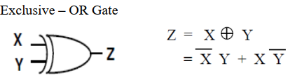
Boolean Expression of three-variable of the XOR
$$A⨁B⨁C=\left(A\overline{B}+\overline{A}B\right)\overline{C}+\left(A\overline{B}+\overline{A}B\right)C$$
$$=A\overline{B}\overline{C}+\overline{A}B\overline{C}+A\overline{B}C+\overline{A}BC$$

The truth table for $A⨁B⨁C$

A | B | C | A⊕B | (A⊕B)⊕C
0 | 0 | 0 | 0 | 0
0 | 0 | 1 | 0 | 1
0 | 1 | 0 | 1 | 1
0 | 1 | 1 | 1 | 0
1 | 0 | 0 | 1 | 1
1 | 0 | 1 | 1 | 0
1 | 1 | 0 | 0 | 0
1 | 1 | 1 | 0 | 1

Prove that: $\overline{A}+AB=\overline{A}+B$
$$\overline{A}+AB=\overline{A}\left(1+B\right)+AB$$
$$=\overline{A}+\overline{A}B+AB$$
=$\overline{A}+B\left(\overline{A}+A\right)$
=$\overline{A}+B$

Prove that: $A+ \overline{A}B=A+B$
$$A+ \overline{A}B=A\left(1+B\right)+\overline{A}B$$
$$=A+AB+\overline{A}B$$
$$=A+B\left(A+\overline{A}\right)$$
$$=A+B$$

Example: Prove that A + A·B = A
Solution
A + A·B = A·1 + A·B Rule: A · 1
= A·(1 + B) Distributive Law
= A·(B + 1) Commutative Law
= A·1 Rule: A + 1 = 1
= A Rule: A · 1 = A
Remember also that rules of Boolean algebra can be proven using a truth table. The example below uses a truth table to derive another rule.

Example: Prove A + $\overline{A}$. B = A + B
The truth table below goes step-by-step through both sides of the expression to prove.
A | B | $$\overline{A}$$ | $$\overline{A}.B$$ | A+$\overline{A}.B$ | A+B
0 | 0 | 1 | 0 | 0 | 0
0 | 1 | 1 | 1 | 1 | 1
1 | 0 | 0 | 0 | 1 | 1
1 | 1 | 0 | 0 | 1 | 1

Example: Prove (A + B)·(A + C) = A + B·C
Solution
(A + B)·(A + C) = (A + B)·A + (A + B)·C Distributive Law
= A·A + B·A + A·C + B·C Distributive Law
= A + B·A + A·C + B·C Rule: A·A = A
= A + A·B + A·C + B·C Commutative Law
= A + A·C + B·C Rule: A + A·B = A
= A + B·C Rule: A + A·B = A
Now that you have a taste for the manipulation of Boolean expressions, the next section will show examples of how complex expressions can be simplified.

Example: prove AB + $\overline{A}$C + BC = AB + $\overline{A}$ C
Solution
= AB + $\overline{A}$ C + 1 · BC rule 1.X=X
= AB +$\overline{A}$ C + (A + $\overline{A}$) · BC rule X+$\overline{X}$=1
= AB +$\overline{A}$ C +ABC+$\overline{A}$BC Distributive Law
=AB+ABC+$\overline{A}$ C+$\overline{A}$BC Commutative Law
=AB(1+C)+$\overline{A}$ C(1+B) Distributive Law
= AB+$\overline{A}$ C rule 1+X=1

Example: Show that X+ Y + $\overline{X.}\overline{Y}$ = 1
X+ Y + $\overline{X.}\overline{Y.}$ = (X+Y+$\overline{X}$) (X+Y+$\overline{Y}$) (Distributive Law) X + YZ = (X + Y)(X + Z)
=(X+$\overline{X}+Y$) (X+Y+$\overline{Y}$) (Commutative Law) X + Y = Y + X
=(1+Y)(X+1) Rule 4
=1.1 Rule2
=1 Rule8

Example: Show (X+ Y). $\overline{X.}\overline{Y}$ =0
(X+ Y). $\overline{X.}\overline{Y}$ = $(X. \overline{X.}\overline{Y}+Y.\overline{X.}\overline{Y} )$ (Distributive Law) X + YZ = (X + Y)(X + Z)
=$(X. \overline{X.}\overline{Y}+Y.\overline{Y }\overline{.X})$ (Commutative Law) X + Y = Y + X
=(0$.\overline{Y}+0.\overline{X})$
= (0 + 0)
= 0

Example: determine the truth table and logic diagram AB+ A (B+C)+ B(B+C)
AB+ A (B+C)+ B(B+C) = AB+AB+AC+BB+BC
=AB+AB+AC+B+BC
= AB+AC+B(1+C)
= AB+B + AC
=B(A+1)+AC
= B+AC

4 Simplification
When a Boolean expression is implemented with logic gates, each literal in the
function is designated as input to the gate. The literal may be a primed or unprimed
variable. Minimization of the number of literals and the number of terms leads to
less complex circuits as well as less number of gates, which should be a designer’s
aim. There are several methods to minimize the Boolean function. In this lecture, simplification or minimization of complex algebraic expressions will be shown with the help of postulates and theorems of Boolean algebra.
Example: Simplify F= (A.B+C)(A.B+D)
From the rules of Boolean algebra, we know that (A + B)(A + C) = A + BC. Substitute A·B for A, C for B, and D for C and we get: (A·B + C)(A·B + D) = A·B + C·D

Example: Simplify F= $\overline{Y}$.(X+$\overline{X}$.Y)
=$\overline{Y}$.X+$\overline{Y.}\overline{X}$.Y Distributive Law
=$\overline{Y}$.X+$\overline{X.}\overline{Y}$.Y Associative Law
=$\overline{Y}$.X+$\overline{X.}0$ Anything AND'ed with its inverse is 0
=$\overline{Y}$.X
=X.$\overline{Y}$

Example: Simplify the Boolean function F=AB+ BC + B′C.
Solution. F = AB + BC + B′C
= AB + C (B + B′)
= AB + C
Example: Simplify the Boolean function F= A + A′B.
Solution. F = A+ A′B
= (A + A′) (A + B)
= A + B
Example : Simplify the Boolean function F= A′B′C + A′BC + AB′.
Solution. F = A′B′C + A′BC + AB′
= A′C (B′+B) + AB′
= A′C + AB′
H.W:Use Boolean algebra to simplify the following Boolean functions:
1. F = AB + (AC)′ + AB′C(AB + C) (Ans: F=1)
2. F = ((XY′ + XYZ)′ + X(Y + XY′))′ (Ans: F=0)
3. F = XYZ + XY′Z + XYZ′ (Ans: F=X(Y+Z))
- F = ($\overline{X}$+Y).(X+$\overline{Y}$)s
$5. F=\overline{X}$.$\overline{Y}$.$\overline{Z}$ + $\overline{X}$.$\overline{Y}$.Z +$\overline{X}$.Y.$\overline{Z}$+$\overline{X}$.Y.$Z$

5 Demorgan's Theorem
The complement of the function F is $\overline{F}$ and is obtained from an interchange of 0’s for 1’s and 1’s for 0’s in the value of F. the complement of a function may be derived algebraically through DeMorgan's theorem . There are two theorem of DeMorgan:
$$\overline{X.Y}=\overline{X}+ \overline{Y}$$ | X Y $$\overline{X.Y}$$ $$\overline{X}+ \overline{Y}$$  0 0 1 1  0 1 1 1  1 0 1 1  1 1 0 0
$$\overline{ X+Y}=\overline{X}. \overline{Y}$$ | X Y $$\overline{X+Y}$$ $$\overline{X}. \overline{Y}$$  0 0 1 1  0 1 0 0  1 0 0 0  1 1 0 0
Complementing Functions:
Use DeMorgan's Theorem to complement a function:
1. Interchange AND and OR operators
2. Complement each constant value and literal
Ex: Fined the complement of the following functions?

Canonical and Standard Forms
Any Boolean function can be expressed in a canonical form, canonical form
includes:-
1- Sum of minterms ( SOM) also known as Sum of products (SOP).
2- Product of Maxterms (POM) also known as Product of sum (POS).
Product Term: An AND function is referred to as a product term. The variables in a
product term can be either in true form or in complemented form. For example,
ABC′ is a product term.
Sum Term: An OR function is referred to as a sum term. Variables in a sum term can
also be either in true form or in complemented form. For example:
A + B + C′ is a sum term.

Example: Express the following complement of product as sum of complement using Demorgan’s theorem:
- $\overline{ABC}=\overline{A}+\overline{B}+\overline{C}$
- $\overline{ABCD}=\overline{A}+\overline{B}+\overline{C}+\overline{D}$
- $\overline{ABCEF}=\overline{A}+\overline{B}+\overline{C}+\overline{D}+\overline{E}+\overline{F}$
- $\overline{A+B+C}=\overline{A}\overline{B}\overline{C}$
- $\overline{A+B+C+D}=\overline{A}\overline{B}\overline{C}\overline{D}$
- $\overline{A+B+C+E+F}=\overline{A}\overline{B}\overline{C}\overline{D}\overline{E}\overline{F}$

Example: Prove that $\left(\overline{X+Y}\right)Z+X\overline{Y}=\overline{Y}(X+Z)$
$=\overline{X.}\overline{Y.}Z+X.\overline{Y}$ (DeMorgan’s Law)
$=\overline{Y}(\overline{X.}Z+X)$ (Distributive Law)
$=\overline{Y}(\overline{X}+X)(Z+X)$ (Distributive Law)
$=\overline{Y}.1(Z+X)$ Rule 4
$=\overline{Y}(Z+X)$

Example: Simplify the following Boolean Expression $\overline{AB+AC}+\overline{A}\overline{B}C$
Step1: apply DeMoragn’s theorem to the first term.
$\left(\overline{AB}\right).\left(\overline{AC}\right)+\overline{A}\overline{B}C$
Step2: apply DeMoragn’s theorem to each term in parentheses.
$\left(\overline{A}+\overline{B}\right)\left(\overline{A}+\overline{C}\right)+\overline{A}\overline{B}C$
Step3: Apply the distributive law to the two terms in parentheses.
$$\overline{A}\overline{A}+\overline{A}\overline{C}+\overline{A}\overline{B}+\overline{B}\overline{C}+\overline{A}\overline{B}C$$
Step4:Apply Boolean Rules $\overline{A}\overline{A}=\overline{A}$ , $\overline{A}\overline{B}+\overline{A}\overline{B}C=\overline{A}\overline{B}\left(1+C\right)=\overline{A}\overline{B}$
$$\overline{A}+\overline{A}\overline{C}+\overline{A}\overline{B}+\overline{B}\overline{C}$$
Step5: Apply Boolean Rule $\overline{A}+\overline{A}\overline{C}=\overline{A}\left(1+\overline{C}\right)=\overline{A}$ to the first and second terms
$$\overline{A}+\overline{A}\overline{B}+\overline{B}\overline{C}$$
Step6: Apply Boolean Rule $\overline{A}+\overline{A}\overline{B}=\overline{A}\left(1+\overline{B}\right)=\overline{A}$ to the first and second terms
$$\overline{A}+\overline{B}\overline{C}$$

6 Sum of Product (SOP) and Product of Sum (POS)
A sum-of-products (SOP) expression is a Boolean expression in a specific format. The term sum-of-products comes from the expression's form: a sum (OR) of one or more products (AND). It is basically an OR operation on AND operated variables. For example, F = AB + BC + AC or F = A′B + BC + AC′ are sum of products expressions. As a digital circuit, an SOP expression takes the output of one or more AND gates and OR's them together to create the final output. The inputs to the AND gates are either inverted or non-inverted input signals. This limits the number of gates that any input signal passes through before reaching the output to an inverter, an AND gate, and an OR gate.
$\overline{A}$BC$\overline{D}$ + A$\overline{B}$D + C$\overline{D}$ + A$\overline{D}$
This also means that an SOP expression cannot have more than one variable combined in a term with an inversion bar.

Example for Sum of Product (SOP): X=AB+BCD+AC

A | B | X | F
0 | 0 | 0
0 | 1 | 1 | $\overline{A}$B
1 | 0 | 1 | A$\overline{B}$
1 | 1 | 0
Example Sum of product

F=$\overline{A}$B+A$\overline{B}$

The product-of-sums (POS) format of a Boolean expression is much like the SOP format with its two levels of logic (not counting inverters). The difference is that the outputs of multiple OR gates are combined with a single AND gate which outputs the final result. It is an AND operation on OR operated variables. For example, F = (A + B + C) (A + B′ + C) (A + B + C′) or F = (A + B + C) (A′ + B′ + C′) are product of sums expressions. The expression below adheres to the format of a POS expression. ($\overline{A}$+B+C+$\overline{D}$)(A+$\overline{B}$+D)(C+$\overline{D}$)(A+$\overline{D}$)
As with SOP expressions, a POS expression cannot have more than one variable combined in a term with an inversion bar. For example, the following is not a POS expression:
($\overline{A+B+C}$+D)(A+$\overline{B}$+D)(C+$\overline{D}$)(A+$\overline{D}$)

Example of Product of Sum (POS): (A+B)(B+C+D)(A+C)

A | B | X | F
0 | 0 | 0 | $\overline{A}$+$\overline{B}$
0 | 1 | 1
1 | 0 | 1
1 | 1 | 0 | A+B
Example:
F=($\overline{A}$+$\overline{B}$)(A+B)

Standard form: In this form, the terms form the function may contain one, two, or any
number of literals. There are two types of standard form: sum of the products (SOP)
or product of the sums (POS) fashion. For examples; F = AB + BC + AC or F = (A +
B + C) (A + B′ + C) (A + B + C′) are the standard forms.
However, Boolean functions are also sometimes expressed in nonstandard forms like
F = (AB + CD) (A′B′ + C′D′), which is neither a sum of products form nor a product
of sums form. However, the same expression can be converted to a standard form with
help of various Boolean properties, as
F = (AB + CD) (A′B′ + C′D′) = A′B′CD + ABC′D′

The following is not an SOP expression:
($\overline{AB}$)C$\overline{D}$ + A$\overline{B}$D + C$\overline{D}$ + A$\overline{D}$
This is because the first term has A and B passing through a NAND gate before being AND'ed with C and D thereby creating a third level of logic. To fix this problem, we need to break up the NAND using DeMorgan's Theorem.
($\overline{AB}$)C$\overline{D}$ + A$\overline{B}$D + C$\overline{D}$ + A$\overline{D}$
($\overline{A}$+$\overline{B}$)C$\overline{D}$ + A$\overline{B}$D + C$\overline{D}$ + A$\overline{D}$
$\overline{A}$C$\overline{D}$+$\overline{B}$C$\overline{D}$ + A$\overline{B}$D + C$\overline{D}$ + A$\overline{D}$

7 Minterms and Maxterms for three Binary variables A Product term which contains each of variables as factor in either complemented or uncomplemented forms is called a minterm. A sum which contains each of n variables complemented or not is called maxterm.
In other words, A product term containing all n-variables of the function in either true (1) or complemented (0) form is called the Minterm. In Minterm, we look for the functions where the output results in “1” (F=1).
A sum term containing all n variables of the function in either true or
complemented form is called the Maxterm. In Maxterm we look for function where
the output results in “0” (F=0).

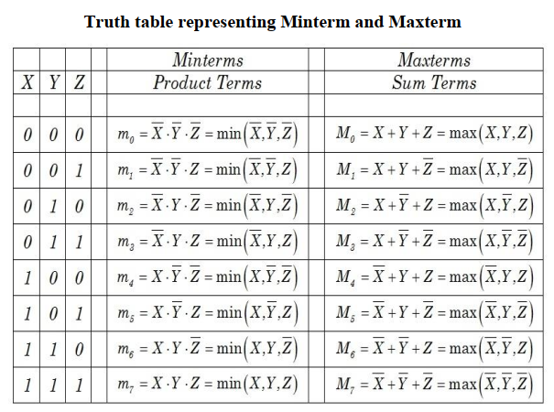

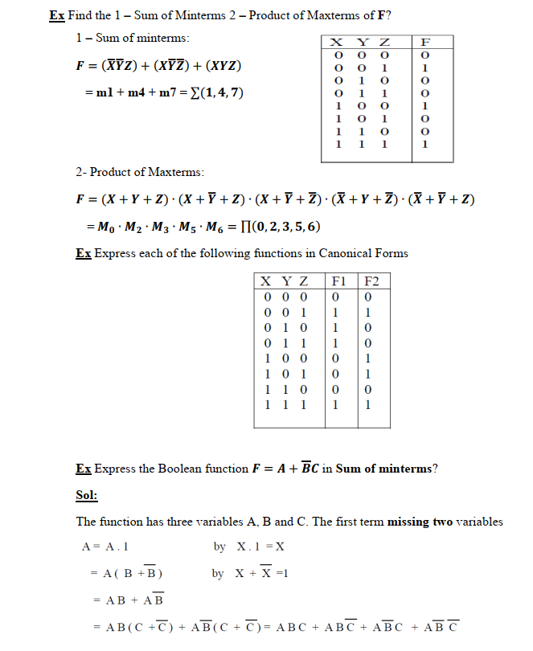

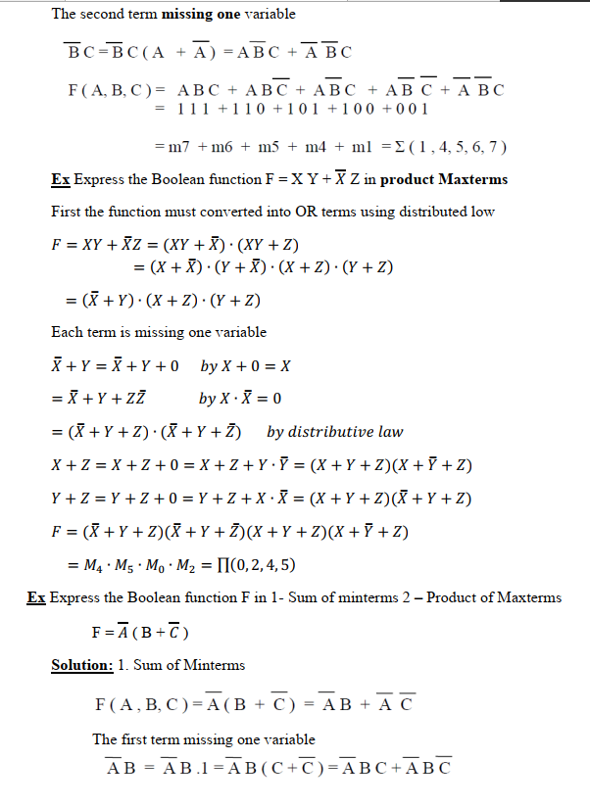

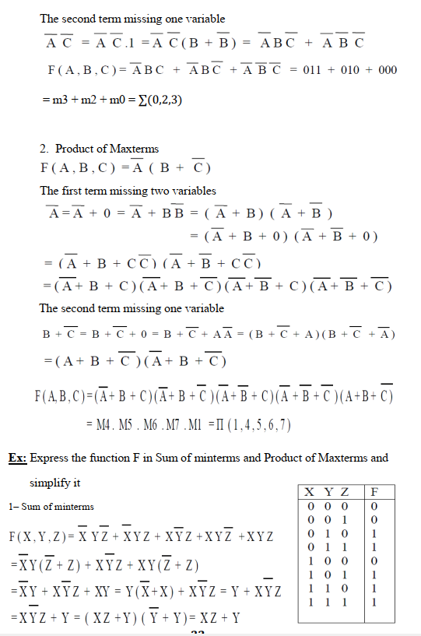

H.W.
1. Obtain the canonical product of the sum form of the following function.
F (A, B, C) = A + B′C
2. Obtain the canonical product of the sum form of the following function.
F (A, B, C) = (A + B′) (B + C) (A + C′)
3. Obtain the canonical sum of product form of the following function.
F (A, B) = A + B
4. Prove the following using Boolean theorems:
(a) (A + C)(A + D)(B + C)(B + D) = AB + CD
(b) (X + Y) ⊕ (X + Z) = X′ (Y ⊕ Z).
5. Find the Boolean expression for F, when F is 1 only if A is 1 and B is 1, or
if A is 0 and B is 0.
6. Convert F = ABCD + A′BC + B′C′ into a sum of minterms by algebraic method.
7. Convert F = AB + B′CD into a product of maxterms by algebraic method.

