**Snell’s Law**

When light travels from one medium to another, its **velocity** and **wavelength** change, but its **frequency** remains constant. Snell’s Law can also be written as:

$$\frac{\sin{θ_{1}}}{v_{1}}=\frac{\sin{θ_{2}}}{v_{2}}$$

$$v_{1}=fλ_{1}$$ $$v_{2}=fλ_{2}$$

*f =* constant, $v_{1}≠v_{1} , λ_{1}≠ λ_{2}$

$$\frac{λ_{1}}{λ_{2}}=\frac{v_{1}}{v_{2}}= \frac{\frac{c}{n_{1}}}{\frac{c}{n_{2}}} =\frac{n_{2}}{n_{1}}$$

$$λ_{1}n_{1}=λ_{2}n_{2}$$

Where, *v* is the velocity of light in the medium, *f* is the frequency and λ is the wavelength.

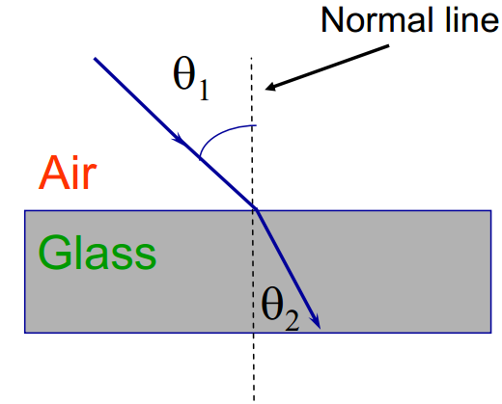

**Fig.(5): Refraction of light in the medium**

**Ex4:**

A light ray of wavelength (650 nm) travel through Air is incident on smooth, flat quartz with refractive index (1.458). Find the velocity of light, wavelength and frequency in quartz?

**Solution:**

the velocity of light in quartz:

$$v=\frac{c}{n}= \frac{3×{10}^{8}}{1.458}=2.048 ×{10}^{8} m/s$$

The wavelength:

*λ2* =445.8 nm

The frequency:

$$f=\frac{v_{2}}{λ_{2}}= \frac{2.048 ×{10}^{8} m/s}{445.8×{10}^{-9 }m}= 4.6×{10}^{14} Hz$$

**Total Internal Reflection**

The phenomenon which occurs when the light rays travel from a more optically denser medium to a less optically denser medium.

Consider the following situation. A ray of light passes from a medium of water to that of air. Light ray will be refracted at the junction separating the two media. Since it passes from a medium of a higher refractive index to that having a lower refractive index, the refracted light ray bends away from the normal [*refraction angle increases when incident angle increases*]. At a specific [angle of incidence](https://byjus.com/physics/angle-of-incidence/), the incident ray of light is refracted in such a way that it passes along the surface of the water. This particular angle of incidence is called the critical angle. Here the angle of refraction is 90 degrees. When the angle of incidence is greater than the critical angle, the incident ray is reflected back to the medium. We call this phenomenon total internal reflection.

**n1 > n2**

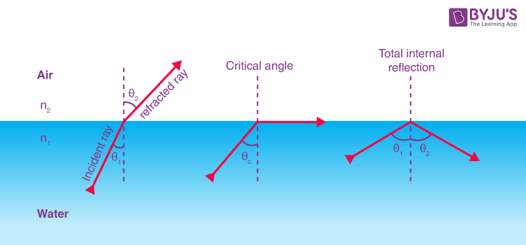

Fig (6): Total internal reflection.

Following are the two conditions of total internal reflection:

* The light ray moves from a more dense medium to a less dense medium.
* The angle of incidence must be greater than the critical angle.

*θ1*= *θc*

*θ2*=90°

**Application of total internal reflection**

Fiber optics is one application of total internal reflection that is in wide use. In communications, it is used to transmit telephone, internet, and cable TV signals. Fiber optics made of plastic or glass. Because the fibers are thin, light entering inside surface at an angle **greater** than the critical angle and, thus, be totally reflected. Fibers are surrounded by a cladding material that has a lower index of refraction than the core.

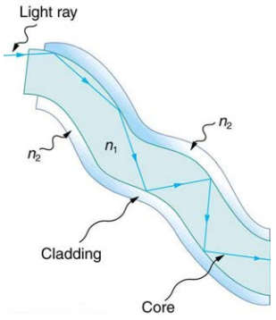

**Fig.(7): Optical fiber**

**3. Dispersion (The Rainbow and Prisms)**

(*It is defined as the spreading of white light into its full spectrum of wavelengths*). How does sunlight falling on clear drops of rain get broken into the rainbow of colors we see? The same process causes white light to be broken into colors by a clear glass prism or a diamond. We see about **six colors** in a rainbow—red, orange, yellow, green, blue, and violet. **(The colors of the rainbow and those produced by a prism are identical).**Refraction is responsible for dispersion , index of refraction *n* increases as wavelength decreases and is greatest for violet light. Thus violet light is bent more than red light. Red deviates the least. [In optical systems, since a laser produces a nearly pure wavelength, its light experiences little dispersion, an advantage over white light for transmission of information].

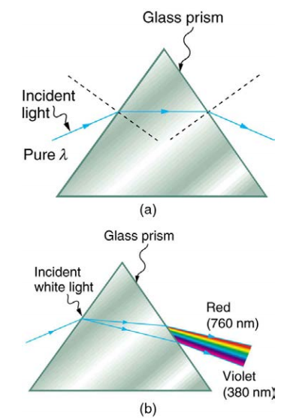

**Fig.(8): A pure wavelength of light falls onto a prism and is refracted at both surfaces. (b) White light is dispersed by the prism**

Rainbows are produced by a combination of refraction and reflection. Light enters a drop of water and is reflected from the back of the drop. The light is refracted both as it enters and as it leaves the drop.

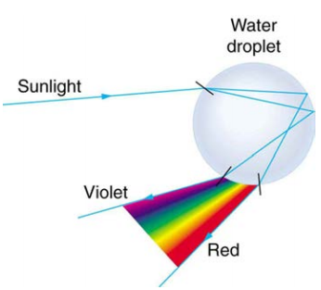

**Figure 9 Rainbow**