**Reflection (**at plane surface mirror**)**

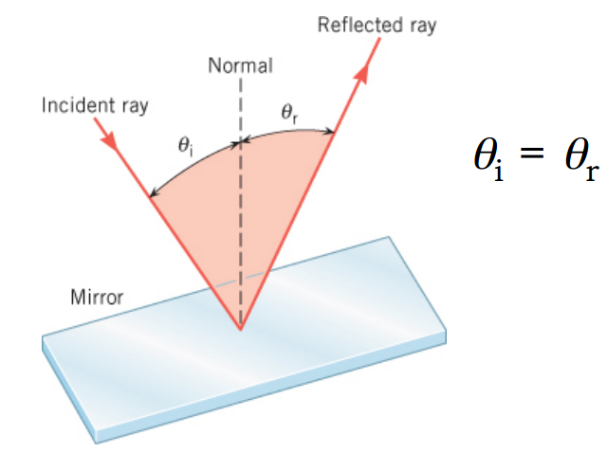The incident ray, the reflected ray, and the normal to the surface all lie in the same plane, and the angle of incidence, (*θ*i), equals the angle of reflection, (*θ*r). The law of reflection from flat mirrors;

**Figure 10 law of reflection**

1. In **specular** reflection, the reflected rays are parallel to each other.
2. 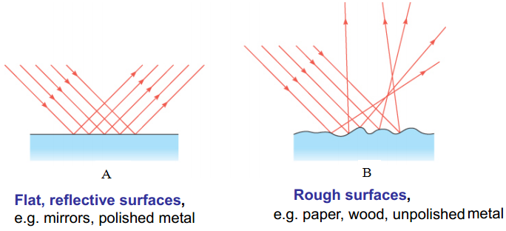In **diffuse** reflection, light is reflected in random directions.

**Types of Images**

**Real** image: Light rays actually pass through an image point.

(Can be displayed on screens)

**Virtual** image: Light rays don’t pass through an image point.

(Cannot be displayed on screens)

**Formation of Images (by a Plane Mirror)**

When a ray of light reflects from the mirror to the eye, the ray seems to come from behind the mirror.

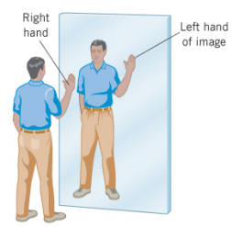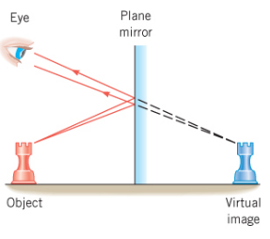

law of reflection Image in a flat mirror has four properties:

1. It is upright and virtual.
2. It is the same size as the object.
3. It is reversed,( The right hand becomes the image ’s left hand)
4. It is as far behind the mirror as the object is in front of it.

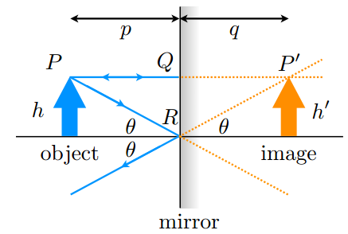

**Figure (11) Mirror ray diagram, location and size of an object and reflected image**

1. The distance between the object and the mirror is ***p***.

2. The distance between the image and the mirror is ***q***.

3. In front of the mirror, ***p*** and ***q*** are positive.

4. Behind the mirror, ***p*** and ***q*** are negative.

5. The object’s height is ***h***, the image’s height is ***h****'*.

6. The ray reflected at point ***R***; make an angle ***θ*** with the horizontal axis

7. The front of the mirror is where real rays propagate,

the back is where virtual rays are formed.

8. Real light rays are solid lines, virtual rays are dotted.

**Magnification**

For flat mirrors, we now know almost everything we need to. Other types of mirrors will not always give images that are the same size as the object, and will not always be the same distance away.

If the image is not the same size as the object, we say that it is ***magnified***. Magnified can either *larger* or *smaller*. The **degree of magnification** (is the ratio of the image height to the object height) – how much larger or smaller is the image compared to the object?

$$M=\frac{ image’s height}{object’s height}= \frac{h'}{h}$$

For a flat mirror, *M*= 1, *h=h'*

**Spherical Mirrors**

Its reflective surface has the shape of an arc of a circle with radius of curvature R.

1. **Concave mirrors** are made by putting a reflective coating on the inside surf ac e of the circle.
2. 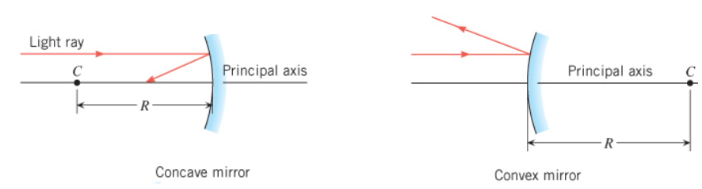**Convex mirrors** are made by putting a reflective coating on the outside surf ac e of the circle.

**Figure 12 Spherical Mirrors**

1. **Concave Mirrors**

An example of a concave mirror is shown in the below figure;

1. The point ***C*** is the center of curvature of the mirror (the center of the circular arc), and is a distance ***R*** from any point on the mirror’s surface.
2. The line passes through the center of curvature ***C*** and a point ***V*** at the center of the arc defines the **principle axis** of the mirror.

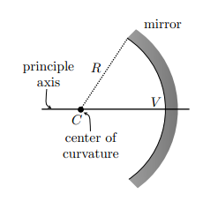

**Figure 13 Concave Mirrors**

1. When parallel rays are incident upon a spherical mirror, the reflected rays intersect at the **focal point *F***. The **focal length** ***f*** is the distance between the focal point and the mirror. **The focal point *F*** of a concave mirror is halfway between the center of curvature of the mirror

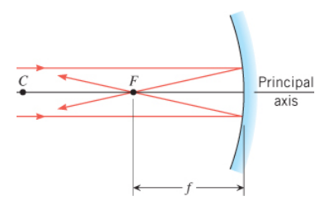

$$f=\frac{R}{2}$$

1. Magnification for a concave spherical mirror
$$M= \frac{h'}{h}= -\frac{q}{p}$$

2. Mirror equation

This last expression is known as the mirror equation, relates the image and object distances to the physical radius of curvature of the mirror alone;

$$\frac{2}{R}=\frac{1}{p}+\frac{1}{q}$$