**Taxonomy:** [Greek taxis = arrangement or order, and nomos = law to distribute or govern] is defined as the science of biological classification, consists of three separate but interrelated parts: ***Classification****,* ***Nomenclature***and***Identification***.

**Classification**: is the arrangement of organisms into groups or taxa

(s., taxon) based on common similarity or evolutionary relatedness.

**Nomenclature:** is the branch of taxonomy concerned with the assignment of names to taxonomic groups in agreement with published rules.

**Identification**: is the practical side of taxonomy, the process of determining that a particular **isolate** belongs to a recognized taxon.

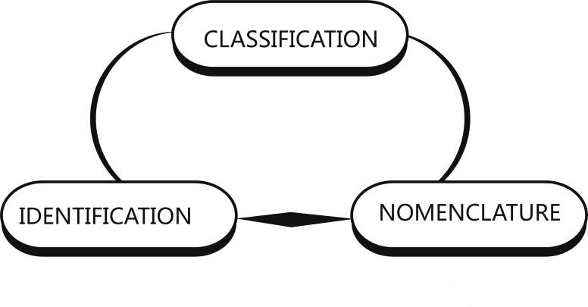

**Taxonomy is important for several reasons** :

**1**- It allows us to organize huge amounts of knowledge about organisms because all members of a particular group share many characteristics.

**2**- Taxonomy allows us to make predictions and frame hypotheses for further research based on knowledge of similar organisms.

**3**- Taxonomy places microorganisms in meaningful, useful groups with precise names so that microbiologists can work with them and communicate efficiently.

**4**- Taxonomy is essential for accurate identification of microorganisms. For example, it is essential to clinical microbiology treatment often is exceptionally difficult when the pathogen is unknown.

**NOTE**: The term **systematics** often is used for **taxonomy**

**1-Classification**

Over 1.5 million **different** organisms have been identified to date. Many **similarities** among living organisms such as:

**1**-Made up of cells surrounded by a plasma membrane.

**2**-Use ATP as energy source.

**3**-Store genetic information as DNA.

**4**-Ribosomes are the site of protein synthesis.

Both differences and similarities among organisms are caused by **natural selection** . Organisms can be classified into taxonomic categories (**taxa**) , based on the differences and similarities among them.

The study of evolutionary relationships of living organisms known as (Phylogeny). Carl Linnaeus was classified all living organisms into two groups: ***Kingdom Plantae*** & ***Kingdom Animalia***.

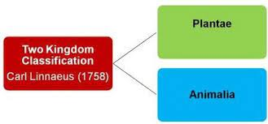

In 1850s bacteria and fungi were incorrectly placed in the Plant Kingdom.

In 1860s Kingdom Protista was proposed by Ernst Haeckel to include bacteria, fungi, algae, and protozoa, but many scientists still classified bacteria and fungi as plants.

In 1930s electron microscopy made it clear that bacterial cells lacked a nucleus. The term **prokaryote** was introduced in 1937.

In 1959 **Kingdom Fungi** was established.

In 1961 the current definition of the term **Prokaryote** was established.

In 1968 the **Kingdom Prokaryotae** was accepted by biologists.

In 1969 Robert Whitaker proposed a **five kingdom system of biological classification** for all living organisms:

**1. Kingdom Prokaryotae (Monera):** Oldest known cells. Lived over 3.5 billion years ago. Lack a nucleus and membrane bound organelles.

(The other four kingdoms are **Eukaryotes**. Have a true nucleus and membrane bound organelles).

**2. Kingdom Protista:** Mostly unicellular, lack tissue organization. Most have flagella during life.

**3. Kingdom Fungi**: May be unicellular (yeasts) or multicellular (molds). Many are saprotrophs.

**4. Kingdom Plantae:** Multicellular, photosynthetic.

**5. Kingdom Animalia:** Multicellular, heterotrophs that ingest food through a mouth or oral cavity.

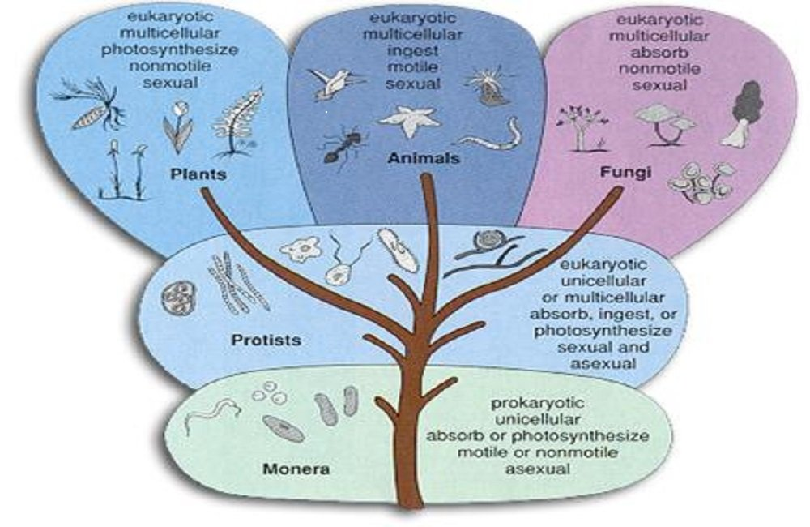

In 1978 Carl Woese proposed **Domain** as level of classification above **kingdom**.

**There are three domains based on the following distinguishing criteria:**

**1**-Cell wall composition

**2**-Membrane lipids

**3**-RNA sequence

**4**-Protein synthesis

**5**-Antibiotic sensitivity

**Three domains of biological classification**:

**1- Domain Eubacteria** (True bacteria)

**2- Domain Archaeabacteria (**Ancient bacteria)

**3- Domain Eukarya:** All eukaryotes( **Protista, Fungi, Plantae , and Animalia)**.

The **archaea** and **bacteria** first diverged, then the eukaryotes developed. These three primary groups are called **domains** and placed above the phylum and kingdom . The domains differ markedly from one another.

Eukaryotic organisms with primarily glycerol fatty acyl diester **membrane** **lipids** and **eukaryotic** rRNA belong to the ***Eukarya.***

The domain ***Bacteria*** contains prokaryotic cells with **bacterial** rRNA and **membrane lipids** that are primarily diacyl glycerol diesters. Prokaryotes having isoprenoid glycerol diether or diglycerol tetraether **lipids in their membrane**s and **archaeal** rRNA compose the third domain, ***Archaea.***

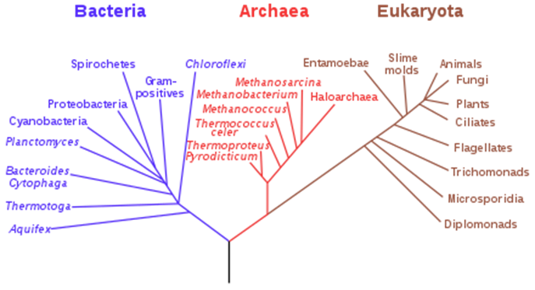

NOTE: Recent developments in molecular biology and biochemistry have revealed that there are **two** types of prokaryotic cells, based on differences in their **ribosomes, cell walls, and metabolism.**

**1. Eubacteria** (True bacteria): Cell wall contains peptidoglycan and

sensitive to antibiotics.

**2. Archaea (**Ancient bacteria): Cell walls lack peptidoglycan, resistant to antibiotics and live in extreme environments.

**There are three kingdoms of *Archaeabacteria* :**

**1. Methanogens**: Strict anaerobes that produce methane.

**2. Extreme Halophiles**: Require high salt concentrations.

**3. Thermoacidophiles:** Live in hot, acidic environments.

**Taxonomic Ranks:**

**In prokaryotic taxonomy the most commonly used levels or ranks (in ascending order) are :**

**Species:** a group of related isolates or strains.

**Genera:** a collection of related species.

**Families**: a collection of similar genera. In prokaryotic nomenclature,

the name of the family ends in the suffix (*aceae*).

**Orders**: a collection of similar families. In prokaryotic nomenclature, the name of the order ends in the suffix (*ales*).

**Classes**: a collection of similar orders. In prokaryotic nomenclature, the name of the class ends in the suffix (*ia*) .

**Phylum or Division**: collection of similar classes.

**Kingdom** : collection of similar phyla or divisions.

**Domain**: collection of similar kingdoms.

**Example: Taxonomic Ranks of the bacterium *Escherichia coli***

|  |  |
| --- | --- |
| **Formal Rank** | **Example** |
| Domain | *Bacteria* |
| Phylum | *Proteobacteria* |
| Class | *Gammaproteobacteria* |
| Order | *Enterobacteriales* |
| Family | *Enterobacteriaceae* |
| Genus | *Escherichia* |
| Species | *coli* |

**2-Scientific Nomenclature**

**Scientific nomenclature**: Universal system for naming and classifying living organisms. Initially developed in the 18th century by Carl Linnaeus.

**Binomial nomenclature**: Each organism (**species**) has a two part name (Genus & Species). Names are either italicized or underlined.

**Genus name**: Always capitalized, always a noun.

**Species name**: Always lower case, usually an adjective.

Names are usually derived from Latin (or Greek) or may have latinized endings.

**Examples: *Escherichia coli*, *Lactococcus lactis***