**Mustansiriyah University** Suhad Abbas Abid

**College of Sciences** MSc. Nano-Biotechnology

**Biology Department**

**Nanotechnology**

**Lab. 3: Biological synthesis of nano-materials**

In natural environment, microbes produce nanomaterials as part of their metabolism; the use of microorganisms in the synthesis of nanomaterials emerges as an eco-friendly and exciting approach.

Biologically synthesized nanomaterials have wide application like biosensors bio-labelling, in cancer therapeutics and in coating of medical appliances.

► Green synthesis is an alternative approach for synthesizing materials using natural resources such as microorganisms and medicinal plants as reducing agents. NPs synthesized by the green method are highly stable, environmental friendly, biocompatible, cost effective, less toxic and safe for diagnostic and therapeutic purpose.

► Biosynthesis of nanomaterials occurs when the microorganisms pull target ions from their environment and then turn the metal ions into the element metal through enzymes generated by the cell activities.

► The biosynthesized nanomaterials have been used in a variety of applications including drug carriers for targeted delivery, cancer treatment, gene therapy and DNA analysis, antimicrobial agents, biosensors, enhancing reaction rates, separation science, and magnetic resonance imaging (MRI).

**1. Biological synthesis of selenium nanoparticles by bacteria**

**Materials**:

Twenty four hours *Escherichia coli* culture, sterile nutrient broth, distilled water, 99% sodium selenite **Na2SeO3 .**

**Methods**:

1. Bacterial suspension prepared by growing a single colony overnight in nutrient broth.

2. Make bacterial dilutions till 107 dilutions.

3. The nutrient broth medium supplemented with sodium selenite of 1.0 mM concentration.

4. Inoculate with 100 µl of bacterial suspension containing 107 CFU/ml and incubate at 37 °C under static conditions and other nutrient broth medium supplemented with sodium selenite will be as control.

5. The synthesis was monitored at regular intervals by visual inspection for colour change and measuring the UV–Vis absorption spectrum at 550 nm.

6. Separate bacterial cells from the culture medium by centrifugation and selenium nanoparticles will be in the culture supernatants.

**Results**:

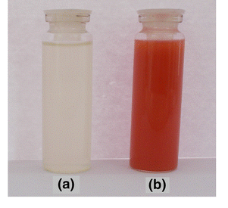

a. represents sodium selenite solution solution

b. represents selenium nanoparticles solution