***Spectroscopy***

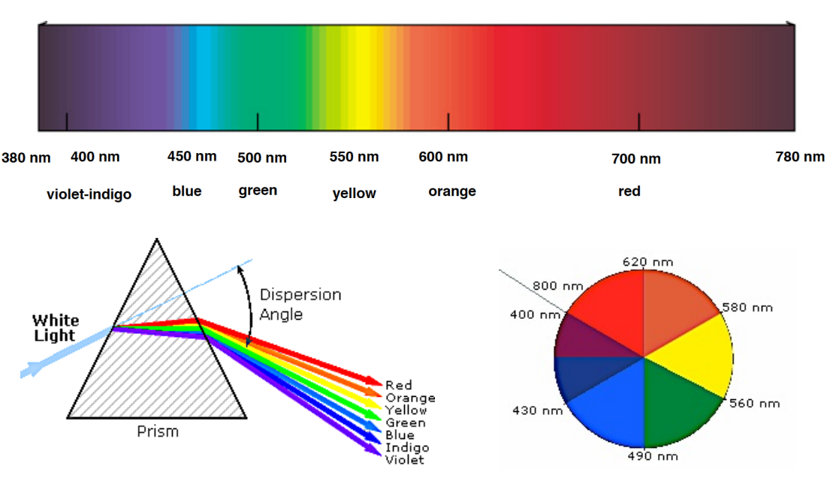

**UV/VIS Spectroscopy**

**1 Introduction**

1.1 Absorption of Radiation

Electronic orbitals of atoms and molecules have characteristic energies, giving rise to a set of discrete energy levels. An electron is able to change from an occupied orbital to another orbital, gaining or losing energy only in amounts exactly corresponding to the difference between two levels: The transition from the ground state (lowest possible

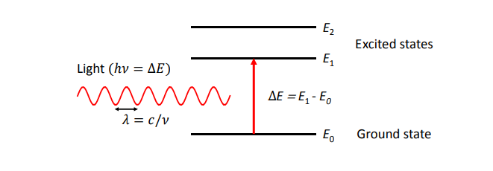

energy) at energy E0 to a higher level at energy En is possible if the molecule absorbs electromagnetic radiation of the corresponding wavelength λ = ch/(En − E0), where c is the speed of light and h is Planck’s constant. Excited states usually exist only for a very short period of time (femtoseconds to microseconds), because the higher energy state is unstable and the extra energy is lost through relaxation processes such as emission of light (see the Experiment Fluorescence Quenching). The typical energy difference between the ground and the first excited levels of many molecules corresponds to electromagnetic waves of the ultra-violet (UV) and visible regions of the electromagnetic spectrum.

**2 Experiment**

**2.1 Components of optical spectrometers**

**2.1.1 Light Sources**

Radiation sources need to be continuous over the range of wavelengths of interest. The earliest sources were simply tungsten filament lamps (light-bulbs!) but these have since been replaced by tungsten-halogen lamps. Such light sources cover the wavelength range from 300-900 nm. To reach further into the UV an additional source is needed. This is usually a deuterium arc lamp, which has a continuous spectrum below 400 nm.

**2.1.2 Monochromator**

A monochromator is used to select the wavelength at which an absorption measurement is made. In fact, it is not possible to select a ’single’ wavelength, but rather a narrow

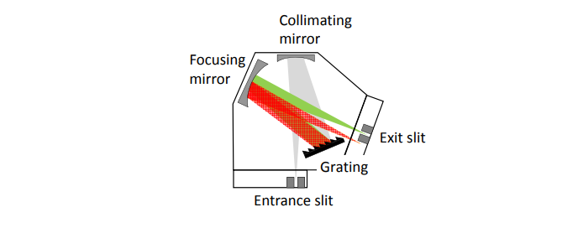

**Figure 1: Schematic representation of a grating monochromator.**

Range of wavelengths, which defines the spectral resolution of the spectrometer. There are two main choices for dispersing light into its different components: a prism, or a diffraction grating. Most modern instruments employ gratings, because it is easier to achieve high spectral resolution. However, gratings have the disadvantage of giving rise to more than one order of diffraction. This means that if the monochromator is set to 600 nm for example, then it will also pass 300 nm (second order) radiation. This problem is easily overcome by the use of additional filters to remove the unwanted radiation. A typical monochromator design is shown in Figure 4. It consists of the diffraction grating (dispersing element), slits, and curved mirrors, which image the entrance slit onto the exit slit and produce a parallel beam at the grating. During a scan, the grating is slowly rotated, and light of different wavelengths will emerge from the exit slit and pass through the sample to the detector. Thus the spectrum is obtained sequentially as the grating is rotated to select the wavelength and the detector observes the transmitted radiation intensity. The spectral resolution can be varied by changing the size of the slits. Narrower slits allow for higher resolution at the expense of light intensity, which can result in larger noise.

**2.1.3 Detectors**

The following detectors are commonly used in UV/Vis spectroscopy: 1. Photomultipliers: A photomultiplier consists of a photocathode and a series of dynodes in an evacuated glass enclosure. Light that strikes the photo cathode causes the ejection of electrons due to the photoelectric effect. The electrons are accelerated towards a series of additional electrodes called dynodes. These electrodes are each maintained at a more positive potential. Additional electrons are generated at each dynode. This cascading effect creates 105 to 107 electrons for each photon hitting the first cathode depending on the number of dynodes and the accelerating voltage. This amplified signal is finally collected at the anode where it can be measured. 2. Semiconductor Photodiodes: When a photon strikes a semiconductor, it can promote an electron from the valence band (filled orbitals) to the conduction band (unfilled orbitals) creating an electron(-) - hole(+) pair. The concentration of these

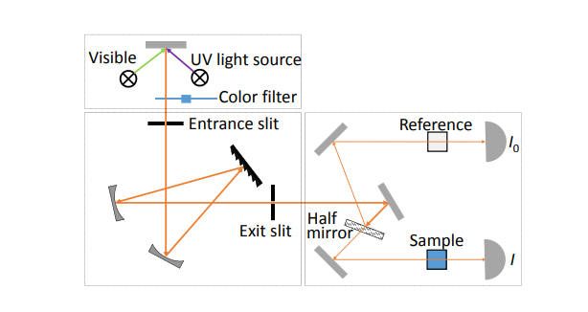

**Figure 5: Schematic view of a dual beam spectrophotometer.**

electron-hole pairs is dependent on the amount of light striking the semiconductor, making the semiconductor suitable as an optical detector. Photovoltaic detectors contain a p-n junction that causes the electron-hole pairs to separate to produce a voltage that can be measured. Photodiode detectors are not as sensitive as PMTs but they are small, cheap and robust.

3. Charge-coupled devices (CCD): A CCD is an integrated-circuit chip that contains an array of capacitors that store charge when light creates electron-hole pairs. The charge accumulates and is read in a fixed time interval. CCDs are used in similar applications as arrays of photodiodes but the CCD is much more sensitive for measurement of low light levels. They can replace the exit slit of a monochromator which disperses light only after it has passed a sample. In this way, full spectra can be accumulated very quickly without moving any optics.

**2.1.4 Dual Beam Spectrophotometers**

A diagram of the components of a typical dual beam spectrometer is shown in Figure 5. A beam of light from either the visible or UV light source is separated into its component in a monochromator. An additonal filter suppresses light at shorter wavelengths to avoid interference from second order diffraction. The monochromatic (narrow bandwidth) beam is then split into two beams of equal intensity by a half-mirror or beam splitter. One beam, the sample beam, passes through the cuvette containing a solution of the compound being studied. The other beam, the reference, passes through an identical cuvette containing only the solvent. The intensities of these light beams are then measured by photo detectors and compared. The intensity of the reference beam, which should have suffered little or no light absorption but the same reflection losses as the sample beam, is defined as I0. The intensity of the sample beam is defined as I. During a wavelength scan, intensity changes and fluctuations are equally sensed by the two detectors and normalized out by the division of I by I0. However, even if both cuvettes contain the same solution, these two intensities may not be exactly the same, for example because of different detector.

efficiencies or spatial beam drifts. This leads to a small background spectrum, which can even be negative in some frequency ranges. Like with a single beam spectrometer (no reference beam) it is thus important to first record the background spectrum with only solvent in the sample cell. This spectrum must then be subtracted from the one recorded with the sample solution. If you do this, the reference compartment may even be left empty.

**2.1.5 Data acquisition**

The earliest instruments simply directly connected the amplified detector signal to a chart recorder. Today, all experimental settings are controlled by a computer and the detector signals are digitized, processed and stored. Nevertheless it is important that you note parameters which you set via the instrument software (slit width, scan range, scan speed, single beam/dual beam) into your laboratory journal, along with the name of the file containing the data (and its path). Otherwise it can become very difficult to find or reproduce a measurement after other users have changed these settings!

**2.2 Quantitative work**

A frequent analytic application of UV-vis spectroscopy is the precise determination of concentration. You should already be familiar with this method from your first year lab course. There, you have determined the Manganese concentration in steel by measuring the absorbance (at a single wavelength) of a solution of permanganate ions that you produced from your steel sample. In addition, you recorded the absorbance of a series of permanganate solutions of known concentration. This allowed you to make a calibration graph of absorbance vs. concentration and fit a straight line with slope d (molar extinction coefficient times the path length). The unknown concentration of sample could then be simply read from the graph or calculated using the value of determined from the slope. Note that the calibration points and the slope of the straight line usually have errors, which must be taken into account when calculating the final uncertainty of the concentration.

**2.3 Indicators**

pH-Indicators are molecules whose colour depends on their protonation state, i.e. they have different colours in different pH-regions. Although the structural changes accompanying protonation and deprotonation may be quite complex, we may simply denote the deprotonated indicator by Ind and the protonated form by HInd and write down the simple equilibrium equation HInd + H2O Ind− + H3O + (12) This equation has an equilibrium constant Ka = [Ind−][H3O+] [HInd] , so that we get: pKa = pH − Log10 [Ind−] [HInd] (13)

It is therefore possible to determine the pKa of the indicator by measuring the concentration ratio of protonated and unprotonated indicator at different pH values. This concentration ratio can be determined from the UV-vis spectra: At low pH the indicator is almost completely in the protonated form and the absorption is due to HInd only. Likewise, at high pH the indicator is completely deprotonated and the absorption is due to Ind−. We can therefore determine the extinction coefficient of the pure protonated and deprotonated forms of the indicator. At a pH close to the pKa, the solution contains appreciable concentrations of both HInd and Ind−, and their relative contributions to the absorption spectrum can be calculated with the help of the individual extinction coefficients.

**1.2 The Electromagnetic Spectrum**

The UV-visible range is only a small part of the total electromagnetic spectrum, and is generally defined from wavelengths of 190 nm at the high energy UV end to about 750 nm at the low energy red end of the spectrum. Light in other regions of the spectrum gives rise to different types of transitions and is the subject of different types of spectroscopy. For example, IR radiation is usually not energetic enough to cause electronic transitions but can excite vibrations of molecules.

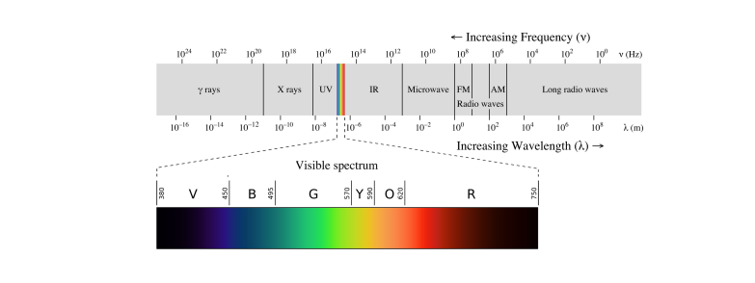

**Figure 3: The electromagnetic spectrum**

The wavelength λ is the distance between adjacent peaks (or troughs) in the time-frozen electromagnetic wave, and is given in meters, centimetres or nanometres (10−9 meters). Visible wavelengths cover a range from approximately 400 to 750 nm. The frequency ν is the number of wave cycles that travel past a fixed point per unit of time, and is usually given in cycles per second, or Hertz (Hz). Frequency and wavelength are related via λ = c/ν = 2πc ω (1) where c is the speed of light. The angular frequency ω = 2πν (radians per second) is often used instead of ν. When polychromatic or ’white’ light passes through or is reflected by a coloured substance, a characteristic portion of the spectrum is absorbed. The remaining light will then exhibit the complementary colour to the wavelength(s) absorbed. Thus, absorption of blue light between 420-430 nm renders a substance yellow, and absorption of green, 500-520 nm light makes it red. Green, to which our eyes are most sensitive, is unique in that it can be created by absorption close to 400 nm as well as absorption near 800 nm.

**1.3. Different types of Electronic Transitions**:

The interaction of molecules with ultraviolet and visible light may results in absorption of photons. This results in electronic transition, involving valance electrons, from ground state to higher electronic states (called excited states). The promoted electrons are electrons of the highest molecular orbitals HOMO.

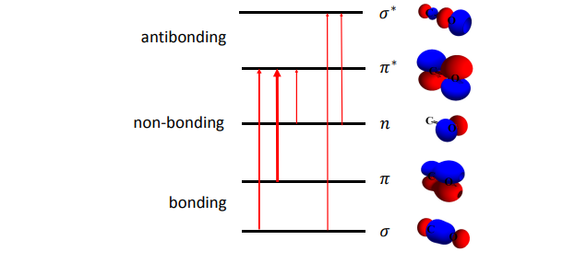

**Figure 4: Illustration of different types of electronic transitions.**

• π → π ∗ transitions: For molecules that possess π bonds like alkenes, alkynes, aromatics, acryl compounds or nitriles, light can promote electrons from a π bonding molecular orbital to a π anti-bonding molecular orbital. This is called a π → π ∗ transition and is usually strong (high extinction coefficient ). Groups of atoms involved in π bonding are thus often called chromophores. The transition energy (or absorption wavelength) can be an indication for different types of π bonds (carbon-carbon, carbon oxygen or carbon-nitrogen in a nitrile group).

• n → π ∗ transitions: Lone pair electrons that exist on oxygen and nitrogen atoms may be promoted from their non-bonding molecular orbital to a π anti-bonding molecular orbital. This is called an n → π ∗ transition and requires less energy (longer wavelength) compared to

a π → π ∗ transitions within the same chromophore. However, the transition probability is usually much lower.

• n → σ ∗ transitions: Saturated compounds with substituents containing lone-pairs such as water, ammonia, hydrogen disulfide only have n → σ∗ and σ → σ ∗ transitions in the UV-visible range.

• d−d transitions: Many transition metal ion solutions are coloured as a result of their partially filled d-levels, which allows promotion of an electron to an excited state (change of d-level occupation) by the absorption of relatively low energy visible light. The bands are often broad and strongly influenced by the chemical environment. They are also usually very weak.

• Charge transfer transitions: Much stronger absorption is found when complexing the metal ion with some suitable organic chelating agent to produce a charge-transfer complex. Electrons may be transferred from the metal to the ligand or vice versa. The high transition probability is exploited to quantitatively detect ions in solution. There are numerous chelating agents available which may or may not complex selectively where there is more than one type of metal ion present. For example 1,10-phenanthroline is a common chelate for the analysis of Fe(II).

**Factors affecting electronic transitions:**

**Molecular structure: 1**-

π-Conjugated Molecules - Nmerous examples from organic and biological chemistry (e.g. β-carotene, 11 conjugated double bonds; chromophore responsible for color vision; etc. - Molecules composed of alternating single and double (or tripl)e) bonds e.g. 1,3-butadiene

All will have different electronic spectra due to differences in molecular structures.

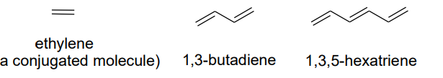

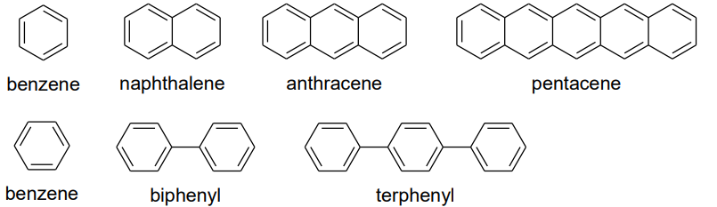

**2. General solvent effects**

Solvents affect electronic spectra due to changes of their polarity (dielectric constant, f(ε), and refractive index, f(n)) as well as hydrogen bonding, by changing the probability and the energy of both absorption and emission .

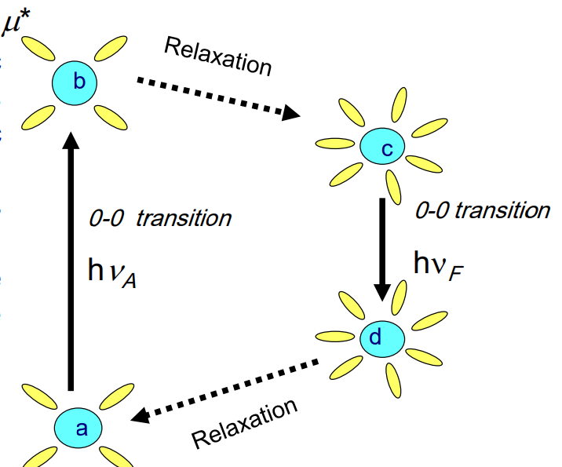

Solvents affect electronic spectra through their ability to stabilize ground and excited states differently, thereby changing the probability and the energy of both absorption and emission.

**Effects on π→π* and n→π* transition**

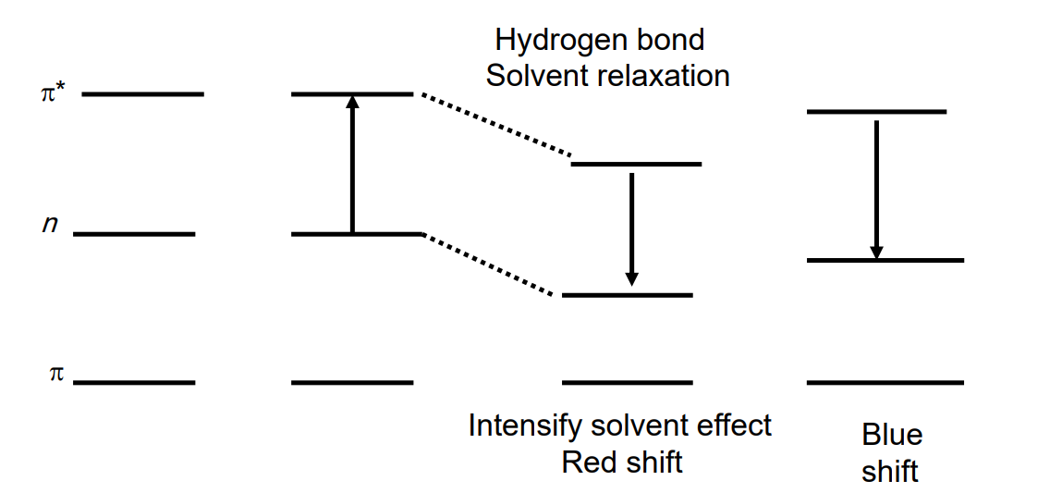

In n → π* transitions as the solvent polarity increases. Solvation stabilizes the nonbonding pair (blue shift ).

In π → π* transitions as the solvent polarity increases. Solvation stabilizes π*, which is often more polar than π (red shift).

**3- Viscosity and pH Effects:**

increasing viscosity leads to increasing of band intensity and formation of vibrational structures of bands due to decreasing of molecular collisions.

Electronic transitions are pH dependent for compounds with acidic or basic substituents Changes in pH influence the degree of ionization, which, in turn, may affect the extent of conjugation or the aromaticity of the compound.

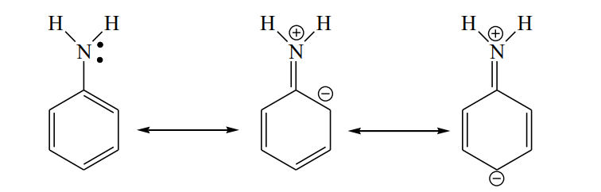

**resonance forms of aniline more resonance forms stabilize excited state**

**Terms describing UV-Vis. Absorptions**

1. Chromophores: functional groups that is responsible for electronic transitions (Group will have a characteristic λ max and εmax). Molecular structure or environment can influence λ max and ε.

2. Auxochromes: substituents with unshared pair of electrons like OH, NH, SH ..., when attached to π chromophore they generally move the absorption max. to longer λ.

3. Bathochromic shift: shift to longer λ, (red shift).

4. Hysochromic shift: shift to shorter λ, (blue shift).

5. Hyperchromic effect: increase in εmax of a band.

6. Hypochromic effect: decrease in εmax of a band.

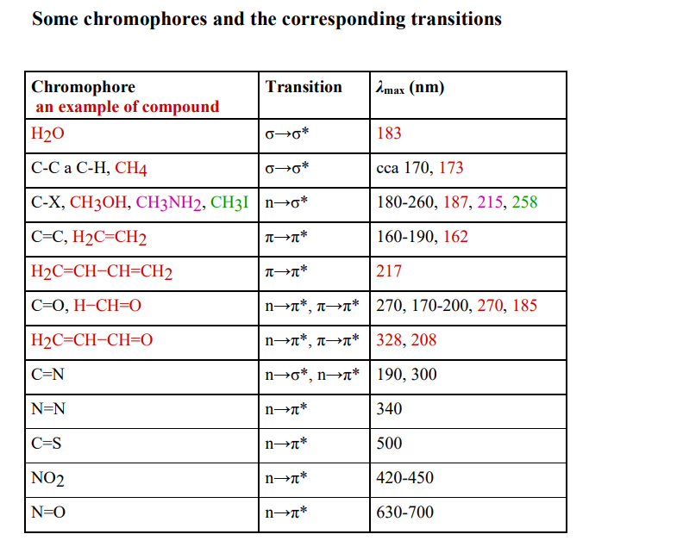

**The Woodward-Fieser rules (Calculation of 𝝀max (nm) in conjugated dienes)**

|  |
| --- |
| 𝜆max (nm)  **Base value:**  Acyclic or heteroannular dienes 214  Homoannular dienes ---- 253  **Increments for:**  Double bond extending conjugation 30  R alkyl substituent or ring residue 5  Exocyclic double bond 5  **Polar groupings:**  -OCOCH3 0  -OR 6  -Cl, -Br 5 |

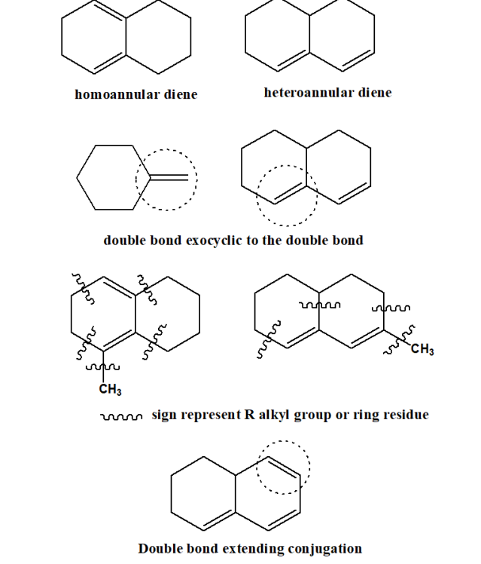

**The Woodward-Fieser rules (Calculation of 𝝀 max (nm) in α,β-unsaturated carbonyl compounds**

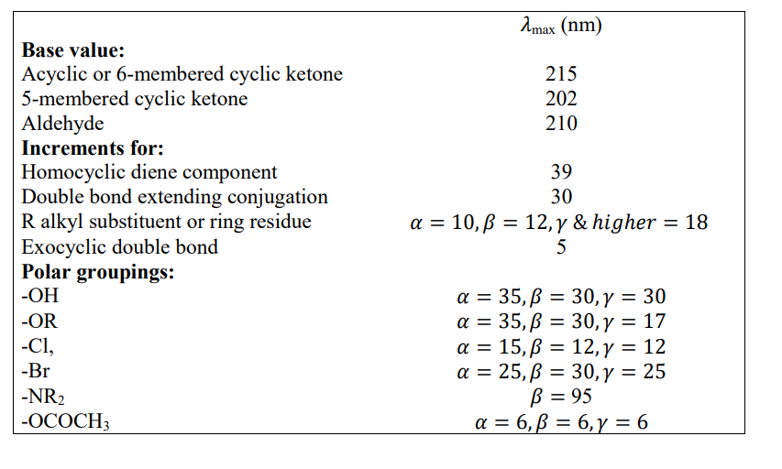

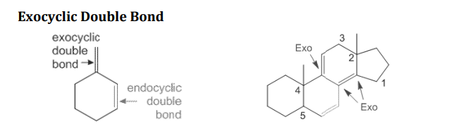

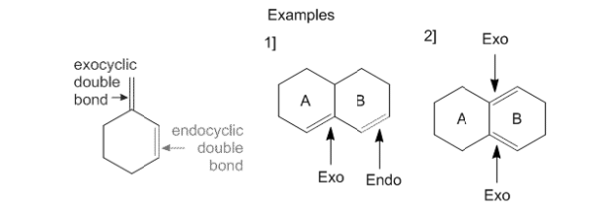

**Aromatic Compounds**

**Parent chromophore:**

Ar = C6H5 Ar-CO-R 246 nm

Ar-CHO 250 nm

Ar-COOH or Ar-COOR 230 nm

**Increment for each substituent on Ar:**

Alkyl or ring residue o, m + 3 nm ,p + 10 nm

OH, OCH3, OAlk o, m + 7 nm, p + 25 nm

NH2 o, m + 13 nm, p + 58 nm

NHCOCH3 o,m + 20 nm ,p + 45 nm

Cl o, m + 0 nm ,p + 10 nm

Br o, m + 2 nm ,p +15 nm

Calc λmax = 246 + 3 (o-ring residue) + 7 (o-OH) =256 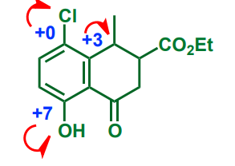

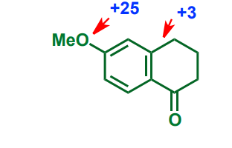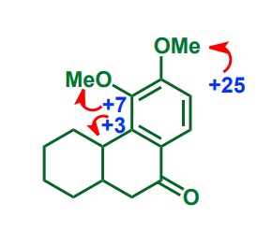

Calc λmax = 246 + 25 + 7 + 3 = 281 nm

Calc λmax = 246 (parent chromophore) + 3 (o-ring residue) + 25 (p-OMe) = 274 nm

**Fieser-Kuhn rules for Conjugated Polyenes**

λmax = 114 + 5M + n(48.0 – 1.7n) - 16.5Rendo – 10Rexo)

Where

n = number of conjugated double bonds

M = number of alkyl or alkyl like substituents on the conjugated system

Rendo = number of rings with endocyclic double bonds in the conjugated system

Rexo = number of rings with exocyclic double bonds

**Example 1**

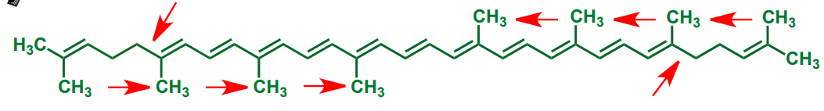

λmax = 114 + 5(8) + 11[48.0 – 1.7(11)] - 0 – 0 = 476 nm

**Example 2**

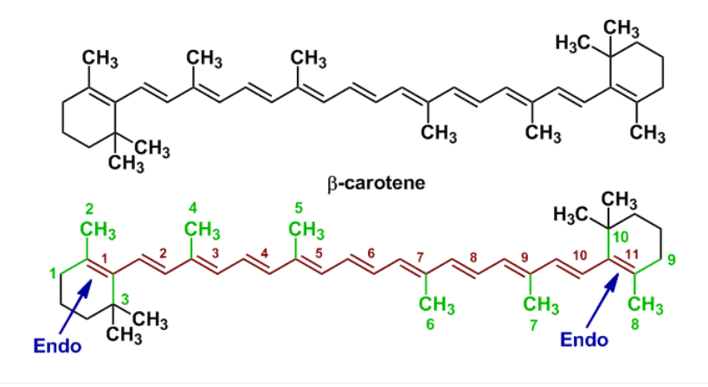

|  |  |
| --- | --- |
| **Base Value** | 114 nm |
| **M (number of alkyl substituents)** | 10 |
| **n (number of conjugated double bonds)** | 11 |
| **Rendo (number of endocyclic double bonds)** | 2 |
| **Rexo (number of exocyclic double bonds)** | 0 |
| **Substituting in equation λmax = 114 + 5M + n (48.0 – 1.7 n) – 16.5 Rendo – 10 Rexo** | **= 114 + 5(10) + 11 (48.0-1.7(11)) – 16.5 (2) – 10 (0)= 114 + 50 + 11 (29.3) – 33 – 0= 114 + 50 + 322.3 – 33**  **Calc. λmax = 453.30 nm** |

**Example 3**

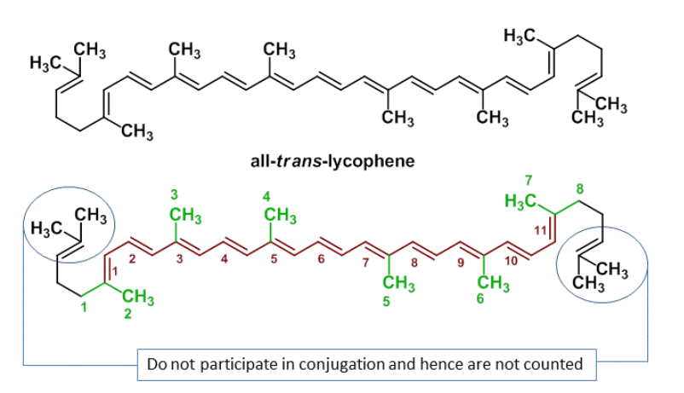

|  |  |
| --- | --- |
| **Base Value** | 114 nm |
| **M (number of alkyl substituents)** | 8 |
| **n (number of conjugated double bonds)** | 11 |
| **Rendo (number of endocyclic double bonds)** | 0 |
| **Rexo (number of exocyclic double bonds)** | 0 |
| **Substituting in equation λmax = 114 + 5M + n (48.0 – 1.7 n) – 16.5 Rendo – 10 Rexo** | **= 114 + 5(8) + 11 (48.0-1.7(11)) – 16.5 (0) – 10 (0)= 114 + 40 + 11 (29.3) – 0 – 0= 114 + 40 + 322.3 – 0**  **Calc. λmax = 476.30 nm** |

Ultraviolet-Visible (UV-Vis) Spectroscopy – Sample Problems Using Woodward-Fieser Rules

In these sample problems you will be shown the structure, then the structure is highlighted to show you key features which would aect the λmax of the molecule. Then the table will show you the solutions on how to solve to get the wavelength of maximum absorption, with a nal calculated λmax using the Woodward-Fieser rules.

**Example/Sample Problem 1**

Name of Compound 2,4-dimethylpenta

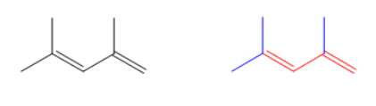

Woodward Component Contribution

CoreTransoid/Heteroannular Diene + 215 nm

Substituents- 3 alkyl groups 3 x 5 = + 15 nm

Other Eects 0

Calculated λmax 230 nm

Observed λmax 234 nm

**Example/Sample Problem 2**

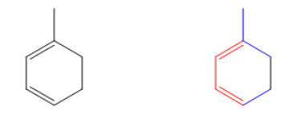Woodward Component Contribution CoreCisoid/Homoannular Diene + 253 nm

Substituents- 3 alkyl groups

3 x 5 = + 15 nm

Calculated λmax 268 nm

**Example/Sample Problem 3**

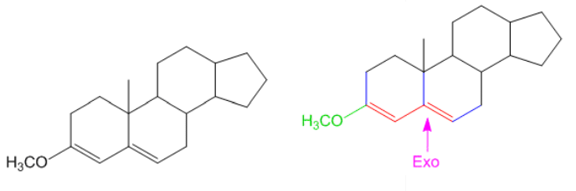

Woodward Component Contribution

Core- Transoid/Heteroannular Diene + 215 nm

Substituents- 3 alkyl groups 1 alkoxy group 3 x 5 = + 15 nm + 6 nm

Exocyclic Double Bond + 5 nm

Calculated λmax 241 nm

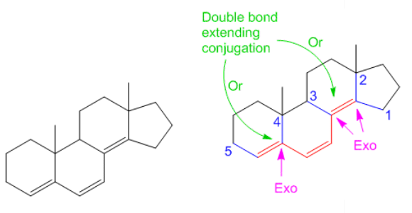

Woodward Component Contribution

CoreTransoid/Heteroannular + 215 nm

Substituents- 5 alkyl groups 5 x 5 = + 25 nm

1 Double bond extending conjugation + 30 nm

3 Exocyclic Double Bond + 15 nm

Calculated λmax 285 nm

**Homoannular system**

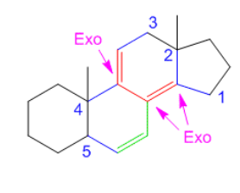

Component Contribution

CoreHomoannular/Cisoid diene + 253 nm

Substituents– 5 alkyl substituent 5 x 5 = + 25 nm

s Double bond extending conjugation + 30 nm

Exocyclic double bonds 3 x 5 = + 15 nm

Calculated λmax 323 nm

**α,β-unsaturated ketone**

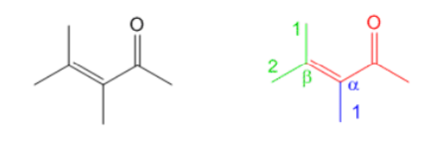

Component Contribution

Core- α,β-unsaturated ketone + 215 nm

Substituents at α-position- 1 alkyl group + 10 nm

Substituents at β-position- 2 alkyl groups 2 x 12 = 24 nm

Calculated λmax 249 nm

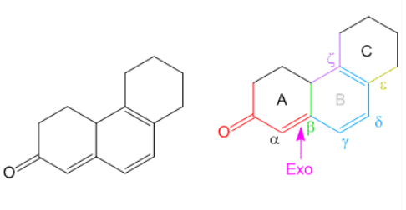

Core- cyclohexenone + 215 nm

Substituents at α-position: 0

Substituents at β-position: 1 alkyl group + 12 nm

Substituents at γ-position: 0

Substituents at δ-position: 0

Substituents at ε-position: 1 alkyl group + 18 nm

Substituents at ζ-position: 2 alkyl group 2 x 18 = + 36 nm

2 Double bonds extending conjugation 2 x 30 = + 60 nm

Homoannular Diene system in ring B + 35 nm

1 Exocyclic double bond + 5 nm

Calculated λmax 381 nm

Observed λmax 388 nm

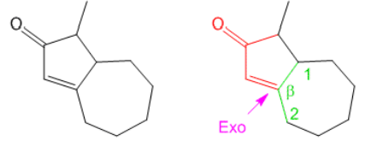

**Component**  **Contribution**

Core cyclopentenone + 202 nm

Substituents at αposition 0

Substituents at βposition- 2 alkyl groups 2 x 12= + 24 nm

1 Exocyclic Double Bond + 5 nm

Calculated λmax 231 nm

***problemes***

