**Experiment No. (10)**

**((Determine The Temperature and Evaporation of water))**

**The theoretical part:**

When evaporation occurs, cooling takes place. Think of how cool you`ve felt getting out of a pool on a windy summer day. Water molecules were evaporating from your skin`s surface, lowering its temperature as each water molecule “ stripped “ a portion of heat from your skin .

**Purpose :**

The purpose of this lab is to demonstrate the evaporation rates of specific amounts of water that are different distances from a heat source .

**Materials needed :**

● Lamp with 100-watt bulb .

● Five shallow bowls .

● 15- centimeter plastic ruler.

● Meter stick.

● Water.

**Procedure :**

Caution! Be sure electrical cords are coiled away from any stink or pans filled with water.

1- see Fig. 5-1 .

2- Arrange the meter stick, lamp, and pans as shown in in Fig. 5-1.

3- Fill the pans with exactly 2.0 centimeters of water.

4- Lay a thermometer over each pan.

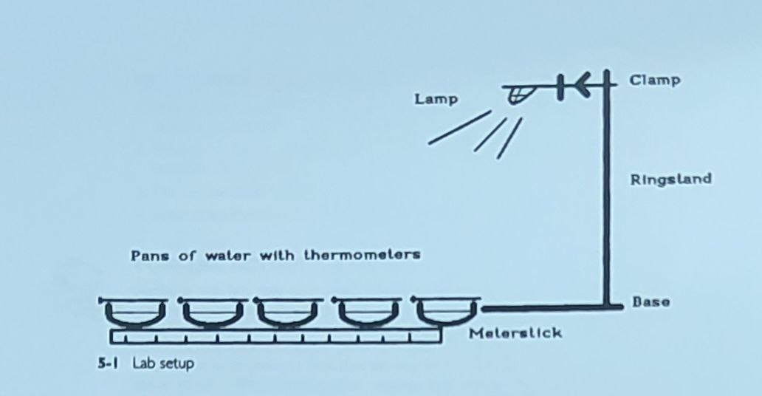

5- Turn on the lamp.

6- After 10 minutes, record the temperature of each thermometer on the chart shown in Fig. 5-2.

7- Leave the lamp on for 24 hours .

8- The next day, record the new height of the water to the nearest 0.1 centimeter on the chart shown in Fig. 5-2.

**Observations :**

1- Would the evaporation amount have been the same if a different level of water had been used? Why or why not?

2- would the rate of water evaporation have been different if the pan had been shaped differently ?

|  |  |  |  |  |
| --- | --- | --- | --- | --- |
| **Amount of water evaporated (cm)** | **New height of water (cm)** | **Initial height of water (cm)** | **Temperature**  **( deg. C)** | **Bowl #** |
|  |  | 2.0 |  | 1 |
|  |  | 2.0 |  | 2 |
|  |  | 2.0 |  | 3 |
|  |  | 2.0 |  | 4 |
|  |  | 2.0 |  | 5 |

**5-2 Heat evaporation data table**

**Questions/ conclusions :**

1- Sometimes it rains heavily over the desert . Yet, the rain can evaporate before reaching the ground . can you explain why?

2- where on the earth would you expect the greatest rate of evaporation from sunlight? Why is this ?

3- Define the term albedo.

4- How does the albedo of an object determine evaporation rate ?

**Post-lab activity – lab 5:**

Perform the lab this time with different types of liquid in each container . use salt water , tap water , distilled water , water/ silt , and water/ isopropyl alcohol . ( wear goggles for safety .) Be sure all levels are the same . see Fig. 5-1 for initial setup. Try different placements of the pans. ( Instead of placing them in a line, center the light over the whole group.)

Run this lab for 24 to 48 hours. Record your results. How are these results different from the original lab results ? How does the location of each pan affect its own evaporation rate ? Does the addition of impurities ( salt, sugar, silt, and isopropyl alcohol) affect the evaporation ? what additional tests could be done to further investigate this ?