**Lab. Meteorological**

**Data analysis ........ Fourth stage**

**(The second Semester)**

**Department of Atmospheric Sciences**

**2024 – 2025**

**Lecturers :**

**Dr.** **Iqbal khalaf , Dr.** **Khawla Zaki , Dr. Farah Haseeb ,**

**L. Ruaa mazin,L. luma mahdi ,L. Salwa salman ,**

**L. Yasamin qusay, A.L.Zahraa abdul razzaq, A.L.Zahraa araf**

***Preparing by: Dr. Farah Haseeb , L. Ruaa mazin , L. Luma Mahdi***

**(( Fifth Lecture ))**

***The Statistical Test of a Hypothesis:***

It is a set of statistical tests that researchers use to make a decision About whether a Null hypothesis is acceptable or not, this is done using a test function Appropriate stats. There is a wide range of statistical tests The choice of hypothesis test depends on Data structure, data distribution, and variable, e.g. (a new treatment might be successful, or a relationship) between the number of sunspots and the amount of precipitation.

***There are two types of hypotheses used in hypothesis testing:***

***1- The null hypothesis***

is the hypothesis To be tested is denoted by the symbol **( Ho)** including the objective of the test, And accepting it means not rejecting the results of the sample, it is in the form of an equation or an equation:

**\* The arithmetic mean of the sample = the arithmetic mean of the population that is, there is no difference between the mean and the sample.**

**For example /** if the null hypothesis to be tested is the average income of the individual in One of the regions is $200 per month. The imposition is written in symbols as follows:

**H0: μ=200**

***2- Alternative Hypothesis* :** It is the hypothesis that is accepted inthecase of reject the null hypothesis .

(**Ho**) It is symbolized by the symbol (**H1**) Take the shape is not equal :

alternative hypothesis (Ha) (**The arithmetic mean of the sample is ≠ the arithmetic mean of the population )**

# H1: μ > 200 Right side test H1: μ <200 left side test

**H1: μ** ≠**200 Not equal to the test of both sides.**

**\***There is more than one type of test such as (**T-tests, Z-tests, and ANOVA tests)** These tests assume that the data have a normal distribution and are called tests parametric.

***Z-test*** :

A statistical test used to compare two populations (the sample and the population). When the mean is The arithmetic is known and the standard deviation coefficient is also known. **𝑍= $\frac{\left(\overline{x}-μ\right)}{(σ/√n ) }$**

**Where:**

the arithmetic mean of the population.



**Note: When the number of samples is more than 30, we use a test z .**

***For example:*** A school principal finds that the students' IQ level is higher than the students of the rest of the school's 40 students (as a sample) arithmetic mean of 112 students proved that their IQ is higher than the rest Schools arithmetic mean of the population is 100 and standard deviation is 15 and error rate =0.05.

**Solue:**

1- we extract values of **z** Calculated from the equation below:

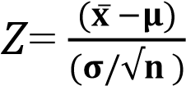

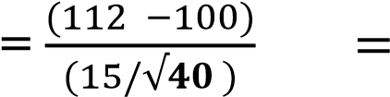12/2.371 = 5.06 **The value of Zcalculated**

2-Calculate the value of Z in the statistical table:

*error rate=0.05, we find the accuracy rate =0.95

* We divide the percentage of accuracy or the value of accuracy by 2 (0.95/2= 0.4750 )
* find the value of z Tabular by finding the location of the value ( 0.475 ).
* We add the value from the table ( row + column) appears, which **equals 1.96**, which represents the tabular value of Z as shown in the statistical table
* *We compare the calculated z value with the tabular z, ***If the calculated value is greater, we reject the null hypothesis and choose the alternative hypothesis. If the values are equal, we accept the null hypothesis (the null hypothesis.***

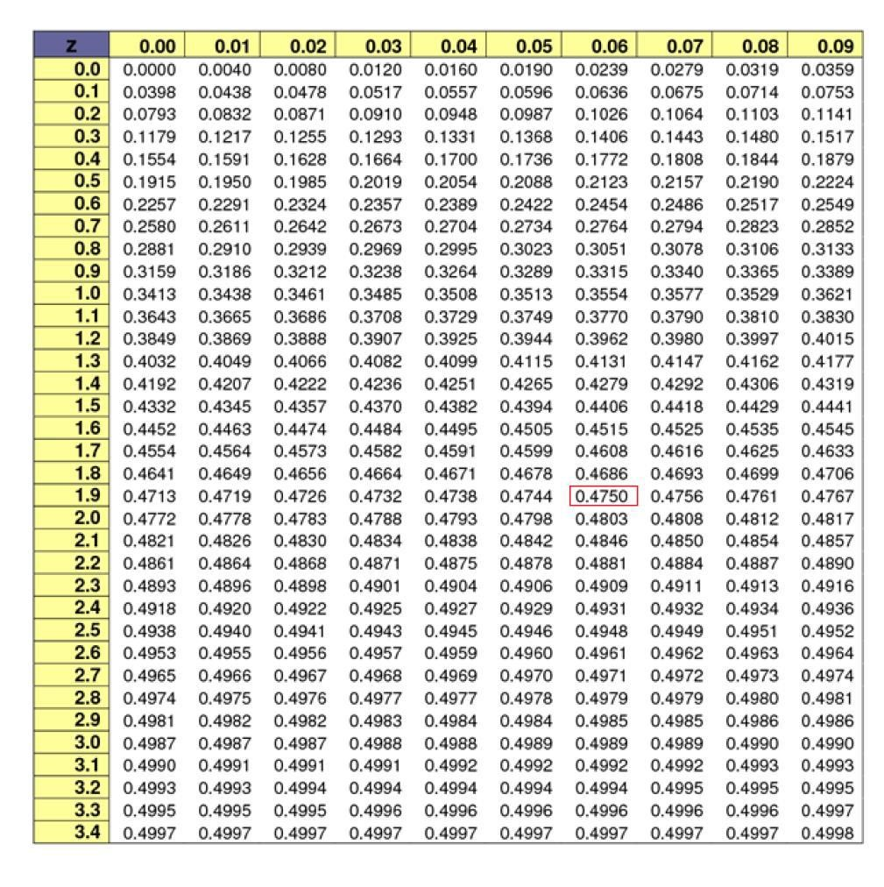

**H.W//** A random sample of 49 people was selected from among the country's members. If the arithmetic mean weekly income of individuals for this sample is $75, the community standard deviation of individuals' income is $14 and the arithmetic mean weekly income of this country is 72. Do you accept the null hypothesis? If you know that the tabular value of z is (1.96) .

***T-test***:

It is a statistical test that enables us to compare the arithmetic mean of the sample and the population.

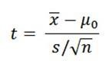

**Where:** 

the arithmetic mean of the population.



***Note: When the number of samples is less than 30, we use a test t .***

***For example*:** A sales company sells $100 transactions. They wanted to increase sales, so share 25 people in development courses, which increased the percentage of sales 130 $ What is the reason for the increase and standard deviation is 15 and error rate =5% .

Solue:

1-we extract values of **t** Calculated from the equation below:



=( 130-100)-(15/SQRT(25)) = **The value of t calculated**

2-Calculate the value of t in the statistical table:

* From the table we determine the value vertical Which represents the error percentage given, 5%(0.05).
* From the table we determine the value horizontal Which **represents degree of freedom** which is equal to (n-1) If the number of samples In the example 25 The degree of freedom is 24.
* find the value of t Tabular by finding the location of the value ( 1.711 ).

*- We compare the value of each (t) tabular and (t) calculated If the calculation is greater than Tabular, ***We reject the null hypothesis and accept the alternative hypothesis.***

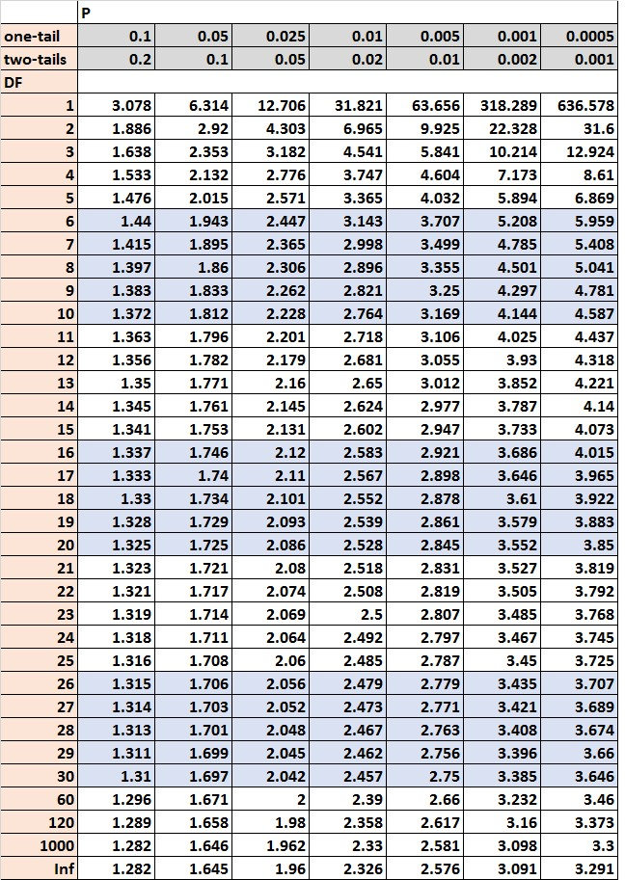

**H.W\**

Q1\ If the average increase in the wages of workers in one of the institutions in 2015 was 36 thousand dinars, and in 2017, a sample was taken from 64 individuals working in this institution, it was found that the arithmetic mean of the increase in their wages is 40 thousand dinars and the standard deviation 8 thousand . Does this indicate that The average increase in wages for employees of the establishment in 2017 differed from the average increase in wages in 2015, at a significant level of 0.05.

Q2\The director of a statistical studies company believes that the average monthly expenditure on food in the homes of an area is equal to 290 thousand dinars. If a random sample of 10 houses is taken, it turns out that its arithmetic mean is 296 thousand and its standard deviation is 5 thousand dinars. Is it possible to rely on this sample to confirm what he assumed. Use the 95% accuracy level.