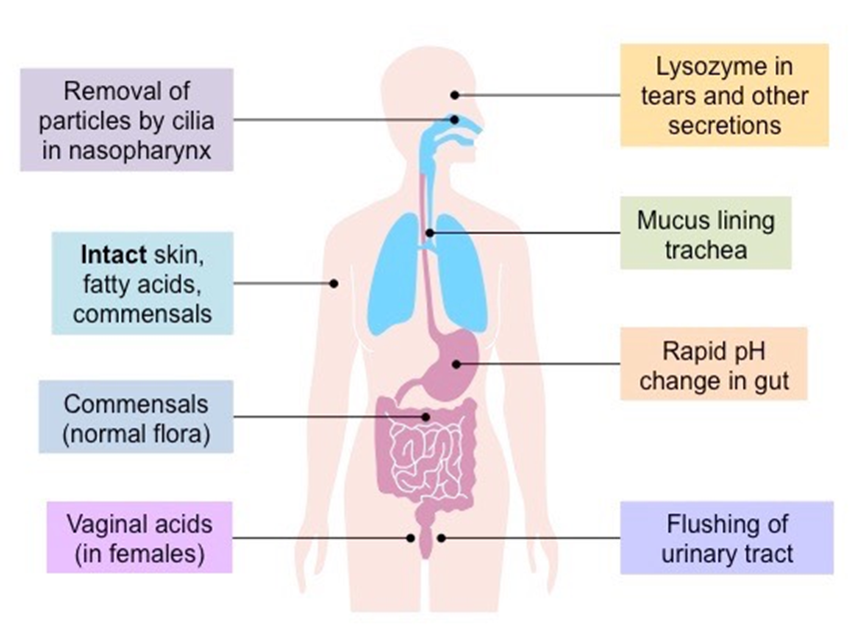

Cells of the Immune System
The immune system is a complex network of cells and molecules that work together to defend the body against pathogens, including bacteria, viruses, fungi, and parasites. Understanding the various types of immune cells and their functions is essential for comprehending how the immune response operates.
The innate immune cells provide immediate defense, while the adaptive immune cells offer a targeted response, ensuring a comprehensive immune defense against pathogens.
All blood cells, including leukocytes, derive from hematopoietic stem cells((are pluripotent)) found in the bone marrow.
White blood cells (WBCs) can be classified based on two criteria:
1- Appearance and function into :
- Granulocytes: These leukocytes contain visible cytoplasmic granules and include: Neutrophils, Eosinophils, Basophils.
- Agranulocytes: These leukocytes lack prominent cytoplasmic granules and include:
  - Lymphocytes: B cells and T cells that mediate adaptive immunity.
  - Monocytes: Differentiate into macrophages and dendritic cells, which are involved in both innate and adaptive immunity.
2- Differentiation from stem cells ‎into 2 lineages: ‎

1. Myeloid Lineage:
Characteristics: Produces cells primarily involved in the innate immune response.
Types of Myeloid Cells:
- Granulocytes((Neutrophils, Eosinophils, Basophils)).
- Monocytes: Differentiate into macrophages (engulf pathogens) and dendritic cells (present antigens to T cells).
- Mast Cells: Involved in allergic reactions and inflammation.
- RBC & platelets

2. Lymphoid Lineage:
Characteristics: Responsible for adaptive immune responses.
Types of Lymphoid Cells:
- Lymphocytes: T Lymphocytes (T Cells) &Lymphocytes (B Cells)
- Natural Killer (NK) Cells

3. Bridging Cells
- Natural Killer (NK) Cells: Develop in the bone marrow and are involved in innate immunity against tumors and virally infected cells, but also play a role in adaptive immunity by targeting tumor and virus-infected cells.
- Phagocytes: Such as macrophages and dendritic cells, serve as a link between innate and adaptive immunity by presenting antigens to T cells.

Characteristics of White Blood Cells (Leukocytes)
White blood cells (WBCs) are essential components of the immune system, playing a crucial role in defending the body against infections and diseases, characteristics of leukocytes:
- Patrolling the Body: Leukocytes continuously circulate through the bloodstream and the lymphatic system, patrolling tissues and organs. This movement allows them to quickly respond to infections or injuries.
- Tissue Migration: They can exit the bloodstream and migrate to tissues, particularly at sites of infection or inflammation, where they accumulate to mount an immune response.
- Individual and Accumulated Cells: Leukocytes can exist as individual cells dispersed throughout the body or as clusters at sites of infection or inflammation, where their numbers increase to combat pathogens.
- Innate Immunity: Certain leukocytes, such as granulocytes (neutrophils, eosinophils, and basophils), monocytes/macrophages, and natural killer (NK) cells, are integral to the innate immune response. They provide immediate defense against pathogens.
- Adaptive Immunity: Other leukocytes, particularly B lymphocytes and T lymphocytes, are key players in the adaptive immune response. They respond specifically to pathogens and provide long-lasting immunity.

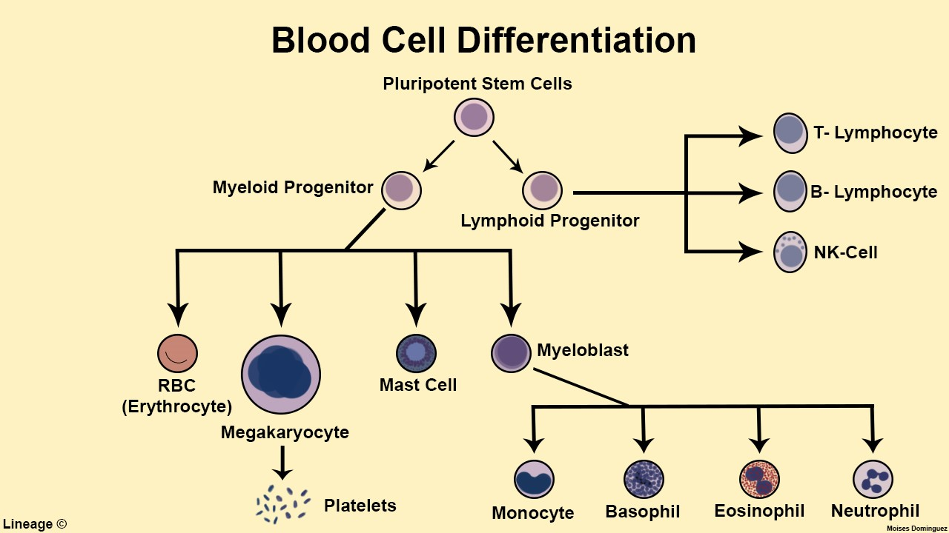

a. T Lymphocytes (T Cells)
- Types:
  - Cytotoxic T Cells (CD8+): Directly kill infected or cancerous cells.
  - Helper T Cells (CD4+): Assist other immune cells by releasing cytokines that enhance the immune response.
- Function: Recognize antigens presented by APCs through their T cell receptors (TCRs).

b. B Lymphocytes (B Cells)
- Origin: Produced in the bone marrow.
- Function: Differentiate into plasma cells that produce antibodies. Antibodies neutralize pathogens and mark them for destruction.

3. Antigen-Presenting Cells (APCs)
APCs play a crucial role in activating T cells. The main types include:
- Dendritic Cells: The most effective APCs, crucial for initiating the adaptive immune response.
- Macrophages: Also serve as APCs and can present antigens to T cells.
- B Cells: Can present antigens to T helper cells, enhancing their activation.
Cells of the myeloid lineage
1-Monocytic cells play a crucial role in the immune system, particularly in the innate immune response.
- Monocytes are large, mononuclear cells present in circulation. Once they exit the bloodstream and enter tissues, they differentiate into macrophages. Known as the body's scavengers, they phagocytose (engulf and digest) cellular debris, foreign cells, and particles, degrading them enzymatically.
- Monocytes account for approximately 5% to 7% of total WBCs.
- Lifespan in Circulation spend 1 to 2 days in circulation before migrating into tissues, where they can survive for several months in their macrophage form.
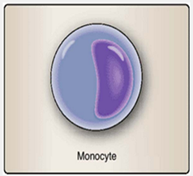

Differentiation into Macrophages
Upon entering tissues, monocytes differentiate into macrophages, which are highly versatile immune cells. Macrophages are categorized based on their tissue location:
- Alveolar Macrophages: Located in the lungs; they play a vital role in clearing inhaled particles and pathogens.
- Kupffer Cells: Found in the liver; they help filter blood and remove pathogens and dead cells from circulation.
- Microglial Cells: Reside in the brain; they are involved in immune surveillance and response in the central nervous system.
- Osteoclasts: Located in bone; they are responsible for bone resorption and remodeling.

Activation of Macrophages
- Enhanced Killing Activity: The killing activity of macrophages is significantly enhanced when they become "activated." This activation can occur through:
  - Contact with Microorganisms: Pathogen recognition through pattern recognition receptors (PRRs) on macrophages.
  - Cytokines: Signals released by certain lymphocytes (e.g., T cells) during the immune response that stimulate macrophage activity.

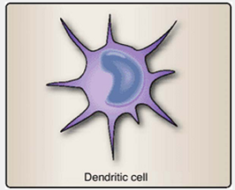
2- Dendritic Cells (DCs) are specialized antigen-presenting cells (APCs) of the immune system, acting as messengers between the innate and adaptive immune responses. They are named for their long, branching membranous projections that resemble the dendrites of neurons.
Types of Dendritic Cells
- Conventional DCs (cDCs): Primarily responsible for antigen
presentation.
- Plasmacytoid DCs (pDCs): Known for producing large amounts
of type I interferons, especially in response to viral infections.

Mechanism of Action
- Antigen Capture:
Dendritic cells reside in peripheral tissues, where they continuously sample their environment. They capture antigens through phagocytosis, receptor-mediated endocytosis, or macropinocytosis.
- Antigen Processing:
After internalizing the antigen, dendritic cells process it into peptide fragments within endosomal or lysosomal compartments.
- Migration to Lymph Nodes:
Upon activation by pathogen-associated molecular patterns (PAMPs) via pattern recognition receptors (PRRs) such as Toll-like receptors, dendritic cells mature and migrate to nearby lymph nodes via lymphatic vessels.
- Antigen Presentation:
In the lymph nodes, mature dendritic cells present processed peptides bound to MHC molecules on their surface:
  - MHC class II → presented to CD4⁺ T helper cells
  - MHC class I → presented to CD8⁺ cytotoxic T cells
- Activation of T Lymphocytes:
Through antigen presentation, costimulatory molecules (e.g., CD80/CD86), and cytokine secretion, dendritic cells activate naïve T cells and initiate the adaptive immune response.

3- Granulocytes

A- Neutrophils are essential components of the innate immune system, providing rapid defense against infections primarily through phagocytosis. Their unique structure, granule composition, and functional capabilities make them vital for maintaining health and responding to inflammatory processes.
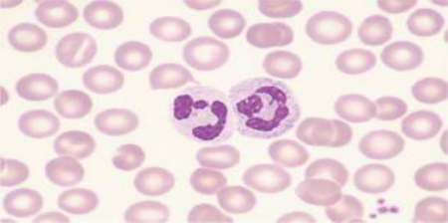
- Population: Comprise 50% to 70% of total peripheral white blood cells (WBCs) in adults.
- Size and Structure:
  - Diameter: Approximately 10 to 15 μm.
  - Nucleus: Typically has 2 to 5 lobes.
- Granules:
  - Stain neutral with Wright's stain.
  - Granules are classified into:
    - Specific Granules: Make up about two-thirds of the granules; contain enzymes and proteins that aid in the immune response.
    - Azurophilic Granules: One-third; involved in phagocytosis and contain enzymes like myeloperoxidase.
- Main Function:
  - Phagocytosis: Responsible for engulfing and destroying foreign particles, including bacteria and fungi.
- Circulation and Adhesion:
  - Half adhere to blood vessel walls.
  - The other half circulate freely for about 6 to 8 hours before migrating to tissues.
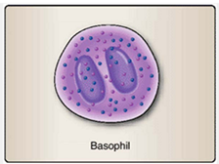
B-Basophils and Mast Cells are crucial components of the immune system involved in allergic reactions. Basophils are rare in blood, while mast cells are more abundant in tissues and larger in size. Both release mediators that enhance inflammatory responses.
- Basophils:
  - Contain active amines like histamine and serotonin,
released upon stimulation.
  - Stain readily with "base-loving" dyes.
  - Have a bilobed nucleus and are found in low numbers in peripheral blood (0% to 1%).
- Mast Cells:
  - Tissue-resident form of basophils, but from a different lineage.
  - Larger than basophils and distributed widely throughout the body, particularly in skin, connective tissue, and mucosal epithelial tissues (e.g., respiratory, genitourinary, digestive tracts).
- Functions:
  - Both basophils and mast cells play significant roles in allergic reactions as part of the adaptive immune response.
  - Mast cells increase vascular permeability and blood flow to affected areas, contributing to allergic responses.
C- Eosinophils are specialized white blood cells with distinctive granules that play a critical role in immune responses, especially against parasitic infections. Their granule content includes various proteins that contribute to their functions in both innate and adaptive immunity.
- Granules: Eosinophils have "eosin-loving" granules that stain with the acid eosin dye, appearing as large orange to reddish-orange granules in the cytoplasm.
- Structure: They are bilobed granulocytes, characterized by their unique cytoplasmic granules that contain basic proteins.
- Population: Eosinophils make up 0% to 5% of peripheral blood leukocytes and are active in both innate and adaptive immune responses, particularly against parasitic helminth (worm) infections.
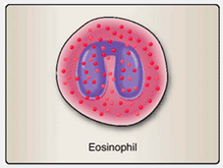
- Granule Composition: Their granules contain a variety of synthesized proteins, including:
  - Eosinophil-derived neurotoxin
  - Peroxidase
  - Histamine
  - Proteases
  - Cytokines (chemical messengers)
  - Growth factors
- Cells of the lymphoid lineage
4- Lymphocytes include B cells, which produce antibodies, and T cells, which mature in the thymus. Natural Killer cells play a vital role in recognizing and destroying infected or abnormal cells without prior sensitization. Together, they form an essential part of the immune system.
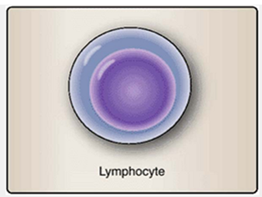
Lymphocytes are a type of white blood cell that differentiate along lymphocytic pathways. They are primarily classified into two types based on their differentiation pathways:

1. B Lymphocytes (B Cells)
- Location: Reside in the bone marrow.
- Function: Capable of synthesizing immunoglobulin molecules.
- Differentiation: B cells can further differentiate into plasma cells,
which are the only cells that produce antibodies.

2. T Lymphocytes (T Cells)
- Origin: Derived from bone marrow but migrate to the thymus for differentiation.
- Thymocytes: Immature T cells that mature in the thymus and exit as functional T lymphocytes.
3. Natural Killer (NK) Cells are a type of lymphocyte, which is a white blood cell that plays a play a vital role in controlling infections, especially viral infections, and in monitoring and eliminating tumor cells, contributing to the overall defense of the body against diseases.
- Function: NK cells can kill target cells without prior exposure, making them a crucial part of the innate immune response.
- Population: Comprise 10% to 15% of circulating lymphocytes, mainly found in the liver, spleen, and peripheral blood.
- Mechanism: Continuously scan for protein irregularities on host cells, acting as the first line of defense against virally infected and tumor cells.
- Granules: Contain proteases called granzymes; their release induces target cell death.
- Morphology: Share a lymphoid morphology with other lymphoid lineage lymphocytes.

Recognition in Immunity
Recognition in immunity is the process by which the immune system identifies and responds to pathogens, foreign substances, and abnormal cells. This process is crucial for initiating an effective immune response and can be categorized into several key components:

1. Antigen Recognition
- Antigens: These are specific molecules, often proteins or polysaccharides, found on the surface of pathogens (such as bacteria, viruses, and fungi) or on abnormal cells (like cancer cells).

2. Pattern Recognition
- Pattern Recognition Receptors (PRRs): These receptors, found on immune cells, detect common patterns on pathogens, known as pathogen-associated molecular patterns (PAMPs) and damage-associated molecular patterns (DAMPs).
- Examples of PRRs: Toll-like receptors (TLRs) and NOD-like receptors (NLRs) play key roles in identifying infections and initiating innate immune responses.

3. Self vs. Non-Self Recognition
- The immune system must distinguish between the self-antigens and foreign invaders (non-self). This differentiation is vital for preventing autoimmune diseases, where the immune system mistakenly attacks healthy tissues.

4. Cellular Recognition
- Natural Killer (NK) Cells: NK cells recognize stressed or infected cells through a balance of activating and inhibitory signals. They can directly kill abnormal cells without prior sensitization.
- Antigen-Presenting Cells (APCs): Macrophages and dendritic cells capture, process, and present antigens to T cells, linking the innate and adaptive immune responses.
- B Cells: B cells recognize antigens through their B cell receptors (BCRs). Upon recognition, they can differentiate into plasma cells that produce antibodies specific to the antigen.
- T Cells: T cells recognize processed antigen fragments presented by other cells. T cell receptors (TCRs) bind to these fragments displayed on Major Histocompatibility Complex (MHC) molecules.

Importance of Recognition in Immunity
Effective recognition mechanisms are essential for:
- Activating Immune Responses: Promptly mobilizing immune cells to target and eliminate pathogens.
- Establishing Immunological Memory: Allowing the immune system to remember previous encounters with pathogens, enabling faster responses to re-infection.
- Maintaining Homeostasis: Ensuring that the immune system does not attack the body’s own tissues, thus preventing autoimmune disorders.
Pathogen-Associated Molecular Patterns (PAMPs) are molecular structures found on pathogens that are recognized by the innate immune system. They consist of various types of molecules, including sugars, proteins, lipids, and nucleic acids, and are essential for the viability of the microorganism. They play a crucial role in distinguishing between self and non-self, enabling the immune system to identify and respond to infections.

Characteristics of PAMPs:
- Unique to Pathogens: PAMPs are specific to microbes, including bacteria, viruses, fungi, and parasites. They are not produced by host cells.
- Common Examples:
- Bacterial Lipopolysaccharide (LPS):
  - A major component of the outer membrane of Gram-negative bacteria.
  - Composed of carbohydrates and lipids.
  - Recognized by Toll-Like Receptor 4 (TLR4) on various immune cells.
- Peptidoglycans: A component of bacterial cell walls.
  - Major components of the cell walls of Gram-positive bacteria.
  - Made up of carbohydrates and proteins.
  - Recognized by TLR2 receptors on phagocytic cells.
  - Present, albeit in a different form, on Gram-negative bacteria as well.
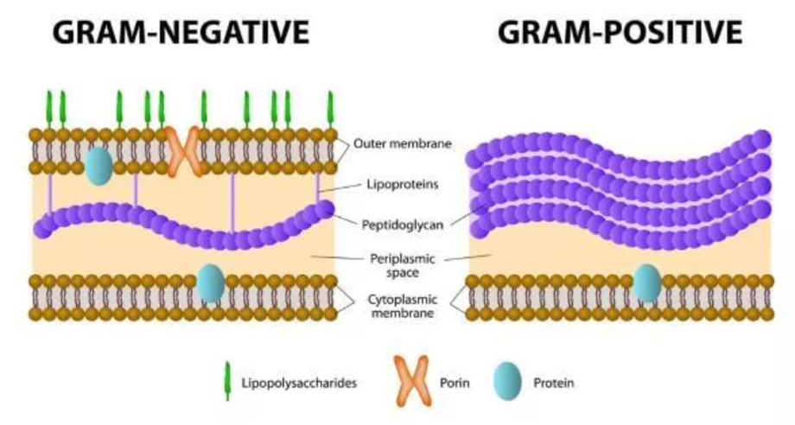

  - Nucleic Acids: Certain forms of RNA and DNA that are associated with viruses or bacteria.
  - Proteins: For example, bacterial flagellin, which is part of the flagella that enable bacterial motility.
  - Glycans: For instance, bacterial lipopolysaccharide (LPS), a component of the outer membrane of Gram-negative bacteria.
- Recognition by PRRs: PAMPs are recognized by pattern recognition receptors (PRRs) on immune cells, such as macrophages and dendritic cells. When PRRs bind to PAMPs, it triggers immune responses, including:
  - Ingestion and degradation of the microbes.
  - Activation of macrophages.
  - Production of cytokines and inflammation.
- Role in Immune Response:
  - Activation of immune cells leads to the production of pro-inflammatory cytokines and chemokines.
  - Enhances the recruitment of additional immune cells to the site of infection.
- When PRRs engage with PAMPs, it leads to:
  - Ingestion of Microbes: Phagocytosis occurs, allowing immune cells to engulf and destroy pathogens.
  - Macrophage Activation: This enhances the macrophage's ability to kill pathogens and produce inflammatory cytokines.
  - Cytokine Production: The release of cytokines helps recruit additional immune cells and promotes inflammation, which is crucial for fighting infections.
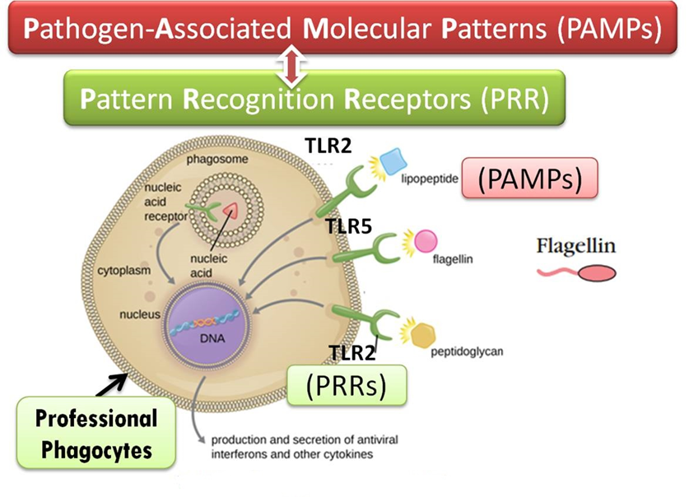

Pattern-Recognition Receptors (PRRs) The innate immune system employs Pattern-Recognition Receptors (PRRs) to identify and respond to microorganisms. These receptors are critical for detecting pathogens through their recognition of Pathogen-Associated Molecular Patterns (PAMPs) and the activation of immune responses.

Features of PRRs
- Germline-Encoded Proteins: PRRs are inherited and do not require prior exposure to pathogens for their expression.
- Location: Primarily found on antigen-presenting cells (APCs) such as dendritic cells and macrophages, but also present on other immune and non-immune cells.

Types of PRRs
- Toll-Like Receptors (TLRs):
  - Function: TLRs recognize specific PAMPs and initiate signaling pathways that lead to the secretion of cytokines.
  - Outcome: This promotes inflammation and enhances the immune response against pathogens.
- Scavenger Receptors:
  - Function: These receptors bind to lipoproteins, polysaccharides, and nucleic acids.
  - Role in Immunity: They play a crucial role in the internalization of bacteria and in the phagocytosis of host cells that are undergoing apoptosis.
- Opsonins:
  - Definition: Opsonins are molecules that bind to the surface of microbes, making them more attractive to phagocytic cells.
  - Opsonization Process: This process enhances the susceptibility of invading microorganisms to phagocytosis, facilitating their clearance from the body.
  - Examples: Antibodies and complement proteins can act as opsonins, marking antigens for phagocytosis.

